Course outline

The Story of Work
Week 1: A Biblical Theology of Work
Week 2: The Problem with Work

Our Work as the Redeemed
Week 3: A New Boss: How Jesus’ Work Changes Our Work
Week 4: A New Goal: Success is Faithfulness

How We Work
Week 5: Motivation: Faithfulness Changes Why We Work
Week 6: Relationships: Imaging Christ in the Workplace
Week 7: Balance: Christians Are Not Balanced People
Week 8: Gender: Being Who You Are in the Workplace
Week 9: Ethics: Case Studies for the Modern Workplace
Week 10: Finding a Job: Putting First Things First
Week 11: Evangelism: Sharing Christ With Your Colleagues
Week 12: Work at different stages of life

Week 13: Panel Q&A

Questions? E-mail jamie.dunlop@capbap.org or patrick.traylor@icloud.com

Suggested reading
- The Gospel at Work (Traeger, Gilbert)
- God at Work (Veith)
- The Call (Guiness)
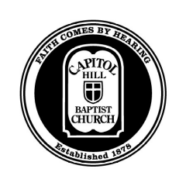
Core Seminars – Engaging the World
Christians in the Workplace
Week 9

Ethics:
Case Studies for the Modern Workplace

Introduction

Guidelines for Ethics in the Workplace

When faithfulness is not clear:

- What clear Biblical commands or principles apply?

- What does your conscience say? Remember:

  - It’s generally unsafe to violate your conscience.
  - Your conscience may be wrong. It might be seared (1 Timothy 4:2); it might need to be educated (1 Corinthians 8:7).
  - We must protect the consciences of others (1 Corinthians 8:12).

- What good opportunities are at stake?

- How will different courses of action make Christ attractive? (Titus 2:10)

- What advice do friends at church give you?

- What advice to Christians at work give you?

Notes on the case studies

