Course outline

The Story of Work
Week 1: A Biblical Theology of Work
Week 2: The Problem with Work

Our Work as the Redeemed
Week 3: A New Boss: How Jesus’ Work Changes Our Work
Week 4: A New Goal: Success is Faithfulness

How We Work
Week 5: Motivation: Faithfulness Changes Why We Work
Week 6: Relationships: Imaging Christ in the Workplace
Week 7: Balance: Christians Are Not Balanced People
Week 8: Gender: Being Who You Are in the Workplace
Week 9: Ethics: Case Studies for the Modern Workplace
Week 10: Finding a Job: Putting First Things First
Week 11: Evangelism: Sharing Christ With Your Colleagues
Week 12: Work at different stages of life

Week 13: Panel Q&A

Questions? E-mail jamie.dunlop@capbap.org or patrick.traylor@icloud.com

Suggested resources:
- The Gospel at Work (Traeger, Gilbert)
- God at Work (Veith)
- The Call (Guiness)

Core Seminars – Engaging the World
Christians in the Workplace
Week 10

Finding a Job:
Putting First Things First

I. Introduction

II. Getting Our Priorities Straight

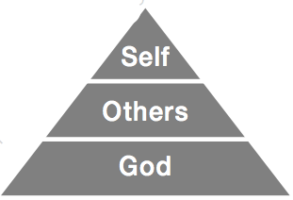

III. The “must-haves”

- Can this job glorify God?
- Does this job permit me to live a Godly life?

- Does this job allow me to be faithful in my other assignments?

- Does this job allow me to be involved in my local church?

- Do the temptations of this job reinforce my besetting sins?

- Does this job provide for my needs and allow me to be a blessing to others?

IV. The “Nice-to-haves”

- Does this job have potential to improve me as a person?

- Does this job use my gifts and talents?

- Is this job something I want to do?

V. The danger of inverted priorities



VI. Conclusion

