VI. Conclusion: Jeremiah 29:7

“But seek the welfare of the city where I have sent you into exile, and pray to the Lord on its behalf, for in its welfare you will find your welfare.”

NOT (stripped from Biblical context): our ultimate hope is the temporal welfare of this city.

BUT (in Biblical context): while we are here, we are eager to do what is good (Titus 2:14).

Questions? Jamie.dunlop@capbap.org or isaac.adams@capbap.org

Core Seminars – Neighboring
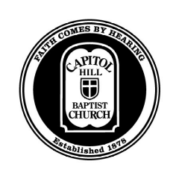
Week 3

Loving Your Neighbor and Your Neighborhood

I. Introduction

Today’s class: not a rule book but a menu.

II. Neighbor and Neighborhood

We can display the glory of God both as we love both at the level of the individual and as we work for a better society.

  - Addressing individual challenges

  - Addressing structural challenges.

The tragedy of the commons / free-ridership problem.

III. Building Friendships with Neighbors

Seven ideas for building friendships with the ultimate hope of seeing them respond to the gospel.

- Introduce Jesus early on.

- Know their stories.

- Live at peace.

- Do good things.

- Give them time.

- Invest in margin.

- Receive their love.

IV. Building Neighborhoods

The value of addressing structural problems at the level of a neighborhood.

Who: Christians. Why Christians are well-suited to investing in the neighborhood.

How: Four pieces of advice:

- Submit to authority (1 Peter 2:13).

- Love your neighbor.

- Be humble.

- Very often there is no “Christian” answer to these challenges.

- Do not let your eagerness to do good lead to division in the body of Christ.

- Put your hope in heaven.

What: the issues that affect those your neighbor.

The value of diversity in the local church

