God’s patience preserves his promises – Numbers 17-36

More disbelief:

- against God’s word (17v13)
- from Moses (20v8-12)
- against Moses (21v4)

People’s Unbelief leads to God’s Patience (21v6-9)

(John 3v14-15)

People – 26v51

Place – 27, 32, 34, 36

Presence – 29v1

Blessing to nations? – 21, 22-24, 31, 24v9

Conclusion:


Core Seminars—Old Testament
Class 7: “Past Promises Will Prevail
In Spite of Present Problems”
Numbers

Context

- Geographical context – God’s people on the move

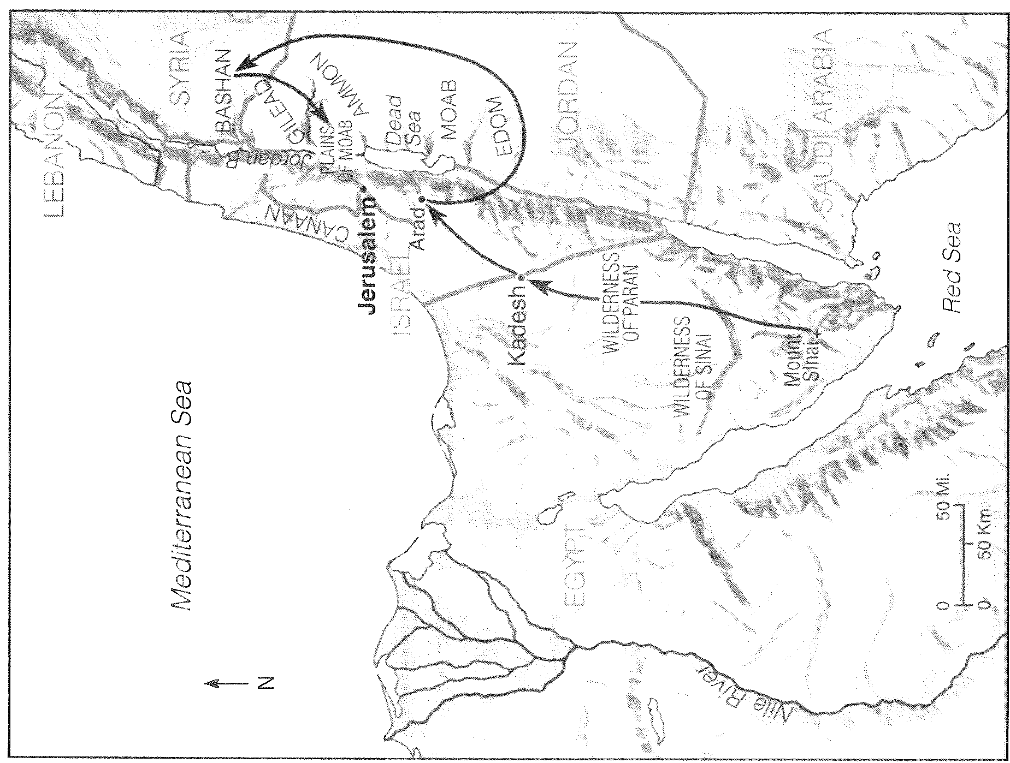
1-10 - Packing up at Sinai
11-12 - Journing to Kadesh
13-19 - Wandering in Paran
20-21 - Journing to Moab
22-36 – Preparing in Moab

- Historical Context – God’s promises to Abraham

People – Genesis 13v15

Place – Genesis 12v2

Presence – Genesis 15v1

Blessing to nations – Genesis 12v3

Theme sentence

Past promises will prevail in spite of present problems

God’s preparation preserves his promises – Numbers 1-10

People – 1v46 (2v32) and 4v48

Place - 10v33

Presence - 5-6, 7, 8v5 and 9v15-18 (John 14v16-18)

Blessing to nations? – 10v29 (Galatians 3v14)

God’s punishment preserves his promises – Numbers 11-16

Complaining:

- at hardships (11v1)
- at food (11v13)
- at Moses (12v1)

- at God! (13v31-33, 14v1-7)

People’s Unbelief = God’s Punishment (14v10-12, v21-23)

People – 14v23 vs. 14v31

Place – 14v25 (Hebrews 3v12-19)

Presence – 15, 16v41-42

Blessing to nations?

