Tracking the key themes:

- Requiring separation as God’s people –
Being influenced by the world

- Requiring punishment that leads to repentance –
Sin’s consequences often bring us to God

- Requiring a perfect Savior who leads to true rest –
Only Jesus gives ultimate rest


Core Seminars—Old Testament
Class 9: Joshua & Judges

Introduction:

Taking the Land (Joshua) Keeping the Land? (Judges)
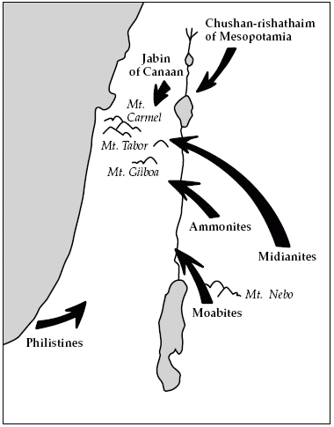
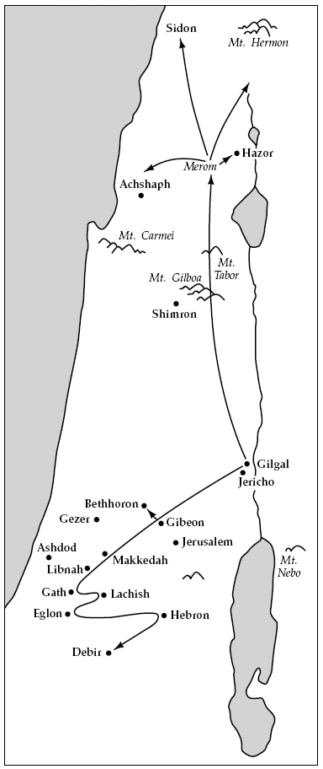

Main Themes:

Joshua - Trusting a faithful savior to lead God’s people to land and rest

Judges - Requiring a perfect savior to maintain this land and rest

Joshua - Trusting a faithful savior
to lead God’s people to land and rest

Overview:

Trusting as they…

…enter the Promised Land (Chapters 1-5)

…take the Promised Land (Chapters 6-12)

…divide the Promised Land (Chapters 13-21)

…accomplish the promised Rest (Chapters 22-24)

Tracking the key themes:

1. Trusting as God’s people – In Christ and with the Spirit

2. Trusting God’s faithful savior – Joshua and Jesus

3. Trusting God for land - Hope of heaven and the fear of hell

4. Trusting God for rest – Fighting sin and resting in Jesus

Hebrews 4:8, Matthew 11:28

Judges - Requiring a perfect savior
to maintain this land and rest

Overview:

Requiring a perfect savior as they…

…lose land and their faithful savior (Chapters 1-2)

…receive imperfect saviors (Chapter 3-16)

Forget and rebel against God

God raises up a savior Suffer God’s wrath

Cry out to God

…crave true rest (Chapter 17-21)

