Questions? zach.schlegel@capbap.org or jamie@capbap.org
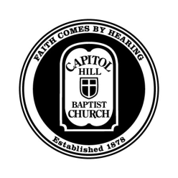

CORE Seminars – Theology of the Church

Capitol Hill Baptist Church

Class #2 – Church Membership

Introduction

1 Corinthians 5:4–5 “When you are assembled in the name of the Lord Jesus and my spirit is present, with the power of our Lord Jesus, you are to deliver this man to Satan for the destruction of the flesh, so that his spirit may be saved in the day of the Lord.”

The Church Represents Heaven

The Keys of the Kingdom of Heaven
Matthew 16:15-19 “He said to them, “But who do you say that I am?” Simon Peter replied, “You are the Christ, the Son of the living God.” And Jesus answered him, “Blessed are you, Simon Bar-Jonah! For flesh and blood has not revealed this to you, but my Father who is in heaven. And I tell you, you are Peter, and on this rock I will build my church, and the gates of hell shall not prevail against it. I will give you the keys of the kingdom of heaven, and whatever you bind on earth shall be bound in heaven, and whatever you loose on earth shall be loosed in heaven.”

The Keys and the Church

Matthew 18:15–18 “If your brother sins against you, go and tell him his fault, between you and him alone. If he listens to you, you have gained your brother. ¹⁶ But if he does not listen, take one or two others along with you, that every charge may be established by the evidence of two or three witnesses. ¹⁷ If he refuses to listen to them, tell it to the church. And if he refuses to listen even to the church, let him be to you as a Gentile and a tax collector. ¹⁸ Truly, I say to you, whatever you bind on earth shall be bound in heaven, and whatever you loose on earth shall be loosed in heaven.”

The Keys Exercised Through Baptism & Lord’s Supper

Matthew 28:19 “Go therefore and make disciples of all nations, baptizing them in the name of the Father and of the Son and of the Holy Spirit.”

“A local church is a group of Christians who regularly gather in Christ’s name to officially affirm and oversee one another’s membership in Jesus Christ and his kingdom through gospel preaching and gospel ordinances.”

Who is Church Membership For?

- Matthew 5:3 ““Blessed are the poor in spirit, for theirs is the kingdom of heaven.”
- Matthew 7:21 ““Not everyone who says to me, ‘Lord, Lord,’ will enter the kingdom of heaven, but the one who does the will of my Father who is in heaven.”
- Matthew 10:32 “So everyone who acknowledges me before men, I also will acknowledge before my Father who is in heaven,”
- Matthew 18:4 “Whoever humbles himself like this child is the greatest in the kingdom of heaven.”

Membership Throughout the New Testament

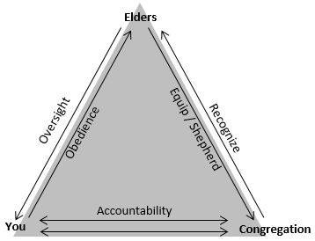
Romans 12:13-16; 15:1
Hebrews 10:24-25
1 Corinthians 5:1-5, Matthew 18:15-20
1 Peter 5:1-6
Galatians 1:6-9

Hebrews 13:17
1 Thessalonians 5:12-13

Discussion…

