Date of Planning Meeting : _____/_____/______

FUNERAL AND MEMORIAL SERVICE PLANNING GUIDE
Please note: This guide is to be filled out with a Pastor during your planning meeting.
Please contact Bethel Lutheran Church at 715-386-8821 to schedule your meeting or to learn more information about the Funeral and Memorial Service options available through the church.

Section 1 – General Information

Christian Service for: _______________________(First), _____________________________(Last),
(Middle name or initial, optional) ________________

Date of Funeral/Memorial Service: Notes
Time of Service:

Visitation at Funeral Home (Date/Time):
and/or
Visitation at Church (Date/Time):

Location of Service:  Downtown Campus  Highlands Campus  Other:____________

Clergy Officiate:________________________________

Primary Family Contact:____________________________________, Relationship to:___________________

Phone: (____)_________________ Email:__________________________________________
Immediate Family Name & Address: ________________________________________________________________________________________________________________________________________________________________________________________________________________________________________________________________________

Bethel Member:  Yes  No Date of Death:_______________

Funeral Home (or Cremation Center) Name:____________________________________________________

Note other Burial/Inurnment information (location, timing): ______________________________________ ________________________________________________________________________________________

Military Honors:  Yes  No Location of Military Honors:________________________

Interest in Bethel Highlands Columbarium:  Yes  No
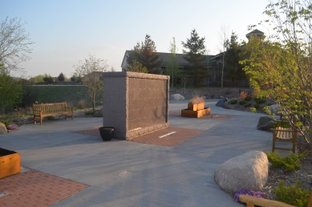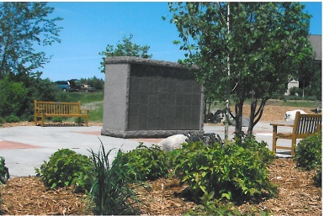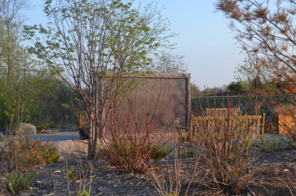

Is the family interested in designating memorial funds to one of Bethel’s ministries?
 Bethel General Fund  Memorial Fund  Endowment Fund
 Other Non-Bethel Organizations:_________________________

Section 2 – Worship Preferences

Have Service Pre-arrangements Been Made?  Yes  No Baptized?  Yes  No

Service Bulletin Heading: _________________________________________________________

The Prelude

Opening Litany

The Processional Hymn: _________________________________________________________

The Invocation

The Prayer

The Scripture Reading (and Readers): _________________________________________________________

(Optional) Other Music or Non-Biblical Readings (and Readers): ____________________________________

(Optional) Eulogists - maximum of 3: __________________________________________________________
________________________________________________________________________________________
(Section 2, continued)

The Gospel Lesson

The Message

Hymn or Solo: _________________________________________________________________

The Apostles’ Creed

Holy Communion Celebrated (in church):  Yes  No

The Prayers

The Lord’s Prayer

The Commendation/Blessing

Announcements

Table Blessing

The Closing Hymn: _____________________________________________________________

The Postlude

Section 3 – The Reception

Funeral receptions are typically coordinated by the funeral home. When a funeral home is not used, family members are responsible for coordinating reception details.

Reception at Bethel following the service:  Yes  No

Reception Date & Time:___________________________________________________________

Reception Location:  Downtown Campus  Highlands Campus  Other:____________

Caterer Involved (if Non-Member) ________________________________________________________
Provide Contact information:

(Reception, continued)

Number of People Expected to Attend the Reception:____________

(If available) Service by Bethel Volunteers – Bethel Coordinator Name:____________________________

Type of Reception:  dessert  cold sandwich  full lunch

Bethel Coffee Equipment used:  Yes  No

Section 4 – Family Responsibilities if No Funeral Home is Involved

Funeral homes perform a variety of behind the scenes activities. The following is a list of tasks that must be performed by family members and friends if no funeral home is involved.

_____ Movement of cremated remains to church (must arrive at Bethel 45 min. prior to start)
_____ Movement of remains to burial place
_____ Ushers during the service (duties include reserving pews, order of exit, assisting others)
_____ Purchase, placement and movement of flowers for visitation and the service
_____ Photographs & mementos, including placement and removal
_____ Coordination of the reception
_____ Selection and coordination of burial/inurnment location
_____ Memorial folder & printing
_____ Writing and placement of obituaries in newspapers
_____ Memorial marker selection and engraving
_____ Guest book and a memorial box for envelopes
_____ Preference for flowers, memorials or gifts to the family
_____ Payment of fees and honorariums

Things to consider on or near the urn:
Flowers Bible or other symbol of faith
_____ Photograph Cross
_____ Flag

Obituary – Funeral homes help families to prepare and place an obituary in local newspapers. If a funeral home is not being used, you may prepare an obituary yourself and ask your pastor for assistance. The family must arrange for placement of the obituary.
A typical obituary contains attributes such as the following:
Full name of the deceased, age, place of residence, how passed away (optional), date of death, date and location of birth, parents’ names (including mother’s maiden name), schools attended, marriage information, children, occupation and employment, military service, accomplishments, interests and things you want people to know about the deceased, how they celebrated life, faith and helped others. The deceased will remain in the hearts of spouse name, names of children (with their spouses in parentheses), grandchildren’s names (optional), brothers and sisters, nieces and nephews (optional). Preceded in death by these family members. A Memorial Service will take place at time, date and location, information about pre-service activity, inurnment location. Memorials are preferred to this organization name. Consider including a photograph for publication.

Additional Service Instructions –
________________________________________________________________________________________________________________________________________________________________________________________________________________________________________________________________________________________________________________________________________________________________________________________________________________________________________________________________________________________________________________________________________________________________________________________________________________________________________________________________________________________________________________________________

