Date: October 19, 2017
- Call to Order
Jeff Johnson called the meeting to order at 7:03pm
- Devotional / Shared Prayer
Jeff Johnson led us in prayer
- Establish a Quorum
So noted
  - Members present: Jeff Johnson, John Shardlow, Mike Dolan, Keith Gilbert, Beth Jacobson, Joe Zeigler, Tom Lund
  - Members absent: Jessie Henry, Darci Bontrager.
  - Others present: Pastor Lauren Wrightsman, Laurel Hofeldt
- Approval of Agenda
Motion to approve the agenda was made by Jeff, seconded by John and approved unanimously.
- Approval of September
The September minutes were moved for approval by Jeff, seconded by Joe and approved unanimously.
- Monthly Reports Reports are attached; additional discussion is listed below as expressed.
  - Finance: Laurel
  - Staff
      - Pastors
        - Senior Pastor
          - Replacement for Pastor Dick
Pastor Dick will be resigning in January. There will be more information in November.
          - Stewardship Update
Sustainer pledges continue to come in, both on cards and online, nearing a goal of 100 new or increased giving members.
          - Innovations in Management
Meetings have taken place and are ongoing between staff, lay leadership and Innovations team members.
        - Associate Pastor
      - Church Administrator
  - Committee Reports
    - Mission & Outreach- Darci
No report

    - Stewardship- Keith
Recent discussion involves looking at steps to continue forward. There was a general Council discussion about giving, relating expenses to the actual amount of giving.
    - Children- Joe
The attached report was outlined.
    - Youth & Family- Jessie
Jeff outlined information sent by Jessie. Policy drafts are in process for presentation at our November meeting. Confirmation is going well. Council members will be needed for a meeting with students during Lent. Michael Jordan is taking 48 youth to MEA get away; 16% of total attendance.
    - Adult Ed- Beth
Getting more information from committee.
    - Christian Life- Beth
Getting more information from committee. Wednesday evening sessions (Neighbors and Me) have been well attended by the community and have been a great success.
    - Nominating- Mike and Tom
Mike contacted committee members; the first meeting will be in December or January.
    - Task Force Updates
      - Strategic Planning:
        - Mission and Outreach Taskforce update
A suggestion to change benevolence payment responsibilities from M/O to Council is attached. The discussion was tabled for now.
        - Facilities and maintenance task force update
Mike had a meeting with Steve Henry and Dave Booms. Steve outlined roof and window repair that is needed on the preschool (1955) building, Activity Center and Worship Center. Steve also forwarded information on past campus evaluations (2005 and 2012) outlining these and other facility issues. Council discussion involved using gift funds for not only these needed repairs but as a seed money for future sustainability enhancements, like solar panels, rain gardens, etc. Steve is refining estimates and will have bids ready for Council. Council is also invited for a facility tour in November, where some of these facility needs can be seen.

      - 75th Anniversary
There was positive response to videos and pictures displayed as part of the celebration. An opportunity may exist for giving to the building fund, tying the anniversary to the future of RLC.

- Items for Discussion
No items were noted.

- New Business (Action Items)
a) Motion to move Synod Benevolence from Mission and Outreach budget to the General Fund
i) Information in the October 17th Council report under Pastor Sara’s report
This item was tabled for now.
b) Motion to move the Conflict of Interest Policy
i) In Laurel’s report

Tom suggested language changes to the policy. The item was tabled for now.
c) Motion to move $9,000 of excess Child Care funds to be used for Deferred Maintenance on the Child-Care house
i) In Laurel’s report

Tom motioned to approve the use of funds for repairs as stated in the report. The motion was seconded by Joe and approved unanimously.
d) Motion to move Pre-school to use Commons area to sell Poinsettias for Christmas Holiday
i) Jennifer Johnson’s letter
Beth moved to approve Pre-School’s use of the Commons for Poinsettia sales. John seconded the motion and it was approved unanimously.
- Upcoming dates
No upcoming dates were noted.
- Adjournment
John moved for adjournment and it was seconded by Joe. The motion was approved unanimously.
- Closing Prayer
Pastor Lauren led Council in the Lord’s Prayer.
Respectfully Submitted,
Mike Dolan
Vice-President

Council Report
Senior Pastor, Lauren Wrightsman
October 12, 2017

- Action Items in Progress / Pending

  - Innovations in Management: Interview schedule is complete. Others will participate in email surveys in November.

  - 75th Anniversary celebration: We have officially kicked off the celebration!

  - Continued work with Stewardship to address the campaign going into the fall

We have received 176 intent cards indicating $488,000 in giving to the general fund and $16,000 to the building fund. 69 donors plan to increase their giving over 2017 plus 4 new online givers.

  - Direction for the Strategic Planning:
Innovations in Management: in process

Worship and Music Task force
Tabled

  - Marriage Policy: Approved

  - Personnel Policy: In process

Budget Requirements (if any)
None

- Action Items Completed

Budget Requirements (if any): None

- Questions for the council to address. Do any require council vote? (Yes or No)

None

- Other comments

Council Report

Staff Member name: Sara Spohr

Date: October 2017

- Action Items in Progress / Pending

- Mission and Outreach task force - we have had our 5th meeting and we are continuing to make great progress. We have an excellent group of people who are diverse in their perspectives and unified in their love for Roseville Lutheran and their desire to see our church make and important impact in our serving. We have been honing our proposed strategic filters for mission and outreach work and moving on with how new and current projects will move through that filter. We are also beginning to think about other specific recommendations we will have.

- Synod Benevolence - Our benevolence giving to the synod has historically fallen under the Mission and Outreach committee to define and distribute. This is a complicated item because it is Mission and Outreach, but it is more than that. This is our relationship to our larger church wide body. I am requesting that council move our synod benevolence giving to a general budget item to be determined by the council and congregation and that it no longer be kept under the purview of mission and outreach.

- Lenten Devotional - I am working on putting together a daily devotional for the season of Lent. This will be distributed via email, with a few print copies available. The devotions will be written by a variety of our Roseville Lutheran Church members and friends. I am really excited about getting more and more people an opportunity to read God’s word daily.

Budget Requirements (if any)

- Action Items Completed

- The Unity Project will be completed soon. We had a very large number of people participating in this project. I will be getting a sign hung that describes the scope of this project.
- Our Fall programs in the CYF department are up and running. We have some of the best adult leaders working with our young people. It is really amazing to see people step up and share their gifts. The CYF staff team has worked hard to get programming in place for Summer 2018, they recently released a brochure about those programs.

Budget Requirements (if any)

- Questions for the council to address. Do any require council vote? (Yes or No)

- Consider moving our synod benevolence giving into our general budget.

- Other comments

Staff Member name: Dave Booms-Church Administrator

Date: 10/12/17

- New items
  - Building and Grounds
    - Fall clean up and Winter prep
  - Design Team
    - See team meeting notes from October, attached.
    - Working with Staff on 75th Anniversary displays
  - Communications
    - No New items
  - Hospitality
    - No New items.

- Action Items in Progress / Pending
  - Building & Grounds
    - Rentals
      - No new rentals, existing rentals being serviced as per calendar
    - Deferred Maintenance
      - Getting updated bids from contractors on existing needs
        - Looking for an outside “expert” to help build and overall priority plan.

    - Projects
      - Security upgrades
      - Paint north end of the Worship Center
      - Volleyball Court maintenance
      - Roof Repair
      - Lighting
        - Permanent theater lighting for the Worship Center
        - Assessing upgrading Florescent lighting to LED

    - 75th anniversary prep
      - Set ups for events

  - Communication
    - Materials for Library Committee
    - 75th Anniversary (Decade Poster production, event advertising for Ken Medema, more decade videos to be edited, presented, placed on website, shared on FB; En Gang Til support materials.)
    - TABLE Deadline - Nov. 1 for Dec-Jan-Feb issue.
    - All Saints, Veterans Day, Advent preparations, designs, mailing/communications
    - Training new Communications Specialist

  - Audio/Visual refit & repair
    - A/V upgrades & maintenance
      - New projector
      - New Amp for Commons
      - Upgrading wiring
      - Analog to Digital upgrades

  - Manual revision
    - Employee
    - Wedding

  - Funerals Sept & Oct
    - Three done, three pending

  - Hospitality
    - Prep
      - 75th
      - Prime time
      - Vets Day
      - Bible Study
      - Luther Connections
      - Kitchen license
      - Cold calling for Senior Activities & other rentals
    - Assessing move to environmentally friendly, sustainable, service-ware.

- Action Items Completed
  - Communication
    - Magazine delivered (75th Anniversary, re-introduction to neighborhood, mailed to 4,200 households, including our membership).
    - Stewardship (Mailing, Website Updates, targeted emails).
    - 75th Anniversary (some decade posters printed, installed. Event advertising...Dance, Ken Medema. First decade videos edited, presented, placed on website, shared on FB.
    - Materials for Mission & Outreach.
    - Prime Time support materials and event support.

  - Building & Grounds
    - Projects
      - Carpet replacement, east entrance
      - 75th anniversary
        - Decades poster mounting, Social Hall
      - Reception area “make-over”
      - Pew card holders
      - Caulk north end of the Worship Center
      - Commons: art install
      - Artifact display
      - Banner install

  - Hospitality
    - Catering for St. Marys of the Lake event
      - Serviced 213 people
    - Three funerals
    - ADK event
    - Prime Time
    - Misc. meetings
    - The first 3 weeks of this month, the Roseville Lutheran church kitchen will produce over 719 meals for our guests.

- Questions for the council to address. Do any require council vote? (Yes or No)

None

- Other comments

Design Committee Report – October 2017

Members Present: Dorothy Borgstrom, Vivian Howatt, Sue Metzger, Carolyn Mohn, Dot Probst,
Steve Henry. Cathy Nelson absent.

Steve Henry discussed some areas he is working on.
* He has contracted Ballantine Paint to paint the wave on the north and south Commons wall.
It will be painted sometime this fall. It will be a newer blue color.

*Committee & Steve picked out a neutral color from the palette for the back wall in Room 40.
Steve will paint this wall when he has time in the near future.

* All is moving along with the 75th Anniversary decades posters, unity ribbon project, etc.

* Paul Oman painting will be installed when the lift is in the building after Nov. 19 for the
Christmas mural.
(Dorothy will meet with Pastor Lauren to discuss paint color around the edges of the canvas.
We will determine if a frame is needed later. If one is needed we will prepare a budget request
to council.)

Ongoing Projects:
* Dot is looking online and through other venues for examples of art work that might look good
in the main office. She will continue to research options. We hope to find welcoming,
colorful, community & spiritual themed art and will seek Trish and office staff for input.

* Carolyn is communicating with Judy Dodd about the processional banner and/or wall
hanging that may be funded with memorial money. There are many questions about size,
banner stand, etc. Vivian will research typical banner sizes and holders/poles/ etc.
Carolyn will meet with Dave Booms about memorial funding to get an estimate of available
funds.

• Nov. 19 Celebration flowers for social hall.
Dorothy will meet with Connie the end of Oct. to discuss arrangements. She will pick out
the vases, etc. Nov. 17 meet at 1:30 at Kohler Dramm (2407 E Hennepin Ave, Minneapolis, MN 55413) with Carolyn to select the flowers. Nov. 18 We will meet at church to arrange the vases with flowers. (Committee members please come to help with this !!)

We still need to come up with a subset of colors from the palette that might work better
for the Children’s Ministry rooms. This will be a part of our ongoing color palette update.
Next Meeting: Nov. 13 Noon - 1:00 Please send names of people to invite to join us !!!
Future meetings: Dec. 4 Jan. 8

Council Report

Laurel Hofeldt, Director of Finance & Data
October 12, 2017

- Action Items in Progress / Pending
  - Conflict of Interest Policy: As part of the external audit completed April 18, 2017, Akins Henke & Company recommended that RLC establish a Conflict of Interest Policy. The Finance Committee has discussed and approved the attached policy, based on the ELCA template, and now recommends it to Council for discussion/approval.
  - Sue Menier – The Child Care ended the 2016-2017 fiscal year with a $25,000 surplus. Sue is requesting approval to spend $9,000 for deferred maintenance. See full bids attached and summary below:
    - Mostad: Bathroom remodel, fence/gate repair and new timber surround on playground bid = $2,515
    - Durand Construction Services: Kitchen cupboard door replacement & rebuilding drawer boxes, power wash and stain fence and playset bid = $5,255 + $1,190
    - Steve Henry was consulted and does not have the resources to do this work himself.
    - Bids are attached along with Sue’s recommendations
  - Stewardship/Intent to Give update as of 10/10/17:
    - 176 intent cards turned in
    - $488,000 in giving committed to the general fund
    - $16,000 committed to the building fund
    - 69 donors plan to increase their giving over 2017 plus
    - 4 new online givers
- Action Items Completed
  - September Month-End Summary and Statement of Operations (attached)

- Questions for the council to address. Do any require council vote? (Yes or No)
  - Discussion/approval of Conflict of Interest Policy requires vote
  - Discussion/approval of bids for Child Care repairs & remodel requires vote

- Other comments:

Roseville Lutheran Church

Operational Ethics Policy

This Operational Ethics Policy addresses conflicts of interest and business ethics but does not include the other ethical values and policies of Roseville Lutheran Church (“the congregation”) of the Evangelical Lutheran Church in America.
1. Each person who is a director (Congregation Council member), officer, ministry team member, committee member or employee (all referred to below as “Congregation Representative”) of Roseville Lutheran Church shall exercise good faith and best efforts in the performance of his or her duties to the Congregation and all entities affiliated with the congregation. In all dealings with and on behalf of the congregation, or any affiliated entity, these Congregation Representatives shall be held to a standard of loyalty and honest and fair dealing with the Congregation and its affiliated entities.
2. No Congregation Representative shall use his or her position, or knowledge gained therefrom, so as to create a conflict, or the appearance of a conflict, between the interests of the congregation or any affiliated entity and the other interests of such Congregation Representative.
3. No Congregation Representative shall accept any material compensation, gift, or other favor that could influence or appear to influence such person's actions affecting the congregation or any affiliated entity. Each Congregation Representative should promptly disclose to the pastor, an officer of the congregation, or a ministry team or committee chair (and as appropriate to the board or committee) any gift, employment, activity, investment, or other interest that might compete or conflict, or appear to compete or conflict, with the interests of the congregation or any affiliated entity. At the discretion of an officer, ministry team or committee chair, the matter may be referred to the Congregation Council or Executive Committee.
4. No Congregation Representative should vote, or be counted in determining the quorum for any vote, on any transaction between the congregation and any other corporation, firm, association, or other entity in which such Congregation Representative has a direct or indirect substantial financial interest. Any such duality of interest should be disclosed by the Congregation Representative to the other appropriate Congregation Representatives as applicable and made a matter of record. In addition to refraining from voting, no Congregation Representative should participate in the deliberations or use personal influence in the matter. Any transaction that involves a Congregation Representative should be at least as fair and reasonable to the congregation as a transaction involving independent parties.
5. For the purposes of Section 4, a Congregation Representative is deemed to have a direct or indirect substantial financial interest in any corporation, firm, association, or other entity in which such person, or such person's parents, spouse, or all descendants of either of such person's parents or such person's spouse have an aggregate, beneficial, equity interest of one percent or more.
6. If a question exists as to the substantiality or significance of a financial interest or conflict and the appropriate action by the Congregation Representative in light of the interest or conflict, the Congregation Representative should seek advice from members of the Congregation Council Executive Committee.
7. After adoption, and then on an annual basis, the secretary, or other person designated by the Congregation Council, shall send a copy of this policy to each director, officer, ministry team member, committee member and employee of the Congregation. All new Congregation Representatives should be given a copy of the policy. Such delivery may be electronic. The congregation also shall work to make this policy accessible through other methods, such as on the congregation website.
8. It shall be the duty of each Congregation Representative to inform the Congregation Council or other appropriate person or body of any conflicts of interest in a timely fashion. No Congregation Representative, in his or her capacity as such, shall act as, or represent that he or she is, an agent of the congregation or any affiliated entity, unless specifically authorized to do so by the Congregation Council.
9. A Congregation Representative has a duty to disclose all breaches of this policy. There will be no retaliation for good faith complaints, reports, or participation in an investigation.

10. Violation of the policy may result in termination from the congregation position, as appropriate.

Adopted by Congregation Council on _______________ [DATE]

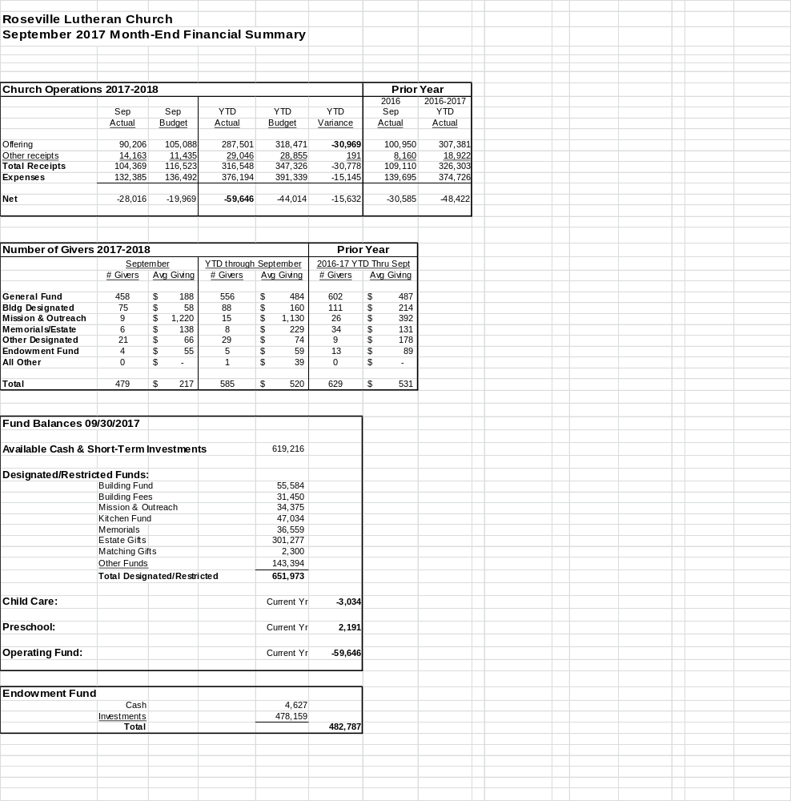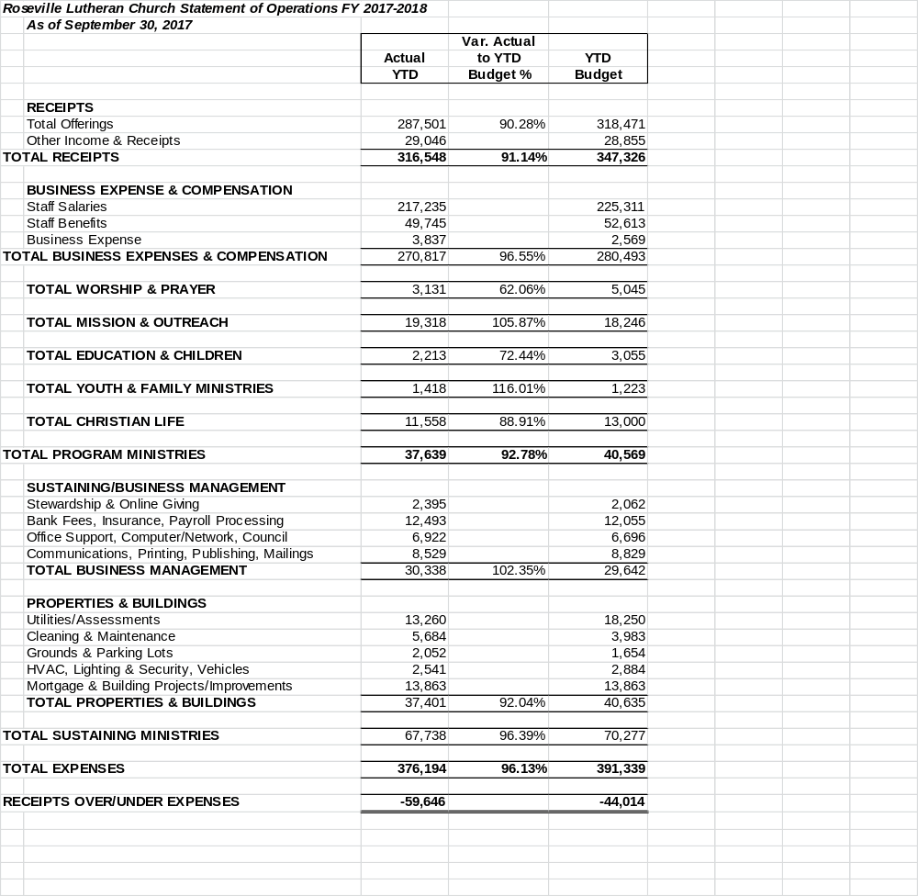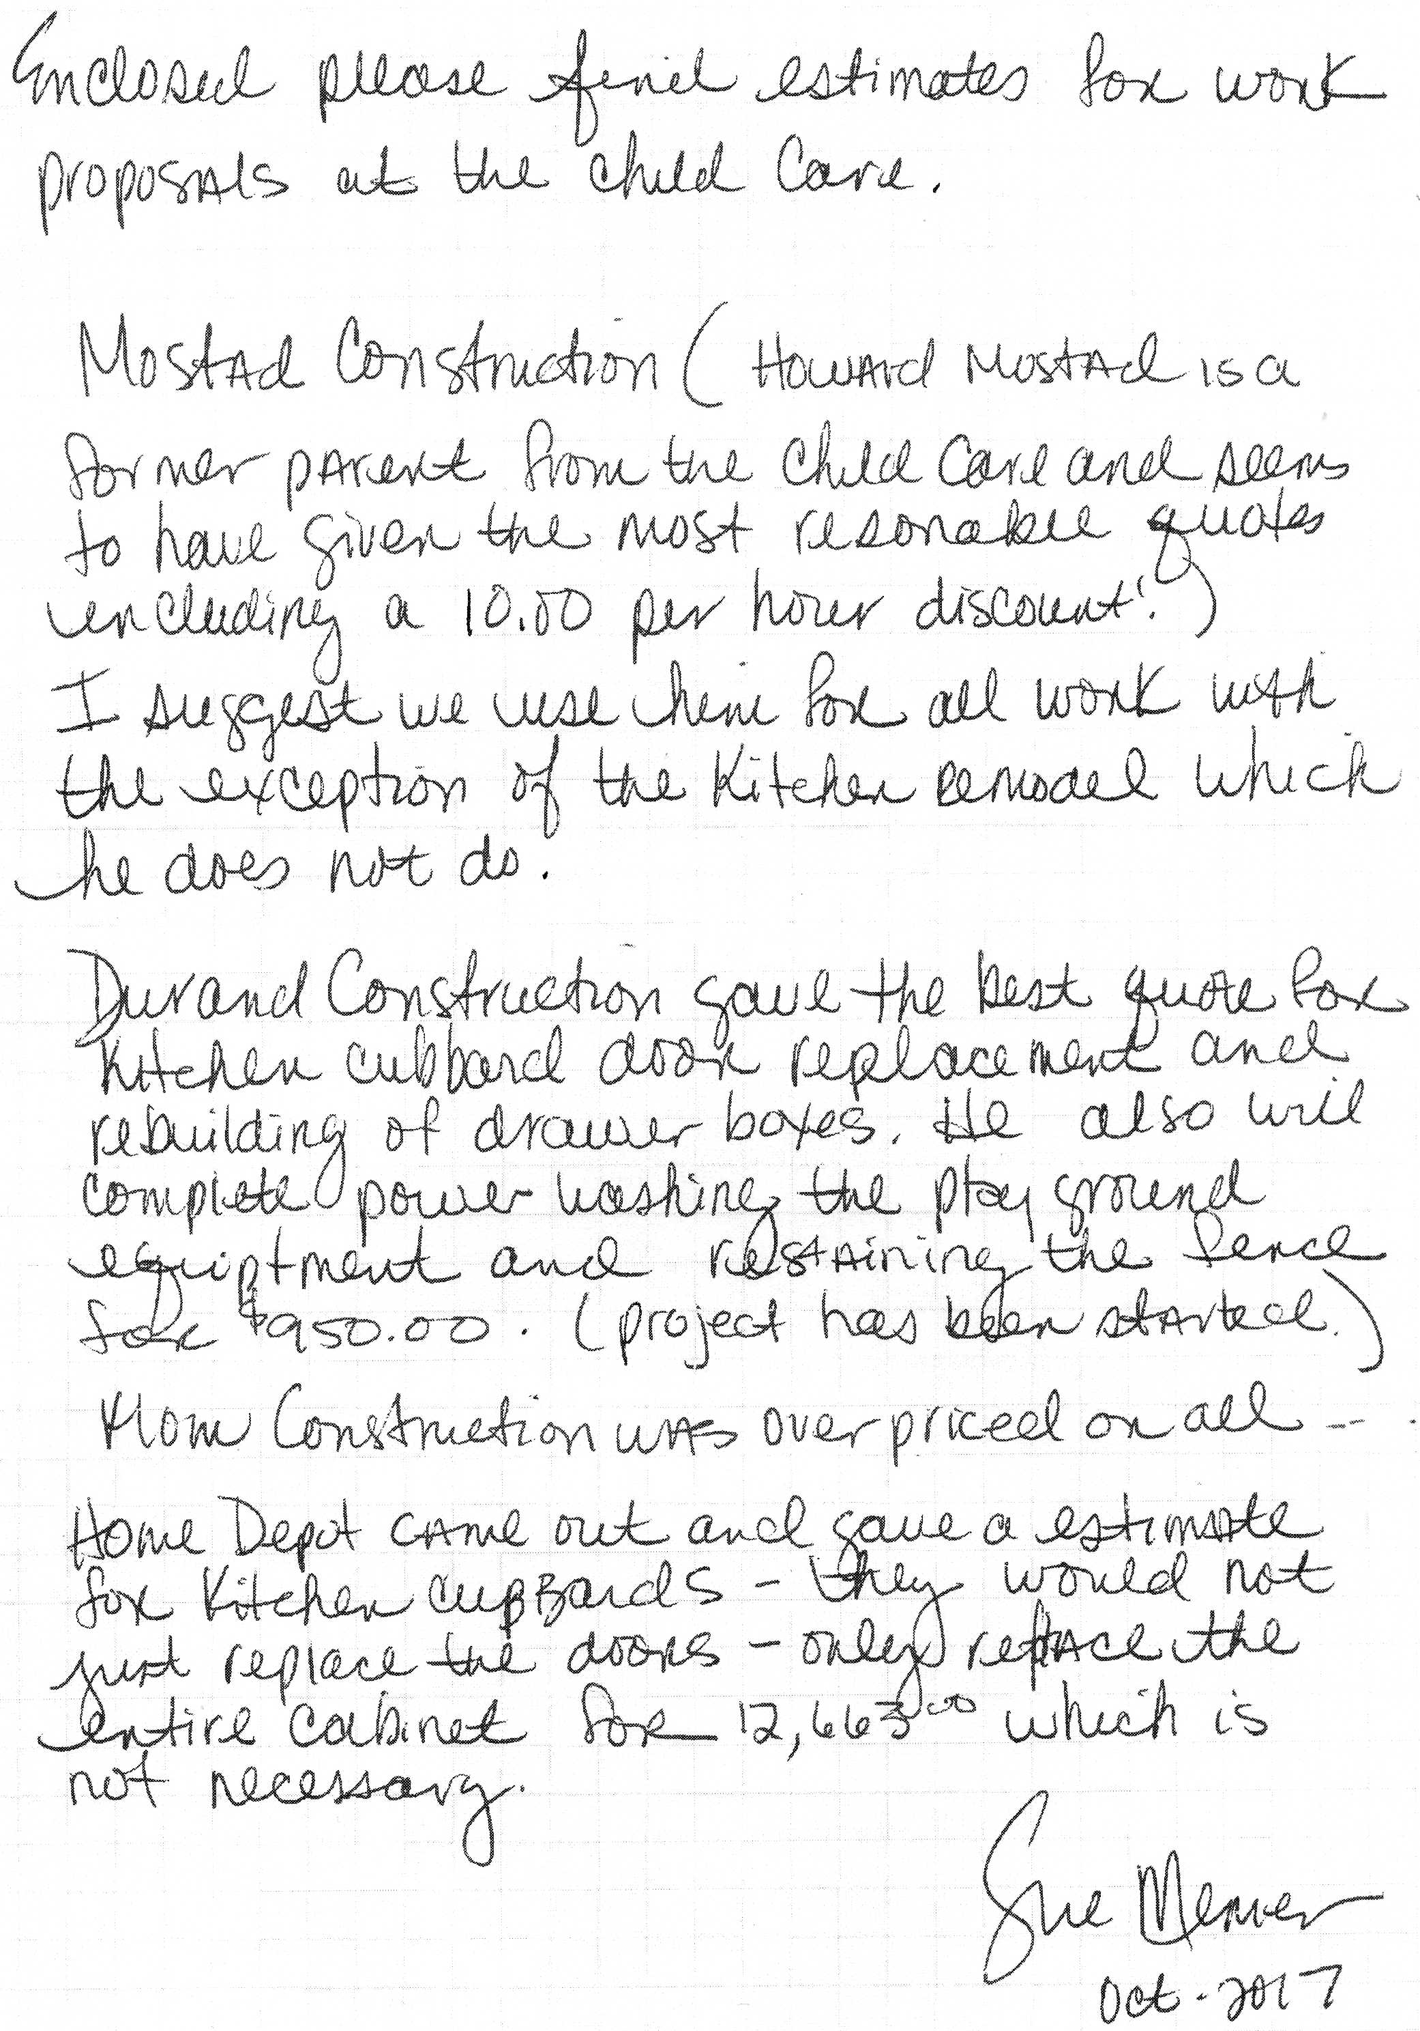
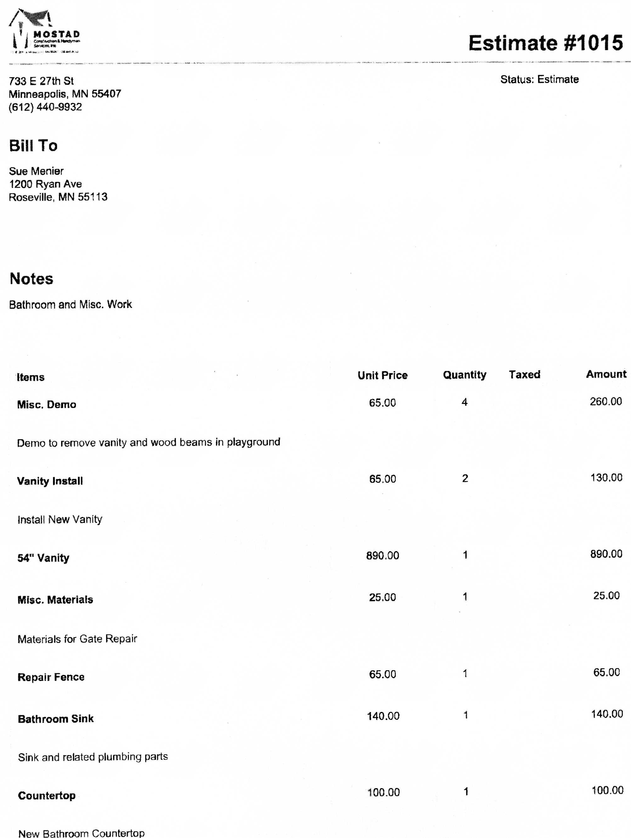
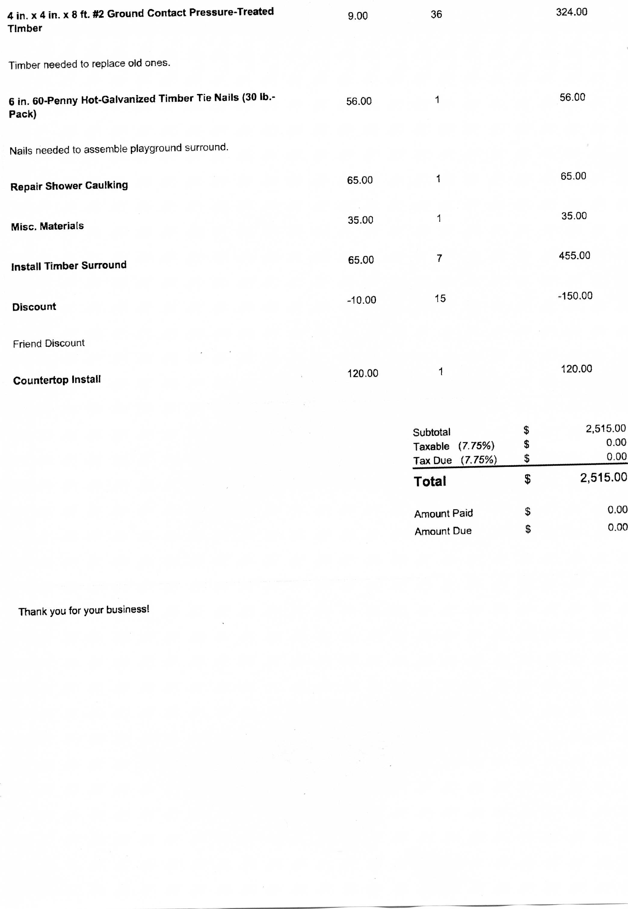
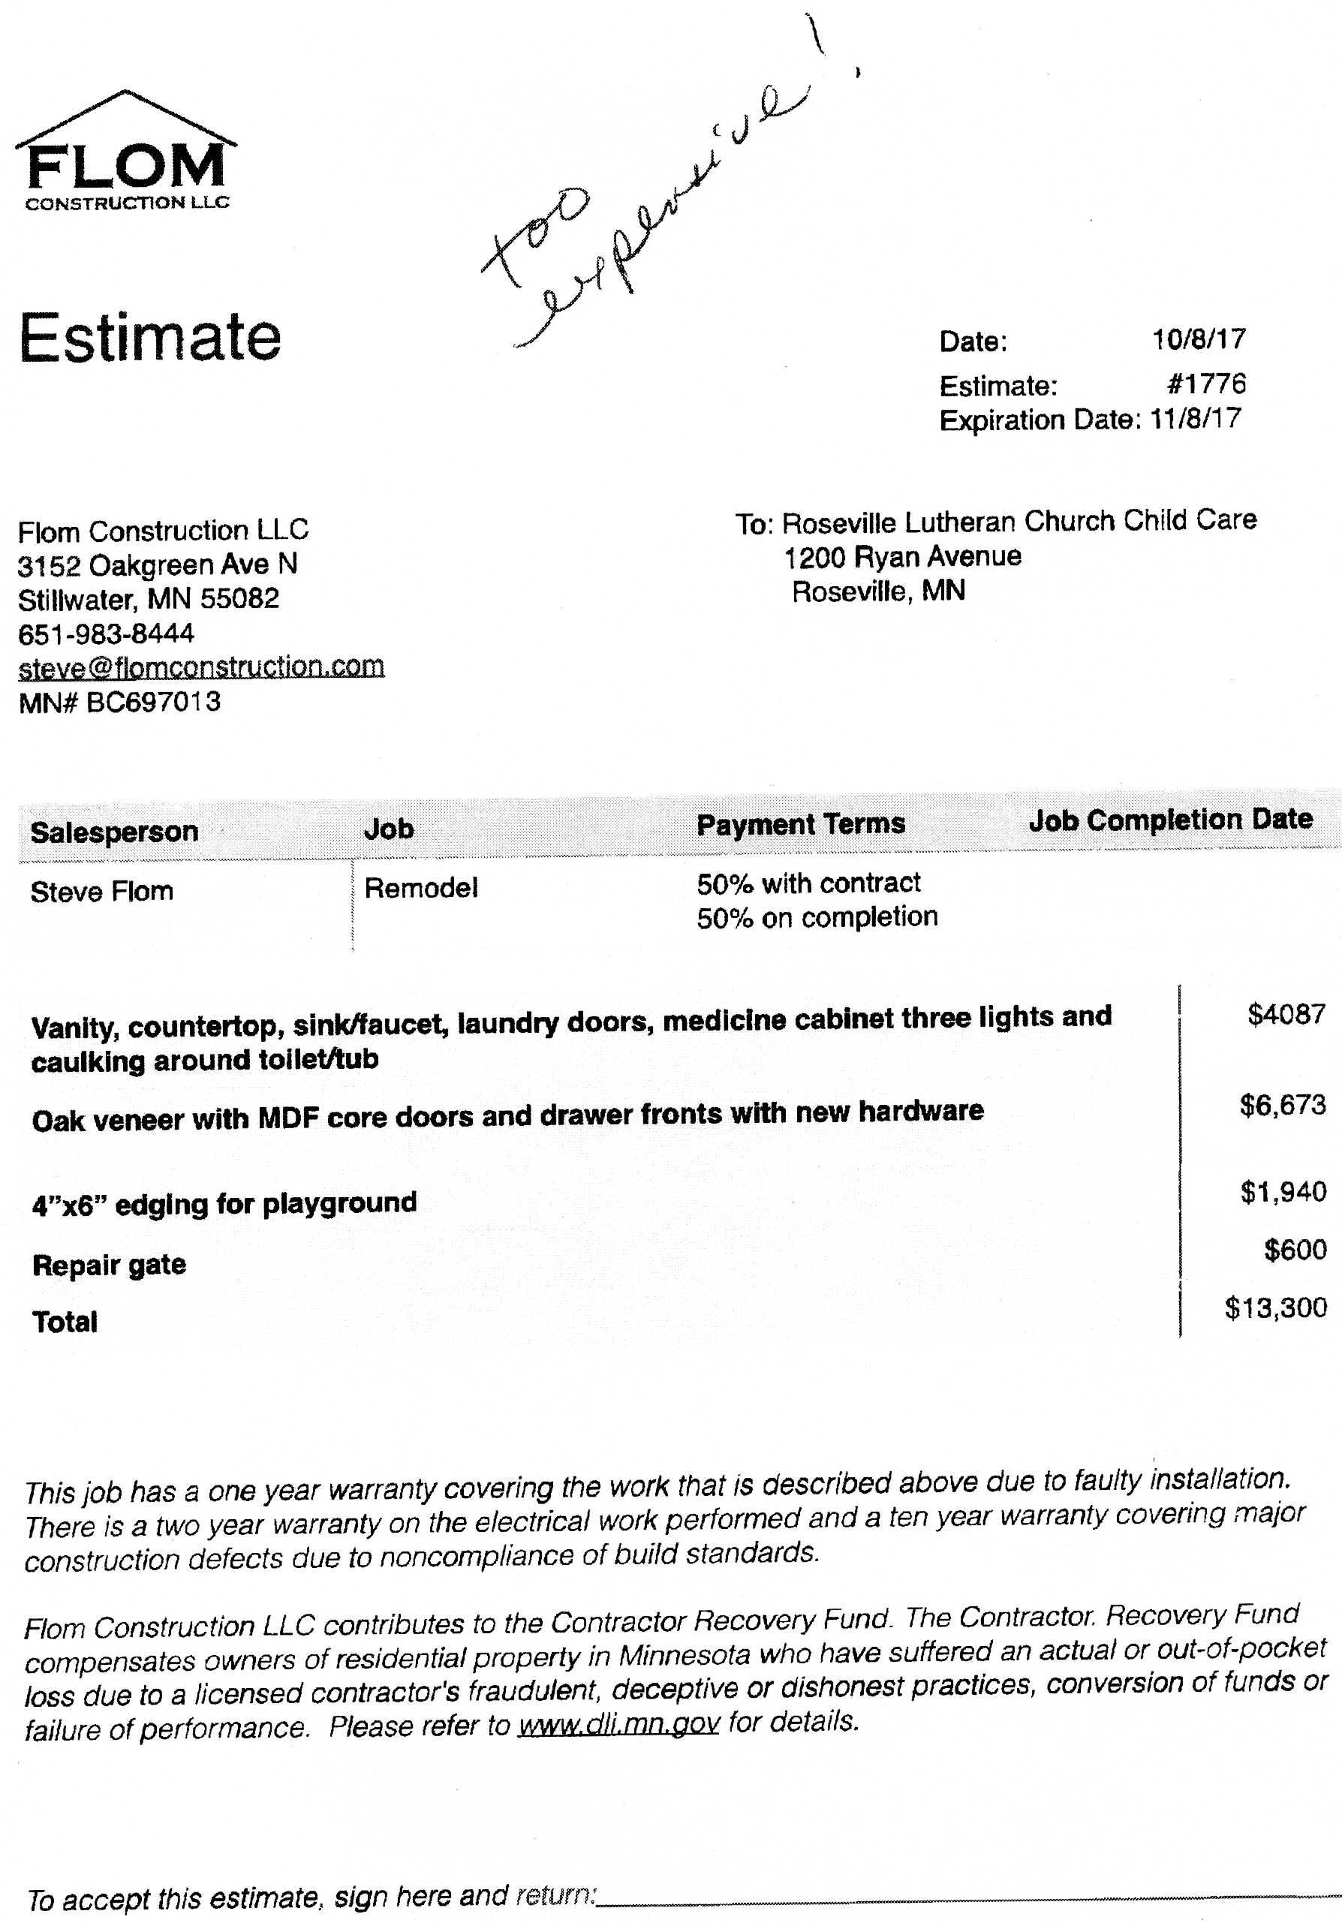
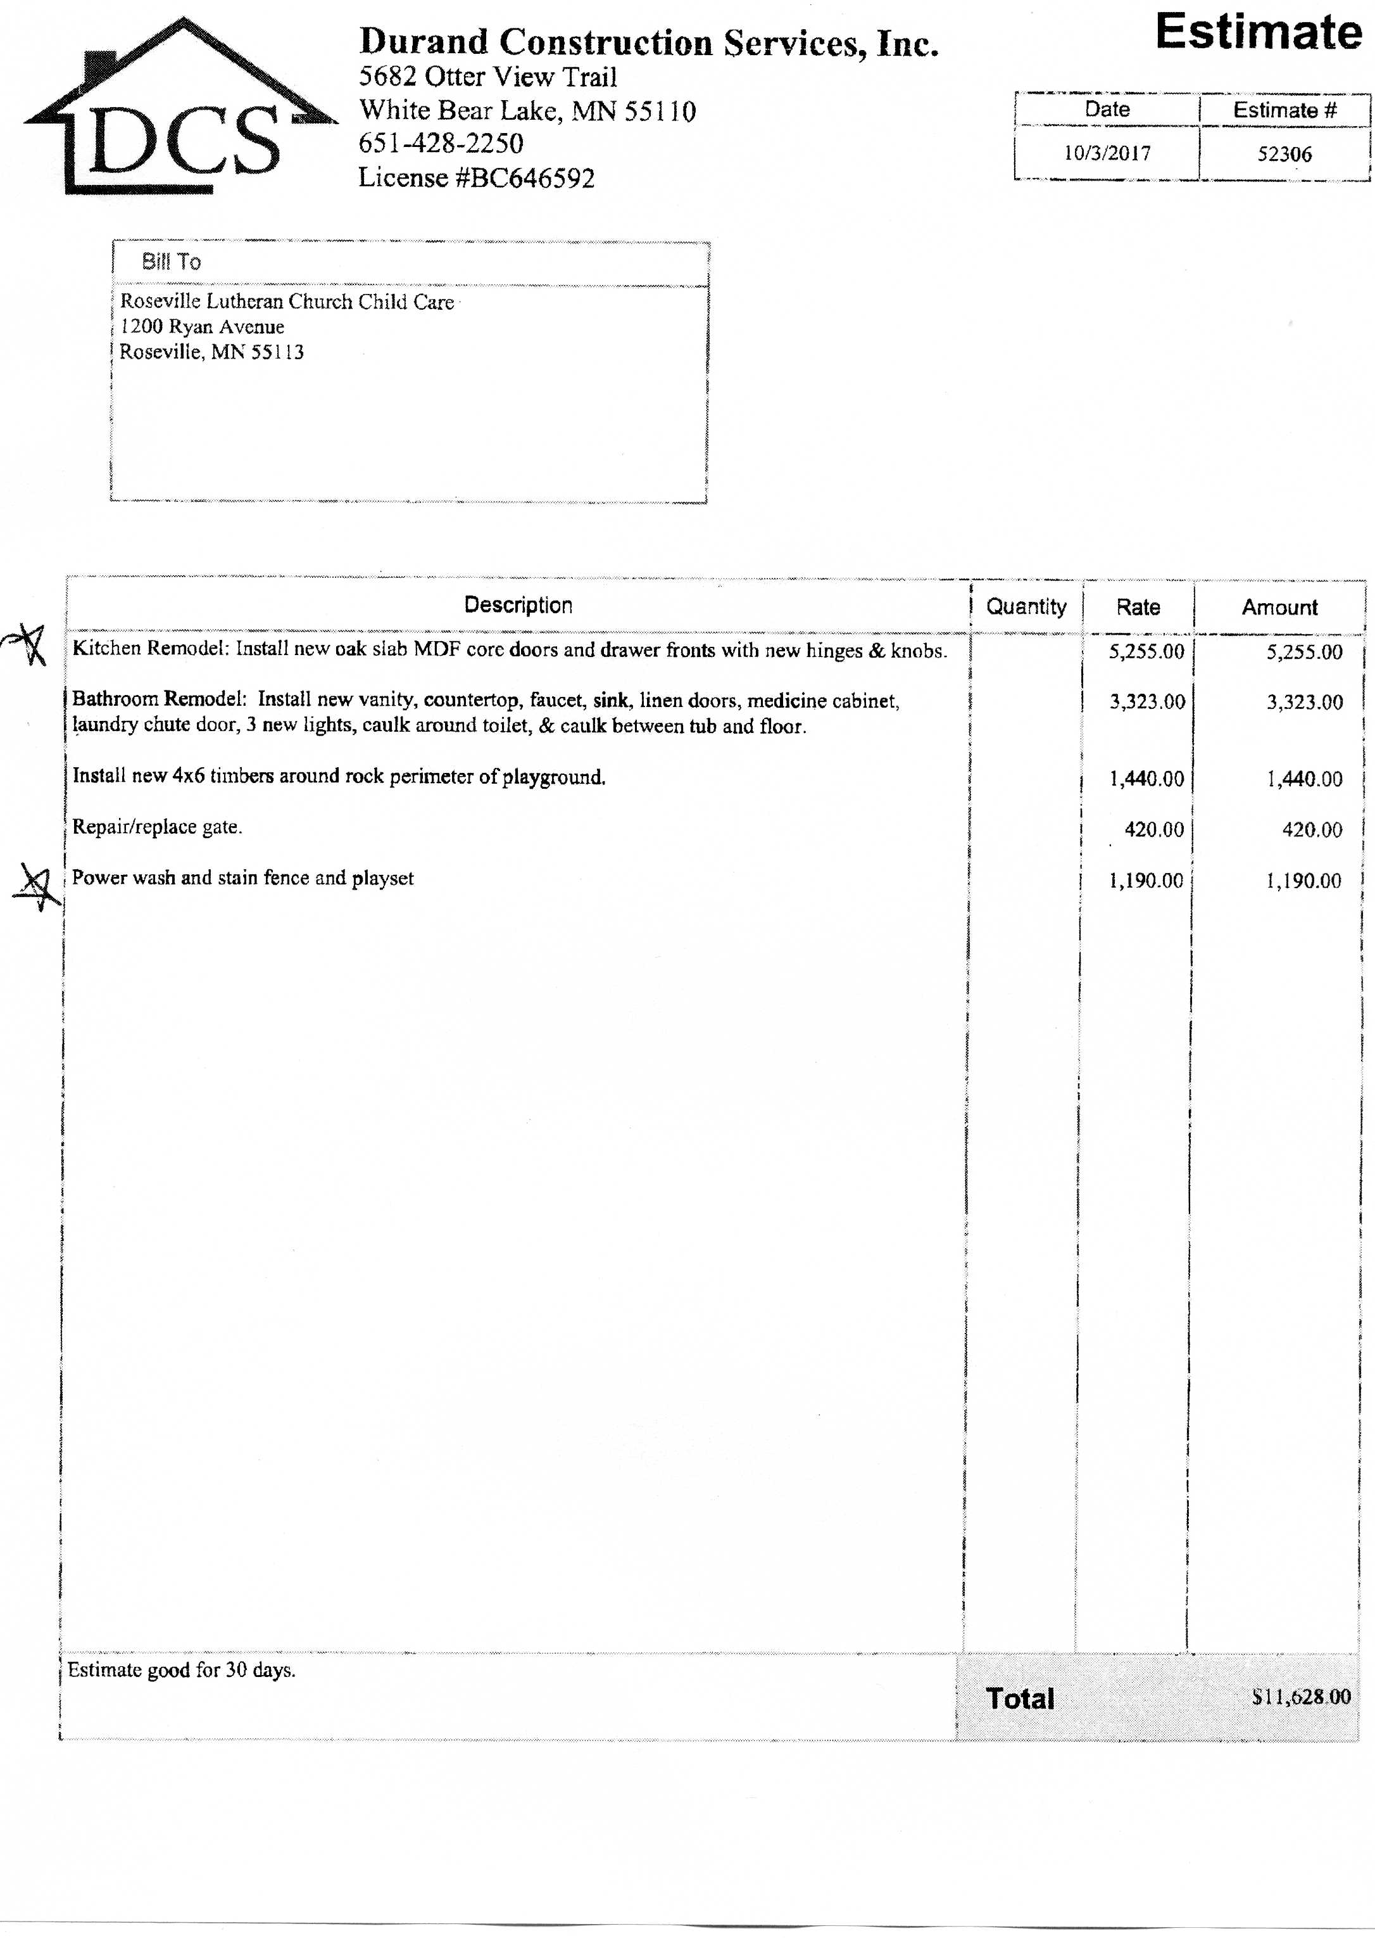
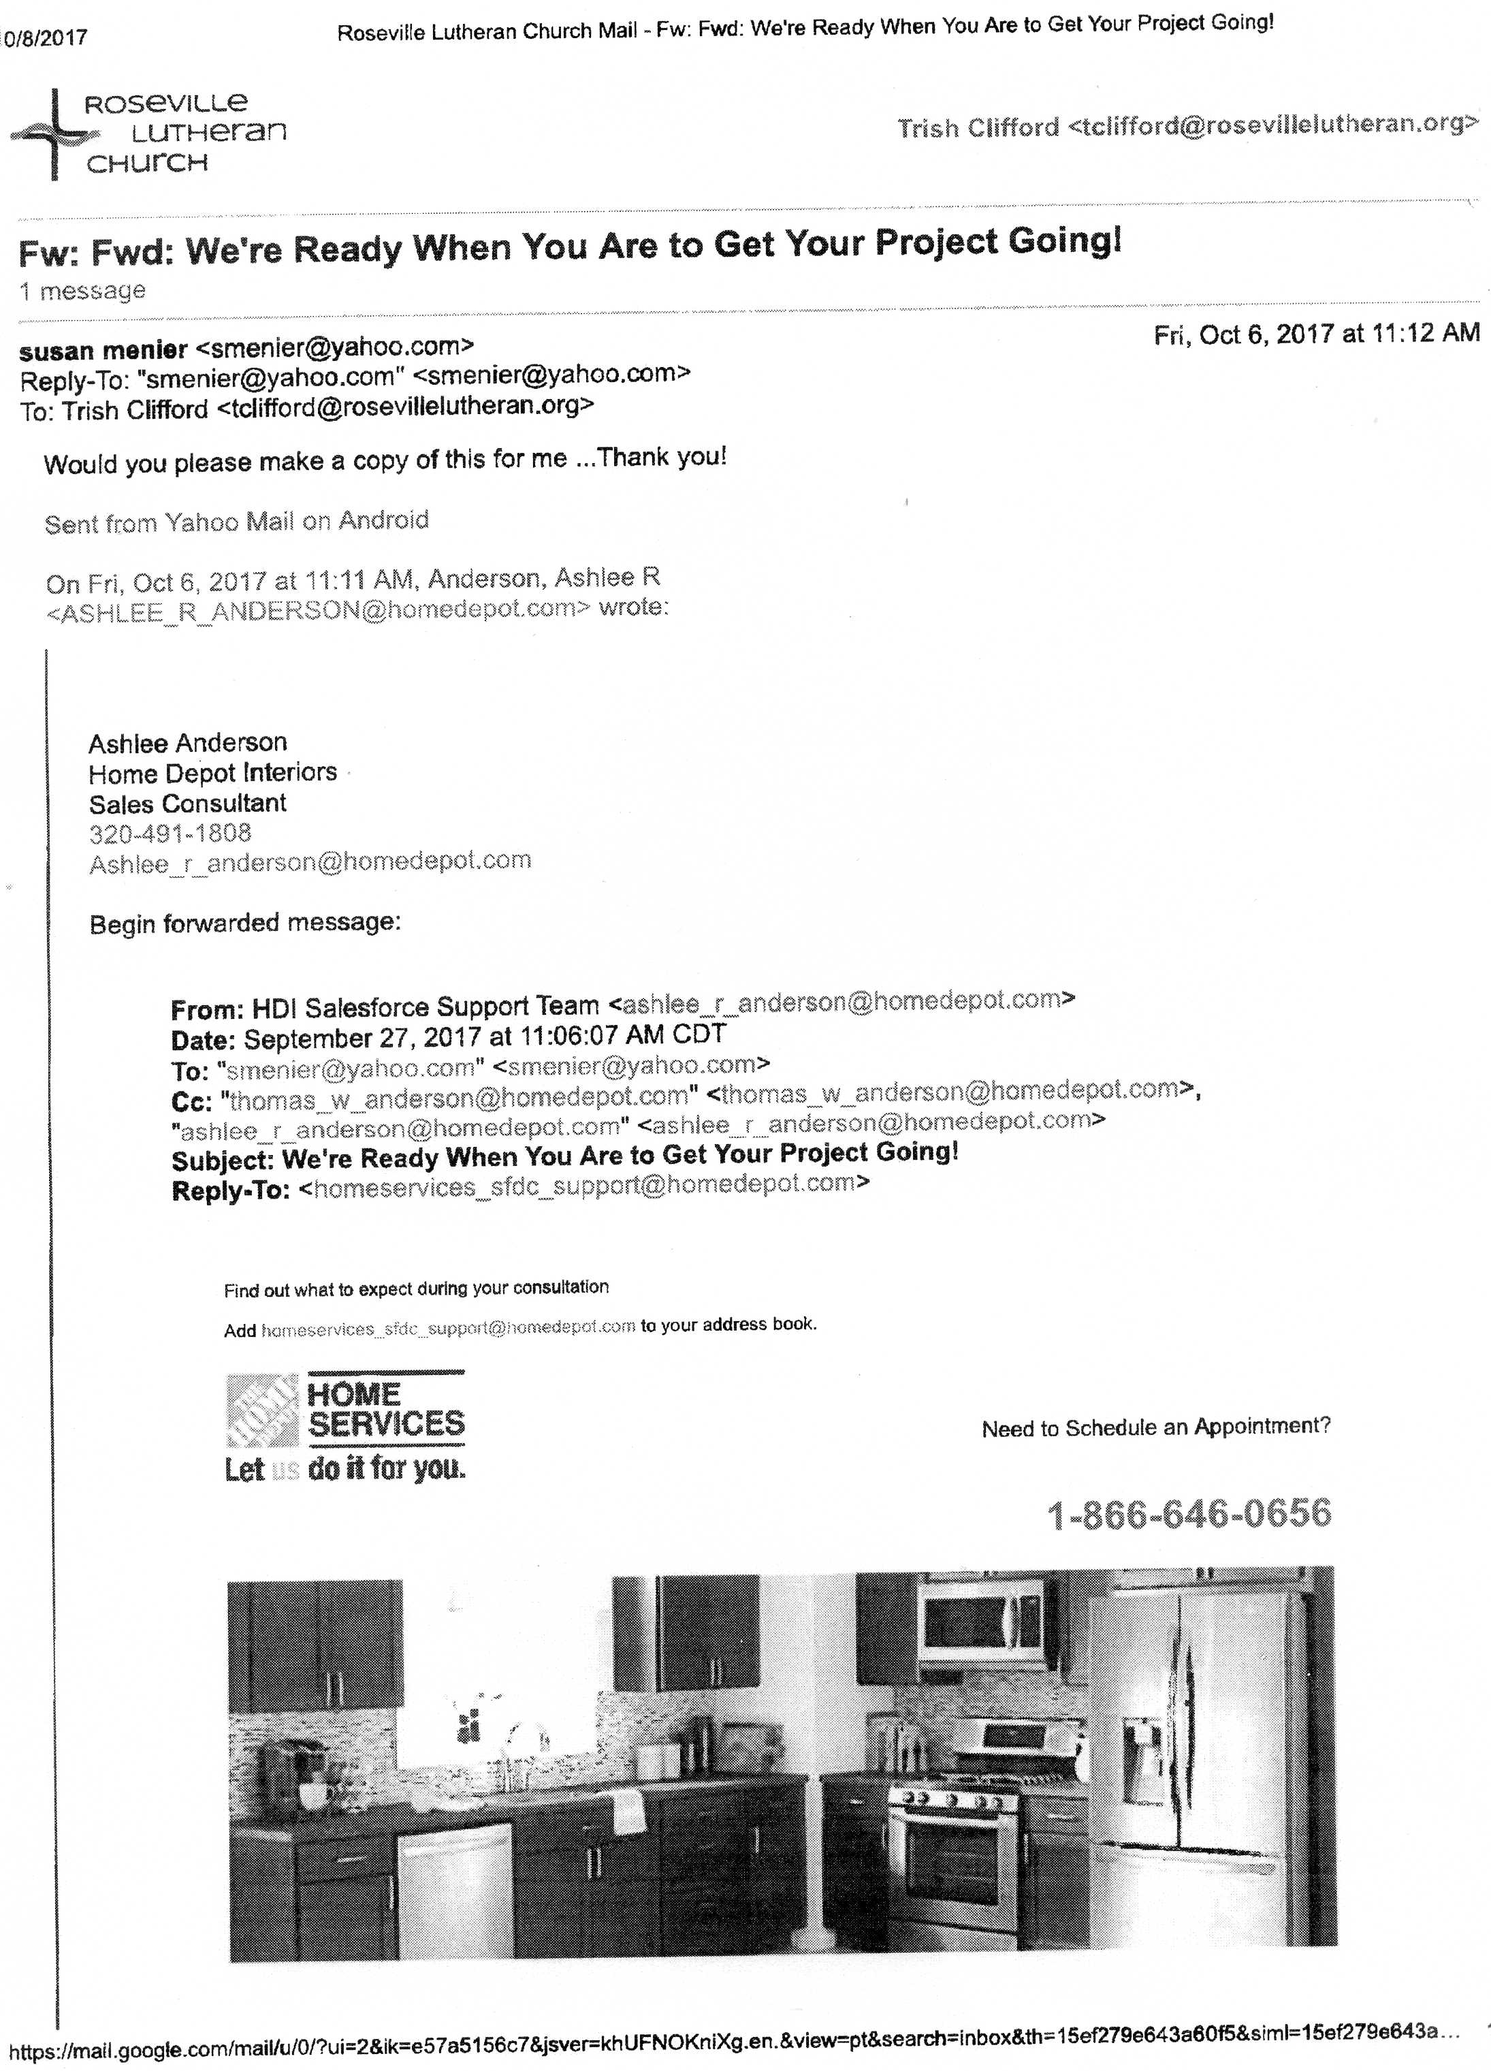
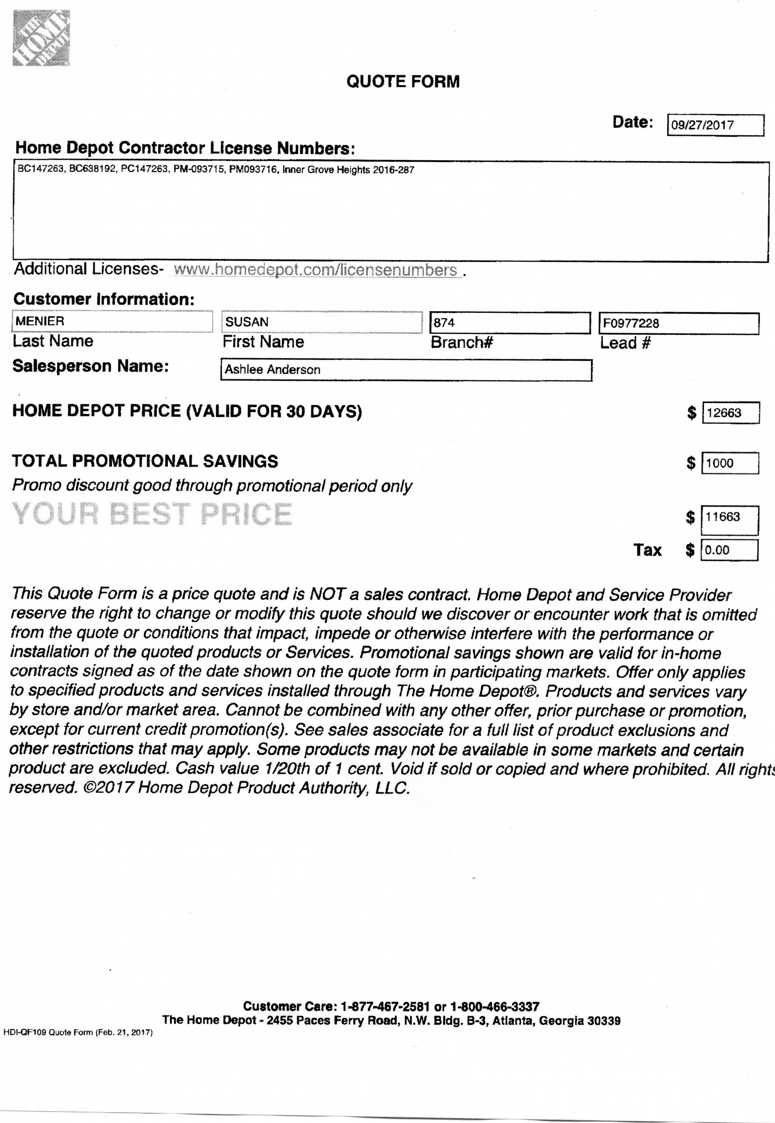

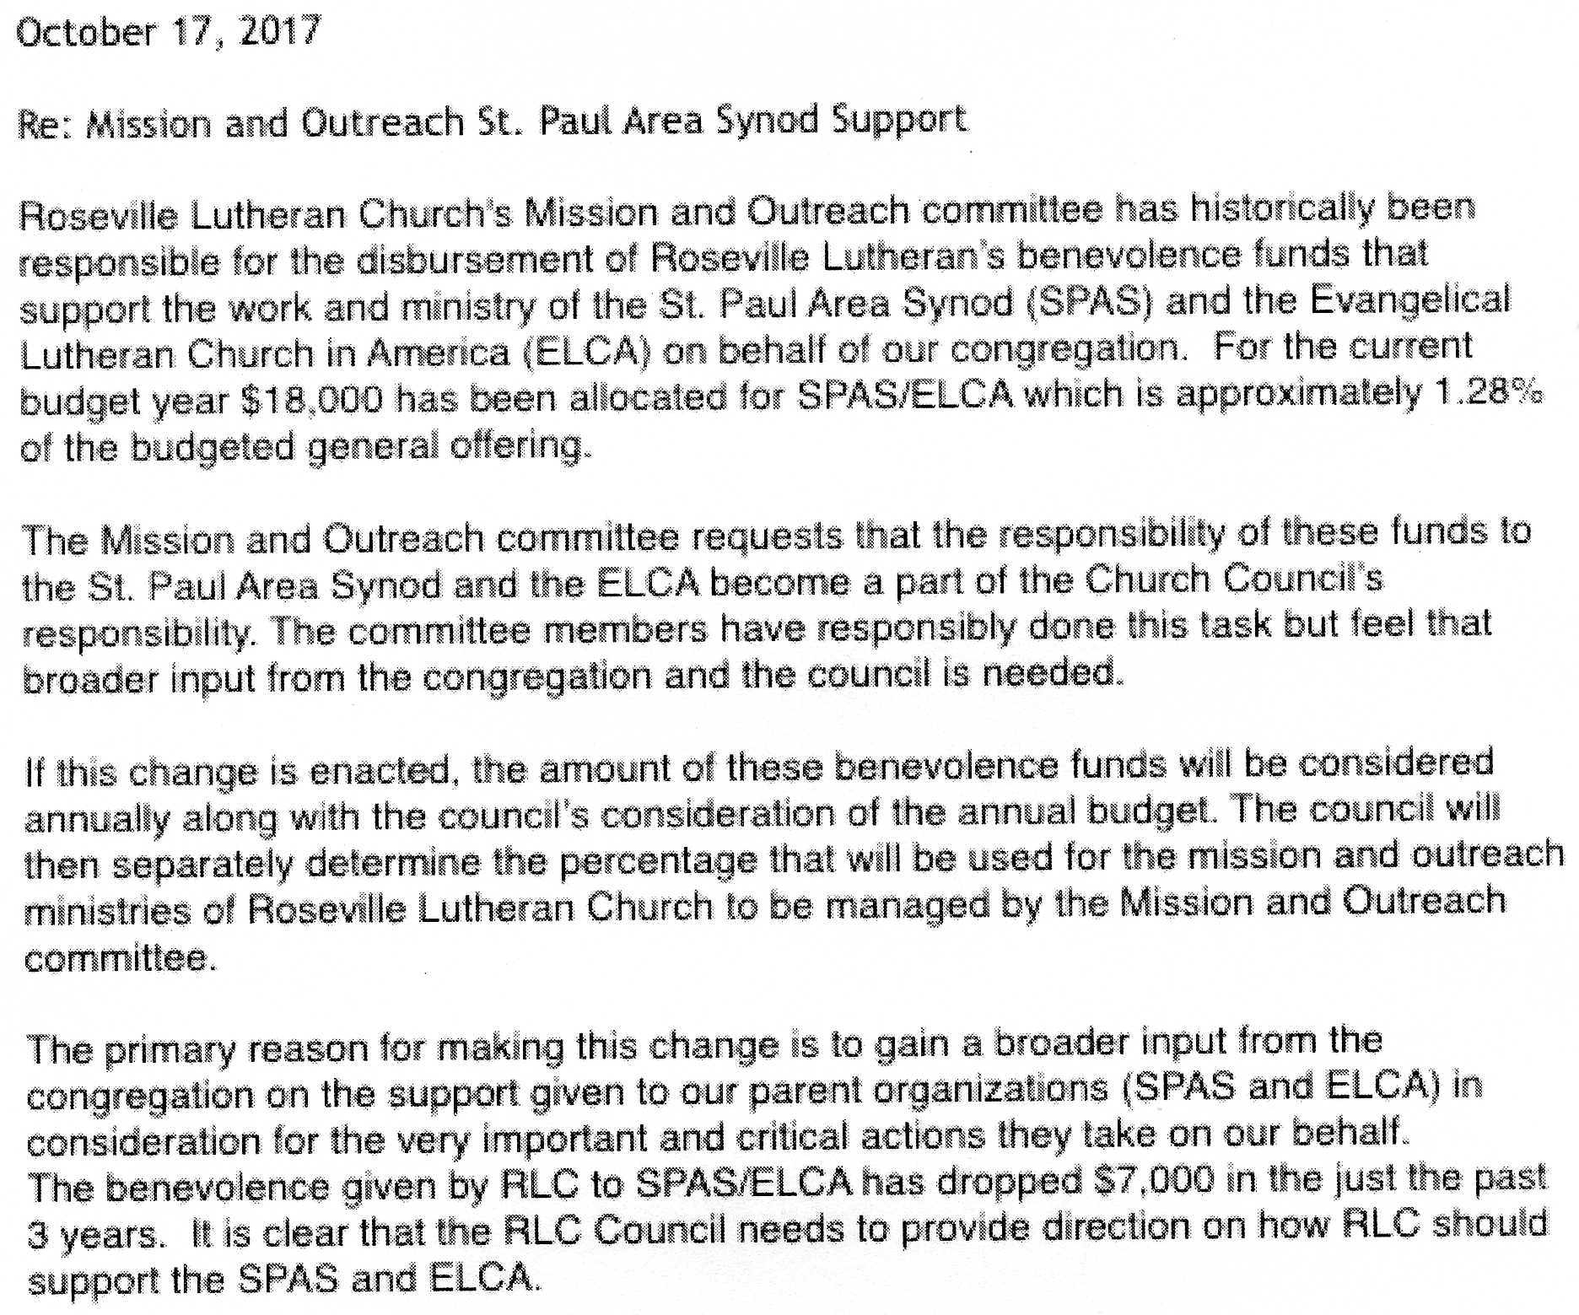

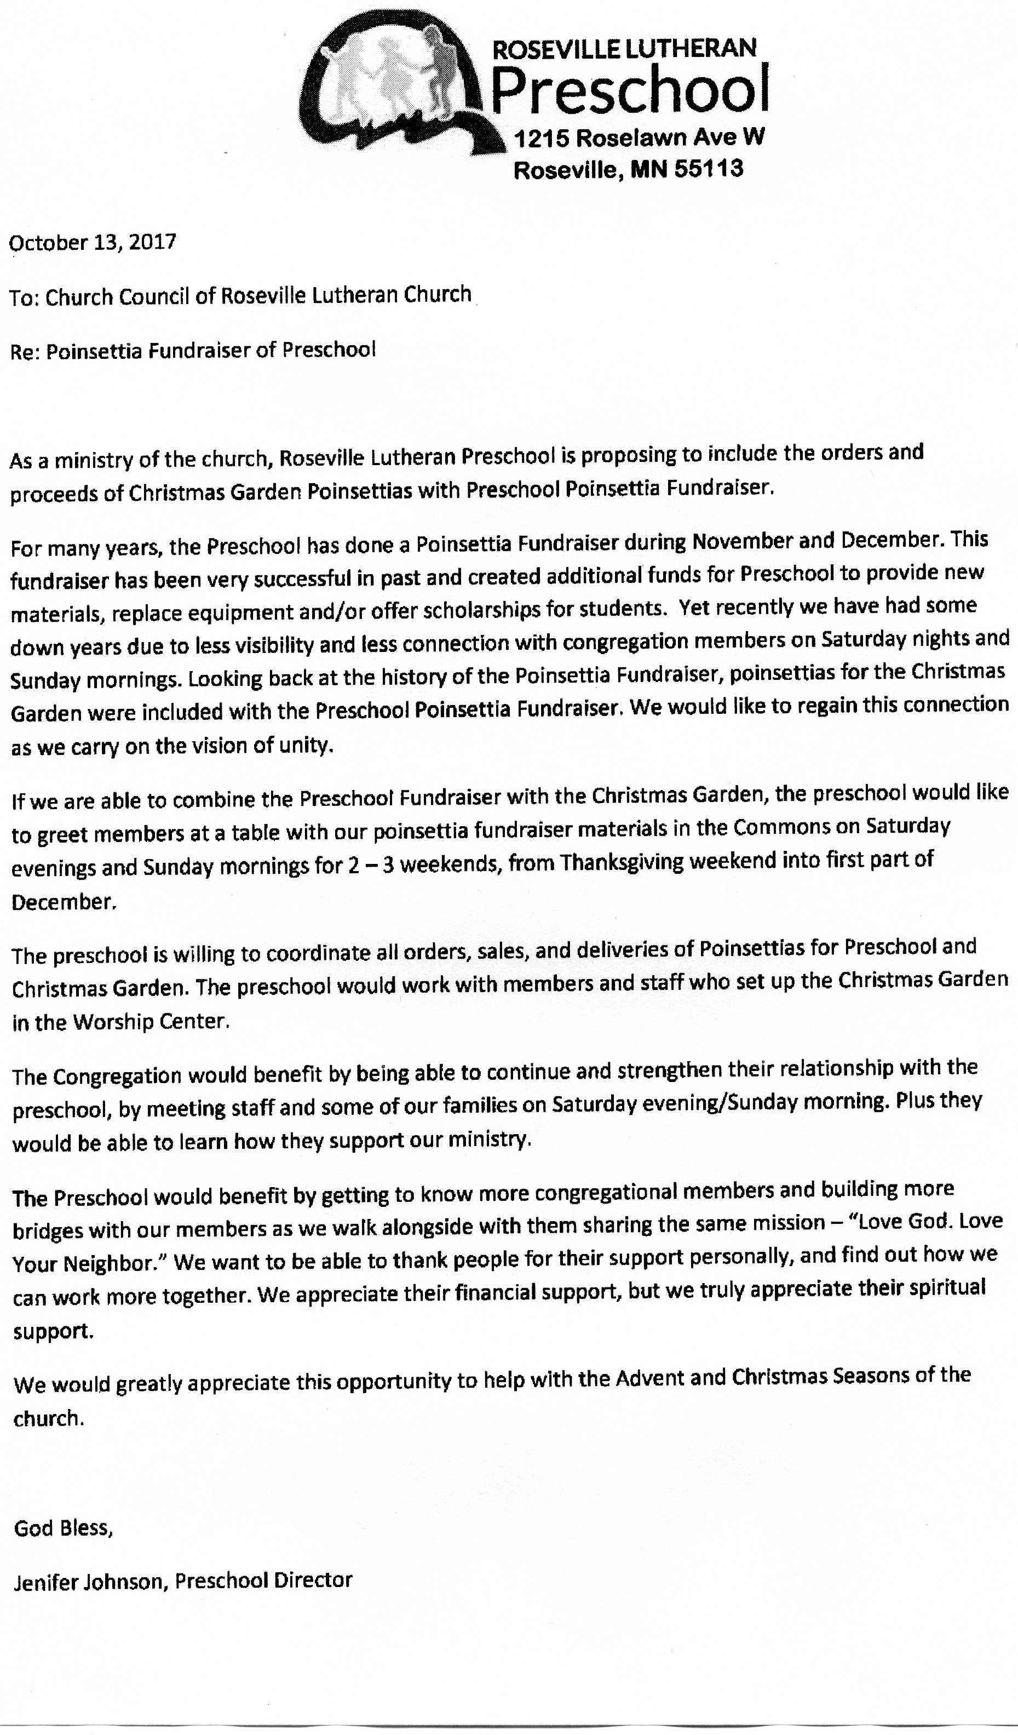
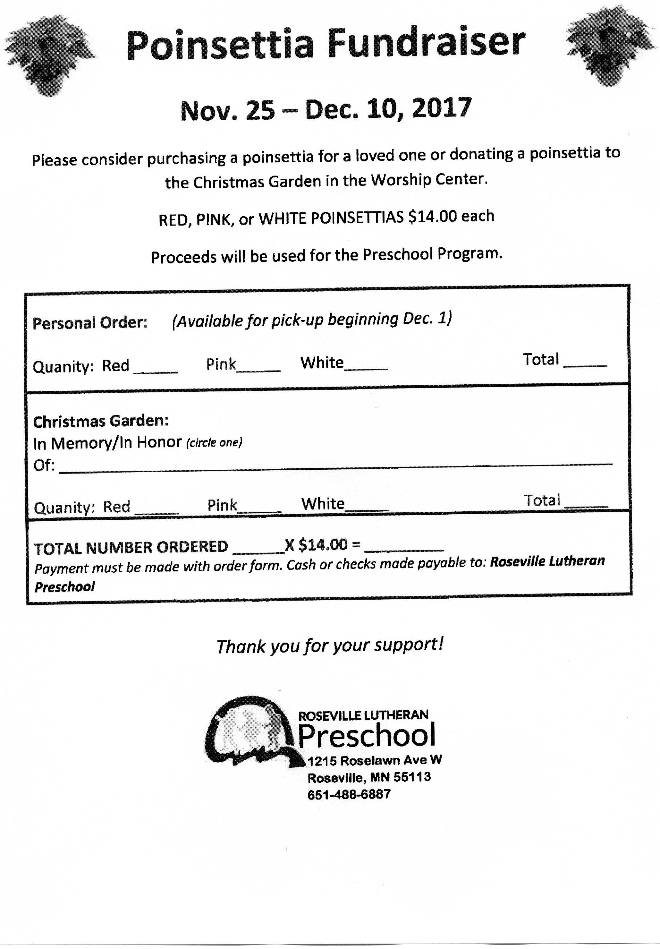
Children’s Ministry Advisory Board
Recap October 16, 2017 - Submitted by Joe Zeigler
Cornerstone is in full swing heading into MEA week end.
Recent activities
- Curriculum development: Julie and Abby attended Orange Tour.
- Serve Sunday: Care packages sent to recent HS grads from RLC.
- New families: Committee members to contact, welcome new Cornerstone families.
- Plans to engage kids in “Happy Birthday” celebration for 75th
- First weekly Cornerstone parent email sent 10/16. Suggested by Tana Bogenholm as a great way to keep parents informed about what is happening in CM at RLC
- Parents Night Out scheduled for Dec 1st, 6 to 9 p.m., kids ages 1 to 10. Youth will babysit. Proceeds to go toward youth camp scholarships. Cost: $15/child, $40 family maximum. Movie, snacks, games and fun!

Council Liaison Observations:
- A significant portion of Cornerstone shepherds are youth. In general, Cornerstone kids connect well with their younger leaders. However, the youth lack the experience that parents or adults bring to the role. Julie and Abby are working hard to provide training and guidance.
  - Example: Coffee Chat- Oct 15: RAHS educator Tana Bogenholm helped facilitate discussion about engaging kids and keeping their attention. Attendance was marginal.
  - Shepherds were invited when Dawn Rundman spoke to RLC families on Sunday, Oct 1, and to RLC and community families on Monday, Oct. 2nd about faith formation and brain development in our little ones. Attendance was low.
- Lay leader attendance at committee meetings lacking. Of 6 lay members on advisory committee, only two were present at the October 16 meeting. The meeting was scheduled a month in advance, and Julie sent reminders prior to it. How might we promote more supportive participation from lay committee members?
- CM is constantly challenged with finding parent volunteers to support activities. On the near horizon, programs which may require trimming or elimination include Advent activity day, Sunday admin team, and the Christmas program.
- Julie preparing report to Council highlighting goals and strategies for CM. Included are some recommendations regarding making RLC facilities more welcoming and accommodating to families. Needed upgrades include:
  - Signage to make the nursery more visible and inviting
  - Bathrooms changing stations
  - A private space for nursing mothers
  - Greater accessibility for families with special needs kids
  - General maintenance, such as roof repair in activity center

Next Meeting: November 27th 6:00 in the Library.

Occasional de minimis gifts of less than $75.00 value, such as flowers or foodstuffs, are exempt from this rule. Gifts that primarily benefit the Congregation and not an individual, such as gifts of hospitality that may be given to the Congregation by businesses in relation to official Congregation business, are exempt from this rule. Persons also may participate in reasonable, normal relationship-building activities, such as meals or entertainment events.

