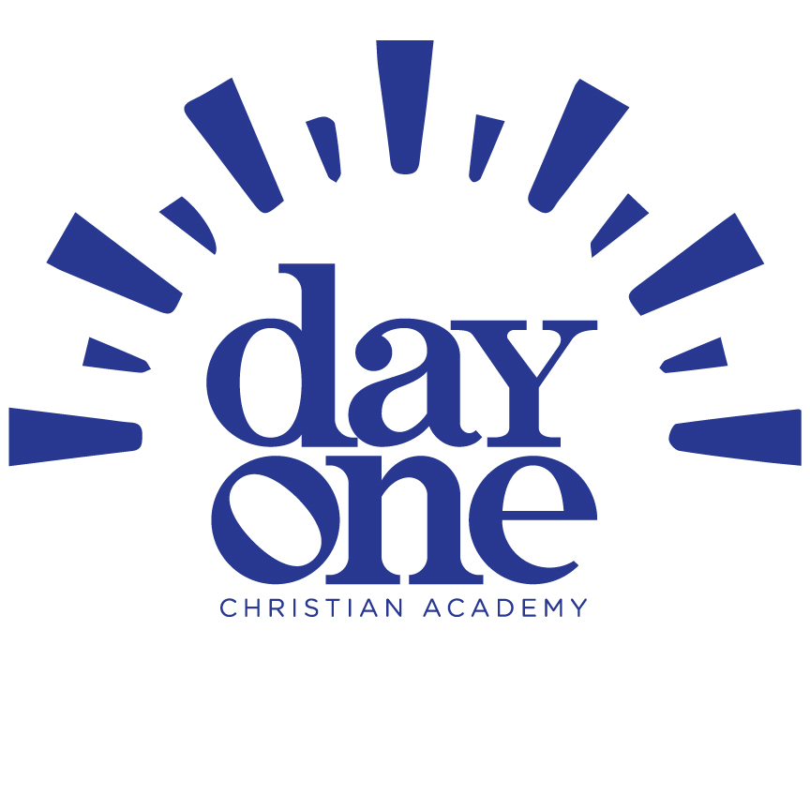
December

After School Care

newsletter

We are thankful for all Blessings…..
Important Dates:
3 – Scrip Orders Due
7- CL Symphony "Pops" Concert www.gdlc.org
11- SCRIP Orders Delivered
12 – Christmas Program @ 6:30pm
18 - Parent Chapel
20 - Joy the Comfort Dog
24 – GDLC Christmas Services
see GDLC.org
24-26–Day One Closed
23,27,30 – No Preschool - Full Time Only
January 6 – Preschool Resumes



Dear Parents,
November has blessed us in many ways. We learned all about harvest and autumn this month. We discovered how God provides food for all His creatures. We explored the difference between healthy and unhealthy foods and how they affect our bodies. The children especially enjoyed making cards for a local nursing home.

Christmas Celebration Begins…..
As December begins, we will be celebrating Jesus’ birth. We will have activities focusing on Jesus and how to follow His word in times of celebration. We will explore the meaning of Christmas and how other countries celebrate Christmas!
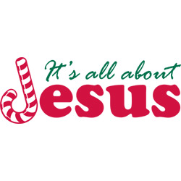
Gloria Dei has some exciting and fun events happening this month! Come and enjoy CL Symphony “Pops” Concert more information at www.gdlc.org on the 7th.

*IMPORTANT NOTICE*
Day One will be closed December 24-26 for the holidays. There will be no preschool on December 23,27, 30, and 31st. We will be open for full-time students only on those dates. Preschool resumes January 6. A sign up will be available in the classrooms.


In His Name,
The After School Program Team

