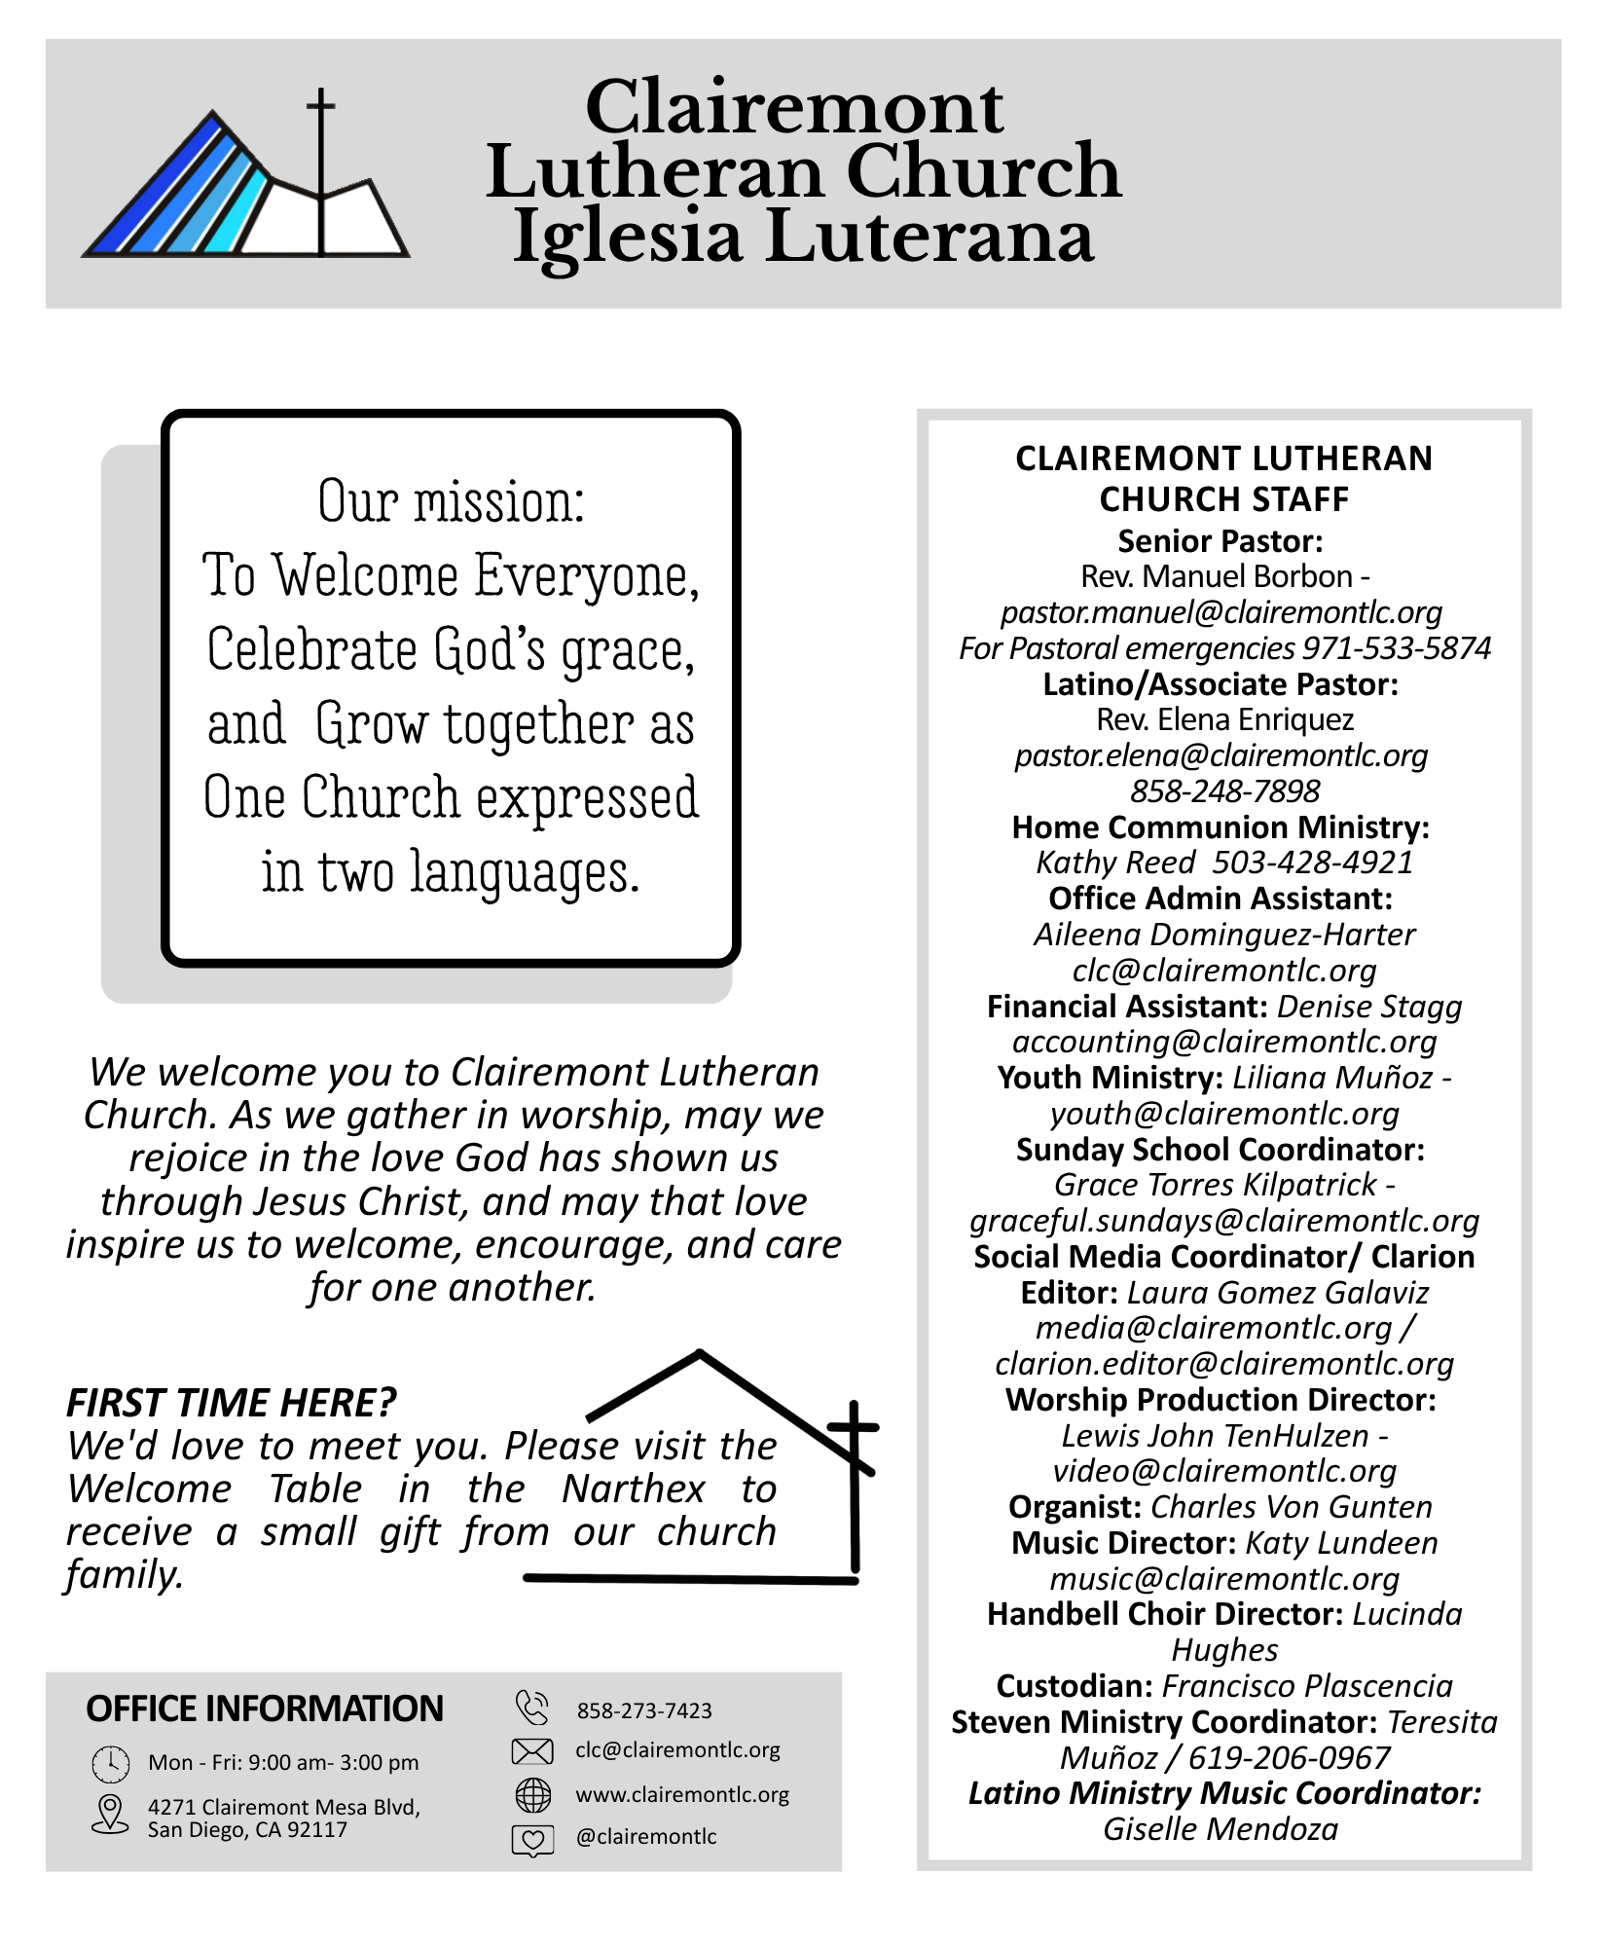


Reformation Sunday -- October 25, 2026

Reformation Sunday Service - October 25, 2026

Today's hymns are projected on the screen. Please stand where the asterisk (*) appears.

Prelude | Rendeau – Jean Joseph Mouret Charles F. von Gunten
Welcome
Mission Statement
C: Our mission is to welcome everyone, celebrate God’s grace, and grow together as one church expressed in two languages.

- Gathering -
Gathering Hymn * Beautiful Savior – ELW 838 (v. 4)

Kids Time Katy Lundeen

Confessions and Forgiveness
P. Blessed be the holy Trinity, ☩ one God,who pours love into our hearts and healing upon the earth. C: Amen.
P: Confident that God justifies us by grace through faith, let us confess our sin.
Silence is kept for reflection.
P: Compassionate God,
C: we confess that we struggle to embody your goodness in the world and in our own hearts. Creation groans from overuse. Jealousy and bitterness strain our relationships. Indifference keeps us from seeking justice. Divisions disrupt your call to show genuine love to others. Turn our hearts back to you. Restore our world and reconcile us to one another. Renew us to live as your holy people, following the way of Jesus Christ. Amen.
P: Hear this good news: We have peace with God through ☩ Jesus Christ, in whom there is no condemnation, but only forgiveness and the promise of eternal life. Receive freely this healing gift of grace. C: Amen.

Hymn Of Praise * Praise God from Whom All Blessings Flow ELW 884

Prayer of The Day
P: Almighty God, gracious Lord,
C: we thank you that your Holy Spirit renews the church in every age. Pour out your Holy Spirit on your faithful people. Keep them steadfast in your word, protect and comfort them in times of trial, defend them against all enemies of the gospel, and bestow on the church your saving peace, through Jesus Christ, our Savior and Lord, who lives and reigns with you and the Holy Spirit, one God, now and forever. Amen. [please be seated]

- Word -
First reading: |  |  | Jeremiah 31:31-34 HB/OT p. 755
R. Word of God, word of life.
C. Thanks be to God
Psalm: | Psalm 46 (sing to ELW 824)
Second reading: |  |  |  | Romans 3:19-28 HB/NT p. 146
R. Word of God, word of life.
C. Thanks be to God
Gospel Acclamation * |  |  |  |  | Alleluia, setting 4 – ELW p. 151
Gospel reading: John 8:31-36 HB/NT p. 96
Response after the announcement: Glory to you, O Lord.
P: The Gospel of the Lord  C: Praise to you, O Christ. |  |  |  |  |  | [please be seated]
SERMON |  | Pastor Manuel Borbon

Anthem Christ Is Our Cornerstone - Phillip Stopford

Apostles’ Creed ELW p. 105
I believe in God, the Father almighty… Amen.

Reception of New Members

The Peace [We invite you to share a sign of God’s peace with those around you.]
P: The peace of Christ be with you always. C. And also with you.

- Meal -

 | Online giving |  |  |  | 
Offering | https://clairemontlc.churchtrac.com/give
 | *Please print your emailed receipt for tax purposes.
Offering Hymn |  | The Church’s One Foundation ELW 654 (vv. 1, 3, & 5)
Offering Prayer
P: God of creation,
C: you send rain and the earth springs forth abundantly. All blessings are from you; make us generous with what we have. Use our gifts, our abilities, and our hearts in service to you and in love to our neighbors, today and always.
Amen.
The Great Thanksgiving  Holy, Holy, Holy  Words of Institution  Thanksgiving Acclamation |  |  | (setting 4) ELW p. 152
The Lord's Prayer (prayed by all) |  |  |  | ELW p. 154
Invitation to Communion |  |  |  | [please be seated]

The Agnus Dei Lamb of God, (setting 4) ELW p. 154

The Communion of Christ’s People
Communion Voluntary |  | Air – Jean Joseph Mouret Charles F. von Gunten
Blessing after Communion
P: May the body and blood of our Lord and Savior Jesus Christ strengthen you and keep you in his grace. C: Amen
Post-Communion Prayer |  |  |  | [prayed by all]
P: Sustaining God, C: with this bread and cup, you nourish us with mercy and abundant life. By your Spirit, send us from this table to serve a needy world. Make us living signs of your liberation, healing, and love, following the way of Jesus, in whose name we pray. Amen.

Announcements [please be seated]

- Sending -
Sending Hymn* |  |  |  | A Mighty Fortress Is Our God ELW 504
Blessing  The Dismissal * |  |  |  | C: Amen
P: Go out in joy. Be led forth in peace. |  |  |  | C: Thanks be to God.
Postlude | Fanfares: Premiere Suite – Jean Joseph Mouret Charles F. von Gunten

Serving Us Today
Pastors: Manuel Borbon
Choir Director: Katy Lundeen
Organist: Charles F. von Gunten
Choirs: GLEE Choir, Rise & Shine Choir, Messenger Choir, Esperanza Youth Choir, Sanctuary Choir
Brass Quintet: Dean Anderson, Ted Trost, Bob Ferris, Russ Mitchell, Lee Hintz
Reader: Karen Cruesere
Communion Assistants: Bonita Martinez, Gary & Aida Jaus
Welcome Team: Sandra Logan, Curtis Cline
Offering Couriers: Lewis John Ten Hulzen & Harriet Carmona
AV: Lewis John TenHulzen, Anamarya Martinez, Mitchell Little

Permission to podcast/stream the music in this service obtained from ONE LICENSE with license #736770-A, or CCLI Streaming License #20371284, CCLI License #1258752. All rights reserved.

Holy Scribbles
Use this space to take notes, doodle, draw, or simply reflect during worship.
Take home one thing God taught you today.

Music Notes by Charles F. von Gunten: The choir anthem, Christ Is Our Cornerstone, was commissioned in 2016 by the Diocese of Ardagh and Clonmacnois of Ireland. It is a rousing anthem on this 8th century Latin text that features unexpected and arresting harmonic progressions. The gathering hymn, Beautiful Savior, is a setting of the favorite hymn by Cindy Berry that features the choirs of Clairemont Lutheran. The prelude, communion, and postlude voluntaries were composed by Jean Joseph Mouret (1682-1738) and arranged for organ and brass by Elaine C. Gardner. If you are of a ‘certain age’ you will remember them from Masterpiece Theater during the time that Alistair Cook hosted the television program.

Welcome to Clairemont Lutheran Church!
WE ARE SO GLAD YOU WORSHIPED WITH US TODAY!

ANNOUNCEMENTS

- FOR THOSE IN NEED if you are facing challenges in life, we have cards with prayers for you, located in the table in the narthex.

- The Remembrance Table honoring our loved ones will be on display throughout October, we invite you to bring photos or small tokens of remembrance to place in the narthex.

- This week’s Altar flowers were given to the glory of God by Gary & Aida Jaus in celebration of their 45th anniversary of marriage.

- This week’s Altar flowers were also given to the glory of God by Ruth Andersen in celebration of all the October birthdays and a thank you for the well wishes.

- Already a member, but need to update your contact information? We invite you to fill out our sign-in sheet in the narthex to receive emails about CLC/ILC’s upcoming events.

- The Hospitality Team will be serving cookies and coffee after Sunday service. Please consider donating to the Fellowship Fund to help provide refreshments and support this time of fellowship.

- Remember in Prayer: Mark Nickel, Bev Covey, Ruth Andersen, Adrienne Lenhoff, Paul Brown, Lee Shigley, Maria Medrano, Clark Carlson, Stella Penyak, Barb Kanneman, LaRae Rabe, Lewis TenHulzen, Emilie Lauchmen, Renée Shepherd, Bob Logan, Jack & Jean Shirley, Carla Faulk, Maria Luisa Velasquez, Bill Huston, Gerald Flax, The Riordon Family, Pat Fredericks, John Sarcona, and all the homebound members.

- Next Week’s Lessons & Gospel: Revelation 7:9-17, Psalm 34:1-10, 22, 1 John 3:1-3, The Gospel of Matthew 5: 1-12

Want to stay up to date on events? Contact the office to subscribe to our weekly emails.

