

Prelude Chorale Prelude on ‘Dundee’ – C. Hubert H. Parry

Welcome

Gathering Hymn The Church’s One Foundation - ELW 654 (vv. 1, 3, & 5)

Kids’ time Pastor Manuel

The Greeting
P: Blessed be the holy Trinity, ☩ one God,who forgives all our sin, whose mercy endures forever. C: Amen.
P: Let us confess our sin in the presence of God and of one another.
(Silence for reflection and self-examination)
P: Gracious God,
C: have mercy on us. We confess that we have turned from you and given ourselves into the power of sin. We are truly sorry and humbly repent. In your compassion forgive us our sins, known and unknown, things we have done and things we have failed to do. Turn us again to you, and uphold us by your Spirit, so that we may live and serve you in newness of life through Jesus Christ, our Savior and Lord. Amen.

P: God, who is rich in mercy, loved us even when we were dead in sin, and made us alive together with Christ. By grace you have been saved. In the name of ☩ Jesus Christ, your sins are forgiven. Almighty God strengthen you with power through the Holy Spirit, that Christ may live in your hearts through faith. C: Amen.

Hymn of Praise Praise God From Whom All Blessings Flow - ELW 884

Prayer of the Day
P The Lord be with you, C and also with you. P Let us pray.
P: Reforming God,
C: we give you thanks for your forgiveness and your blessing. We pray for ourselves and your church throughout the world. Fill us with a spirit of openness to your Spirit, to hear and receive your promises and to keep our covenant with you. Where we are corrupt, purify us. Where we are in error, direct us. Where we are in need, provide for us. Where we are divided, reunite us. And where we are close-minded, reform us and make us new. We pray in Jesus’ name. Amen.

First reading: Jeremiah 31:31-34
The days are surely coming, says the Lord, when I will make a new covenant with the house of Israel and the house of Judah. It will not be like the covenant that I made with their ancestors when I took them by the hand to bring them out of the land of Egypt—a covenant that they broke, though I was their husband, says the Lord. But this is the covenant that I will make with the house of Israel after those days, says the Lord: I will put my law within them, and I will write it on their hearts, and I will be their God, and they shall be my people. No longer shall they teach one another or say to each other, “Know the Lord,” for they shall all know me, from the least of them to the greatest, says the Lord, for I will forgive their iniquity and remember their sin no more.
P: Word of God, word of life. C: Thanks be to God.

Psalm 46 – sing ELW 855
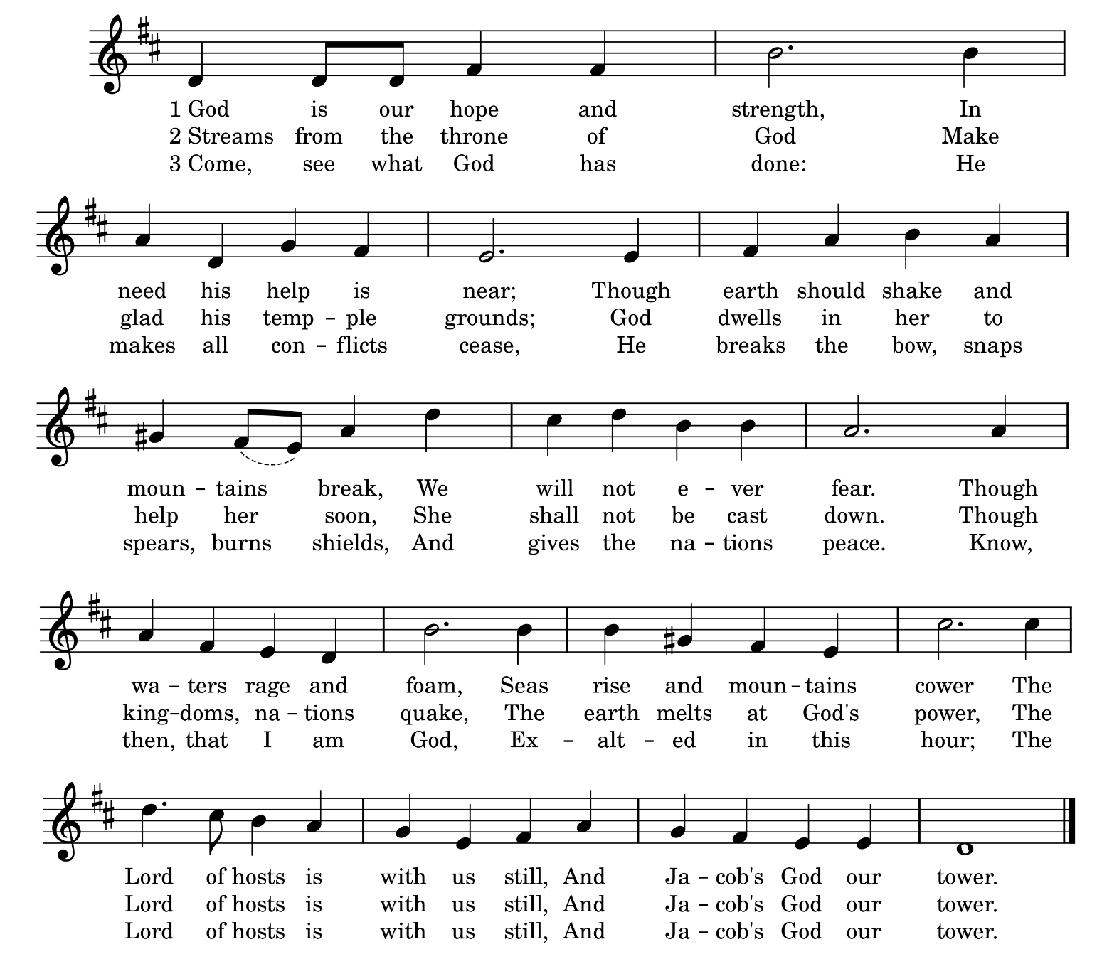

Second reading: Romans 3:19-28
Now we know that, whatever the law says, it speaks to those who are under the law, so that every mouth may be silenced and the whole world may be held accountable to God. For no human will be justified before him by deeds prescribed by the law, for through the law comes the knowledge of sin.
But now, apart from the law, the righteousness of God has been disclosed and is attested by the Law and the Prophets, the righteousness of God through the faith of Jesus Christ for all who believe. For there is no distinction, since all have sinned and fall short of the glory of God; they are now justified by his grace as a gift, through the redemption that is in Christ Jesus, whom God put forward as a sacrifice of atonement by his blood, effective through faith. He did this to demonstrate his righteousness, because in his divine forbearance he had passed over the sins previously committed; it was to demonstrate at the present time his own righteousness, so that he is righteous and he justifies the one who has the faith of Jesus.
Then what becomes of boasting? It is excluded. Through what kind of law? That of works? No, rather through the law of faith. For we hold that a person is justified by faith apart from works prescribed by the law.
P: Word of God, word of life. C: Thanks be to God.

Gospel Acclamation Alleluia – ELW p. 151 (please stand)

Gospel: John 8:31-36
Response after the announcement: Glory to you, O Lord
Jesus said to the Jews who had believed in him, “If you continue in my word, you are truly my disciples, and you will know the truth, and the truth will make you free.” ³They answered him, “We are descendants of Abraham and have never been slaves to anyone. What do you mean by saying, ‘You will be made free’?”
Jesus answered them, “Very truly, I tell you, everyone who commits sin is a slave to sin. The slave does not have a permanent place in the household; the son has a place there forever. So if the Son makes you free, you will be free indeed.”
P: The Gospel of the Lord C: Praise to you, O Christ.
Sermon Pastor Manuel Borbón (please be seated)
Hymn of the Day Beautiful Savior - ELW 838 (vs. 1, 2, & 4)

Apostles' Creed
I believe in God, the Father almighty, creator of heaven and earth.
I believe in Jesus Christ, God’s only Son, our Lord, who was conceived by the Holy Spirit, born of the virgin Mary, suffered under Pontius Pilate, was crucified, died, and was buried; he descended to the dead. On the third day he rose again; he ascended into heaven, he is seated at the right hand of the Father, and will come to judge the living and the dead. I believe in the Holy Spirit, the holy catholic Church, the communion of saints, the forgiveness of sins, the resurrection of the body, and the life everlasting. Amen.
RECEPTION OF NEW MEMBERS

Pastor: These individuals desire to ask questions, follow Christ, serve and support each other in this community of faith:
(As your name is called please come forward)

P: Joining in this faith-journey are their mentors: (enter names)
(As your name is called please come forward and stand beside your mentee)

P: Do you intend to continue in the covenant God made with you in Holy Baptism: to live among God's faithful people, to hear the Word of God and share in the Lord’s Supper, to proclaim the good news of God in Christ through word and deed, to serve all people, following the example of Jesus and to strive for justice and peace in all the earth?

Each person responds: I do, and I ask God to help and guide me.

P: People of God, do you promise to support these sisters and brothers and pray for them in their life in Christ at Clairemont Lutheran Church/Iglesia Luterana Clairemont?

C: I do, and I ask God to help and guide me.

(Mentors will lay a hand upon the shoulder of the new member)
P: Let us pray: Thank you, Lord for these new members who remind us of your reforming and revitalizing hand on our congregation. By your life-giving power, bind us to each other in you, strengthen us for service, support us all our days, and bring us at length to that day when all your children will be one and you will be All-in-All.
C: Amen.

Prayers
P: Confident in the gracious and ever-widening mercy of God, let us pray for the world, the body of Christ, and all who yearn for wholeness of life.
After each portion of the prayers
P: in your mercy, C: hear our prayer.

P: Listen to us when we call upon you, most merciful God, and grant us grace to entrust our lives and our world to your unfailing love, through Christ our Lord.
C: Amen.

Sharing of the Peace
P: The peace of Christ be with you always. C: And also with you.
We invite you to share a sign of God’s peace with those around you.

Offering

Anthem: Christ is the Rock – Lloyd Larson
Esperanza, GLEE, & Sanctuary Choirs, and Brass Quartet

The Offering Prayer (please stand)
C: Lord of the harvest, we return to you a portion of what you have given to us.
Turn us to set our hope not on the uncertainty of riches, but on you, who richly provides for us. Multiply what we have gathered to bless all who are suffering and in need, through Jesus Christ our Lord. Amen.

The Great Thanksgiving- ELW 152
Pastor: It is indeed right, our duty…We praise your name and join
their unending hymn
Holy Holy, Holy – ELW 153
Words of Institution

P: For as often as we eat of this bread and drink from this cup, we proclaim the Lord’s death until he comes.

Thanksgiving acclamation setting 4 - ELW p. 153
C: Christ has died. Christ is risen. Christ will come again.

Lord's Prayer
Our Father in heaven, hallowed be your name, your kingdom come, your will be done, on earth as in heaven. Give us today our daily bread. Forgive us our sins, as we forgive those who sin against us. Save us from the time of trial, and deliver us from evil. For the kingdom, the power, and the glory are yours, now and forever. Amen.
Invitation to Communion (please be seated)

The Agnus Dei Lamb of God – ELW p. 154
The Communion of Christ’s People
Communion Voluntary ‘Christe, redemptor omnium (Jesus, the very thought is sweet)’ – C. Hubert H. Parry
Blessing after Communion
P: May the body and blood of our Lord and Savior Jesus Christ strengthen you and keep you in his grace.

Prayer after Communion
C: God of the faithful, we give thanks for Your abundant blessings. Thank You for our fathers and mothers in the faith who, sometimes with significant risk, stood up for their beliefs. Give us the courage to speak out and speak up, that we might share Your merciful love and grow in grace. In Your holy name, we pray. Amen.
Announcements

Sending Hymn A Mighty Fortress - ELW 504

Benediction
P: For all that God can do within us, for all that God can do without us,
C: Thanks be to God!
P: For all in whom Christ lived before us, for all in whom Christ lives beside us,
C: Thanks be to God!
P: For all the Spirit wants to bring us, for where the Spirit wants to send us,
C: Thanks be to God!
P: The blessing of God, Father, Son and Holy Spirit, be with you and on your way together, now and forever.
C: Amen.

Dismissal
P: Go in peace. Do not lose heart. C: Thanks be to God.

Postlude Toccata – Eugene Gigout

Serving Us Today
Pastor Manuel Borbón
Choir Director: Katy Lundeen, GLEE. Esperanza and Sanctuary Choirs
Organist: Charles F. von Gunten
Brass: Greg Hasson& Theodore Trost on trombone, Russ Mitchell & Brett Castile trumpet
Crucifer: Josua Purba
Bible Bearer: Joseph Purba
Banner: Jeremiah Purba
Reader: Susan Gjerset
Communion Assistants: Gary and Aida Jaus
Welcome Team: Sandra Logan, Curtis Cline, Karen Creusere
Offering Couriers: Kathy Reed, Gary Lange
AV: Lewis John TenHulzen & Mitchell Little
Slides Creator: Lorri Carlsen

All are Welcome! As a community of faith the members of Clairemont Lutheran Church/ Iglesia Luterana Clairemont are called to include all people seeking a relationship with Jesus, regardless of age, economic status, ethnic background, physical or mental ability, sexual orientation, immigration status or marital status. We gather as one congregation, worshiping in two languages, celebrating many cultures. We affirm that in Christ ” There is neither Jew nor Greek, there is neither slave nor free, there is neither male nor female” (Galatians 3:28)
FIRST TIME HERE? Welcome to Clairemont Lutheran Church. For those who are here for the first time we have a welcome gift for you on the table in the Narthex. Please see one of the greeters in the Narthex to receive your gift. Thank you for being with us today.
FOR THOSE IN NEED If you are facing challenges in life, we have cards with prayers for you, located on the table in the narthex on the following subjects. 1. Anxiety 2. Coping with the death of a loved one. 3. Dealing with discouragement and despair. 4. Hope. 5. Loneliness. 6. Need for forgiveness and 7. Patience.

Remember in Prayer: Mark Nickel, Bev Covey, Ruth Andersen, Adrienne Lenhoff, Paul Brown, Ken Hanson, Lee Shigley, Maria Medrano, Clark Carlson, Stella Penyak, Barb Kanneman, LaRae Rabe, Lewis TenHulzen, Emilie Lauchmen, Renée Shepherd, Bob Logan, Peggy Ritchie, Jack & Jean Shirley, the Skoglund family, and all the homebound members.

Lecturn flowers are given to the Glory of God by Teresa Munoz in memory of my loving sister Andrea Wicks Martinez. Happy Heavenly Birthday.

Next Week’s Lessons: Isaiah 1:10-18, Psalm 32:1-7, 2 Thessalonians 1:1-4, 11-12, and the Gospel of Luke 19: 1-10.

The Zoom studies for the Gospel readings for the coming Sunday led by Bill Fredericks are on Mondays at 4:00pm. You can contact Bill Fredericks at william.h.fredericks@gmail.com

Charles’ Music Notes: The choral anthem incorporates an energetic, strong, rhythmic accompaniment in an ABA format with the center section featuring the hymn, The Solid Rock. The combined choirs from Clairemont Lutheran Church join brass and organ for a dynamic choral presentation. The prelude, Chorale Prelude on ‘Dundee’ is an English setting of the tune we will sing for the psalm; the communion voluntary, Chorale Prelude on ‘Christe, redemptor omnium (Jesus, the very thought is sweet)’, is an evocative setting of a 6th century text and tune celebrating the coming of Christ. The postlude, Toccata, by Eugene Gigout, is a ‘big’ organ work to round out the festive nature of todays celebration of the Reformation.
In churches with excellent organs, a strong music program, and a singing congregation, it is common for the organist to reharmonize the last verse of a hymn to provide variety and interest. A ‘signal’ that this will happen is a short musical flourish or bridge before the last verse. The congregational response is to sing in unison; the parts in the hymnal won’t ‘fit’ the new harmonization. Interestingly, this is currently a listed requirement in some of the advertisements for organist positions in the San Diego area.


We will support CCSA providing Family Christmas Food Baskets. A poster in the narthex will have information about non-perishable food items. Donations of food, $50.00 or $75.00 gift cards from Target or Walmart, and any monetary donations can be brought to church or given to the Office by Sunday November 30. We will assemble baskets Sunday December 7 after the 11:30 Service. Contact Heidi Acosta 858-373-8634 if questions. Thank you for your support of this wonderful Christmas gift of giving.

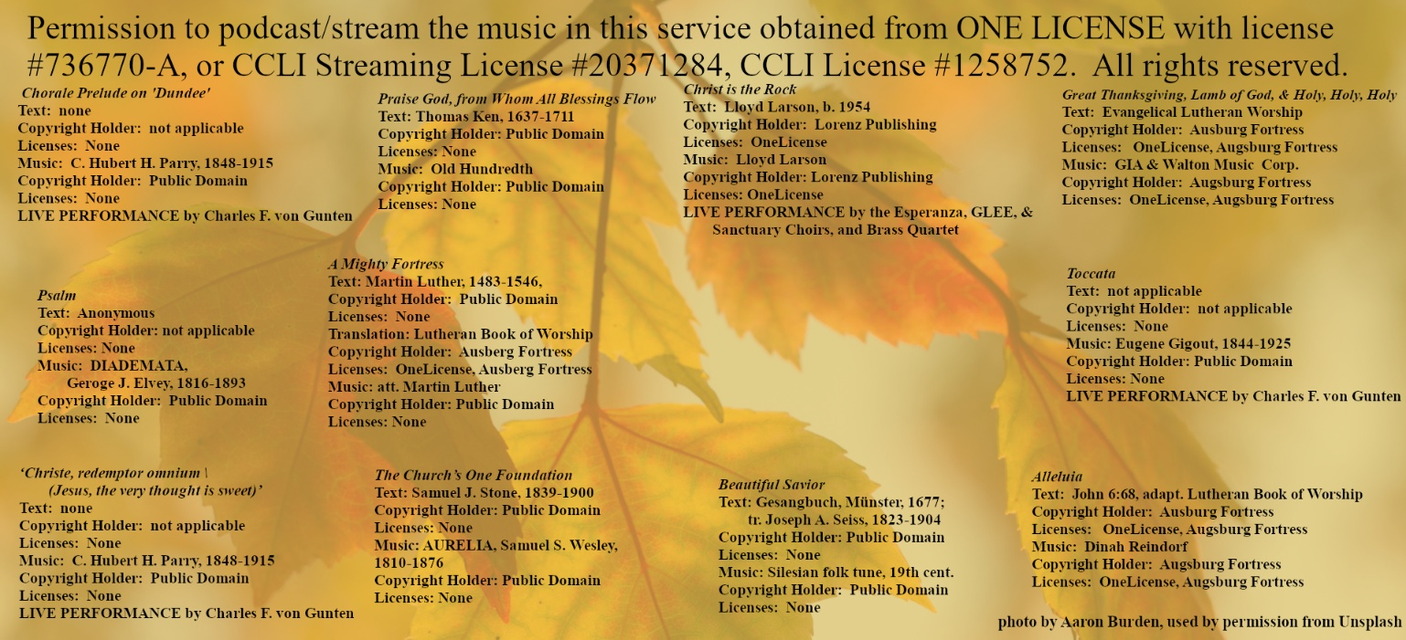



Monday October 27
4:00pm Gospel Study on zoom
5:30-6:30pm Glee Choir,
6:30-7:30pm Esperanza Youth Choir,
7:30-9pm Sanctuary Choir
Thursday October 30
8:00am Sandwich Ministry
Friday October 31
8am-12pm Food Distribution
Saturday November 1
12:00pm Old Globe presents “ Julius Caesar
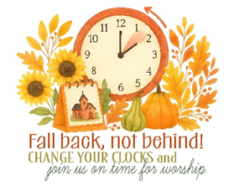
Sunday November 2

