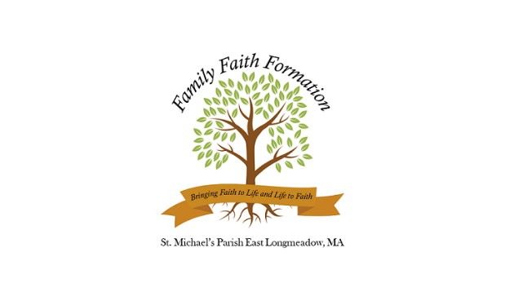

Grades 1 – 8 Faith Formation Calendar 2025 – 2026
Tuesday evening classes for each grade meet from 6:00-7:30pm
at the St Michael’s Parish Community Center (PCC) at 53 Somers Road OR at the Church

† FAMILY EVENTS ARE PART OF EVERY GRADE’S CURRICULUM

GRADE 1
- Tuesday, 10/28 (PCC)
- Tuesday, 1/27 (PCC)
- Tuesday, 4/7 (PCC)

GRADE 2
- Sunday, 9/28, 11:30am mass (Church) Blessing of the Candidates (w/ Confirmation students)
- Tuesday, 10/21 (PCC)

First Reconciliation, Saturday, 10/25
Parent and student, 8:45am-10:15am (Church)

- Tuesday, 1/20 (Church)
- Tuesday, 3/31 (PCC)

First Communion: Students will be divided into two masses (TBD)
Rehearsal (Church)
- Tuesday, 5/5, 6pm OR Wednesday, 5/6, 6pm
Ceremonies (Church)
- Saturday, May 9, 10am OR 12pm

GRADE 3
- Tuesday, 10/14 (Church) with a parent
- Tuesday, 1/13 (PCC)
- Tuesday, 3/24 (PCC)

GRADE 4
- Tuesday, 10/7 (PCC)
- Tuesday, 12/16 (PCC)
- Tuesday, 3/17 (PCC)

GRADE 5
- Tuesday, 9/30 (PCC)
- Tuesday, 12/9 (PCC)
- Tuesday, 3/3 (PCC), dinner with a parent
GRADE 6
- Tuesday, 9/23 (PCC)
- Tuesday, 12/2 (PCC)
- Night in Bethlehem*, Friday, 1/9 (PCC)
*Grade 6 runs this evening, which is a family event
- Tuesday, 2/24 (PCC)

GRADE 7
- Tuesday, 9/16 (Church) with a parent
- Tuesday, 11/25 (Church) with a parent
- Tuesday, 2/10 (Church) with a parent

GRADE 8
- Tuesday, 9/9 (Church) with a parent
- Tuesday, 11/4 (PCC)
- Tuesday, 2/3 (PCC) dinner with a parent

† Family Events (ALL GRADES)
- Sunday, 9/7, 4:30pm Opening Mass (Church)
Blessing of the Backpacks
- Tuesday, 10/6, 6:00pm (Church)
Family Rosary
- Sunday, 11/30, 4:30pm (Church)
Family Advent Mass
- Friday, 1/9, 6:30-8pm (PCC)
Night in Bethlehem
- Sunday, 2/8, after all masses
“Spread the Love” Food Drive
- Monday, 3/23, 6:00pm (Church)
Stations of the Cross for Families

