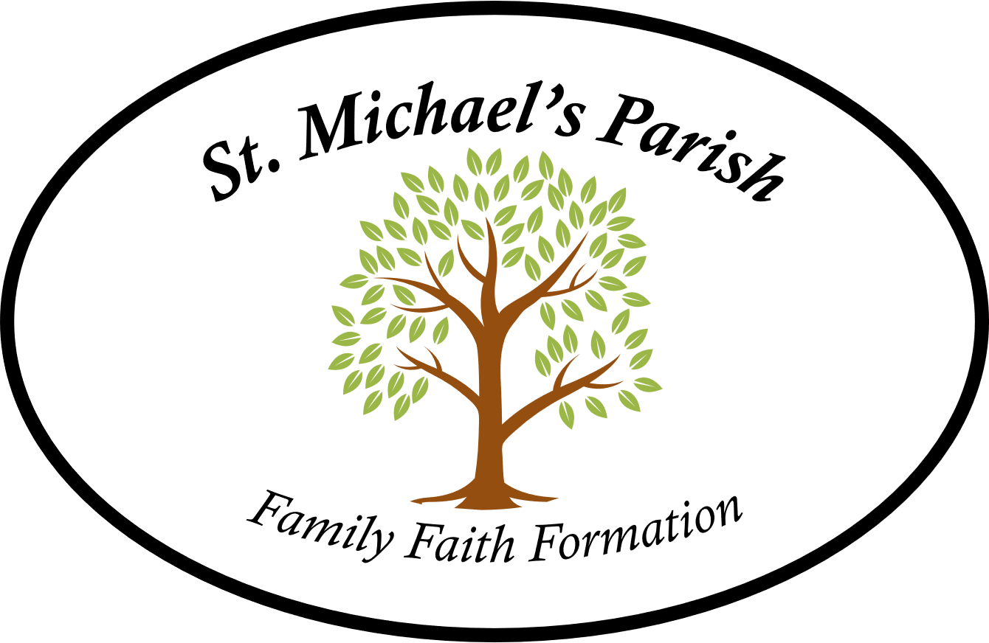

CONFIRMATION CALENDAR 2025 – 2026
Classes meet on Sunday evenings from 6:00-7:30pm
at the St Michael’s Parish Community Center (PCC) at 53 Somers Rd OR at the Church

- Sunday, 9/07/25 Opening Mass Celebration 4:30 p.m. @ Church
- Sunday, 9/14/25 Candidates, Parents & Sponsors (if chosen) 6:30-7:30 pm @ Church
- Sunday, 9/21/25 Class 6:30-7:30 p.m. @ Church
- Sunday, 9/28/25 Blessing of the Candidates 11:30 Mass (First Communion/Confirmation)
- Sunday, 10/05/25 Class 6:30-7:30 p.m. @ Church
- Monday, 10/06/25 FAMILY EVENT: “Rosary for families” 6:00 p.m. @ Church
- Sunday, 10/19/25 Class 6:30-7:30 p.m. @ Church
- Sunday, 10/26/25 Class 6:30-7:30 p.m. @ Church
- Sunday, 11/02/25 Class 6:30-8:00 p.m. @ Church
- Sunday, 11/30/25 FAMILY EVENT Advent Teaching Mass 4:30 p.m. @ Church
- Sunday, 12/07/25 6:30-8:30 p.m. @ Church
- Sunday, 1/04/26 Class 6:30-8:30 p.m. @ PCC with Parent or Sponsor
- Sunday, 2/01/26 Class 6:30-8:30 p.m. @ Church
- Sunday, 3/01/26 Class 6:30-8:30 p.m. @ Church
- Monday, 3/23/26 FAMILY EVENT:Stations of the Cross 6:00 p.m. @ Church
- Sunday, 3/29/26 Candlelight Prayer Service 7:00 p.m. with families, sponsors, candidates
- Confirmation Ceremony TBD

