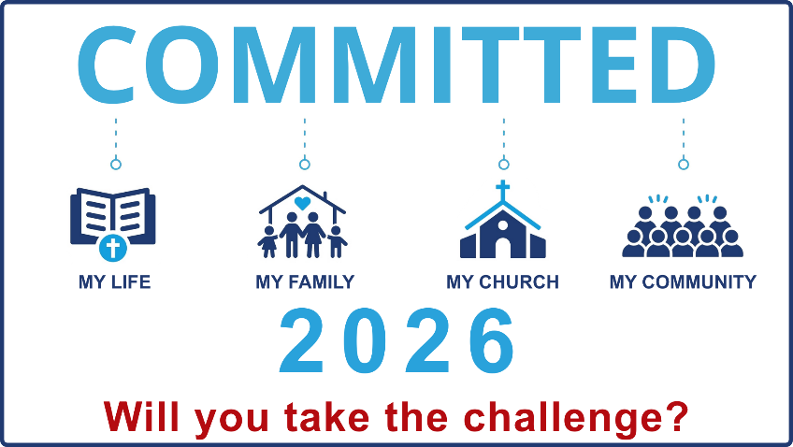

During 2026, we will be a church committed to transformation in our lives, our families, our church & our community.

MY LIFE
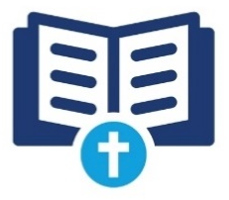
Every person committed to reading every Word
Be present with Jesus
- Daily read thru God’s Word
- Daily use the Committed Journal
- Daily spend time in prayer
- Memorize two verses a month
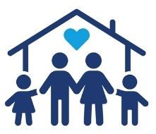

MY FAMILY
Every family committed to spending one meal a week together around the Word
Be present with your family
- Spend one meal time together as a family with no distractions (no electronic devices)
- Spend some time reading God’s Word together / devotional / God Time, etc.
- Work on memory verses together each week.

During 2026, we will be a church committed to transformation in our lives, our families, our church & our community.

MY LIFE
Every person committed to reading every Word
Be present with Jesus
- Daily read thru God’s Word
- Daily use the Committed Journal
- Daily spend time in prayer
- Memorize two verses a month

MY FAMILY
Every family committed to spending one meal a week together around the Word
Be present with your family
- Spend one meal time together as a family with no distractions (no electronic devices)
- Spend some time reading God’s Word together / devotional / God Time, etc.
- Work on memory verses together each week.
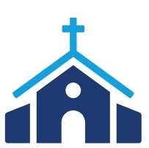
MY CHURCH
Every person committed to faithfully serving, giving, & being present to hear the Word
Be present at Church
- Be in church most every Sunday
- Be in a LifeGroup most every Sunday/Wednesday
- Be a part of Wednesday nights
- Be faithfully serving somewhere
- Be faithful in your giving

MY COMMUNITY
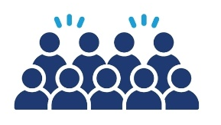
Every person committed to sharing Christ (the Word with at least one person this year
Be present with people
- Inviting someone to church
- Sharing the Gospel with someone
- Discipling someone (be in a T Group)
- Going on a mission trip (Vision 2030)

WEEKLY CHECK-IN
Go to petalfbc.com/links and then click My Commitment 2026 or use the QR code to do your weekly check-in


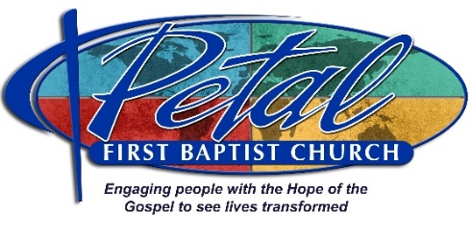

MY CHURCH
Every person committed to faithfully serving, giving, & being present to hear the Word
Be present at Church
- Be in church most every Sunday
- Be in a LifeGroup most every Sunday/Wednesday
- Be a part of Wednesday nights
- Be faithfully serving somewhere
- Be faithful in your giving

MY COMMUNITY
Every person committed to sharing Christ (the Word with at least one person this year
Be present with people
- Inviting someone to church
- Sharing the Gospel with someone
- Discipling someone (be in a T Group)
- Going on a mission trip (Vision 2030)

WEEKLY CHECK-IN
Go to petalfbc.com/links and then click My Commitment 2026 or use the QR code to do your weekly check-in



