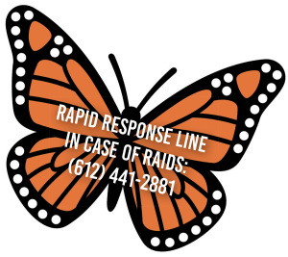
Where Do We Go from Here???

- Isaiah - isaiahmn.org/
- Monarca - monarcamn.org/

Reminders and Resources
Write down key phone numbers at home and work, such as a lawyer or legal aid organization, a trusted friend or family member, and your child’s school or daycare. Also keep it available in your wallet. Make sure your children know who to call if needed.
- Unidos MN Know Your Rights Line. Call for guidance on legal rights, resources, and support. (651) 372-8642
- Rapid Response Line. Call immediately if ICE is at your home, workplace, or in the community. (612) 441-2881
- Immigrant Law Center of Minnesota, ilcm.org
- Minnesota Freedom Fund provides bail and support to people who need to post an immigration bond to be released from custody, mnfreedomfund.org
- Mid-Minnesota Legal Aid, mylegalaid.org
- Southern Minnesota Regional Legal Services, smrls.org
- Private lawyers who practice immigration law, aila.org

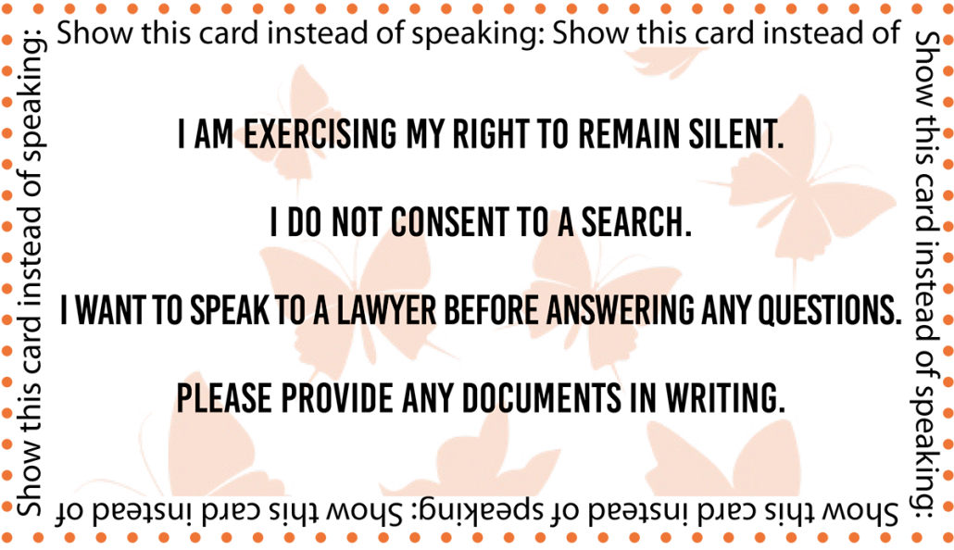

Romans 12:9-21 NRSVUE
Let love be genuine; hate what is evil; hold fast to what is good; ¹⁰ love one another with mutual affection; outdo one another in showing honor. ¹¹ Do not lag in zeal; be ardent in spirit; serve the Lord. ¹² Rejoice in hope; be patient in affliction; persevere in prayer. ¹³ Contribute to the needs of the saints; pursue hospitality to strangers. ¹⁴ Bless those who persecute you; bless and do not curse them. ¹⁵ Rejoice with those who rejoice; weep with those who weep. ¹⁶ Live in harmony with one another; do not be arrogant, but associate with the lowly; do not claim to be wiser than you are. ¹⁷ Do not repay anyone evil for evil, but take thought for what is noble in the sight of all. ¹⁸ If it is possible, so far as it depends on you, live peaceably with all. ¹⁹ Beloved, never avenge yourselves, but leave room for the wrath of God, for it is written, “Vengeance is mine; I will repay, says the Lord.” ²⁰ Instead, “if your enemies are hungry, feed them; if they are thirsty, give them something to drink, for by doing this you will heap burning coals on their heads.” ²¹ Do not be overcome by evil, but overcome evil with good.


