I Will Not Be Shaken
By: Joiya Morrison-Efemini
1 Samuel 25; Psalm 55:23; Psalm 16:8; Psalm 62:6

This picture from November 14, 1960 depicts Ruby Bridges, just eight years old, flanked by deputy U.S. marshals. She’s on her way to school, and that simple, bold act integrated William Frantz Elementary School. Whenever I see images of Ms. Bridges, I think of two people who are not shown - her parents - and the strength, courage, and unshakable faith it takes to send one’s child into enemy territory, for a righteous cause.

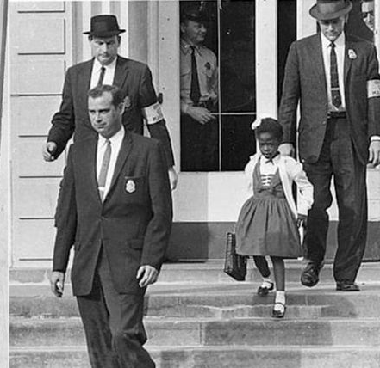
“Cast your cares on the LORD and he will sustain you; he will never let the righteous be shaken.”

1 Samuel 25 shows us a similar example of unshakable faith, and of entering enemy territory for a righteous cause. Abigail’s simple, bold act changes dire circumstances. She is “a woman with courage and faith whom God used in a very specific way.”

At the start of the chapter, Abigail is married to Nabal, who is described as “surly and mean in his dealings” (v. 3). A servant describes Nabal as “wicked” and his disposition is such that “no one can talk to him” (v. 17). By contrast, Abigail is known to be “intelligent” (v. 3). She is wise in her dealings.

When David sends his men to Nabal to collect payment for, in essence, security services. Nabal acts (within his nature) to insult David and potentially bring calamity down on his entire household. David, in his anger, vows to kill every male under Nabal’s authority.

It seems that everyone except Nabal understands the gravity of the situation. War is coming to their doorstep. Servants tend to know their lords well. Somewhat like children, they come to anticipate how each “parent” tends to react. Because of Abigail’s reputation, a household servant goes to her with the news of Nabal’s foolish behavior. Abigail acts quickly (v. 18). She rushes out to intercept David, loaded down with gifts, before he can exact his intended revenge upon Nabal. She is humble (v. 23), honest (v. 25), and discreet (v. 19). Abigail delivers “the longest speech given by a woman in the Old Testament.” She repeats the sentiments of the servant, calling Nabal “wicked” and “foolish” (v. 25). She intervenes to diffuse a volatile situation, putting herself in harm’s way between a foolish man and an angry one. But Abigail does not stand alone. She brings God into it because she knows the character of her LORD, much the same as her servant knows Abigail’s character. She mentions Him seven times (vs. 26-31). She trusts Him to guide her and to protect her, and she reminds David who He must trust and be led by.

Abigail brings peace (v. 35), by imploring David not to take matters into his own hands. She advises David against shedding blood. She reminds him that God avenges and that he should not take matters into his own hands (v. 26). She also hints at harm befalling Nabal for his foolishness (v. 26).

Harm is exactly what happens to Nabal, as God causes his heart to seize the next day, when Abigail tells him what she did (v. 37). And then God strikes Nabal dead just ten days later (v. 38).

Abigail put her burdens on the Lord and encouraged David to do the same. The Psalms are clear that we are meant to cast off our burdens and to be unshaken. To be peacemakers while we trust in God to fight our battles and exact His own revenge (Proverbs 20:22). Abigail is a model for exactly how this can be played out in our daily lives, on behalf of ourselves and others, in righteousness.

Reflect:
- How can we remain unshaken in a world that’s so easily shaken?
- How can you be a peacemaker in times of conflict/turmoil?

Dig a little deeper:
- Daniel 3 offers another example of unshakable faith.
- I first delved deeply into Abigail’s story here. I highly recommend this powerful study of 34 women.
- Be unshakable. Act quickly. Call on the name of Jesus next time you face strife/turmoil. Psalm 62:6
- Lord, remind us to call on you quickly in times of trouble. Help us to be humble, and to trust you to deliver us, even in our darkest hours. Touch our hearts, Lord, and help us to leave all vengeance to your just hands. We implore you, Lord, to make us women of unwavering, unshakable faith. In your MIGHTY and GLORIOUS NAME, Amen.

REFERENCES
New International Version (2022), Zondervan
Devoted: 30 Days With Women Of The Bible, Lifeway Women

