
TBC is scheduling a Rebuild Trip to Boone the week of October 20th. The plan will be to leave early Monday morning and return when we finish working on Friday afternoon. We will stay at the housing facility in Boone. It doesn’t matter what your skill level is. All you need is a willingness to go and serve. Steve Evans will need a head count by Sept. 15, so if anybody is interested, please let him know. His contact information is listed below.
If you need more information about BOM opportunities you can check with Steve or Michelle Clayton. Her information is listed with Steve’s below.
Steve Evans
336-504-1017
Stephen.p.evans1968@gmail.com
Michelle Clayton
336-503-7303
Michelle.clayton@duke.edu


APPLE ORCHARD TRIP
You There will be a group traveling to the apple
orchards of Virginia on Saturday, Oct. 18th. No
cost for trip other than what you purchase at
the orchards, and for lunch. Transportation will
on TBC Van. If you are interested in going, please
see or contact Sandy Jordan (336) 597-4945.



8-24-25: 8:30 Jan Mitchell, Sheila Clayton
11:00 Kim and Melissa Gilliam
Children’s Church: Nicole Palmer, Landon Frazier
8-31-25: 8:30 Susan Carver, Cindy Sumner
11:00 Tonya Peterson & Girls
Children’s Church: Michelle Clayton, Baylee Long


MEN’S FALL CAMPOUT
MAYO LAKE
FRI, SEPT 26 – SAT, SEPT 27

Exact time TBD soon. Dinner Friday night will be provided as well as breakfast on Saturday morning. Personal snacks and drinks will need to be brought with you. You will also need tents/and or camping equipment for the night. We will be finished by mid-morning Saturday. PLEASE SIGN UP IN SS CLASSES OR AT WELCOME CENTER FOR FOOD COUNT!
Interested or Questions?
Contact Fran or Michelle Clayton.

336-503-7303
Fran
336-583-0442
Michelle
336-503-7303

Received Sunday, 8-17-25
Regular Offering $ 6,655.00
OCC Shoeboxes $ 50.00
Rockie Stuart Scholarship $ 100.00


Theresa
Baptist Church
“Theresa Baptist Church exists
to Glorify God through
Growing Disciples who Go
with the Gospel of Jesus Christ.”


Theresa Baptist Church
3919 Chub Lake Road
Roxboro, NC 27574
Theresabaptist3919@gmail.com
www.theresabaptist.org

Church Phone
(336) 599-0635
Pastor Ben Francis
Cell: (704) 860-2727
Pastor Garrett Pope
Cell: (704) 961-6890

August 24, 2025
Prelude
Hymn: Crown Him with Many Crowns # 304
Welcome and Scripture Reading
Hymn: It Is Well # 447
Scripture Reading
Hymn: Because He Lives # 449
Pastoral Prayer
Special Music Choir
His Strength is Perfect
Message: “Sarah’s Death and God’s Faithfulness” Pastor Ben
Main Idea: God is faithful to settle His Genesis 23
people in the Promised Land.
Closing Hymn
Hymn: The Solid Rock # 511

What’s Happening This Week

Sunday, August 24th
8:30/11:00am Worship Services
9:45am Sunday School
Monday, August 25th
6:30pm “Romans” Ladies’ Bible Study
Wednesday, August 27th
6:30pm Awana Regular Club Night, Youth Meeting
7:00pm Bible Study
8:00pm Choir Practice

Visit our Welcome Center!
We welcome our Visitors, New Members, or Long-Time Members to our WELCOME CENTER and MEDIA CENTER located down the hall from the Sanctuary. You’ll find prayer lists, hand-outs, news, devotionals and books to check out.

BAPTISTS ON MISSION – DISASTER RELIEF
If you have taken Disaster Relief Training (in any area) please see the sign-up sheets at the Welcome Center and at the Missions Table. We are trying to get a complete list of those trained at TBC and what they are trained in. This will help up make sure you get all the Disaster Relief Information we receive.

Come by and help out or come see what we’ve been up to!

If you can’t commit to work, could you partner with us by providing a meal for our volunteers? Contact Michelle Clayton (336-503-7303) michelle.clayton@duke.edu .
Projects still remaining:
-Interior Painting -Refinishing Floors
-Deep Cleaning -Decorating
-Electrical Updating
-Repairing Exterior Entryways
-Cleaning and Painting Exterior Windows and Soffit
-Installing Finish Floor in Hallway
We’d love to see you there!
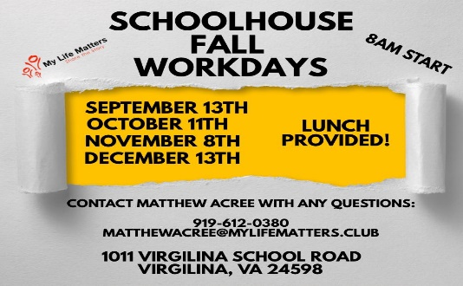

Sarah’s Death and God's Faithfulness
Genesis 23 - Pew Bible, pg. 16

Main Idea: God is faithful to settle His people in the Promised Land.

1 - God is Faithful to Establish Abraham in the Promised Land.

2 - God is Faithful to Establish His People in the Promised Land Forever.

Now What? -

