

3-8-26: 8:30 Stacey and Kelly Davis
9:30 Sandra and Jenna Seamons
Children’s Church: Bonnie Ogle, Aubrey Bowes
3-15-26: 8:30 Jan Mitchell, Sheila Clayton
9:30 Sandra and Jenna Seamons
Children’s Church: Vickie and Lydia McKinney

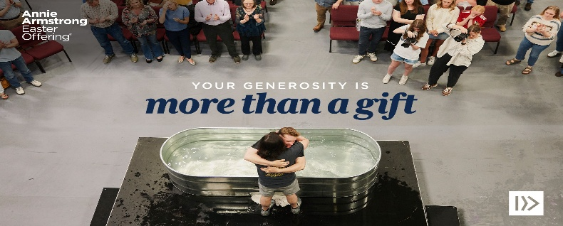

ANNIE ARMSTRONG EASTER OFFERING
FOR NORTH AMERICAN MISSIONS
We will be collecting this throughout the month of March!

Received Sunday, 3-1-26
Regular Offering $ 9,707.56
Building Fund $ 100.00
Mem. Earlie, Emma & Larry Harris


Theresa
Baptist Church
“Theresa Baptist Church exists
to Glorify God through
Growing Disciples who Go
with the Gospel of Jesus Christ.”


Theresa Baptist Church
3919 Chub Lake Road
Roxboro, NC 27574
Theresabaptist3919@gmail.com
www.t$heresabaptist.org
Church Phone
(336) 599-0635
Pastor Ben Francis
Cell: (704) 860-2727
Pastor Garrett Pope
Cell: (704) 96-6890

March 8, 2026
Prelude
Hymn: Praise Him! Praise Him! # 149
Welcome and Scripture Reading
Hymn: ‘Tis So Sweet to Trust in Jesus # 502
Scripture Reading
Hymn: What a Friend We Have in Jesus # 154
Pastoral Prayer
Special Christ the Sure and Steady Anchor Quartet
Message: “The Story of Joseph”
Genesis 37:1-36 Pastor Ben
Main Idea: God is at work in the details of life.
Closing Hymn
Hymn: All the Way My Savior Leads Me # 474

Sunday, March 8th
8:30/11:00am Worship Services
9:45am Sunday School
Monday, March 9th
6:30pm Women’s “Romans” Bible Study
Tuesday, March 10th
6:30pm Roxboro Assisted Living Visitation Program
Wednesday, March 11th
6:30pm Awana “Missions Night” (Write a “Thank You” note to
your parents.), Youth Meeting
7:00pm Adult Bible Study Groups
8:00pm Easter Choir Practice
Saturday, March 14th
10:00am Women’s “Using Scripture in Prayer” Study Group,
Women’s “Spiritual Disciplines” Study Group

Visit our Welcome Center!
We welcome our Visitors, New Members, or Long-Time Members to our WELCOME CENTER and MEDIA CENTER located down the hall from the Sanctuary. You’ll find prayer lists, hand-outs, news, devotionals and books to check out. ;


[Grab your reader’s attention with a great quote from the document or use this space to emphasize a key point. To place this text box anywhere on the page, just drag it.]

Interested in Singing With the Choir?
Come join us on Wednesday nights as we begin working on a choir
special for our combined service Easter Sunday. We will practice
for 6 Wednesday nights for approximately 30 minutes, beginning
at 8:00pm. Anyone interested in singing is invited to come
and join us.


TUESDAY, MARCH 17TH 11:00AM

PLEASE SIGN UP!



Saturday, 3-21-26
7:00am
(Please Sign Up!)
The Story of Joseph
Gen. 37:1-36 — Pew Bible pg. 31
March 8, 2026

Main Idea: God is at work in the details of life.

1 - A Coat of Favoritism and a Sovereign God.
(v. 1-11)

2 - Divine Slavery. (v. 12-36)

Now What? -

