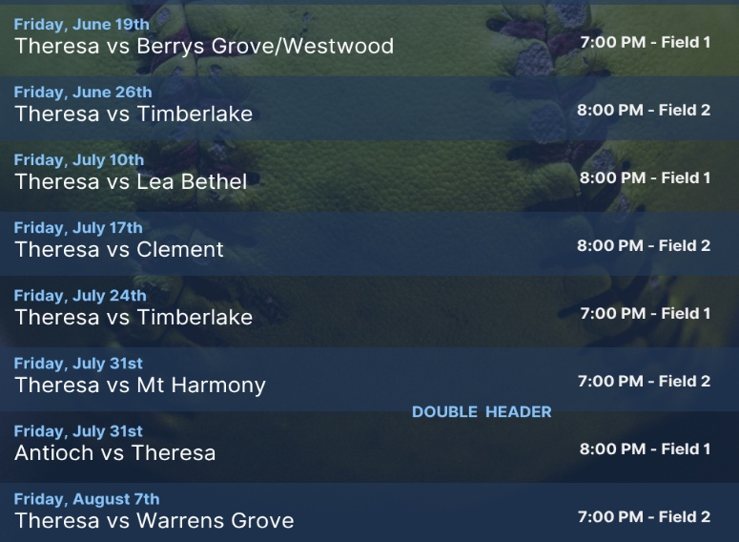
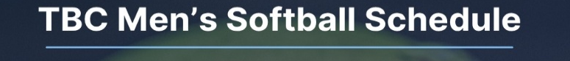



*

QR Code used for student and volunteer registration.
* Please note change of dates!



6-14-26: 8:30 Stuart and Caitlin Clark
9:30 Sandra and Jenna Seamons
Children’s Church: Nicole Palmer, Aubrey Bowes
6-21-26: 8:30 Anna and Garrett Whitfield
9:30 Sandra and Jenna Seamons
Children’s Church: Vickie and Lydia McKinney

OPERATION CHRISTMAS CHJILD SHOPPING LISTS
Leah Clayton has worked hard coming up with some gift registries for the OCC shoeboxes. It is so much information that it is too big to fit on the bulletin. There are flyers in all couples/ladies Sunday School classes giving you QR code options and gift ideas. With this, you can make sure you are getting the most for your money. There will also be some flyers at the Welcome Center and at the front entrance of the church.

Received Sunday, 6-7-26
Regular Offering $ 6,474.75
Hungary Mission Trip $ 835.00
Youth (Caswell) $ 975.00
Building $ 100.00
Mem. Of Earlie, Emma, &
Larry Harris


Theresa
Baptist Church
“Theresa Baptist Church exists
to Glorify God through
Growing Disciples who Go
with the Gospel of Jesus Christ.”


Theresa Baptist Church
3919 Chub Lake Road
Roxboro, NC 27574
Theresabaptist3919@gmail.com
www.theresabaptist.org
Church Phone
(336) 599-0635
Pastor Garrett Pope
Cell: (704) 961-6890

June 14, 2026

Prelude
Hymn: How Great is Our God # 1
Welcome and Believer’s Baptism
Hymn: Crown Him with Many Crowns # 5
Scripture Reading
Hymn: All Hail the Power of Jesus’ Name # 4
Special How Great Thou Art Group
Message: “Wisdom and Warning Pastor Garrett
Main Idea: Be wise and be warned: Humbly Psalm 2
submit to and worship Jesus Christ, God’s
anointed Son-King!.
Communion
Closing Hymn
Hymn: O Praise the Name

Sunday, June 14th
9:00am Sunday School
10:00am Fellowship w/Light Refreshments
10:30am Combined Worship Service w/Communion and
Baptism
Monday, June 15th
6:30pm Women’s “Romans” Bible Study
Wednesday, June 17th
7:00pm TBC Kid’s Club, Youth Meeting,
Adult Bible Study
Friday, June 19th
TBD Group Leaves for Hungary Mission Trip
7:00pm Men’s Softball – Field 1 vs. Berry’s Grove/Westwood

Visit our Welcome Center!
We welcome our Visitors, New Members, or Long-Time Members to our WELCOME CENTER and MEDIA CENTER located down the hall from the Sanctuary. You’ll find prayer lists, hand-outs, news, devotionals and books to check out. ;

HELP NEEDED
The monthly Roxboro Assisted Living Visitation group is asking for help. They are down to just a few ladies who minister to the residents of Roxboro Assisted Living one Tuesday night per month. If you would be interested in helping with a devotion or snack, please contact either Diane Carver (919-323-7823), or Jeannie Carver (336-503-2931)

SENIOR ADULT LUNCHEON
Please join us in the TBC Fellowship Hall on Tuesday, June 23rd at 11:00am for our Summer Senior Adult Luncheon. Sign up sheets in SS Rooms and at Welcome Center!

Wisdom and Warning
Psalm 2 - Pew Bible pg. 448
June 14, 2026

Main Idea: Be wise and be warned: Humbly submit
to and worship Jesus Christ, God’s Anointed Son-
King!

- The kings of earth: A foolish plan

- The King of Heaven: A sure plan

- The Anointed Son-King, Jesus: A victorious plan

- The King and you

