.



10-26-25: 8:30 Jan Mitchell, Sheila Clayton
11:00 Sandra and Jenna Seamons
Children’s Church: Nicole Palmer, Aubrey Bowes
11-2-25: 8:30 Susan Carver, Cindy Sumner
11:00 Sandra and Jenna Seamons
Children’s Church: Bonnie Ogle, Eli Francis


TRUNK OR TREAT 5:30-7:00PM
If you would like to provide a trunk for us,
please let Michelle Clayton know @ (336-
503-7303) or michelle.clayton@duke.edu.
you can provide candy/prizes or we can
Sunday provide them for you. Please have vehicles
October 26th In lower parking lot by 5:00pm.
** We need “trunks” for our event. Please prayerfully
consider volunteering to decorate your vehicle and hand out
treats. Also, we are taking donations for individually wrapped
candy.Please place all donations in the tub provided at church.

Received Sunday, 10-19-25
Regular Offering $24,031.71
OCC Shoeboxes Shipping $ 200.00
Lottie Moon Offering $ 100.00


Theresa
Baptist Church
“Theresa Baptist Church exists
to Glorify God through
Growing Disciples who Go
with the Gospel of Jesus Christ.”


Theresa Baptist Church
3919 Chub Lake Road
Roxboro, NC 27574
Theresabaptist3919@gmail.com
www.theresabaptist.org
Church Phone
(336) 599-0635
Pastor Ben Francis
Cell: (704) 860-2727
Pastor Garrett Pope
Cell: (704) 961-6890

October 26, 2025
Prelude
Hymn: The Solid Rock #511
Welcome and Scripture Reading
Baptism (2nd Service Only)
Hymn: How Firm a Foundation #456
Scripture Reading
Hymn: Trust and Obey #500
Pastoral Prayer
Special Music Choir
Standing On the Promises
Message: “God Blesses Jacob” Pastor Ben
Main Idea: God overrules human deceit Genesis 30:25-43
and schemes to accomplish His will and bless His people.
Closing Hymn
Hymn: In Christ Alone #506

What’s Happening This Week

Sunday, October 26th
8:30/11:00am Worship Services
9:45am Sunday School
5:30-700:pm Trunk or Treat (Please have cars in lower parking lot
by 5:00pm.)
Monday, October 27th
6:30pm “Romans” Ladies’ Bible Study
Tuesday, October 28th
6:00am Men’s “Hebrews” Bible Study
Wednesday, October 29th
10:00am “Jesus-Shaped Life” Ladies’ Bible Study
6:30pm Awana Costume Night, Youth Meeting
7:00pm Bible Studies
8:00pm Choir Practice
Friday, October 31st
9:00am Sonshiner’s Preschool Fall Fun Day/Party
Saturday, November 1st
Midnight Daylight Savings Time Ends
(Turn clocks BACK 1 hour!)
Visit our Welcome Center!
We welcome our Visitors, New Members, or Long-Time Members to our WELCOME CENTER and MEDIA CENTER located down the hall from the Sanctuary. You’ll find prayer lists, hand-outs, news, devotionals and books to check out.

DEATH: Sue Briggs (Wife of Earl Briggs)

Come by and help out or come see what we’ve been up to!

If you can’t commit to work, could you partner with us by providing a meal for our volunteers? Contact Michelle Clayton (336-503-7303) michelle.clayton@duke.edu .
Projects still remaining:
-Interior Painting -Refinishing Floors
-Deep Cleaning -Decorating
-Electrical Updating
-Repairing Exterior Entryways
-Cleaning and Painting Exterior Windows and Soffit
-Installing Finish Floor in Hallway
We’d love to see you there!

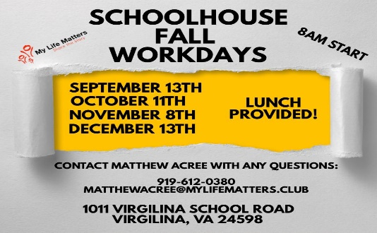

-

JOINT WORSHIP SERVICE
Change of times for joint
Worship Service on Sunday, November 2nd.
9:00am Sunday School
10:00am Fellowship Time in Fellowship Hall
10:30am Joint Worship Service w/Communion in Fellowship Hall
Don’t Be Too Early!
Turn clocks BACK one hour Saturday Night,
Nov. 1st for end of Daylight Savings Time!
God Blesses Jacob
Genesis 30:25-43 — Pew Bible pg. 24
Oct. 26, 2025

Main Idea: God overrules human deceit and schemes to accomplish His will and bless His people.

1 - God’s People Anticipate the Fulfillment of God’s
Promises. (v. 25-34)

2 - God’s Promises Always Hold True. (v. 35-43)

Now What? - God is doing something in the world.

