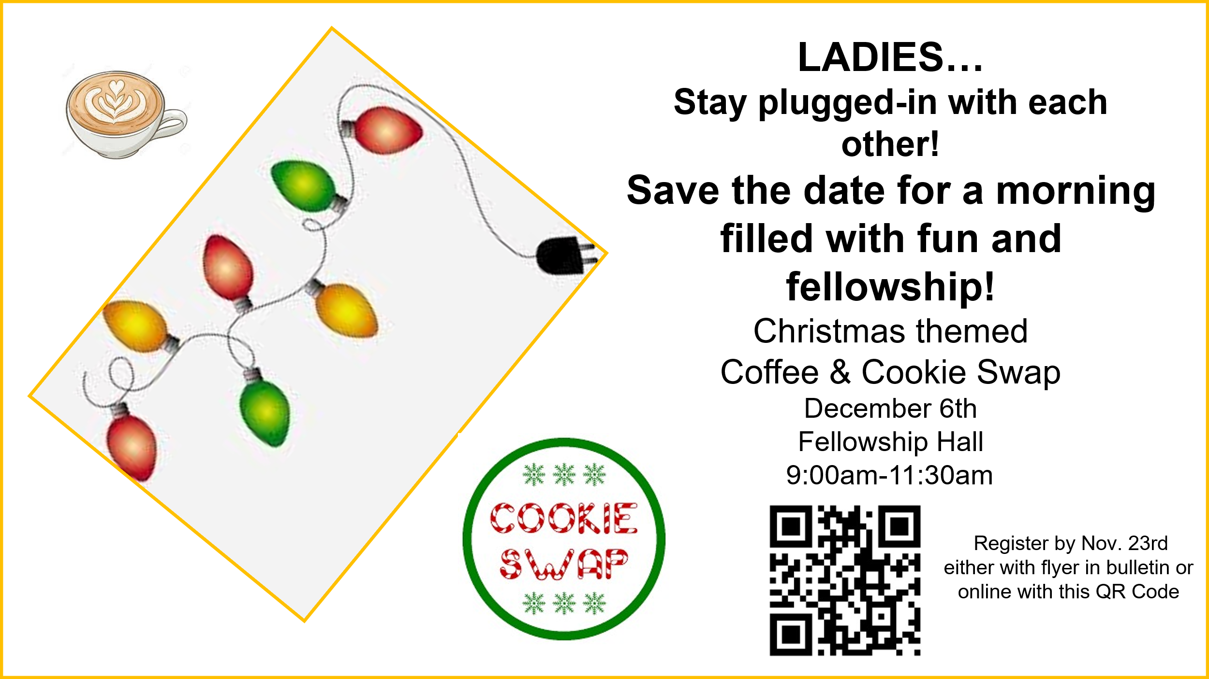

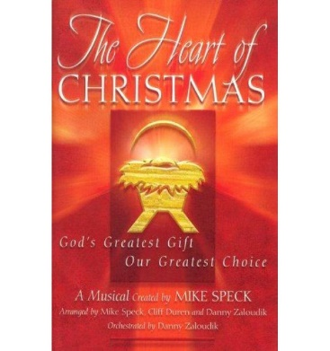
The Heart of Christmas
The Heart of Christmas
The TBC Choir would like to invite you
all to our Christmas Cantata being
presented on Sunday, December 7th at
6:00pm in the Sanctuary. Come hear a
dynamic and heart-felt expression of
Christmas in music. Afterward, please
bring your favorite Christmas Goodies
to share with others in the Fellowship
Hall following the cantata.



Saturday, December 13th @ 7:00am
Please sign up at Welcome Center.

NEW MEMBER’S CLASS
Pastor Ben will hold a New Member’s Class on Sunday, December 14th, in the Sanctuary at 9:45am during Sunday School. This class is for those who have recently joined the family of Theresa Baptist or those interested in what is involved in being a member here.



11-30-25: 8:30 Caitlin and Stuart Clark
11:00 Sandra and Jenna Seamons
Children’s Church: Michele and James Solomon
12-7-25: 8:30 Anna and Garrett Whitfield
11:00 Sandra and Jenna Seamons
Children’s Church: Bonnie Ogle, Baylee Long

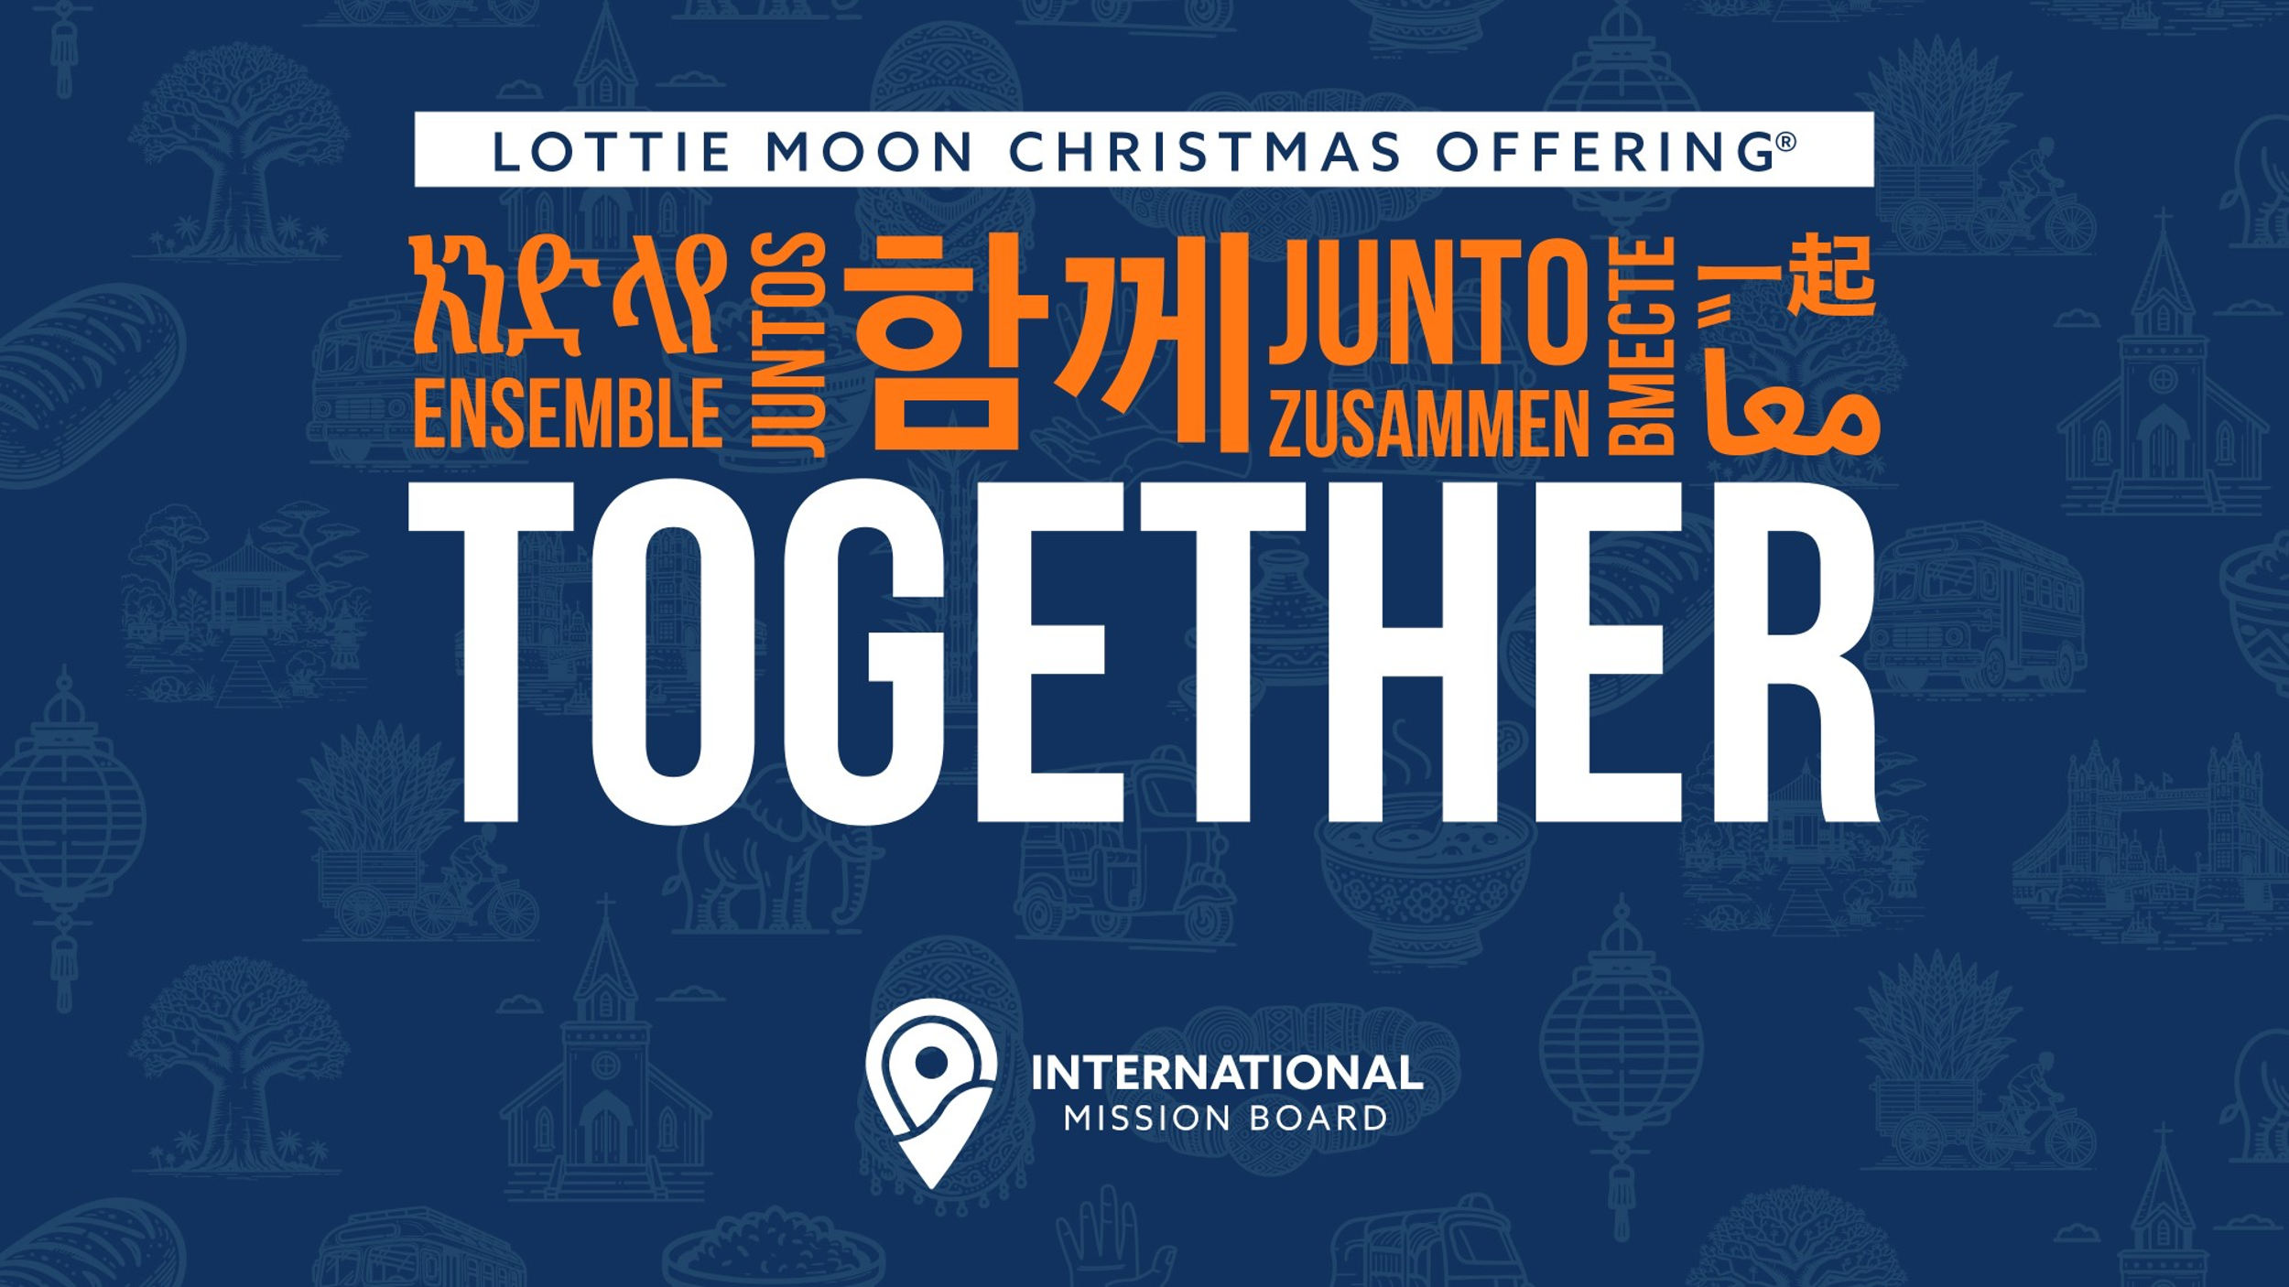

Week of Prayer for International Missions
Nov. 30 – Dec. 7, 2025
Taking up LMCO through December.

News from TBC Book Nook
Slow down and appreciate the wonder of Christmas with a beloved Bible teacher. Dr. R. C. Sproul’s book “The Advent of Glory”! Mixing scripture and heartwarming application, Sproul’s 24 Advent readings explore the details of the nativity story--and how they can impact our lives today. It also features daily prayers from Sinclair Ferguson, Tim Challies, Joni Eareckson Tada, and many others.

In the Book Nook you can also find gifts like “The Jesus Storybook Bible” for the children on your list.

Enhance a loved ones devotion time with selections like “New Morning Mercies”, “Everyday Gospel”, and “The Valley of the Vision”.

Challenge yourself in spiritual growth during the New Year with selections like “Knowing God”, “Spiritual Disciplines of the Christian Life” and many others that are available.

Received Sunday, 11-23-25
Regular Offering $20,
Building Fund $ 2,
OCC Shipping $ 50.00
Lottie Moon Offering (Total) $ 100.00


Theresa
Baptist Church
“Theresa Baptist Church exists
to Glorify God through
Growing Disciples who Go
with the Gospel of Jesus Christ.”


Theresa Baptist Church
3919 Chub Lake Road
Roxboro, NC 27574
Theresabaptist3919@gmail.com
www.theresabaptist.org
Church Phone
(336) 599-0635
Pastor Ben Francis
Cell: (704) 860-2727
Pastor Garrett Pope
Cell: (704) 961-6890

November 30, 2025
Prelude
Hymn: Praise to the Lord, the Almighty # 1
Welcome and Scripture Reading
Hymn: Joyful, Joyful, We Adore Thee # 13
Scripture Reading
Hymn: To God Be the Glory # 28
Pastoral Prayer
Choir Special Choir
How Great Thou Art
Message: “Great is the LORD” Pastor Ben
Main Idea: God is to be praised. Psalm 145
Closing Hymn
Hymn: How Firm a Foundation #456

What’s Happening This Week

Sunday, November 30th Last Day for Cuba Supplies!
8:30/11:00am Worship Service
9:45am Sunday School
10:00am Children’s Cantata Practice (Sanctuary)
Monday, December 1st
6:00pm Choir Cantata Practice
6:30pm Women’s “Romans” Bible Study
Tuesday, December 2nd
6:00am Men’s “Hebrews” Bible Study
Wednesday, December 3rd
6:30pm Awana Mission Night (Write a “thank-you” note to
your pastors.), Youth Underground
7:00pm Adult Bible Study
8:00pm Choir Cantata Practice
Thursday, December 4th
9:00am Sonshiners Toddlers, 3s, & 4s (Tue./Thur.) Class
Pajama-Movie Day
Friday, December 5th
9:00am Sonshiners 2s, 3s & 4s Pajama-Movie Day
Saturday, December 6th
9:00-11:30am Plugged-In Women’s Coffee & Cookies – Breakfast,
Fellowship, Cookie Swap (Wear your Christmas Attire)
Visit our Welcome Center!
We welcome our Visitors, New Members, or Long-Time Members to our WELCOME CENTER and MEDIA CENTER located down the hall from the Sanctuary. You’ll find prayer lists, hand-outs, news, devotionals and books to check out.

Come by and help out or come see what we’ve been up to!

If you can’t commit to work, could you partner with us by providing a meal for our volunteers? Contact Michelle Clayton (336-503-7303) michelle.clayton@duke.edu .
Projects still remaining:
-Interior Painting -Refinishing Floors
-Deep Cleaning -Decorating
-Electrical Updating
-Repairing Exterior Entryways
-Cleaning and Painting Exterior Windows and Soffit
-Installing Finish Floor in Hallway
We’d love to see you there!
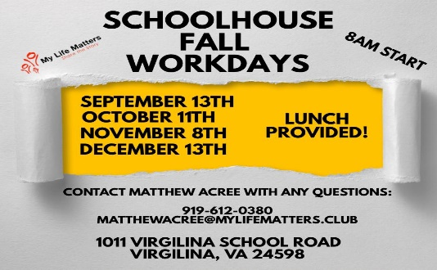

Steve Evans will be traveling to Cuba with Baptist
On Mission to provide Hurricane Melissa relief. Below
is a list of supplies he has been asked to collect. He will
need these items by Sunday, November 30th (Today!)
so that he can pack them to take when he goes.
He has a box set up in the Welcome Center.
Supplies
Cash - $100 bills work best but any amount will suffice
canned chicken dried red beans
dried black beans ibuprofen (can be generic)
acetaminophen (can be generic)
Benadryl (can be generic) Senior incontinence supplies
toothpaste (larger sizes) toothbrushes (plain only)
rolled gauze gauze pads (all sizes)
adhesive bandages Neosporin (Can be generic)
Children's fever reducing liquid (can be generic)
Great is the LORD
Psalm 145 - Pew Bible pg. 524
Nov. 30, 2025

Main Idea: God is to be praised!

