NOTES

Scan our QR Code for upcoming events,
online giving, and more, or visit
benttree.org/tree




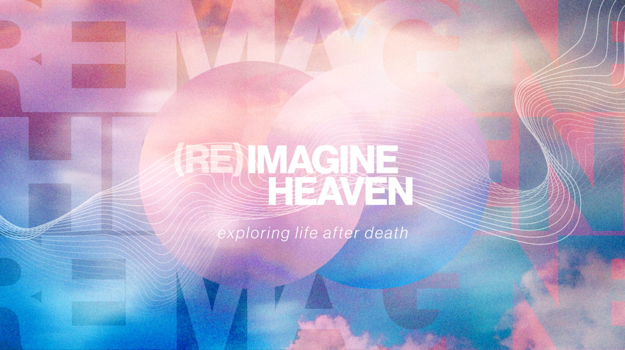

THE LITURGY OF HEAVEN
May 17, 2026
Libin Abraham

Worship begins with __________________________.
Worship is the soul fully awakened to the beauty, holiness, and worth of God.
Revelation 1:1 The revelation of Jesus Christ that God gave him to show his servants what must soon take place…
Revelation 4:2-3 Immediately I was in the Spirit, and there was a throne in heaven and someone was seated on it. ³ The one seated there had the appearance of jasper and carnelian stone. A rainbow that had the appearance of an emerald surrounded the throne.
“Worship in heaven will never become boring because God is infinitely interesting.” Randy Alcorn

Worship Embodied:
- Falling Down – Humility and Surrender (Rev 5:14)
- Standing Up – Honor and Readiness (Rev 7:9)
- Singing – Joy and Celebration (Rev 5:9)
- Crying out Loud – Passion without Shame (Rev 7:10)
- Silence – Awe and Reverence (Rev 8:1)
- Casting Crowns – Surrendering achievements - (Rev 4:10)
- Hands Lifted – Celebration and Triumph (Rev 7:9)
- Serving Joyfully – Worship as Vocation and Service (Rev 7:15)
- Beholding His Face – Delight and Intimacy (Rev 22:4)

Song 1 (Rev 4:8-11) - Jesus is _____________ because he is eternal

Song 2 (Rev 5:8-14) – Jesus is ____________ because he was slain

Song 3 (Rev 7:9-12) – Jesus is _________________ because he gathers every people group

Song 4 (Rev 11:15-18) – Jesus is ______________ because he reigns forever

Song 5 (Rev 15:3-4) – Jesus is _____________ because his ways are just

Song 6 (Rev 19:1-8) – Jesus is our __________________ because he is victorious

