“If You Knew Me – You Would Ask”
Trevin Wax

If you knew me – you would give.

A Statement On Stinginess – Stop It!
Luke 6:38, 2 Corinthians 9:6-11, Galatians 6:6-9

“Give, and you will receive. Your gift will return to you in full - pressed down, shaken together to make room for more, running over, and poured into your lap. The amount you give will determine the amount you get back.”
Luke 6:38

The Big Picture

1. Sowing and reaping is a law of the natural world.

“bearing seed” and fruit “with seed in it.”
Gensis 1:12

2. Sowing and reaping is a law of the spiritual world.

“Do not be deceived: God cannot be mocked. A man reaps what he
sows.”
Genesis 6:7

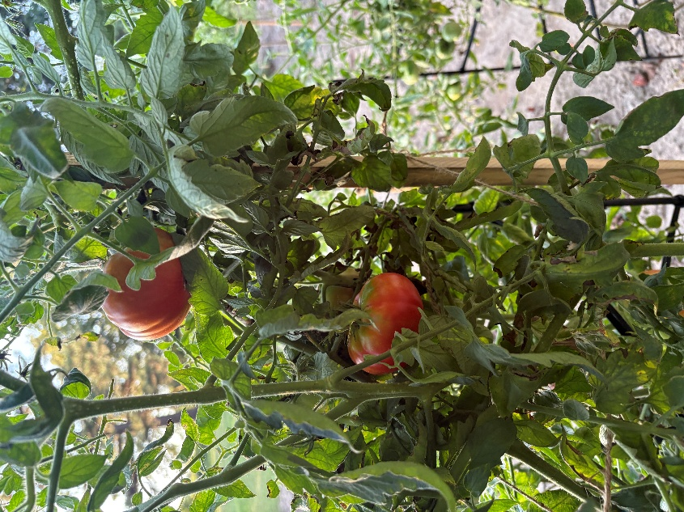

3. We reap in kind to what we sow.

“Whoever sows to please their flesh, from the flesh will reap destruction; whoever sows to
please the Spirit, from the Spirit will reap eternal life.”
Galatians 6:8

“The one who sows righteousness reaps a sure reward.”
Proverbs 11:18

“whoever sows injustice reaps calamity.”
Proverbs 22:8

4. The more we sow, the more we reap.

“Whoever sows sparingly will also reap sparingly, and whoever sows generously will also reap
generously.”
2 Corinthians 9:6

5. We reap more than what we sow.

“a hundred, sixty or thirty times what was sown.”
Matthew 13:8

Context of the Luke 6:38 . . .
- This is part of the famous Sermon on the Mount.
- The longer version is in Matthew 5-7.
- The shorter version is in Luke 6.
- Verse 38 comes at the end of a section dealing with how to deal with people:

Luke 6:27-30 - rapid fire commands:
- Love your enemies – 6:27
- Do good to those who hate you – 6:27
- Bless those who curse you – 6:28
- Pray for those who mistreat you – 6:28
- Give to everyone who asks you – 6:30

“Do to others as you would have them do to you.”
Luke 6:31

“Do not do to others what you do not want done to you.”

Luke 6:32-37 - reasons for these radical commands:
- You must go beyond what sinners do – 6:32-34
- You will win a great reward from God – 6:35
- You will prove to be the sons of God – 6:35
- You will reflect God’s character – 6:36
- You will be treated as you treat others – 6:37

If you are stingy, God will be stingy in return!

If you are generous, God will be generous in return!

“Remember this—a farmer who plants only a few seeds will get a small crop. But the one who
plants generously will get a generous crop. You must each decide in your heart how much to
give. And don’t give reluctantly or in response to pressure. “For God loves a person who gives
cheerfully.” And God will generously provide all you need. Then you will always have everything
you need and plenty left over to share with others. As the Scriptures say,
‘They share freely and give generously to the poor. Their good deeds will be remembered
forever.’
For God is the one who provides seed for the farmer and then bread to eat. In the same way, he
will provide and increase your resources and then produce a great harvest of generosity in
you. Yes, you will be enriched in every way so that you can always be generous. And when we
take your gifts to those who need them, they will thank God. So two good things will result
from this ministry of giving—the needs of the believers in Jerusalem will be met, and they will
joyfully express their thanks to God.”
2 Corinthians 9:6-12

We give to get to give more.

The prosperity gospel says you should give in order to get - and stops there.
The Bible says you should give in order to get - so you can give even more away.

“God says, ‘You go first.’ We don’t like that. We want God to go first.
We say, ‘You give me the money and then I’ll give.’
God says, ‘I’ve give you my Word. Isn’t that enough?’
‘Well, your Word is nice, but I’d like some cash to go along with it.’
To all our bargaining, God says, ‘Trust me. You give and I’ll take care of you.
And I promise you’ll never be disappointed.’”

Why can we trust this verse?
Everything Jesus says rests in the character of God.

“Let all that I am praise the Lord;
with my whole heart, I will praise his holy name.
Let all that I am praise the Lord;
may I never forget the good things he does for me.
He forgives all my sins
and heals all my diseases.
He redeems me from death
and crowns me with love and tender mercies.
He fills my life with good things.
My youth is renewed like the eagle’s!”
Psalm 103:1-5
A short list of God’s gifts
victory
peace
hope
life
success
what is good
wisdom
knowledge
understanding
strength
health
discretion
honor
power
love
children
a heart to know him
songs in the night
joy in the morning
answers to prayer
food to the hungry
water to the thirsty
rest to the weary
good gifts to those who ask
eternal life
living water
all things
a spirit of unity
the new birth
the crown of life

the Word of God.
“For God so loved that he gave his only begotten Son, that whosoever believeth in him should
not perish, but have everlasting life.”
John 3:16

Points to ponder . . .

1. Generous givers are not the people with a large bank account, but the people with a
large view of God.

2. When we give generously, we do so because we truly believe God will reward us one
way or the other.

So how does God reward his generous children?
Might be with money
Might be with answered prayer
Might be with deep inner joy
Might be with new friendships
Might be with more opportunities to give
Might be with a new understanding of His power in our lives.
Might be a miracle
Might be with the peace that passes all understanding.

3. Generous givers understand the shovel principle.

“I shovel it out and God shovels it in, and he’s got a bigger shovel than I do.”

4. Generous giving is a testimony to an unbelieving world that our God is alive and well
today.

Lord Jesus, teach us that we only keep what we give away.
We have tried so hard to hoard things, only to have them slip through our fingers.
We have tried stinginess, Lord, and it didn’t work.
Teach us to be generous.
We thank you that we have everything we need - and more besides.
Open our eyes to see what you are doing in the world.
Save us from spending our lives building castles of sand.
Help us to give as you did, bleeding, dying for us.
Amen.

