“a large public procession, often of a festive nature, held in honor of an anniversary, person, event”
dictionary.com

Did you know that the . . .

- Largest parade in the world is held in Rio De Janerio, Brazil.

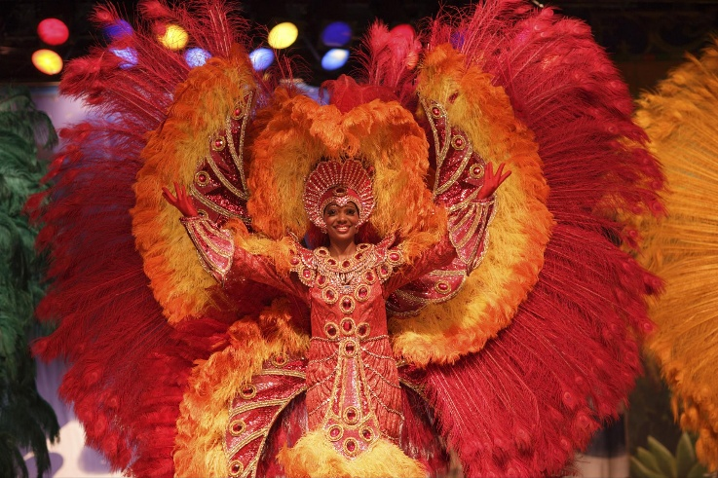

- Oldest continuous parade is the “Pace Egg” parade dating back to the 12th century in England and celebrates Easter with plays, mock combats, and the rolling of eggs.

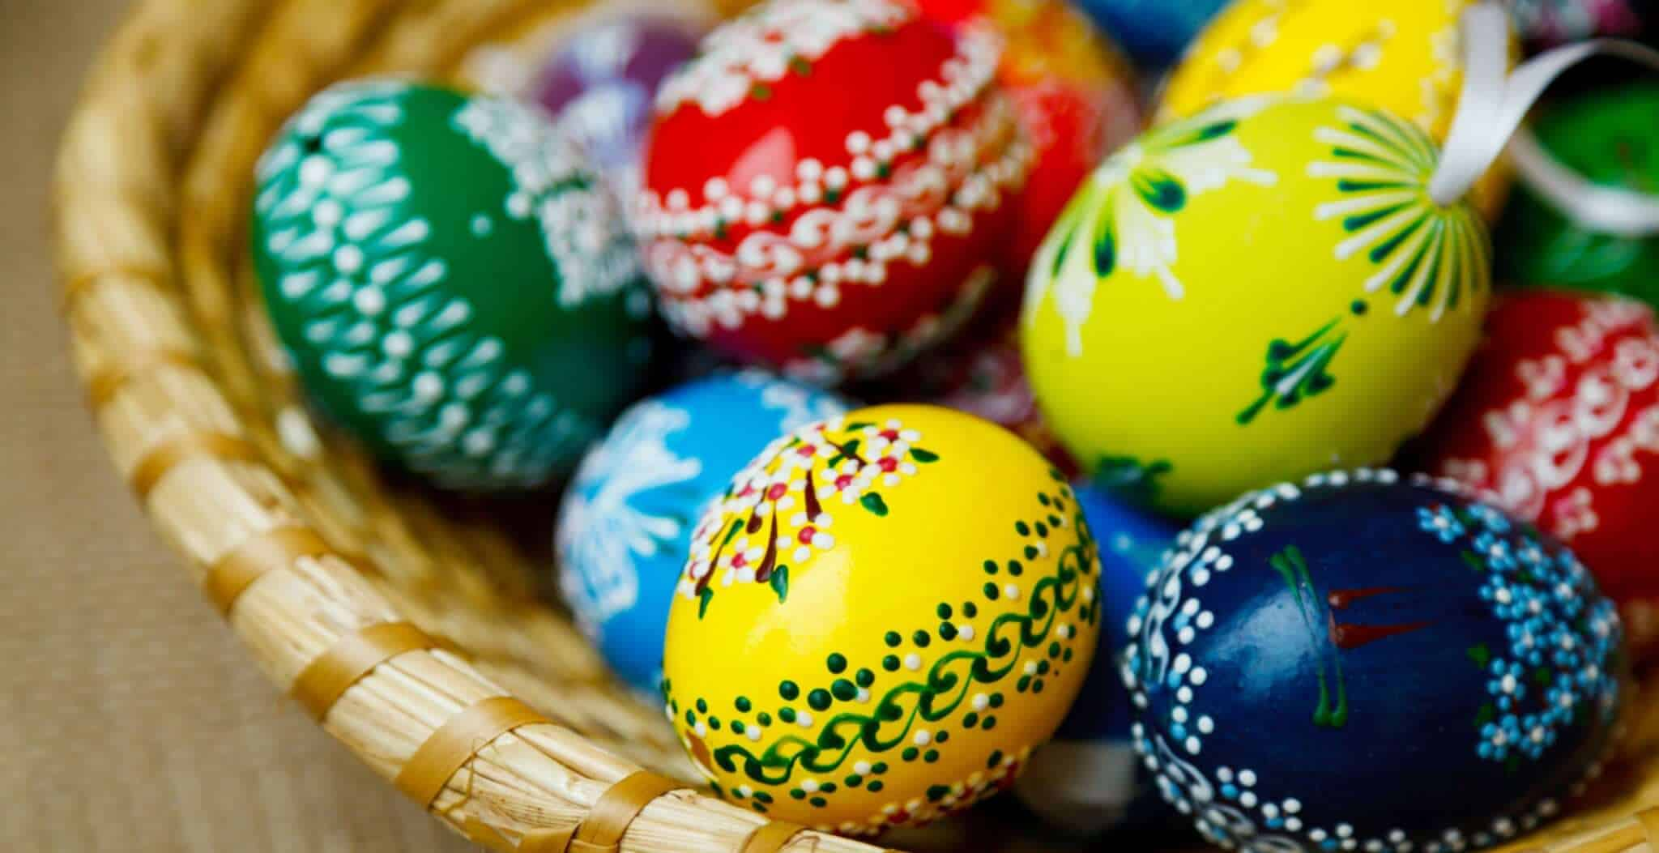

- Most iconic parade is Macy’s Thanksgiving Day Parade in New York City held annually since 1924

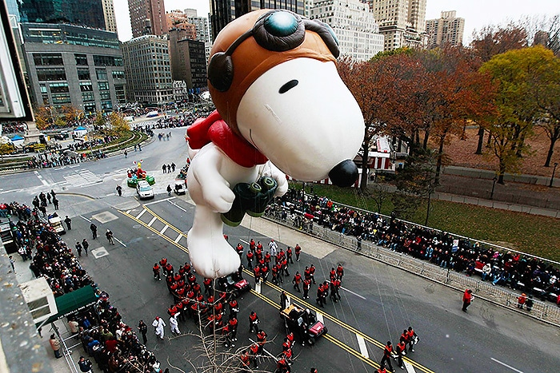

- Over 9,000 participants march through the streets for Oktoberfest Parade in Munich, Germany.

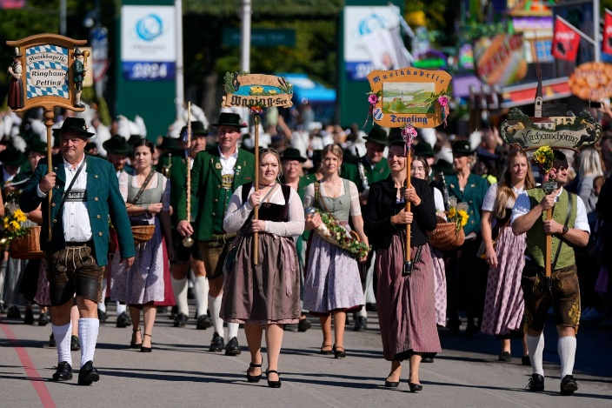

- Largest and most elaborate parade in Asia is the Chinese New Year Day Parade in Hong Kong.

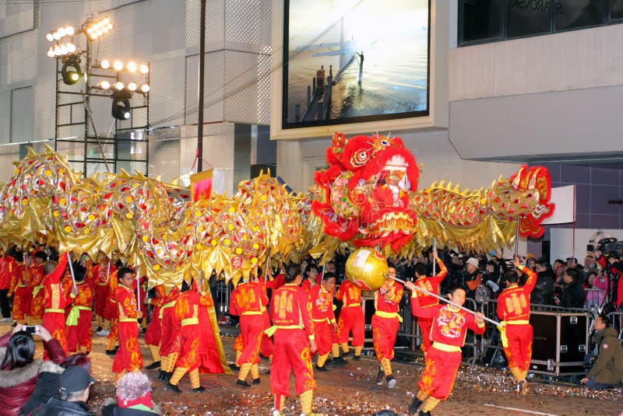

- Saint Patrick’s Day Parade in Dublin, Ireland attracts over 500,000 spectators who celebrate Irelands patron saint.

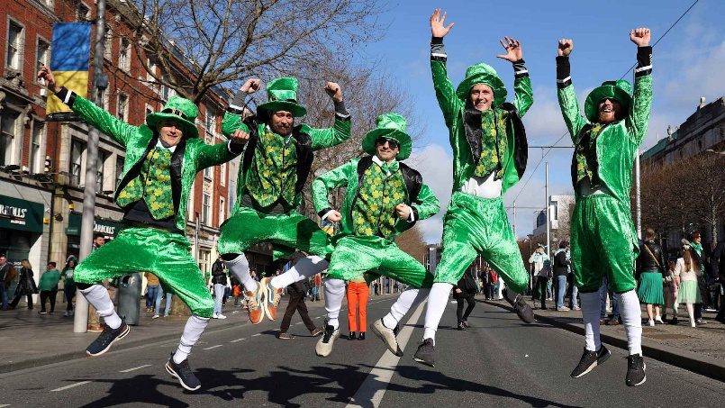

- Rose Parade in Pasadena, California on New Year’s Day which features elaborate floats made entirely of flowers.

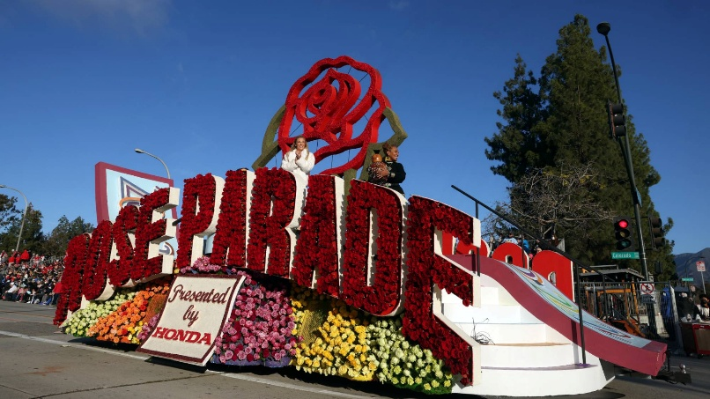

- Sapporo Snow Festival Parade in Japan that features elaborate snow and ice sculptures and floats made entirely of snow.

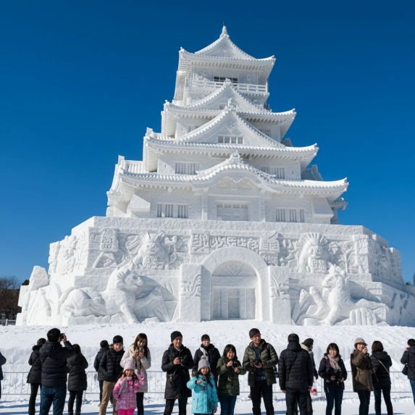

- La Tomatina Parade held in Bunol, Spain which is really a massive tomato fight parade held year after year.

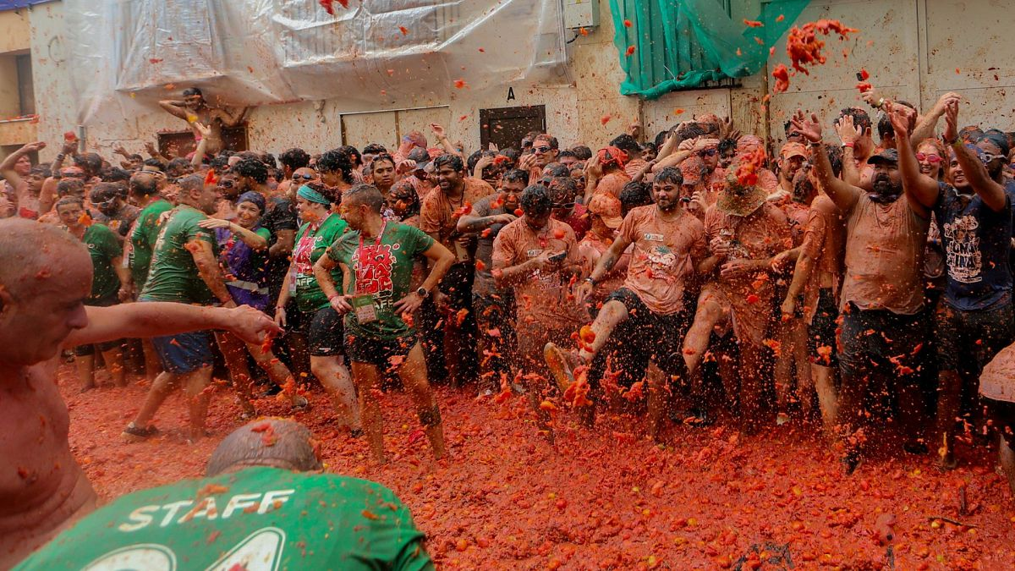

- Easter Jeep Safari and Parade in Moab, Utah features a veritable freak show of refitted Jeeps—stripped to their frames, fortified, painted over, militarized, and Frankensteined.

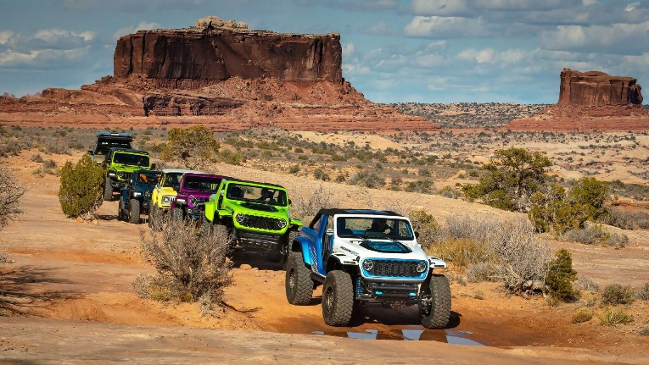

A Donkey, Some Disciples, the Declaration of Jesus,
and the Definitive Beginning of the End
Matthew 21:1-11

Palm Sunday
Jesus enters Jerusalem riding on a donkey welcomed by the crowds.
This marks the beginning of the final week of His crucifixion.
(Matthew 21:1-11, John 12:12-19)

Holy Monday
Jesus clears the temple by driving out money changers who were exploiting worshippers.
Jesus also curses a barren fig tree as a symbol of spiritual emptiness.
(Matthew 21:12-17, Mark 11:12-14)

Holy Tuesday
Jesus teaches in the temple about
faith, judgement and God’s kingdom.
He also speaks to his disciples about faith and forgiveness.
(Mark 11:22-26)

Holy Wednesday
Jesus rests in Bethany while
Mary of Bethany anoints Him with perfume.
Judas secretly agrees with Jewish leaders to betray Jesus.
(Matthew 26:14-15)

Maundy Thursday
Jesus shares the Last Supper with His disciples and washes
their feet as a lesson in humility.
Later that night He prays in the garden and is arrested.
(Luke 22:7-23)

Good Friday
Jesus is tried, mocked and crucified by Roman authorities.
He dies on the cross as the sacrifice
for our sins and is buried in a tomb.
(John 19, Luke 23:32-47)

Holy “Black” Saturday
Jesus’ body rests in a tomb while followers
are scattered, mourn and wait.
It is a day of silence and anticipation before the resurrection.
(Luke 23:55-56)

Easter Sunday
Jesus rises from the dead, defeating death and fulfilling
His promise of salvation.
His resurrection is the central event of the Christian faith.
He is risen – He is risen indeed!
(Luke 24:1-10, John 20:19-20)

Holy Week:
Jesus’ arrival in Jerusalem.
His teachings and final moments.
His crucifixion and sacrifice.
His resurrection and victory over sin and death.

Matthew 1–2: the first thirty years of Jesus’ life.

Matthew 3–20: featured snapshots from Jesus’ three years of ministry.

Matthew 21–28: the gospel writer slowed his pace to detail each event surrounding Jesus’ passion and death, devoting a third of his gospel to just one week.

“Now when they drew near to Jerusalem and came to Bethphage, to the Mount of Olives, then Jesus sent two disciples, saying to them, ‘Go into the village in front of you, and immediately you will find a donkey tied, and a colt with her. Untie them and bring them to me. If anyone says anything to you, you shall say, ‘The Lord needs them,’ and he will send them at once.’

This took place to fulfill what was spoken by the prophet, saying,
“Say to the daughter of Zion,
‘Behold, your king is coming to you,
humble, and mounted on a donkey,
on a colt, the foal of a beast of burden.’”
Matthew 21:1-6

- Jesus wasn’t a king like most other kings.

“Jesus could not have chosen a more dramatic moment; it was into a city surging with people keyed up with religious expectations that he came.”
William Barclay

In God’s timing there is always a time to wait
and always a time to move.

In God’s timing there is always a time to show restraint
and always a time to be courageous.

In God’s timing there is always a moment of truth when you either exercise faith or succumb to fear.

Low Down on Donkeys
Foal:
Baby male or female donkey under 1 year old.

Colt:
Male donkey under 4 years old.

Filly:
Female donkey under 4 years old.

Gelding:
Castrated male donkey.

Stallion:
Uncastrated male donkey.

Yearling:
Male or female donkey between 1 and 2 years old.

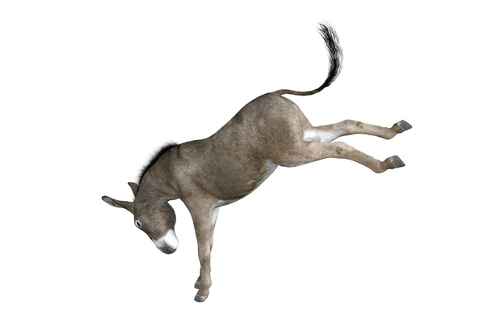

Jesus is in control our situation from start to finish.

“Have the same mindset as Christ Jesus:
Who, being in very nature God,
did not consider equality with God something to be used to his own advantage;
rather, he made himself nothing
by taking the very nature of a servant,
being made in human likeness.
And being found in appearance as a man,
he humbled himself
by becoming obedient to death—
even death on a cross!”
Philippians 2:5-8

“Now I saw heaven opened, and behold, a white horse. And He who sat on him was called Faithful and True, and in righteousness He judges and makes war.

His eyes were like a flame of fire, and on His head were many crowns. He had a name written that no one knew except Himself.

He was clothed with a robe dipped in blood, and His name is called The Word of God.

And the armies in heaven, clothed in fine linen, white and clean, followed Him on white horses.

Now out of His mouth goes a sharp sword, that with it He should strike the nations.

And He Himself will rule them with a rod of iron.

He Himself treads the winepress of the fierceness and wrath of Almighty God.

And He has on His robe and on His thigh a name written:
KING OF KINGS AND
LORD OF LORDS.”
Revelation 19:11-16

“The disciples went and did as Jesus had directed them. They brought the donkey and the colt and put on them their cloaks, and he sat on them. Most of the crowd spread their cloaks on the road, and others cut branches from the trees and spread them on the road. And the crowds that went before him and that followed him were shouting, ‘Hosanna to the Son of David! Blessed is he who comes in the name of the Lord! Hosanna in the highest!’ And when he entered Jerusalem, the whole city was stirred up, saying, ‘Who is this?’ And the crowds said, ‘This is the prophet Jesus, from Nazareth of Galilee.”
Matthew 21:7-11

- The crowds received Jesus as King . . . for now.

“Hosanna” comes from the Hebrew term meaning “please save”
They didn’t want the donkey riding humble Messiah –
they wanted the white horse sword wielding Messiah.

We need a suffering, sacrificial, substitutionary death, life giving
Messiah to save us from our sins first.

