For any action or endeavor in the Christian life to have true spiritual significance and impact – it must be covered by strategic prayer.

Praying With Purpose
Nehemiah 1:4-11

“As soon as I heard these words I sat down and wept and mourned for days, and I continued fasting and praying before the Lord God of heaven.”
Nehemiah 1:4

Why pray first and not last?

- I cannot pray and work at the same time.

- I cannot pray and worry at the same time.

“Do not be anxious about anything, but in everything by prayer and supplication with thanksgiving let your requests be made known to God. And the peace of God, which surpasses all understanding, will guard your hearts and mind in Christ Jesus.”
Philippians 4:6-8

“Knees don’t knock as much when we kneel with them.”

- I cannot pray and stay the same at the same time.

- I cannot pray and then not act in faith over time.

“As soon as I heard these words I sat down and wept and mourned for days, and I continued fasting and praying before the Lord God of heaven.”
Nehemiah 1:4

Nehemiah prays no less than 11 times in 13 chapters
(1:5-11; 2:4; 4:4, 9; 5:19; 6:9, 14; 13:14, 22, 29, 31)

Elements of effective prayer . . .

- Adoration

“And I said, ‘O Lord God of heaven, the great and awesome God who keeps covenant and steadfast love with those who love him and keep his commandments. let your ear be attentive and your eyes open, to hear the prayer of your servant that I now pray before you day and night for the people of Israel your servants,”
Nehemiah 1:5-6
Because
God is bigger than the boogie man
He's bigger than Godzilla, or the monsters on TV
Oh, God is bigger than the boogie man
And He's watching out for you and me
- Confession

“confessing the sins of the people of Israel, which we have sinned against you. Even I and my father's house have sinned. We have acted very corruptly against you and have not kept the commandments, the statutes, and the rules that you commanded your servant Moses.”
Nehemiah 1:6-7

- Thanksgiving (Confirmation)

“Remember the word that you commanded your servant Moses, saying, ‘If you are unfaithful, I will scatter you among the peoples, but if you return to me and keep my commandments and do them, though your outcasts are in the uttermost parts of heaven, from there I will gather them and bring them to the place that I have chosen, to make my name dwell there.’ They are your servants and your people, whom you have redeemed by your great power and by your strong hand.”
Nehemiah 1:8-10

- Supplication

“O Lord, let your ear be attentive to the prayer of your servant, and to the prayer of your servants who delight to fear your name, and give success to your servant today, and grant him mercy in the sight of this man.”
Nehemiah 1:11

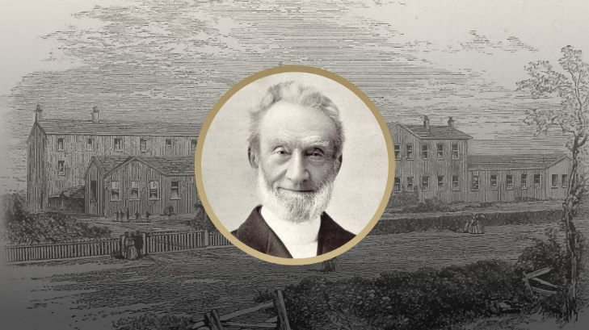

“This is the confidence which we have before Him, that, if we ask anything according to His will, He hears us. And if we know that He hears us in whatever we ask, we know that we have the requests which we have asked from Him . . .”
1 John 5:14,15

