Life is a combination of both blessings and burdens . . .

Faith filled hope and practical living in a messed up world.

What are we going to do when opposition arises?

The Sheep Gate . . .

- At the northern most tip of the city – which was also the highest point in Jerusalem.

- The animals that were to be sacrificed at the temple were brought into the city through this gate.

- It was the closest gate to the temple.

- This gate is a symbol of the cross.

- There is no rebuilding in your life unless you come to the Sheep Gate.

- There is no restoration in your life unless you deal with the sin issues and recognize that you need a Savior who was your sacrifice.

- There is no renewal in your life unless you come through that first gate – the gate of sacrifice where you can be cleansed by the blood of Jesus.

- It was repaired differently than all the other gates.

“they consecrated it and set its doors.”
Nehemiah 3:1

“consecrate” means “to set
something aside for a unique task.”

- When the Sheep Gate was consecrated – the whole wall was clean and holy.

- Once you are cleansed – you are entirely cleansed – not just partly.

“set its doors, its bolts, and bars.”

The door to salvation is ever open to any sinner!

“And next to him”
Nehemiah 3:2

“And next to them”
“Next to him”
“After them”
“After him”

None of us were meant to live to ourselves.

We need each one another.

Disunity is one of the most effective tools of Satan and discouragement in the church today.

This is the church – everybody next to somebody doing something important
with the goal of advancing the kingdom.

Within the church
unity is essential but individuality is valued.

Within the body of Christ –
we don’t all have the same role,
but we all have some role.

In the church
we must work towards building a culture where not only does everyone count,
but everyone also contributes.

When we refuse to serve others,
we end up robbing others.

“And next to them the Tekoites repaired, but their nobles would not stoop to serve their Lord.”
Nehemiah 3:5

Is there something that needs to be done –
respond to the need.

If you serve only according to your passion and not according to need,
you’re only serving yourself.

“Now when Sanballat heard that we were building the wall, he was angry and greatly enraged, and he jeered at the Jews.”
Nehemiah 4:1
“And he said in the presence of his brothers and of the army of Samaria, ‘What are these feeble Jews doing? Will they restore it for themselves? Will they sacrifice?”
Nehemiah 4:2

“’Will they revive the stones out of the heaps of rubbish, and burned ones at that?’”
Nehemiah 4:2

God can and likes to use broken stones – rejected stones - for His glory.

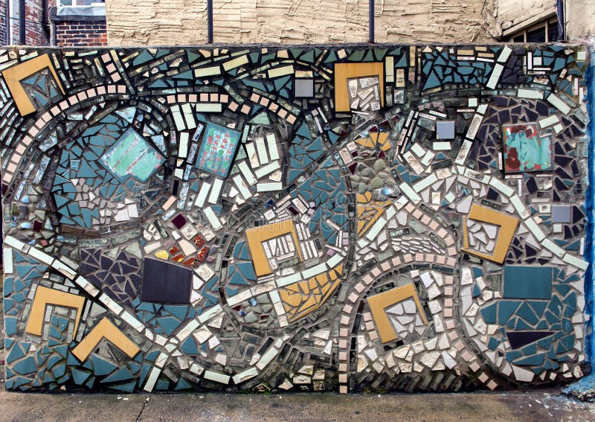

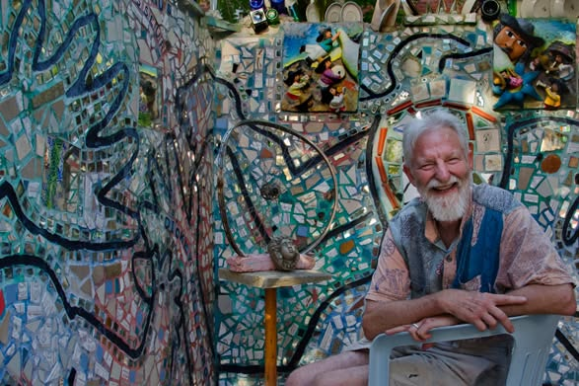

“And he said in the presence of his brothers and of the army of Samaria, ‘What are these feeble Jews doing? Will they restore it for themselves? Will they sacrifice? Will they finish up in a day? Will they revive the stones out of the heaps of rubbish, and burned ones at that?’ Tobiah the Ammonite was beside him, and he said, ‘Yes, what they are building—if a fox goes up on it he will break down their stone wall!’”
Nehemiah 4:2-3
Critics . . .

- Always criticize the character of others.

- Always question your staying power.

- Always mock your enthusiasm and your optimism.

- Always magnify your problems.

- Always try to eat away at your confidence.

- Are always resistant to change – even change that leads to progress and growth.

- Are always content with the status quo – the way things are.

- Always run in packs like wolves or wild dogs – critics run with critics.

