“For something to be so clearly God’s will for my life – why am I so bad at it?”

For most of us the spiritual discipline of prayer is one of the most disheartening activities in the Christian life – and yet is there an activity that is more necessary and indispensable in the Christian life?

The Delight and Duty of the Disciples Prayer
Matthew 6:1-13
Luke 11:1-4

“Lord, teach us to pray.”
Luke 11:1

Jesus didn’t teach the disciples . . .
how long their prayers should be
at what time of day they should pray
how many times each day they should pray
what they should feel as they pray
whether they should be standing or sitting or kneeling
if they should close their eyes and fold their hands
whether they should lift their hands and eyes to heaven

Jesus was most concerned with WHAT they prayed, more than with when or where or for how long.

Two most important things:

- We must not neglect to pray.

- We need to pray about what Jesus told us to pray about.

Jesus wants to make sure we are praying for the right reasons
from the right heart.

What better way to look impressive before others than to be spiritually impressive?

“And when you pray . . .”
Matthew 6:5

Prayer is for everyone who is a true follower of God.

You can’t be a Christian and not pray.

There are two big no-no’s (Jesus said so) when it comes to how we pray:

- Don’t be like the hypocrites.

“When you pray, you must not be like the hypocrites. For they love to stand and pray in the synagogues and at the street corners, that they may be seen by others. Truly, I say to you, they have received their reward. But when you pray, go into your room and shut the door and pray to your Father who is in secret. And your Father who sees in secret will reward you.”
Matthew 6:5–6

hypokrites means “play actor”
someone who puts on a mask and plays a part, someone who pretends to be something he is not

Hypocrites profess to believe one thing
but actually live a completely different way.

Professing one thing in public
but living a different way in private is hypocrisy.

Jesus’ warning –
being spiritually impressive in public more than being genuinely spiritual in private is hypocrisy.

Beware of spiritual professionalism.

Prayer is matter of faith between you and the Lord.

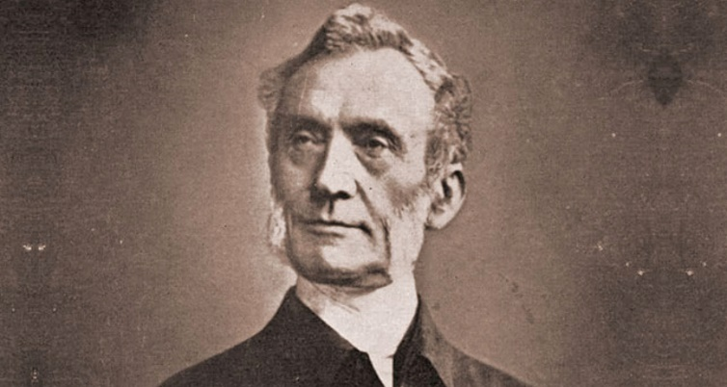

Mueller had over fifty thousand specific recorded answers to prayers in his journals, thirty thousand of which he said were answered the same day or the same hour that he prayed them.

Five hundred definite answers to prayer each year—more than one per day—every single day for sixty years!

God funneled over half a billion dollars (in today’s dollars) through his hands in answer to prayer.

- Don’t be like the pagans.

“And when you pray, do not heap up empty phrases as the Gentiles do, for they think that they will be heard for their many words. Do not be like them, for your Father knows what you need before you ask Him.”
Matthew 6:7–8

battalogeo means to heap up empty phrases or to keep on babbling.

“When you pray, don’t babble on and on as the Gentiles do. They think their prayers are answered merely by repeating their words again and again.”
Matthew 6:7 (NLT)

The goal in prayer is not the completion of some mechanical ritual.

You don’t get extra credit for adding extra words.

Prayer is not a formula.
Prayer is not an incantation.
Prayer is not a recipe.
Prayer is a relationship.

“As midday passed, they raved on until the time of the offering of the oblation, but there was no voice. No one answered; no one paid attention.”
1 Kings 18:29

“O Lord, God of Abraham, Isaac, and Israel, let it be known this day that you are God in Israel, and that I am your servant, and that I have done all these things at your word.”
1 Kings 18:36

“Answer me, O Lord, answer me, that this people may know that you, O Lord, are God, and that you have turned their hearts back.”
1 Kings 18:37

At the heart of praying in the right way is understanding that our God is not hard of hearing, and He is not hard of heart.

Speak to Him.

Shoot straight with Him.

Be plain with Him.

You don’t need to impress Him.

You just need to show up and talk to Him.

