By Faith
Hebrews 11

“Now faith is the assurance of things hoped for, the conviction of things not seen . . . And without faith it is impossible to please Him, for whoever would draw near to God must believe that He exists and that He rewards those who seek Him.”
Hebrews 11:1, 6

What is faith?
What difference does it make in my life?



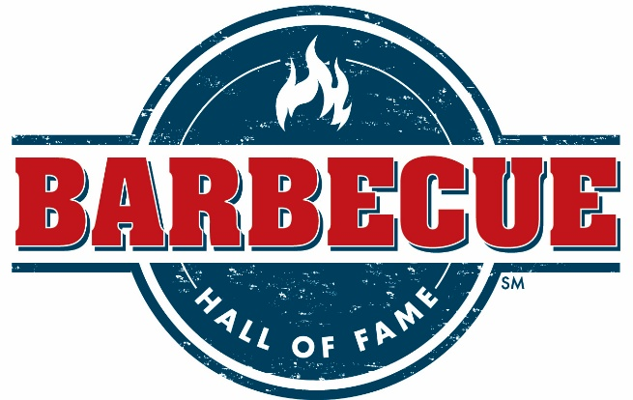



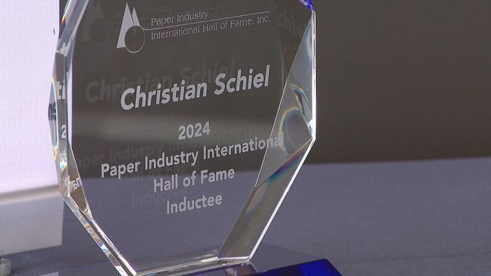

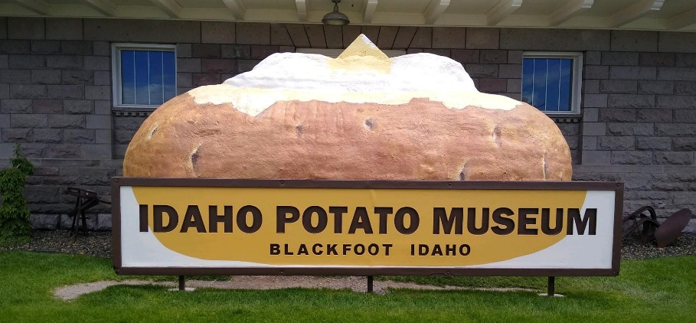

Potato Hall of Fame



God is real.
He keeps His promises.
Seeking Him is way worth the effort.

Faith is man’s response to what God has said.

Initial genuine faith in Christ always leads to living by faith for Christ.

By faith it is undeniable that God can be trusted even when He compels me to do something or walks me through something that is unexplainable.



Three types of faith described in the Bible:

- Saving faith
Jesus died as a sinless man for sinful man.

Just because Christ died for us – and rose for us –
we do not receive His mercy and forgiveness automatically.
We must receive it intentionally.

“because, if you confess with your mouth that Jesus is Lord and believe in your heart that God raised him from the dead, you will be saved. For with the heart one believes and is justified, and with the mouth one confesses and is saved.”
Romans 10:9-10

- The Gift of faith

“. . . to another faith by the same Spirit . . .”
2 Corinthians 12:9

- Living by faith – Hebrews 11

Many folks claim to have saving faith but in reality it was a false profession of faith.

A genuine saving faith always leads to an authentic living faith.

If your understanding of the Gospel is . . .
“I believe in God, therefore I can do whatever I want to.”
You don’t really understand the Gospel.

Your faith in God is not genuine if it is not life changing.
“by faith” was their motto and mantra for life.
From the text:

- Living faith makes us a hopeful people.

“Now faith is the assurance of things hoped for . . .”
Hebrews 11:1

Faith gives present assurance to a future hope.

It’s the conviction that God is telling the truth and adjusting our lives accordingly.

“assurance” also translated “being sure” – means “that which goes underneath something which causes or makes it to stand.”

Faith is to the Christian what a foundation is to a house.

“hope” means the exact opposite of despair – to wait for something with confidence and assurance.

“We have this as a sure and steadfast anchor of the soul . . .”
Hebrews 6:19

- Living faith involves seeing what is unseen.

“Now faith is . . . the conviction of things not seen.”
Hebrews 11:1

Faith is spiritual sight!
Living faith sees what others do not see.

“conviction” or “certain” means “evidence and proof”

If you can see it, then it’s not faith
“We live by faith, not by sight.”
2 Corinthians 5:7

Which statement best describes you at the present?
I need to have saving faith in the Lord Jesus Christ.
I want to grow in my living faith for the Lord Jesus Christ.

I cannot wait to see how far faith in Christ will take us!!

