1 Corinthians 13 is known as the ______________ chapter.

Genesis 1:1 says _____________________.

Exodus 20 contains the __________________________.

We all know the first verse (and probably all the verses) of Psalm 23 ___________________________________.

By Faith
Hebrews 11:1-3

We have learned that . . .

- Faith is the foundation that gives strength to your hopes.

- Faith is a deep conviction in your heart concerning realities that you cannot see.

- You cannot become a Christian without saving faith.

- Genuine saving faith leads to an authentic living faith.

- Uncommon faith can be demonstrated by common (ordinary) people.

“Lord, teach us to pray.”
Luke 11:1

“Lord, increase our faith.”
Luke 17:5

“The more skeptical and materialistic our world becomes, the more outlandish the person of faith will be. How strange it will seem to take God at His word, believe in the unseen, and invest in eternity. A true believer feels supreme love for One whom he has never seen, talks familiarly to every day to Someone he cannot see, and has hope in promise yet unfulfilled.”
A.W. Tozer in The Root of Righteousness

Areas in which we must practice faith:
- When praying for the salvation of a spouse, child, co-worker, friend.
- When praying for a prodigal child to return home.
- When the unknown or the unexpected rears its ugly head.
- When you are lonely.
- When you are overwhelmed in life.
- When you are considering a job change.
- When you feel God is distant.
- When your prayers are not being answered.
- When you don’t feel hopeful.
- When you are standing against the world.
- When temptation comes.
- When decisions need to be made.
- When you are giving sacrificially to the church.
- When you are anxious or worried.
- When stepping into the unknown.
- When you need courage and strength.
- When you are sick.
- When you are struggling financially.
- When death comes knocking at your door.

From the text:

- Many Old Testament believers got an “A” in faith – 11:2

“people of old” - “ancients” - “elders”

‘people of old’ refers to those people in the Old Testament who took God at His word and bet their lives on it, and the author of Hebrews wrote to tell us about.

“commended” - means to give a good report

They were not commended for being faultless but for their faith.

God is never looking for faultless lives – but lives lived by faith.

So what pleases God?

It is not sinless saints but saints that are sure that God exists – that His promises are true – and that He rewards those who seek Him.

“commended” - means affirmation or validation

Sometimes God affirmed and validated their faith as . . .
they walked through fire unharmed,
slept through the night next to hungry lions,
knocked down giants with slingshots
and parted oceans down the middle.

James (brother of John): Beheaded by King Herod Agrippa I.
Peter: Crucified upside down in Rome.
Andrew: Crucified on an X-shaped cross in Greece.
Philip: Stoned to death in North Africa.
Bartholomew: Flayed alive.
Thomas: Speared to death in India.
John: Exiled to the island of Patmos.
Judas (not Iscariot): Stoned to death.
Matthew: Stabbed to death in Ethiopia.
James (son of Zebedee): Beheaded.
James (son of Alphaeus): Stoned and clubbed to death.
Matthias: Burned to death.
Simon (the Zealot): Cut in half.
Paul: Beheaded in Rome.

Living by faith does make you exempt from hard things
but endurance to walk through the hard things.

Faith is not just trusting in the end result – but whatever result God gives or allows.

- The first “By faith” . . . creation – 11:3

“Faith is not limited to things present but invisible or to things future and unknowable but also necessary to take God at His word regarding things past and unobservable.”
Chuck Swindoll

“Ah, Sovereign LORD, you have made the heavens and the earth by your great power and outstretched arm. Nothing is too hard for you.”
Jeremiah 32:17

“By the word of the LORD the heavens were made, and by the breath of His mouth all their host ... For He spoke, and it was done; He commanded, and it stood fast.”
Psalm 33:6,9

We have the Word – the Bible – which records His Words!

Truth is the basis for trust.

If you doubt the truth of God’s Word, including His promises for the future, you cannot trust Him and you will be distant from Him.

The people of old believed what God said was trustworthy because God Himself is trustworthy.

creation ex nihilo - meaning that when God created the universe, He did so using nothing because there was nothing, except for God.

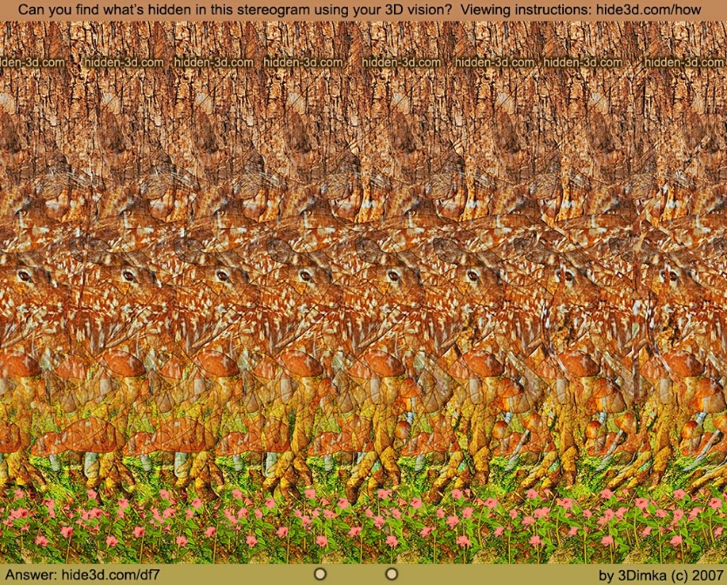

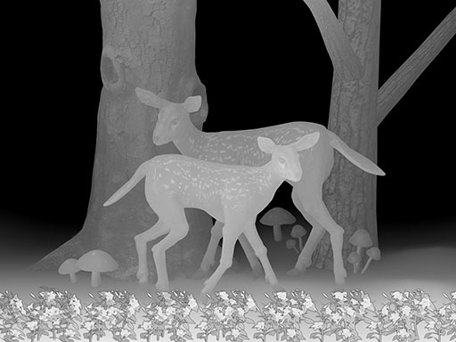

“For the scientist who has lived by his faith in the power of reason, the story ends like a bad dream. He has scaled the mountains of ignorance, he is about to conquer the highest peak; as he pulls himself over the final rock, he is greeted by a band of theologians who have been sitting there for centuries.”
Robert Jastrow in God and the Astronomers

