By Faith
Hebrews 11:23
Exodus 2:1-10

Every choice you make in life has significant consequences.

Did you know that . . .

- In 1920, the management of the Boston Red Sox made the choice to sell a young player to the New York Yankees.


Babe Ruth!

- In 1938, Joe Schuster and Jerry Siegel sold all their rights for a comic book character that they had invented for $130.


Superman!

- In 1955, Sam Phillips sold to RCA Victor Records his exclusive contract to a young singer.

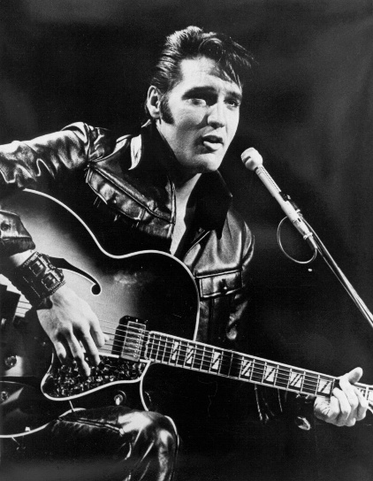
Elvis Presley!

“By faith Moses, when he was born, was hidden for three months by his parents, because they saw that the child was beautiful, and they were not afraid of the king's edict.”
Hebrews 11:23

Even if you have messed up as a parent – God is bigger than your failures.

Living by faith in God . . .

- Moves you to make courageous decisions – 2:1-2

Parents . . . You cannot give what you do not have.

“Hear, O Isreal: The LORD our God, the Lord is one. You shall love the Lord your God with all your heart and with all your soul and with all your might. And these words that I command you today shall be on your heart. You shall teach them diligently . . .”
Deuteronomy 6:4-7

“I am reminded of your sincere faith, a faith that first dwelt in your grandmother Lois, and your mother Eunice, and now, I am sure, dwells in you as well.”
2 Timothy 1:5

“Train up a child in the way of the Lord and when he is old he will not depart from it.”
Proverbs 22:6

Parents and grandparents – do your children and grandchildren see faith in you?

Do they see you taking courageous steps of faith?

Do they see faith directing your time – energy – thoughts – money?

- Means that you will protect your sons and daughters – 2:2

Don’t be afraid to guard what they hear and say.

Make sure you guide their hearts and minds to an understanding of sin and grace.

Determine to give Biblical answers when they are young to all of life’s questions.

“When you walk – they will lead you. When you lie down, they will watch over you; and when you awake, they will talk to you. For the commandment is a lamp and the teaching a light and the reproofs of discipline are the way of life.”
Proverbs 6:22:23

“If you will but train your children up in the way of the Lord, though later on they may drift from it as kids often do, at some point in life that training, those prayers, that hope, that commitment, will be like arms of love, reaching across the years and decades, bringing at last those children back to God.”

- Is not passive fatalism but proactive action (faith and planning) – 2:3-8

“When a man’s ways are pleasing to the Lord, He makes even his enemies to live at peace with Him.”
Proverbs 16:7

Parents . . . Practical actions are not a lack of faith.

We walk in faith - but we still have to walk.

Moms . . . Your child/children desperately need your nurture, support, and attention.

- Acts and then trusts God with the results – 2:10

There is a time to train up your children and a time to let go
and trust God with your children.

Parents . . . Give your child a firm foundation to stand upon but then be willing to let them go.

“By faith Moses, when he had grown up, refused to be called the son of Pharaoh’s daughter.”
Hebrews 11:24

The Nile – a place of drowning became a place of deliverance.

“this Jesus, delivered up according to the definite plan and foreknowledge of God, you crucified and killed by the hands of lawless men. God raised Him up, loosing the pangs of death, because it was not possible for him to be held by it.”
Acts 2:23

“works all things according to the counsel of His will.”
Ephesians 1:11

