By Faith
Hebrews 11:7

In what areas of your life are you stepping out in faith?

In what areas of your life are you resting in faith?

What faith choices have you made this week and how have those choices affected others?

“By faith Noah, when warned about things not yet seen, in holy fear built an ark to save his family. By his faith he condemned the world and became heir of the righteousness that comes by faith.”
Hebrews 11:7

We resent the warnings of God because it means . . .
- we must change our course of action.
- we must give up something we presently enjoy doing.
- we must do something we have not been doing at present.

How do we properly respond – pay attention to – take notice of – listen to and act upon the warnings of God?

- You have to view God in the right way.

- God’s warnings are meant for your good.

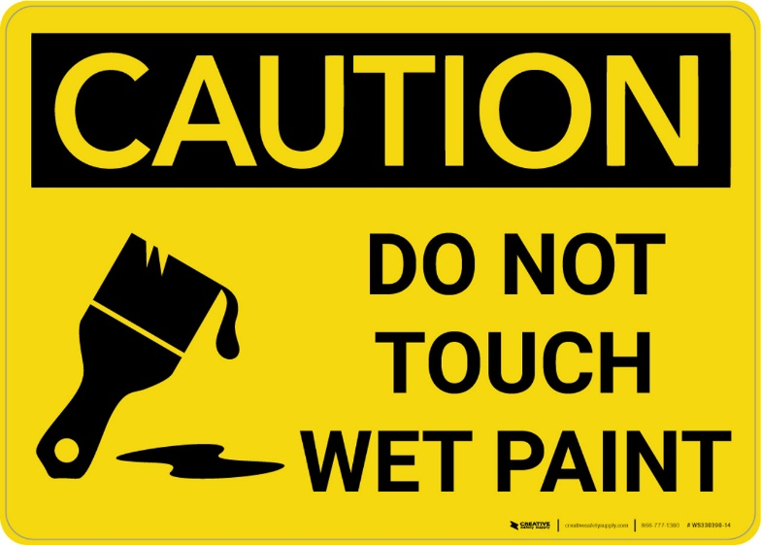

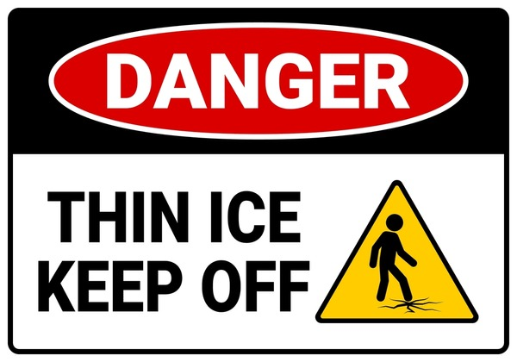

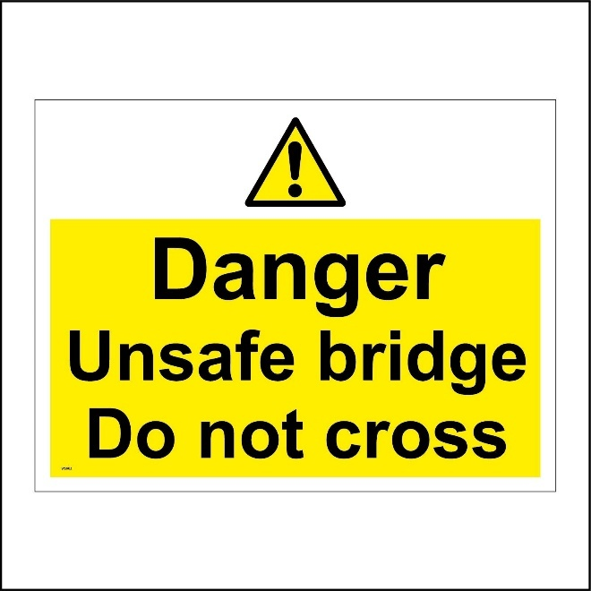

- God’s warnings are based on God’s knowledge and God’s goodness.

Do you trust God’s knowledge, and do you trust God’s motivation?

Do you believe that God knows everything, and do you believe that God is on your side?

“All Scripture is God-breathed and is useful for teaching, rebuking, correcting and training in righteousness.”
2 Timothy 3:16

“in holy fear”

“holy fear” is a single word which means “to be moved with reverence, awe and respect.
Why should you treat God with reverence, awe and respect?

- God is awesome.

“For the Lord Most High is awesome,
the great King over all the earth.”
Psalm 47:2

- God is sovereign.

“Our God is in heaven; He does whatever He pleases.”
Psalm 115:3

- God is the all-knowing judge.

“Nothing in all creation is hidden from God’s sight. Everything is uncovered and laid bare before the eyes of him to whom we must give account.”
Hebrews 4:13

“Do not be deceived: God cannot be mocked. A man reaps what he sows. The one who sows to please his sinful nature, from that nature will reap destruction; the one who sows to please the Spirit, from the Spirit will reap eternal life.”
Galatians 6:7

- God has the power to throw you into hell.

“I tell you, my friends, do not be afraid of those who kill the body and after that can do no more. But I will show you whom you should fear: Fear him who, after the killing of the body, has power to throw you into hell. Yes, I tell you, fear him.”
Luke 12:4-5

- God is the giver of life, and He is the taker of life.

“I am going to put an end to all people, for the earth is filled with violence because of them. I am surely going to destroy both them and the earth.”
Genesis 6:13

“warned about things not yet seen.”

Just because something is in the future did not make it any less real.

- You have to trust God as you do things His way.

You have to move from attitude to action.
“built an ark.”

What is the appropriate action when God is about to flood the world?
Build a boat!!

- We must follow God’s instructions exactly.

“Noah did everything just as God commanded him.”
Genesis 6:22

“And Noah did all that the LORD commanded him.”
Genesis 7:5

Genuine faith requires full obedience and not partial obedience.

Partial obedience is disobedience.

God never tells you to do something without a reason.
If God gives you a warning in Scripture, it is there for your good.
When God gives you certain instructions,
He means for you to follow them.

Noah built the ark - what action do you need to take today?

“The man of integrity walks securely, but he who takes crooked paths will be found out.”
Proverbs 10:19

“Marriage should be honored by all, and the marriage bed kept pure, for God will judge the adulterer and all the sexually immoral.”
Hebrews 13:4

“Discipline your child, for in that there is hope; do not be a willing party to his death.”
Proverbs 19:18

“Those who lead blameless lives and do what is right,
speaking the truth from sincere hearts.
Those who refuse to gossip
or harm their neighbors
or speak evil of their friends.”
Proverbs 15:2-3

“For the love of money is a root of all kinds of evils. It is through this craving that some have wandered away from the faith and pierced themselves with many pangs."
1 Timothy 6:10
What are the results when we take God’s warnings seriously?

- You will stick out like a sore thumb.

- You will cause others to recognize that they are condemned without faith.

“By his faith Noah condemned the world”

When you make the right choices in life, it only highlights the wrong choices of others.

“a preacher of righteousness”
2 Peter 2:5

The world does not like to be
reminded about God’s warnings.

The world does not like to be
reminded of human accountability to God.

“If the world hates you, keep in mind that it hated me first. If you belonged to the world, it would love you as its own. As it is, you do not belong to the world, but I have chosen you out of the world. That is why the world hates you.”
John 15:18-19

- You graciously receive the great benefit from God.

“became heir of the righteousness that comes by faith.”

Lessons learned . . .

- God judges sin.

- Even in judgment, God displays His grace.

- The ark points to Jesus – He is our covering – He is the ark of salvation.

“Christ Jesus is our ark now: big enough for the whole world, strong enough to withstand the shocks of life, the rising waters of death, and the upheavals of the last judgment. There is safety here in the Son of God, sent to be for us all the shelter, the salvation, that we so desperately needed; our ark and safe passage into the new world God has planned. From that ark we will emerge to inherit a new heaven and a new earth.”
Peter Lewis

“I am the way, the truth and the life. No one comes to the Father except through me.”
John 14:6

“For the wages of sin is death, but the gift of God is eternal life in Christ Jesus our Lord."
Romans 6:23

“Just as it was in the days of Noah, so also will it be in the days of the Son of Man. People were eating, drinking, marrying and being given in marriage up to the day Noah entered the ark. Then the flood came and destroyed them all.”
Luke 17:26-27

