“There are three stages in most great tasks undertaken for God:
Impossible . . . Difficult . . . Done.”
J. Hudson Taylor

When A Wall Is An Opportunity For Faith
Instead Of An Obstacle of Fear
Hebrews 11:30
Joshua 6

“When you pass through the waters, I will be with you; and when you pass through the rivers, they will not sweep over you.”
Isaiah 43:2

“I want to remind you that the Lord delivered his people out of Egypt but later destroyed those who did not believe.”
Jude 5

“They did not believe in God or trust in his deliverance.”
Psalm 78:22

“By faith the walls of Jericho fell,
after the people had marched around them for seven days.”
Hebrews 11:30

Jericho . . .
- had two walls, an inner wall and an outer wall, both built on a slope, making it virtually impregnable to any attacking army.

- the outer wall was some 12-15 feet high - on top was a mudbrick wall 6 feet thick and about 20-26 feet high - in front of the outer wall was a roughly 46-foot-high embankment.

- 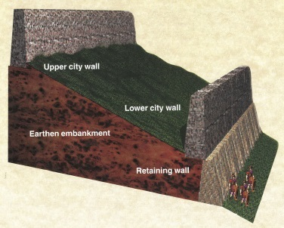

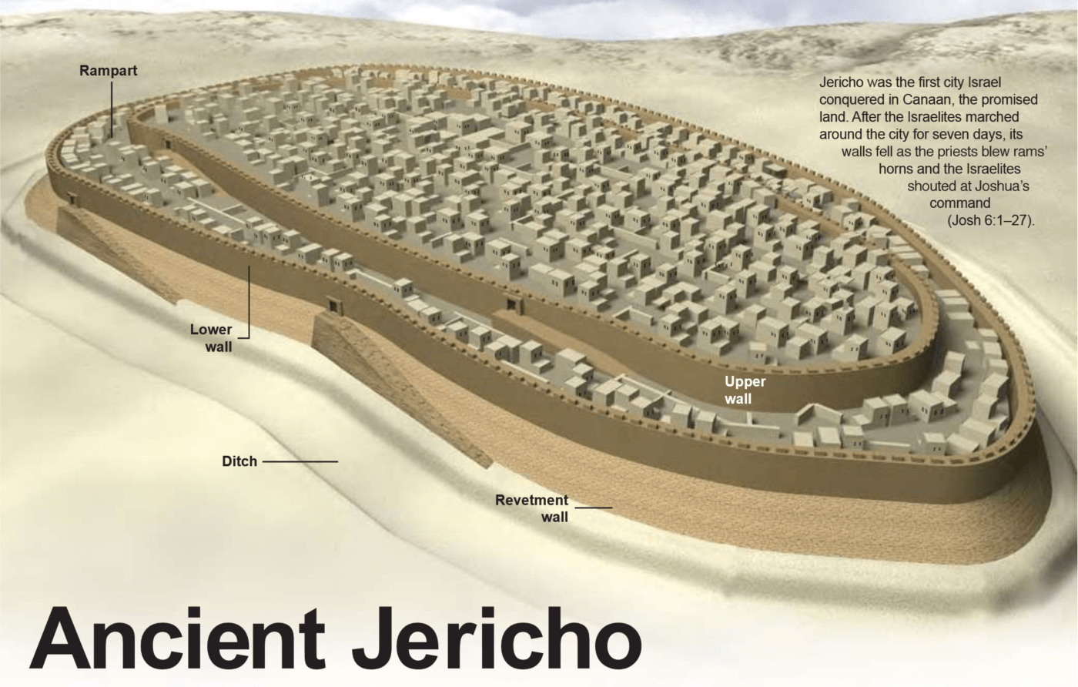

- was prepared for a siege – having a fresh spring inside the walls – harvest had just taken place as well.

From an earthly perspective the battle
seemed to be over before it started.

Truths to consider . . .

- The greater the odds against you means the greater the opportunity to show that God is for you.

“See, I have delivered Jericho into your hands, along with its king and its fighting men.”
Joshua 6:2

“What is impossible with men is possible with God.”
Luke 18:27

Don’t look at the size of the obstacle – look at the size of your God.

- Faith in God’s plan will sometimes cause people to say – “Say What?”

- March around the town once a day for six days (6:3)
- March with the Ark of the Covenant (6:4)
- Put seven priests in front of the Ark (6:4)
- On the seventh day march around Jericho seven times (6:5)
- Have the priests blow rams’ horns as they march (6:5)
- On the seventh time around on the seventh day, have the people shout (6:5).
- When the people shout, the walls will come down (6:5)
- When the walls come down, enter the city and conquer it (6:5).

“The walls collapsed; so every man charged straight in, and they took the city.”
Joshua 6:20

- God Himself (His Word, His power, His promise) is the plan.

- God said He was going to give them the city before He gave them the plan – 6:2

“See, I have delivered Jericho into your hands, along with its king and its fighting men.”
Joshua 6:2

We live in the present – God lives in the present and future.

- God put Himself in the middle of the battle plan – 6:4

By faith means God first.

- Following God in faith does not mean doing nothing.

What was the real battle of Joshua 6?

The real battle of Jericho was not with the Canaanites.
The real battle was in the hearts of the people of God.
In the Hebrew language, Joshua means “God saves”.
In Greek it was shortened to “Jesus” or “Savior.”

