



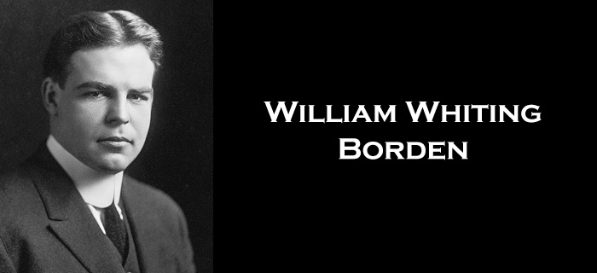

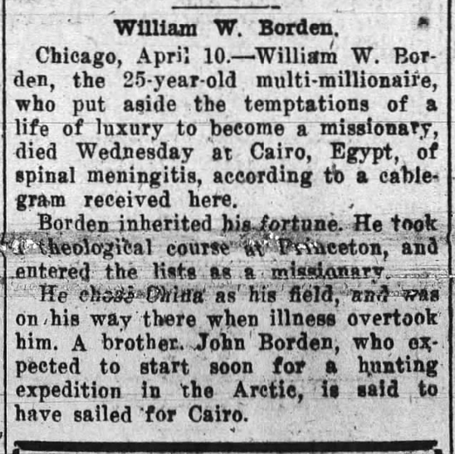

“No regrets. No remorse. No reserve.”

“Apart from faith in Christ, there is no explanation for such a life.”
On the tombstone of William Borden

What are you going to do with your life?
Are you going to use it in a way that only makes sense
if eternity is real and the gospel is true?

If Christ is risen, then nothing invested into His kingdom is ever wasted.
If He is risen, everything we invest anywhere else is.

All of us will end up somewhere in life.
Some of us will end up there on purpose.

Having a God-centered vision is the key to ending up where God wants us to end up.

“Where there is no vision – the people perish.”
Proverbs 29:18

A clear vision has the power to bring
what’s most important to the surface of your schedule and lifestyle.

A clear vision makes it easy to weed out of your life
those things that stand in the way of achieving what matters most.





A clear vision empowers you to move purposefully
in a predetermined direction.

“You are not your own; you were bought at a price. Therefore honor (glorify) God with your bodies.”
1 Corinthians 6:19-20

Honoring or glorifying God means discovering
His picture or vision of what our lives could and should be.

“For we are His workmanship, created in Christ Jesus for good works, which God prepared beforehand so that we would walk in them.”
Ephesians 2:10

“I am God’s workmanship.”

If you are a follower of Christ – you do not have the right to take your talents, abilities, experiences, resources, opportunities and education and do what you want to do.

When No Is Not An Option
Nehemiah 1:1-11
“The words of Nehemiah the son of Hacaliah. Now it happened in the month of Chislev, in the twentieth year, as I was in Susa the citadel”
Nehemiah 1:1

“that Hanani, one of my brothers, came with certain men from Judah. And I asked them concerning the Jews who escaped, who had survived the exile, and concerning Jerusalem.”
Nehemiah 1:2

His priorities in life went way beyond his day job.

Vision causes you to live for something bigger than yourself.

“And they said to me, ‘The remnant there in the province who had survived the exile is in great trouble and shame. The wall of Jerusalem is broken down, and its gates are destroyed by fire.’”
Nehemiah 1:3

“As soon as I heard these words I sat down and wept and mourned for days, and I continued fasting and praying before the God of heaven.”
Nehemiah 1:4

“I have been driven many times to my knees by the overwhelming conviction that I had nowhere else to go. My own wisdom and that of those around me seemed insufficient for the day.”
Abraham Lincoln

Because vison takes us beyond our human possibilities –
we must pray.

“And I said, ‘O Lord God of heaven, the great and awesome God who keeps covenant and steadfast love with those who love him and keep his commandments”
Nehemiah 1:5

“let your ear be attentive and your eyes open, to hear the prayer of your servant that I now pray before you day and night for the people of Israel your servants, confessing the sins of the people of Israel, which we have sinned against you. Even I and my father's house have sinned. We have acted very corruptly against you and have not kept the commandments, the statutes, and the rules that you commanded your servant Moses.”
Nehemiah 1:6-7

“Remember the word that you commanded your servant Moses, saying, ‘If you are unfaithful, I will scatter you among the peoples, but if you return to me and keep my commandments and do them, though your outcasts are in the uttermost parts of heaven, from there I will gather them and bring them to the place that I have chosen, to make my name dwell there.’ They are your servants and your people, whom you have redeemed by your great power and by your strong hand.”
Nehemiah 1:8-10

“O Lord, let your ear be attentive to the prayer of your servant, and to the prayer of your servants who delight to fear your name, and give success to your servant today, and grant him mercy in the sight of this man.”
Nehemiah 1:11

An assurance of who God is will enable us to ask God boldly to accomplish His work.

From the text to our lives . . .

- A God-centered vision will become a compelling unrelenting force in your life that you cannot deny or avoid.

“For the love of Christ controls us, because we have concluded this: that one has died for all, therefore all have died; and he died for all, that those who live might no longer live for themselves but for him who for their sake died and was raised.”
2 Corinthians 5:14,15

- A God-centered vision requires spiritual action first and practical action second.

Where are you presently going?
Where does God want you to go?
What will you do to get there?

