
Saint Andrew’s Anglican Church
email: standrewsanglican@windstream.net
Facebook: Saint Andrew’s Anglican Church, Douglas
Website: www.saintandrewsanglicandouglas.org

Bishop:
The Rt. Rev. Alex Farmer

Clergy
The Rev. Dr. James L. Guthrie, Jr., Interim Rector
The Rev. Chris Brown, Curate
The Rev. Robert Millott, Deacon
The Rev. Diane Millott, Deacon
The Rev. Bill McNeill, Deacon

Venmo @StAndrewsAnglicanChurch

Fourth Sunday After Pentecost
June 16, 2024
All baptized Christians who receive communion in their Church are welcome to receive Holy Communion regardless of denominational background. If you are unable to come forward, please speak to an usher and Communion will be brought to you. The bread is received in the open palm. The wine, can be taken by dipping the wafer and then placing it on your tongue. If you do not wish to receive the wine, simply cross your arms over your chest to indicate this.

Processional Hymn Jesus Lover of My Soul Hymn 699 Red Hymnal
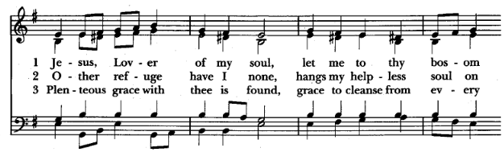
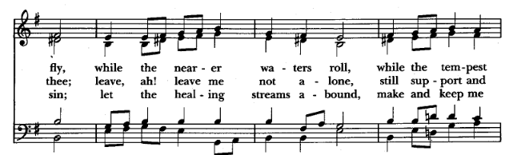
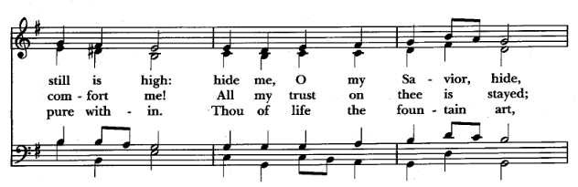
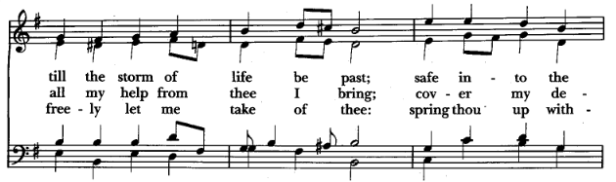
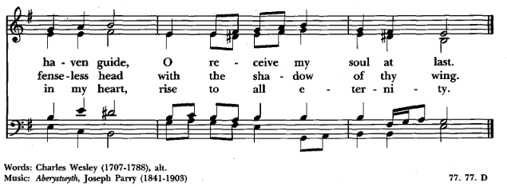

THE ACCLAMATION
The People standing, the Celebrant says this or a seasonal greeting (pages 145-146)
Celebrant Blessed be God, the Father, the Son and the Holy Spirit.
People And blessed be his kingdom, now and forever. Amen.

THE COLLECT FOR PURITY - said kneeling ACNA 2019 BCP page 124
The Celebrant prays (and the People may be invited to join)

Almighty God, to you all hearts are open, all desires known, and from you no secrets are hid: Cleanse the thoughts of our hearts by the inspiration of your Holy Spirit, that we may perfectly love you, and worthily magnify your holy Name; through Christ our Lord. Amen.

THE SUMMARY OF THE LAW - kneeling ACNA 2019 BCP page 124

Hear what our Lord Jesus Christ says:
You shall love the Lord your God with all your heart and with all your soul and with all your mind. This is the first and great commandment. And the second is like it: You shall love your neighbor as yourself. On these two commandments depend all the Law and the Prophets.
MATTHEW 22:37-40^{T}

THE KYRIE

Kyrie Sung using this form —kneeling
Lord, have mercy upon us,
Christ, have mercy upon us,
Lord, have mercy upon us.

Gloria in Excelsis Sung using this form —standing

Glory be to God on high, and on earth peace, good will toward men. We praise thee, we bless thee, we worship thee, we glorify thee, we give thanks to thee for thy great glory, O Lord God, heavenly King, God the Father Almighty. O Lord, the only begotten Son, Jesus Christ; O Lord God, Lamb of God, Son of the Father, that takest away the sins of the world, have mercy upon us. Thou that takest away the sins of the world, receive our prayer. Thou that sittest at the right hand of God the Father, have mercy upon us. For thou only art holy; Thou only art the Lord; Thou only, O Christ, with the Holy Ghost, art most high in the glory of God the Father. Amen.

THE COLLECT OF THE DAY

The Celebrant says to the People - congregation kneeling

The Lord be with you.
People And with your spirit.
Officiant Let us pray.

The Celebrant prays the Collect.

O Lord, from whom all good proceeds: Grant us the inspiration of your Holy Spirit, that we may always think those things that are good, and by your merciful guidance may accomplish the same; through Jesus Christ our Lord, who lives and reigns with you and the Holy Spirit, one God, for ever and ever. Amen.

THE LESSONS

One or more Lessons, as appointed, are read, the Reader first saying

A reading from:

Ezekiel 31:1-6(7-9)10-14

In the eleventh year, in the third month, on the first day of the month,
the word of the LORD came to me: 2 “Son of man, say to Pharaoh king
of Egypt and to his multitude: “Whom are you like in your greatness? 3 Behold, Assyria was a cedar in Lebanon, with beautiful branches and forest shade, and of towering height, its top among the clouds. 4 The waters nourished it; the deep made
it grow tall, making its rivers flow around the place of its planting, sending forth its streams to all the trees of the field. 5 So it towered high above all the trees of the field; its boughs grew large and its branches long from abundant water in its shoots. 6 All the birds of the heavens made their nests in its boughs; under its branches all the beasts of the field gave birth to their young, and under its shadow lived all great nations. ( 7 It was beautiful in its greatness, in the length of its branches; for its roots went down to abundant waters. 8 The cedars in the garden of God could not rival it, nor the fir trees equal its boughs; neither were the plane trees like its branches; no
tree in the garden of God was its equal in beauty. 9 I made it beautiful in the mass of its branches, and all the trees of Eden envied it, that were in the garden of God. )10 “Therefore thus says the LORD God: Because it towered high and set its top among the clouds, and its heart was proud of its height, 11 I will give it into the hand of a mighty one of the nations. He shall surely deal with it as its wickedness deserves. I have cast it out. 12 Foreigners, the most ruthless of nations, have cut it down and left it. On the mountains and in all the valleys its branches have fallen, and its boughs have been broken in all the ravines of the land, and all the peoples of the earth have gone away from its shadow and left it. 13 On its fallen trunk dwell all the birds of the
heavens, and on its branches are all the beasts of the field. 14 All this is in order that no trees by the waters may grow to towering height or set their tops among the clouds, and that no trees that drink water may reach up to them in height. For they are all given over to death, to the world below, among the children of man, with those who go down to the pit.

Reader: The Word of the Lord.
People Thanks be to God.

THE PSALM

Psalm 92

1 It is a good thing to give thanks unto the |LORD, *
and to sing praises unto your Name, O Most |High,
2 To tell of your loving-kindness early in the |morning, *
and of your faithfulness in the night |season,
3 Upon an instrument of ten strings and upon the |lute, *
with the sound of melody upon the |harp.
4 For you, LORD, have made me glad by your |deeds, *
and I will shout for joy because of your handi|work.
5 O LORD, how glorious are your |works; *
your thoughts are very |deep.
6 The dull of heart does not consider |this, *
and a fool does not understand |it:
7 Though the ungodly are as green as the grass, and though all the workers of wickedness |flourish, *
they shall be destroyed for ever; but you, LORD, are the Most High
for ever|more.
8 For lo, your enemies, O LORD, lo, your enemies shall |perish, *
and all the workers of wickedness shall be |destroyed.
9 But my horn shall be exalted like the horns of wild |bulls; *
for I am anointed with fresh |oil.
10 My eye also shall see its desire upon my |enemies, *
and my ear shall hear with joy the end of the wicked who rise up
against |me.
11 The righteous shall flourish like a palm |tree, *
and shall spread abroad like a cedar in |Lebanon.
12 Those who are planted in the house of the |LORD *
shall flourish in the courts of our |God.
13 They also shall bring forth fruit in their old |age, *
and shall be green and full of |sap,
14 That they may show how upright the LORD |is, *
my rock, in whom there is no un|righteousness.
Glory be to the Father, and to the ׀ Son‖
And to the Holy ׀ Ghost‖
As it was in the beginning is now and ever ׀ shall be‖
World without end׀ Amen‖

2 Corinthians 5:1-10

For we know that if the tent that is our earthly home is destroyed, we have a building from God, a house not made with hands, eternal in the heavens. 2 For in this tent we groan, longing to put on our heavenly dwelling, 3 if indeed by putting it on we may not be found naked. 4 For while we are still in this tent, we groan, being burdened—not that we would be unclothed, but that we would be further clothed, so that what is mortal may be swallowed up by life. 5 He who has prepared us for this very thing
is God, who has given us the Spirit as a guarantee.6 So we are always of good courage. We know that while we are at home in the body we are away from the Lord, 7 for we walk by faith, not by sight. 8 Yes, we are of good courage, and we would rather be away from the body and at home with the Lord. 9 So whether we are at home or
away, we make it our aim to please him. 10 For we must all appear before the judgment seat of Christ, so that each one may receive what is due for what he has done in the body, whether good or evil.

Reader: The word of the Lord.
People: Thanks be to God

Gospel Hymn Beneath the Cross of Jesus Hymn 498 Red Hymnal

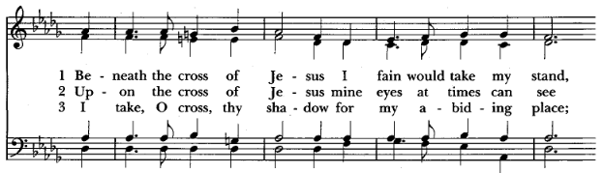
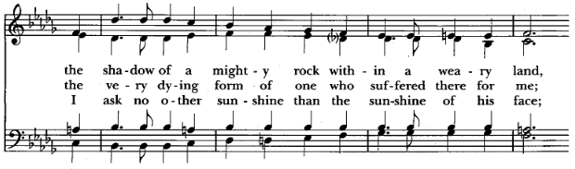
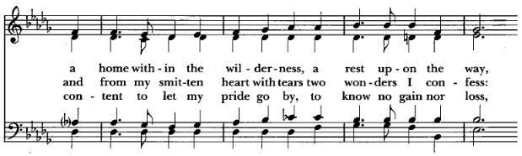
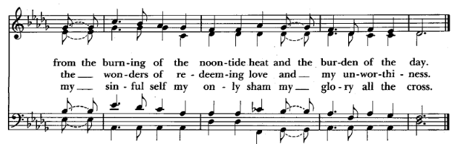

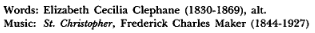

Deacon: The Holy Gospel of Our Lord Jesus Christ, according to St. Mark
People: Glory to you, Lord Christ.

Mark 4:26-34
And he said, “The kingdom of God is as if a man should scatter seed on the ground. 27 He sleeps and rises night and day, and the seed sprouts and grows; he knows not how. 28 The earth produces by itself, first the blade, then the ear, then the full grain in the ear. 29 But when the grain is ripe, at once he puts in the sickle, because the harvest has come.”30 And he said, “With what can we compare the kingdom of God, or what parable shall we use for it? 31 It is like a grain of mustard seed, which, when sown on the ground, is the smallest of all the seeds on earth, 32 yet when it is sown it grows up and becomes larger than all the garden plants and puts out large branches, so that the birds of the air can make nests in its shade.” 33 With many such parables he spoke the word to them, as they were able to hear it. 34 He did not speak to them without a parable, but privately to his own disciples he explained everything.

Deacon: The Gospel of the Lord.
People: Praise to you, Lord Christ

THE SERMON

THE NICENE CREED said Standing ACNA 2019 BCP p. 127

Let us confess our faith in the words of the Nicene Creed:

Celebrant and People

We believe in one God,
the Father, the Almighty,
maker of heaven and earth,
of all that is, visible and invisible.

We believe in one Lord, Jesus Christ,
the only-begotten Son of God,
eternally begotten of the Father,
God from God, Light from Light,
true God from true God,
begotten, not made,
of one Being with the Father;
through him all things were made.
For us and for our salvation he came down from heaven,
was incarnate from the Holy Spirit and the Virgin Mary,
and was made man.
For our sake he was crucified under Pontius Pilate;
he suffered death and was buried.
On the third day he rose again in accordance with the Scriptures;
he ascended into heaven
and is seated at the right hand of the Father.
He will come again in glory to judge the living and the dead,
and his kingdom will have no end.

We believe in the Holy Spirit, the Lord, the giver of life,
who proceeds from the Father [and the Son],
who with the Father and the Son is worshiped and glorified,
who has spoken through the prophets.
We believe in one holy catholic and apostolic Church.
We acknowledge one Baptism for the forgiveness of sins.
We look for the resurrection of the dead,
and the life of the world to come. Amen.

THE PRAYERS OF THE PEOPLE - All kneeling ACNA 2019 BCP page 128

The Deacon or other person appointed says these prayers, or the Prayers of the People in the Anglican Standard Text. The reader pauses after each bidding, and the people may add petitions, either silently or aloud.

Let us pray for the Church and for the world, saying, “hear our prayer.”

For the peace of the whole world, and for the well-being and unity of the people of God.

For Foley., our Archbishop, and Alex., our Bishop, and for all the clergy and people of our Diocese and Congregation. In the Diocesan cycle of prayer, we pray for Servants of Christ, Gainesville, Florida; Resurrection Anglican, Shalimar, Florida; other clergy John Commins and Marios Tsangarides.

Almighty God, giver of every good gift: Look graciously on your Church, and so guide the minds of those who shall choose an Archbishop for the Anglican Church in North America, that we may receive a faithful pastor who will preach the Gospel, care for your people, equip us for ministry, and lead us forth in fulfillment of the Great Commission; through Jesus Christ our Lord. Amen.

For all those who proclaim the Gospel at home and abroad; and for all who teach and disciple others.

For our brothers and sisters in Christ who are persecuted for their faith.

For our nation, for those in authority, and for all in public service especially Joseph our President.

For all those who are in trouble, sorrow, need, sickness, or any other adversity especially Jake, Stone, Leila, Cleary, John, Jennifer and Christy, Elaine Hinson, Daniel Robinson, Kim Fry, Susanne Sawyer, Jimmy Stewart, Leo Barnes, Ben Walls, Mark Limbird, Jessica Porter, Eric Bruner, Patricia Thompson, Sam and Sandy DeCasper, Lindsey, Jana Burke, Brenda Meritt, Laris Browning, Philip Groom, C J Morris, Barbara Patton, Tyler Kidd, Katherine Gaskins, The Scheoler Family, Kaitlyn Diaz, Gray and Teri Stephenson, The Royal Family, Connie, Doug Campbell, Christopher Barnes, The Gabbard Family for all who protect our freedoms at home and abroad, and all first responders.

For all those who have departed this life in the certain hope of the resurrection, in thanksgiving let us pray.

Additional petitions may be added. Thanksgivings may also be invited.
The celebrant adds a concluding collect

The Confession and Absolution of Sin All kneeling ACNA 2019 BCP p. 130

Most merciful God, we confess that we have sinned against you in thought, word, and deed, by what we have done, and by what we have left undone. We have not loved you with our whole heart; we have not loved our neighbors as ourselves. We are truly sorry and we humbly repent. For the sake of your Son Jesus Christ, have mercy on us and forgive us; that we may delight in your will, and walk in your ways, to the glory of your Name. Amen.

The celebrant pronounces absolution and comfortable words

The Peace all standing ACNA 2019 BCP p. 131

Celebrant The Peace of the Lord be always with you.
People And with your spirit.

Then the Ministers and People may greet one another in the Name of the Lord.

THE OFFERTORY Come Thou Fount Hymn 11 Blue Hymnal

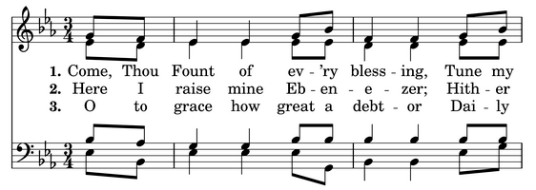
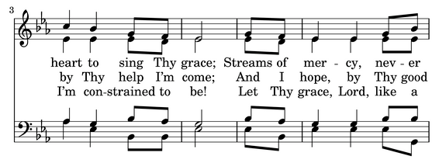
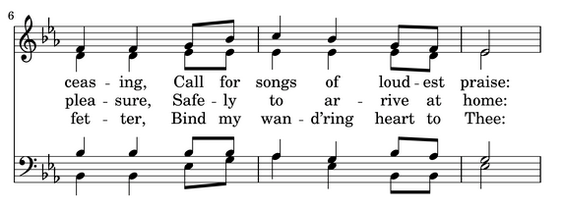
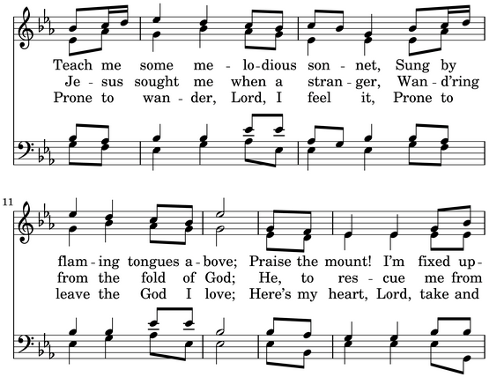

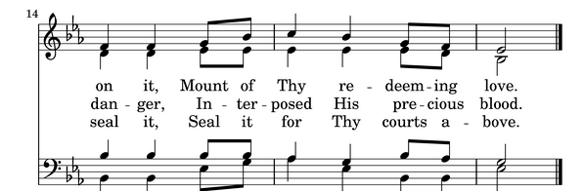

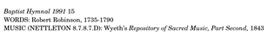

Doxology standing as the alms are presented

Praise God, from whom all blessings flow;
praise him, all creatures here below;
Praise him above, ye heavenly host;
praise Father, Son, and Holy Ghost. Amen.
THE HOLY COMMUNION

THE SURSUM CORDA ACNA BCP 2019 p. 132

The People remain standing. The Celebrant faces them and sings or says

The Lord be with you.
People And with your spirit.
Celebrant Lift up your hearts.
People We lift them up to the Lord.
Celebrant Let us give thanks to the Lord our God.
People It is right to give him thanks and praise.

The Celebrant continues

It is right, our duty and our joy, always and everywhere to give thanks to you, Father Almighty, Creator of heaven and earth.

Here a Proper Preface (pages 152-158) is normally sung or said

Therefore we praise you, joining our voices with Angels and Archangels and with all the company of heaven, who for ever sing this hymn to proclaim the glory of your Name:

The Sanctus Sung using these words

Celebrant and People
Holy, holy, holy, Lord, God of Hosts:
Heaven and earth are full of thy glory.
Glory be to thee, O Lord Most High
Blessed is he that cometh in the name of the Lord.
Hosanna in the highest.

The Prayer of Consecration ACNA 2019 Book of Common Prayer Page 132
The people kneel. Then the Celebrant continues

Therefore we proclaim the mystery of faith:

Celebrant and People

Christ has died.
Christ is risen.
Christ will come again.

The Lord’s Prayer ACNA 2019 BCP Page 134
The People stand or kneel. The Celebrant continues

And now as our Savior Christ has taught us, we are bold to pray:

Celebrant and People together pray

Our Father, who art in heaven,
hallowed be thy Name,
thy kingdom come,
thy will be done,
on earth as it is in heaven.
Give us this day our daily bread.
And forgive us our trespasses,
as we forgive those
who trespass against us.
And lead us not into temptation,
but deliver us from evil.
For thine is the kingdom,
and the power, and the glory,
for ever and ever. Amen.

THE FRACTION

Celebrant [Alleluia.] Christ our Passover is sacrificed for us.
People Therefore let us keep the feast. [Alleluia.]

THE PRAYER OF HUMBLE ACCESS in unison, kneeling ACNA 2019 BCP Pg. 135

Celebrant and People together may say

We do not presume to come to this your table, O merciful Lord,
trusting in our own righteousness,
but in your abundant and great mercies.
We are not worthy so much as to gather up
the crumbs under your table;
but you are the same Lord
whose character is always to have mercy.
Grant us, therefore, gracious Lord,
so to eat the flesh of your dear Son Jesus Christ,
and to drink his blood,
that our sinful bodies may be made clean by his body,
and our souls washed through his most precious blood,
and that we may evermore dwell in him, and he in us. Amen.

The Agnus Dei Sung using this form —kneeling

O Lamb of God, that takest away the sins of the world, have mercy upon us.
O Lamb of God, that takest away the sins of the world, have mercy upon us.
O Lamb of God, that takest away the sins of the world, grant us thy peace.

Invitation to Communion

Communion Hymn Rock of Ages Hymn 277 Blue Hymnal

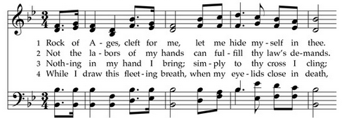

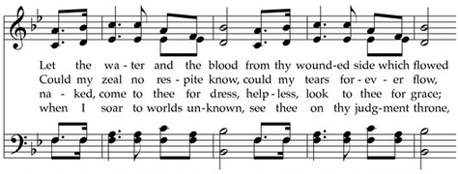

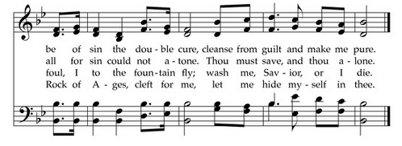

THE POST COMMUNION PRAYER ACNA 2019 BCP page 137

After Communion, the Celebrant says

Let us pray.

Celebrant and People together say the following, or the Post Communion Prayer in the Anglican Standard Text

Heavenly Father,
We thank you for feeding us with the spiritual food
of the most precious Body and Blood
of your Son our Savior Jesus Christ;
and for assuring us in these holy mysteries
that we are living members of the body of your Son,
and heirs of your eternal kingdom.
And now, Father, send us out to do the work you have given us to do,
to love and serve you as faithful witnesses of Christ our Lord.
To him, to you, and to the Holy Spirit,
be honor and glory, now and for ever. Amen.

THE BLESSING

The Bishop when present, or the Priest, gives this or an alternate blessing

The peace of God, which passes all understanding, keep your hearts and minds in the knowledge and love of God, and of his Son Jesus Christ our Lord; and the blessing of God Almighty, the Father, the Son, and the Holy Spirit, be among you, and remain with you always. Amen.

A hymn, psalm, or anthem may be sung after the Blessing (or following the Dismissal).

Recessional Hymn How Sweet the Name of Jesus Hymn 644 Red Hymnal

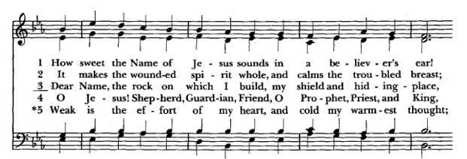
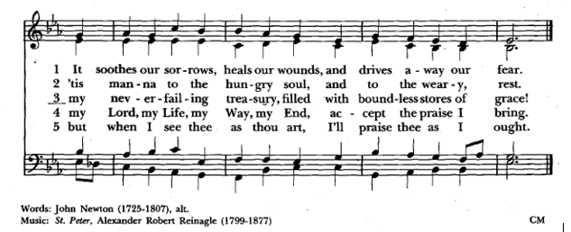

THE DISMISSAL
The Deacon, or the Priest, may dismiss the People with these words

Deacon Alleluia!! Alleluia!! Let us go forth into the world, rejoicing in the power of the Holy Spirit.
People Thanks be to God. Alleluia!! Alleluia!!

Organists:
Dr. Anne Vickers
Mr. Gray McKinnon
Ms. Deb Schulz
Lay Eucharistic Minister: George Blampied
Lector: George Blampied
Acolyte: Asher Adams
Ushers: Henry Martin and Jeanette Blampied
Altar Guild: Anne Vickers

*If you require a gluten-free wafer for Communion, please speak
to an usher or a member of the clergy before the service.
St. Andrew’s Anglican Church
~Parish Life~

___________________________________________________________________________________

St. Andrew’s Prayer List:
Jake, Stone, Leila, Cleary, John, Jennifer and Christy, Elaine Hinson, Daniel Robinson, Kim Fry, Susanne Sawyer, Jimmy Stewart, Leo Barnes, Ben Walls, Mark Limbird, Jessica Porter, Eric Bruner, Patricia Thompson, Sam and Sandy DeCasper, Lindsey, Jana Burke, Brenda Meritt, Laris Browning, Philip Groom, C J Morris, Barbara Patton, Tyler Kidd, Katherine Gaskins, The Scheoler Family, Kaitlyn Diaz, Gray and Teri Stephenson, The Royal Family, Connie, Doug Campbell, Christopher Barnes, The Gabbard Family for all who protect our freedoms at home and abroad, and all first responders.

IMPORTANT DATES TO REMEMBER
· The Coffee County Food Bank is in need of items to help fill 800 bags for children in our community. The items needed are: Fruit Cups, Pop Tarts, Potato Chips, Gold Fish, and similar items. Please place donations in the box in the back of the church.
· June 25 – 27 – VBS – 9:00 a.m. to 12 noon. Please respond to Fr. Chris to sign up and let us know your child is attending.
· July 7 – Parish Breakfast – 9:30 a.m.
· July 25-27—Christian Healing Ministries Healing Prayer Level 1 Training—Jacksonville, Florida
· August 22-24—Christian Healing Ministries Healing Prayer Level 2 Training—Jacksonville, Florida
· September 20-22—125th Anniversary Celebration of St. Andrew’s more details to come.
· October 17-19—Chrisitan Healing Ministries Healing Prayer Level 3 Training—Jacksonville, Florida

Standing Announcements:
Healing prayer each Sunday during communion at the back of the church
Flower chart at the back of the church for donating Altar Flowers
Wednesday night dinner and bible study at 6:00 P.M.
Feel free to text prayer requests to 833-356-8870

Music reprinted under CCLI License # 11235605 and CCLI streaming License # 20405071

The phrase “and the Son” (Latin filioque) is not in the original Greek text. See the resolution of the College of Bishops concerning the filioque in Documentary Foundations (page 768).

