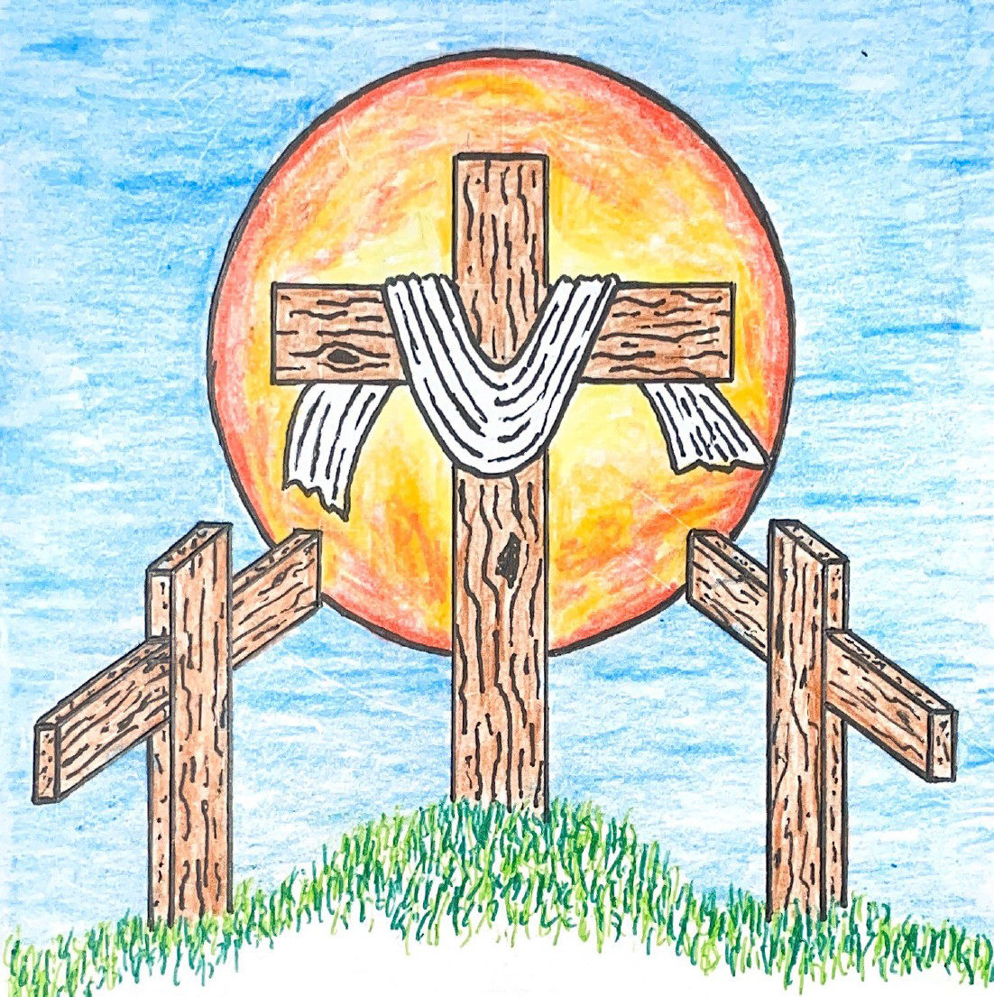

10th Sunday after Pentecost
August 2, 2026 10:00 am
Pastor Mark Swanson
549 Across the Lands CW 549

Stand

In the name of the Father and of the T Son and of the Holy Spirit.
Amen.

Confession
If we claim to be without sin, we deceive ourselves and the truth is not in us.
If we confess our sins, God is faithful and just
and will forgive us our sins
and purify us from all unrighteousness.

Let us confess our sins to the Lord.
Holy God, gracious Father,
I am sinful by nature
and have sinned against you in my thoughts, words, and actions.
I have not loved you with my whole heart;
I have not loved others as I should.
I deserve your punishment both now and forever.
But Jesus, my Savior, paid for my sins
with his innocent suffering and death.
Trusting in him, I pray: God, have mercy on me, a sinner.

Silence for meditation and reflection

Our gracious Father in heaven has been merciful to us. He sent his only Son, Jesus Christ, who gave his life as the atoning sacrifice for the sins of the whole world. Therefore, as a called servant of Christ and by his authority, I forgive you all your sins in the name of the Father and of the T Son and of the Holy Spirit.
Amen.

Lord, Have Mercy
In peace let us pray to the Lord.
Lord, have mercy.

For the peace from above and for our salvation, let us pray to the Lord.
Lord, have mercy.

For the peace of the whole world, for the well-being of the Church of God, and for the unity of all, let us pray to the Lord.
Lord, have mercy.

For this holy house and for all who offer here their worship and praise, let us pray to the Lord.
Lord, have mercy.

Help, save, comfort, and defend us, gracious Lord.
Amen.

519 There Is a Redeemer CW 519
1 There is a Redeemer,
Jesus, God’s own Son,
precious Lamb of God, Messiah,
Holy One. (Refrain)

Ref Thank you, O my Father,
for giving us your Son
and leaving your Spirit till
the work on earth is done.

2 Jesus, my Redeemer,
name above all names,
precious Lamb of God, Messiah,
hope for sinners slain. (Refrain)

3 When I stand in glory,
I will see his face;
there I’ll serve my King forever
in that holy place. (Refrain)
Text: Melody Green, b. 1946
Text: © 1982 Birdwing Music/Ears To Hear Music/Universal Music - Brentwood Benson Publ., admin. CapitolCMGPublishing,com. Used by permission: OneLicense no. A-740069

The Word

The Lord be with you.
And also with you.

Prayer of the Day
Let us pray.

Almighty and everlasting God, you are always more ready to hear than we to pray and willing to give far more than we either desire or deserve. Pour upon us the abundance of your mercy, forgiving us those things of which our conscience is afraid, and giving us those good things for which we are not worthy to ask except through the merits and mediation of your Son, Jesus Christ our Lord, who lives and reigns with you and the Holy Spirit, one God, now and forever.
Amen.

Be seated

First Reading 1 Kings 17:1–6
1Elijah from Tishbe, one of the settlers in Gilead, said to Ahab, “As surely as the Lord lives, the God of Israel before whom I stand, there will be no dew or rain during the coming years, except at my word.”
2Then the word of the Lord came to him: 3“Leave this place and turn east. Hide yourself by the Kerith Ravine, east of the Jordan. 4You will drink from the stream, and I will command the ravens to provide for you there.”
5So Elijah went and did just as the Lord had said. He lived in the Kerith Ravine, east of the Jordan. 6The ravens brought him bread and meat in the morning and in the evening, and he drank from the stream.

The Word of the Lord.
Thanks be to God.

602 Great Is Thy Faithfulness CW 602

Second Reading Ephesians 1:3–10
3Blessed be the God and Father of our Lord Jesus Christ, who has blessed us in Christ with every spiritual blessing in the heavenly places.
4He did this when he chose us in Christ before the foundation of the world, so that we would be holy and blameless in his sight. In love 5he predestined us to be adopted as his sons through Jesus Christ. He did this in accordance with the good purpose of his will, 6and for the praise of his glorious grace, which he has graciously given us in the one he loves.
7In him we also have redemption through his blood, the forgiveness of sins, in keeping with the riches of his grace, 8which he lavished on us in all wisdom and insight. 9He made known to us the mystery of his will in keeping with his good purpose, which he planned in Christ. 10This was to be carried out when the time had fully come, in order to bring all things together in Christ, things in heaven and things on earth.

The Word of the Lord.
Thanks be to God.

Stand

Gospel Matthew 14:13–21
13When Jesus heard this, he withdrew from there in a boat to a deserted place to be alone. When the crowds heard this, they followed him on foot from the towns.
14When Jesus got out of the boat, he saw a large crowd. He had compassion on them and healed their sick. 15When evening came, his disciples came to him and said, “This is a deserted place and the hour is already late. Send the crowds away, so that they can go into the villages and buy food for themselves.”
16But Jesus said to them, “They do not need to go away. You give them something to eat.”
17They told him, “We have here only five loaves and two fish.”
18“Bring them here to me,” he replied. 19Then he instructed the people to sit down on the grass. He took the five loaves and the two fish. After looking up to heaven, he blessed them. He broke the loaves and gave them to the disciples. The disciples gave the food to the people. 20They all ate and were filled. They picked up twelve basketfuls of what was left over from the broken pieces. 21Those who ate were about five thousand men, not even counting women and children.

The Gospel of the Lord.
Praise be to you, O Christ!

Be seated

803 Day by Day CW 803

Sermon What We Need

Stand

Nicene Creed
We believe in one God, the Father, the Almighty,
maker of heaven and earth,
of all that is,
seen and unseen.

We believe in one Lord, Jesus Christ, the only Son of God,
eternally begotten of the Father,
God from God, Light from Light, true God from true God,
begotten, not made,
of one being with the Father.
Through him all things were made.
For us and for our salvation, he came down from heaven,
was incarnate of the Holy Spirit and the Virgin Mary,
and became truly human.
For our sake he was crucified under Pontius Pilate.
He suffered death and was buried.
On the third day he rose again in accordance with the Scriptures.
He ascended into heaven
and is seated at the right hand of the Father.
He will come again in glory to judge the living and the dead,
and his kingdom will have no end.

We believe in the Holy Spirit,
the Lord, the giver of life,
who proceeds from the Father and the Son,
who in unity with the Father and the Son
is worshiped and glorified,
who has spoken through the prophets.
We believe in one holy Christian and apostolic Church.
We acknowledge one baptism for the forgiveness of sins.
We look for the resurrection of the dead
and the life of the world to come. Amen.

Be seated

Prayer of the Church

Almighty God and Father, we thank you for all your mercies, especially for the gift of your Son, through whom you have revealed your gracious will. We praise you for the Holy Spirit and his working through the means of grace.
Plant your Word in our hearts, and cause it to produce fruit in our lives.

Strengthen and defend your Church, that by your Word and sacraments faith may grow and love toward all may increase.
Support all who spread the light of your truth throughout the world.

Keep our children in the grace of their baptisms. Enable their parents to train them in lives of faith.
Raise up Christians to serve you in the ministry of the Word and in all godly walks of life.

Preserve our nation in justice and honor. Guide and bless all who make, administer, and judge our laws.
Give them wisdom that they may promote justice and hinder evil.

Let your blessing rest on planting and harvest, commerce and industry, medicine and science, the arts and culture. Protect all who travel, and care for those whose work is difficult or dangerous.
Be with all who devote themselves to any useful task.

Comfort all who are in sorrow or need, sickness or adversity. Remember those who suffer persecution for the faith. Have mercy on those for whom death draws near.
Grant them your love, and take them into your tender care.

Hear us, Lord, as we pray in silence.

Silent prayer

We remember with thanksgiving those who have loved and served you, who now rest from their labors. Console those who are mourning or living with sadness.
Keep us in the true faith, and bring us at last to the joys of heaven.

Grant us these things, Father, for the sake of Jesus, who died and rose again.
Amen.

Lord’s Prayer
Our Father, who art in heaven,
hallowed be thy name,
thy kingdom come,
thy will be done
on earth as it is in heaven.
Give us this day our daily bread;
and forgive us our trespasses,
as we forgive those
who trespass against us;
and lead us not into temptation,
but deliver us from evil.
For thine is the kingdom
and the power and the glory
forever and ever. Amen.

The Sacrament

Stand

Preface
The Lord be with you.
And also with you.

Lift up your hearts.
We lift them up to the Lord.

Let us give thanks to the Lord our God.
It is right to give him thanks and praise.

It is truly good and right . . . and join their glorious song:

Holy, Holy, Holy
Holy, holy, holy Lord, God of power, God of might.
Heav’n and earth are full of your glory.
Hosanna in the highest. Blessed is he who comes in the name of the Lord.
Hosanna in the highest, hosanna in the highest!

Words of Institution
Our Lord Jesus Christ, on the night he was betrayed, took bread; and when he had given thanks, he broke it and gave it to his disciples, saying, “Take and eat; this is my T body, which is given for you. Do this in remembrance of me.”

Then he took the cup, gave thanks, and gave it to them, saying, “Drink from it, all of you; this is my T blood of the new covenant, which is poured out for you for the forgiveness of sins. Do this, whenever you drink it, in remembrance of me.”

The peace of the Lord be with you always.
Amen.

O Christ, Lamb of God
O Christ, Lamb of God, you take away the sin of the world; have mercy on us.
O Christ, Lamb of God, you take away the sin of the world; have mercy on us.
O Christ, Lamb of God, you take away the sin of the world; grant us your peace. Amen. Amen.

358 Of the Father’s Love Begotten CW 358

Stand

Give thanks to the Lord, for he is good;
his mercy endures forever.

Whenever we eat this bread and drink this cup,
we proclaim the Lord’s death until he comes.

We give thanks, almighty God, that you have refreshed us with this saving gift. We pray that through it you will strengthen our faith in you and increase our love for one another. We ask this in the name of Jesus Christ our Lord, who lives and reigns with you and the Holy Spirit, one God, now and forever.
Amen.

Blessing
The Lord bless you and keep you.
The Lord make his face shine on you and be gracious to you.
The Lord look on you with favor and T give you peace.
Amen.

930 Go, My Children, with My Blessing CW 930

Acknowledgments
Setting Four from Christian Worship
Unless otherwise noted, Scripture quotations are from the Holy Bible, Evangelical Heritage Version® (EHV®) © 2017 Wartburg Project. All rights reserved. Used by permission.
Liturgical and musical settings of Scripture based on text from The Holy Bible, New International Version®, NIV®. Copyright © 1973, 1978, 1984, 2011 by Biblica, Inc.TM Used by permission of Zondervan. All rights reserved worldwide.
Software distributed in partnership with Northwestern Publishing House.
Created by Christian Worship: Service Builder © 2026 Concordia Publishing House.

Sat, Aug 8 Ruby Purcell Funeral 11 am
Sun, Aug 16 Quarterly Voters meeting 11 am
Sun, Sep 13 Council Meeting 5pm

Bible Class will resume this morning with the topic of Christian Worship.

The Christian Funeral for Ruby Purcell will be Saturday, August 8th at 11 am with luncheon to follow.

Sunday August 16, we will have our Quarterly Voters meeting.

In Holy Communion Jesus assures us that all our sins have been forgiven. When we receive the Lord’s Supper, we are expressing our unity in the faith. While we do not want to judge anyone's heart, we also recognize that there are differences among churches. For this reason we ask that only communicant members of our congregation or another WELS/ELS congregation come forward to receive the Lord’s supper. If you have questions about this, please speak with Pastor.

Welcome to Trinity
God welcomes you, no matter who you are or where you come from—and so do we. We believe that Jesus Christ is the true Savior of all people. By his perfect life, innocent death, and triumphant resurrection, he saves all lost sinners even without our help. Jesus Christ makes us special people, right with God and ready for life! We learn this from the Bible, God's authentic message of grace and guidance for us. Whether you are here for the first-time or returning, we are delighted to share our worship with you.

Quiet Room Available
If your child becomes restless during worship, that's okay—we're glad they're here! You may take them into the fellowship hall which we have set up so you can still hear and see the service. This way you can teach your child they're still "in church" and will return to the Sanctuary when they've calmed down.

Wi-Fi Available
Network: Trinity Public Password: triunegod
Regular Worship Schedule
Every Sunday morning at 10:00am.

Our Pastor
Pastor Mark Swanson
Mdws89@gmail.com or telcwels@gmail.com
Office: 541-344-9719
Church Cell: 541-729-4681
Pastor’s Cell: 920-609-6204
Our Church Body
Trinity is affiliated with the
Wisconsin Evangelical Lutheran Synod (WELS).
Follow Us
www.trinityeugene.org
Facebook: “Trinity Evangelical Lutheran Church”
Give Online
Go to www.trinityeugene.org/firstfruits

Address and Phone Number
1310 Echo Hollow Road, Eugene, OR 97402 541-344-9719

