

Christian Funeral
Ruby Purcell
August 8, 2026 11:00 am
Clergy: Pastor Mark Swanson
God’s Comfort
We have come together to seek God’s comfort in our sorrow and to rejoice in the promise of the resurrection. Grace and peace to you from God our Father and from the Lord Jesus Christ who said, “I am the resurrection and the life. Those who believe in me will live, even though they die; and whoever lives by believing in me will never die.”

The wages of sin is death,
but the gift of God is eternal life in Christ Jesus our Lord.

Death has been swallowed up in victory! Thanks be to God!
He gives us the victory through our Lord Jesus Christ.

When Christ, who is our life, appears,
then we also will appear with him in glory.

Reading Psalm 23
1The Lord is my shepherd.
I lack nothing.
2He causes me to lie down in green pastures.
He leads me beside quiet waters.
3He restores my soul.
He guides me in paths of righteousness for his name's sake.
4Even though I walk through the valley of the shadow of death,
I will fear no evil, for you are with me.
Your rod and your staff, they comfort me.
5You set a table for me in the presence of my foes.
You drench my head with oil.
My cup is overflowing.
6Surely goodness and mercy will pursue me all the days of my life,
and I will live in the house of the Lord forever.

522 Beautiful Savior CW 522
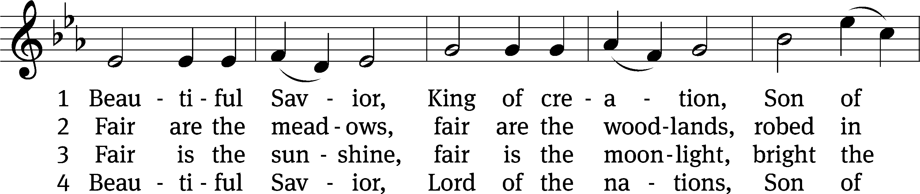
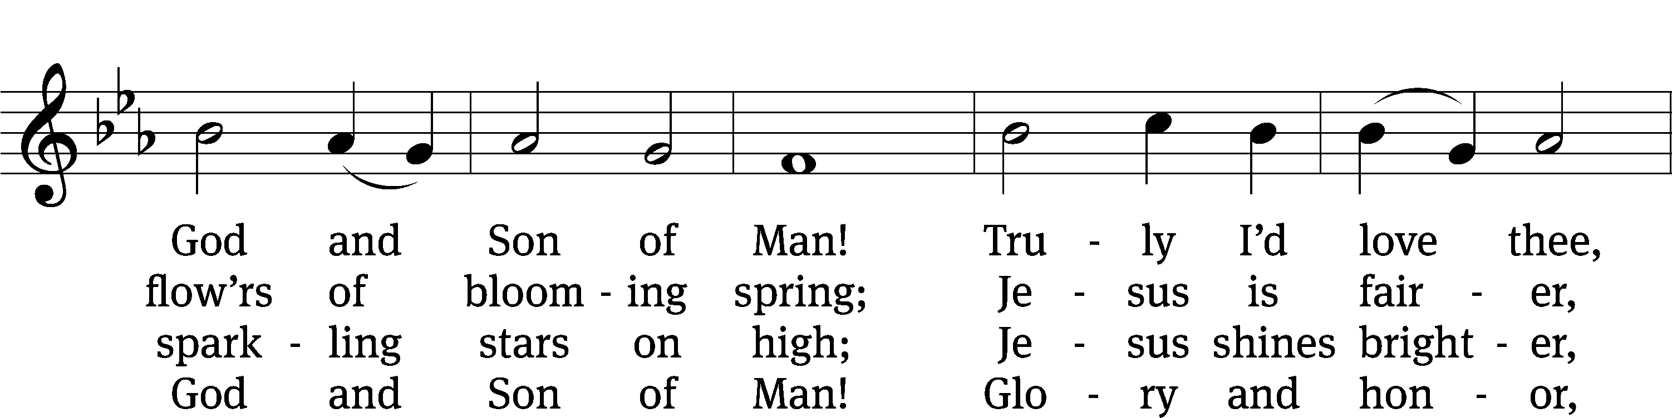
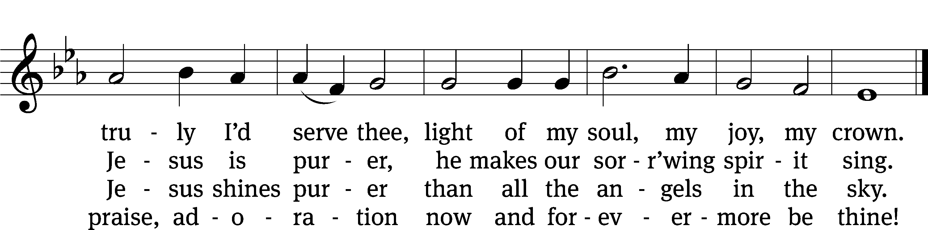
Text: Münsterisch Gesangbuch, Münster, 1677, abr.; tr. Joseph A. Seiss, 1823–1904
Tune: Silesian, 19th cent.
Text and tune: Public domain

Let us pray.

Lord Jesus, you wept at the grave of your friend Lazarus, and you consoled Mary and Martha in their distress. Draw near to us who mourn the loss of Ruby, and dry the tears of all who weep. Calm our troubled hearts; dispel our doubts and fears. We thank you for bringing her to faith and giving her the gift of eternal life. Strengthen us with your Word and sacraments, and keep us in the saving faith until we are united with you and all the saints where you live and reign with the Father and the Holy Spirit, one God, now and forever.
Amen.

Reading Job 19:23–27
23Oh how I wish that my words were written down.
Oh how I wish that they were inscribed in bronze,
24that they would be engraved in rock forever
with an iron tool and letters filled with lead.
25As for me, I know that my Redeemer lives,
and that at the end of time he will stand over the dust.
26Then, even after my skin has been destroyed,
nevertheless, in my own flesh I will see God.
27I myself will see him.
My own eyes will see him, and not as a stranger.
My emotions are in turmoil within me.

The Word of the Lord.
Thanks be to God.

Reading Revelation 21:1–6
1Then I saw a new heaven and a new earth, because the first heaven and the first earth had passed away. And the sea no longer existed. 2And I saw the Holy City, the New Jerusalem, coming down out of heaven from God, prepared as a bride adorned for her husband.
3And from the throne I heard a loud voice that said, “Look! God's dwelling is with people. He will dwell with them, and they will be his people. God himself will be with them, and he will be their God. 4He will wipe away every tear from their eyes. There will be no more death or sorrow or crying or pain, because the former things have passed away.”
5The one who was seated on the throne said to me, “Look, I am making everything new!” He also said, “Write, for these words are trustworthy and true.” 6And he said to me:
It is done.
I am the Alpha and the Omega, the Beginning and the End.
To anyone who is thirsty,
I will give freely from the spring of the water of life.

The Word of the Lord.
Thanks be to God.

Reading John 11:17–25
17When Jesus arrived, he found that Lazarus had already been in the tomb for four days.
18Bethany was near Jerusalem, about two miles away. 19Many Jews had come to Martha and Mary to comfort them concerning their brother.
20When Martha heard that Jesus was coming, she went to meet him, while Mary was sitting in the house.
21Martha said to Jesus, “Lord, if you had been here, my brother would not have died. 22But even now I know that whatever you ask from God, God will give you.”
23Jesus said to her, “Your brother will rise again.”
24Martha replied, “I know that he will rise in the resurrection on the Last Day.”
25Jesus said to her, “I am the resurrection and the life. Whoever believes in me will live, even if he dies.

The Word of the Lord.
Thanks be to God.

576 Amazing Grace CW 576
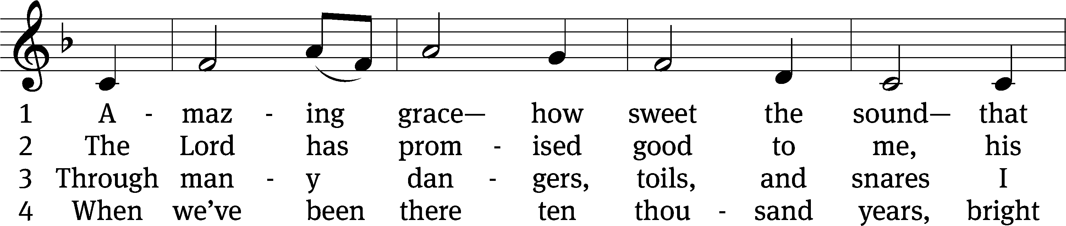
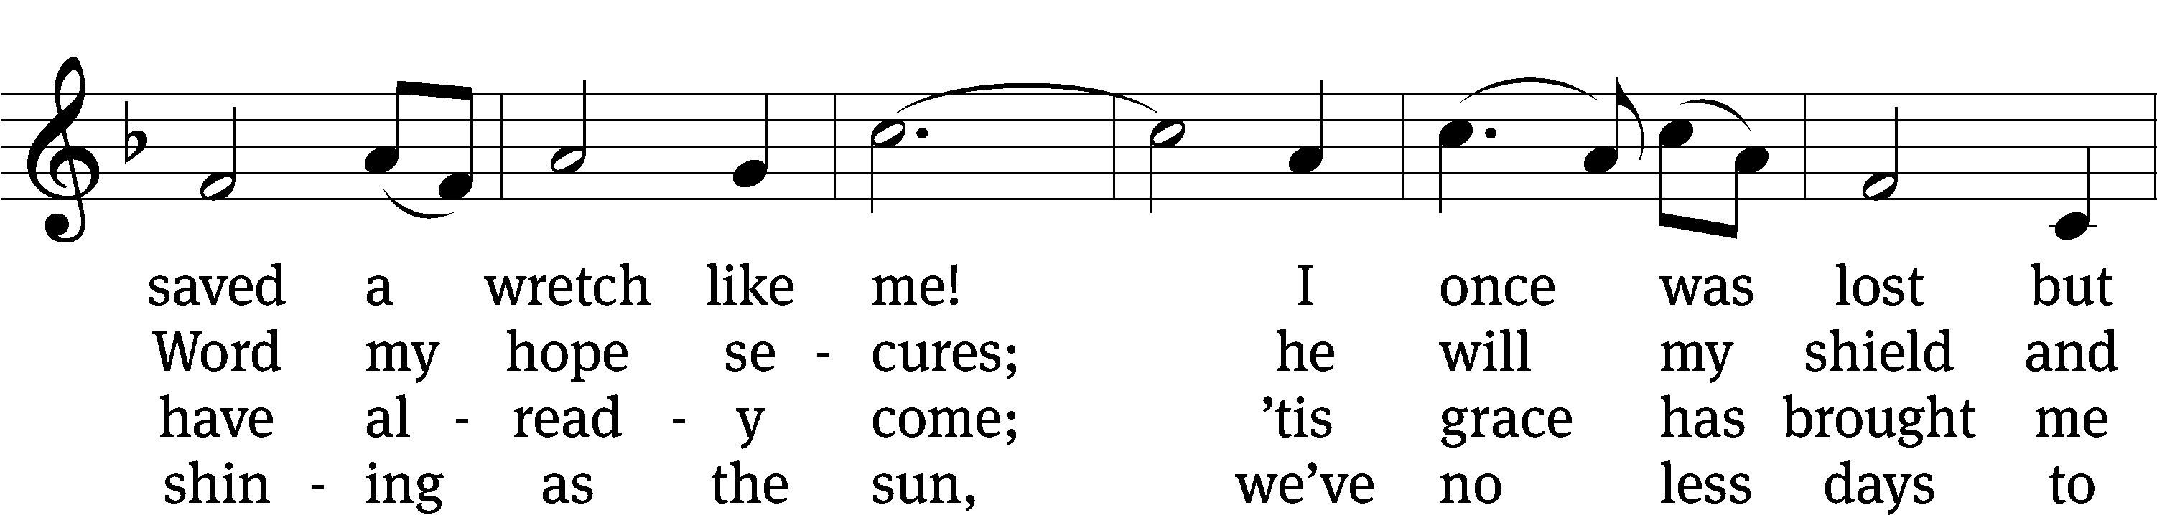
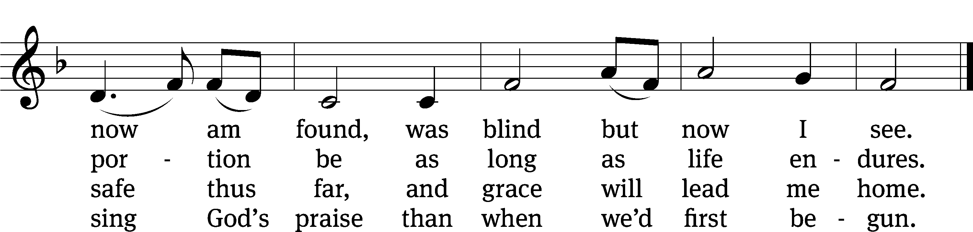
Text (sts. 1–3): John Newton, 1725–1807, alt.; (st. 4): A Collection of Sacred Ballads, Richmond, 1790
Tune: Columbian Harmony, Cincinnati, 1829, ed. Benjamin Shaw; ed. Charles H. Spilman
Text and tune: Public domain

Sermon

Apostles’ Creed
I believe in God, the Father Almighty,
maker of heaven and earth.

I believe in Jesus Christ, his only Son, our Lord,
who was conceived by the Holy Spirit,
born of the Virgin Mary,
suffered under Pontius Pilate,
was crucified, died, and was buried.
He descended into hell.
The third day he rose again from the dead.
He ascended into heaven
and is seated at the right hand of God the Father Almighty.
From there he will come to judge the living and the dead.

I believe in the Holy Spirit,
the holy Christian Church,
the communion of saints,
the forgiveness of sins,
the resurrection of the body,
and the life everlasting. Amen.

The following responsive prayer or another prayer may be said:

Lord God, heavenly Father, you are always with us, especially when our hearts are heavy with grief. Send us your Spirit so that even as we grieve we are filled with hope. You have convinced us that your Son Jesus died and rose again, and so we believe that our loved ones who have fallen asleep in Christ are resting in peace with you. Let nothing shake our confidence in your promise that we will be united with you and them in glory forever. Lord, in your mercy,
hear our prayer.

What great mercy you have shown us, Father in heaven! Through your Son’s resurrection, our hope is alive and our inheritance is certain. The bliss and security we will enjoy in your presence are blessings that will never perish, spoil, or fade. Shield us with your power and give us faith to trust in you in every trial until we inherit the glorious riches you are keeping for us in heaven. Lord, in your mercy,
hear our prayer.

Gracious God, we see your abiding love in the kindness shown to us by family and friends. As we receive comfort and encouragement from others, we are experiencing your care. Help us bear all our burdens patiently. Be the strength of your people, now and in difficult days to come. Lord, in your mercy,
hear our prayer.

O Lord, support us all day long, till the shadows lengthen and the evening comes and the busy world is hushed and the fever of life is over and our work is done. Then, in your mercy, grant us a safe lodging and a holy rest and peace at the last; through Jesus Christ our Lord.
Amen.

Lord’s Prayer
Our Father in heaven,
hallowed be your name,
your kingdom come,
your will be done
on earth as in heaven.
Give us today our daily bread.
Forgive us our sins,
as we forgive those
who sin against us.
Lead us not into temptation,
but deliver us from evil.
For the kingdom, the power,
and the glory are yours
now and forever. Amen.

Blessing
The Lord bless you and keep you.
The Lord make his face shine on you and be gracious to you.
The Lord look on you with favor and T give you peace.
Amen.

552 The King of Love My Shepherd Is CW 552
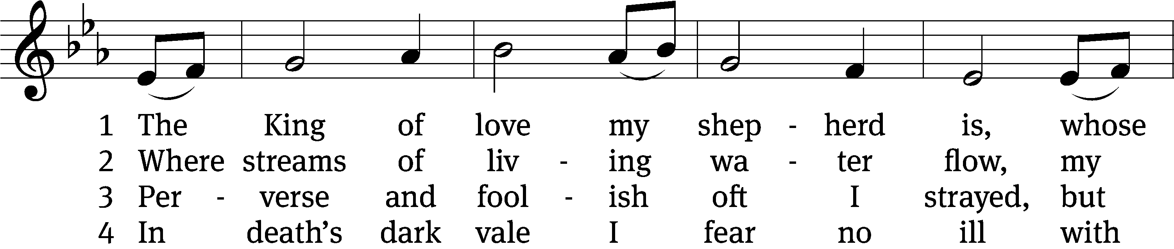
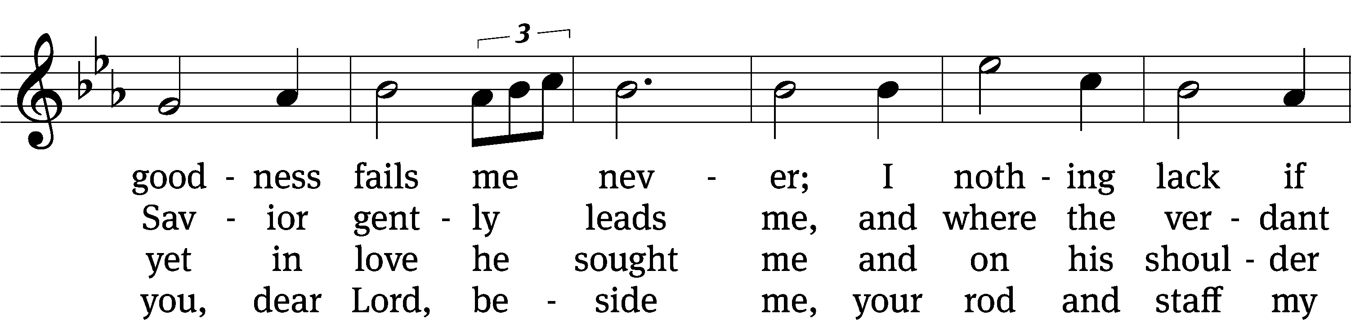
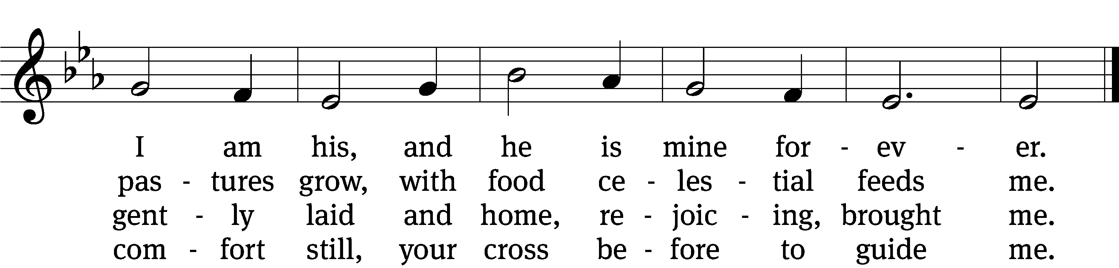

5 You spread a table in my sight,
a banquet here bestowing;
your oil of welcome, my delight;
my cup is overflowing!

6 And so through all the length of days
your goodness fails me never;
Good Shepherd, may I sing your praise
within your house forever!
Text: Henry W. Baker, 1821–1877, alt.
Tune: Irish, 18th cent.
Text and tune: Public domain

Acknowledgments
Christian Funeral from Christian Worship
Unless otherwise noted, Scripture quotations are from the Holy Bible, Evangelical Heritage Version® (EHV®) © 2017 Wartburg Project. All rights reserved. Used by permission.
Liturgical and musical settings of Scripture based on text from The Holy Bible, New International Version®, NIV®. Copyright © 1973, 1978, 1984, 2011 by Biblica, Inc.TM Used by permission of Zondervan. All rights reserved worldwide.
Software distributed in partnership with Northwestern Publishing House.
Created by Christian Worship: Service Builder © 2026 Concordia Publishing House.

Welcome to Trinity
God welcomes you, no matter who you are or where you come from—and so do we. We believe that Jesus Christ is the true Savior of all people. By his perfect life, innocent death, and triumphant resurrection, he saves all lost sinners even without our help. Jesus Christ makes us special people, right with God and ready for life! We learn this from the Bible, God's authentic message of grace and guidance for us. Whether you are here for the first-time or returning, we are delighted to share our worship with you.

Quiet Room Available
If your child becomes restless during worship, that's okay—we're glad they're here! You may take them into the fellowship hall which we have set up so you can still hear and see the service. This way you can teach your child they're still "in church" and will return to the Sanctuary when they've calmed down.

Wi-Fi Available
Network: Trinity Public Password: triunegod
Regular Worship Schedule
Every Sunday morning at 10:00am.

Our Pastor
Pastor Mark Swanson
Mdws89@gmail.com or telcwels@gmail.com
Office: 541-344-9719
Church Cell: 541-729-4681
Pastor’s Cell: 920-609-6204
Our Church Body
Trinity is affiliated with the
Wisconsin Evangelical Lutheran Synod (WELS).
Follow Us
www.trinityeugene.org
Facebook: “Trinity Evangelical Lutheran Church”
Give Online
Go to www.trinityeugene.org/firstfruits

Address and Phone Number
1310 Echo Hollow Road, Eugene, OR 97402 541-344-9719

