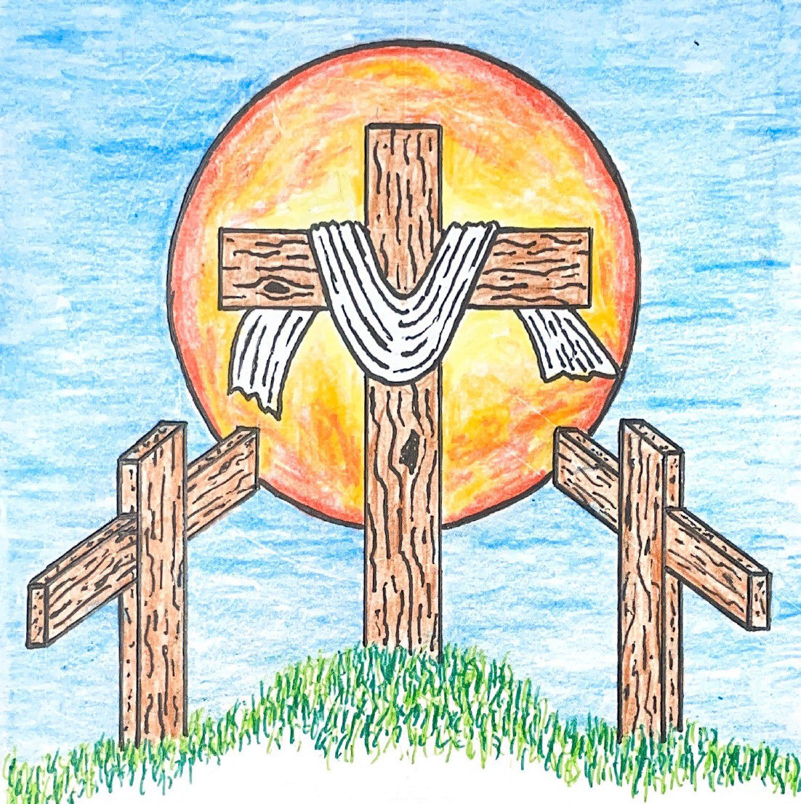

12th Sunday after Pentecost
August 16, 2026 10:00 am
Pastor Mark Swanson
746 I Love to Tell the Story CW 746 sts. 1, Ref, 3

Stand

In the name of the Father and of the T Son and of the Holy Spirit.
Amen.

Confession CW 154
If we claim to be without sin, we deceive ourselves and the truth is not in us.
If we confess our sins, God is faithful and just
and will forgive us our sins
and purify us from all unrighteousness.

Let us confess our sins to the Lord.
Holy God, gracious Father,
I am sinful by nature
and have sinned against you in my thoughts, words, and actions.
I have not loved you with my whole heart;
I have not loved others as I should.
I deserve your punishment both now and forever.
But Jesus, my Savior, paid for my sins
with his innocent suffering and death.
Trusting in him, I pray: God, have mercy on me, a sinner.

Silence for meditation and reflection

Our gracious Father in heaven has been merciful to us. He sent his only Son, Jesus Christ, who gave his life as the atoning sacrifice for the sins of the whole world. Therefore, as a called servant of Christ and by his authority, I forgive you all your sins in the name of the Father and of the T Son and of the Holy Spirit.
Amen.

Lord, Have Mercy
In peace let us pray to the Lord.
Lord, have mercy.

For the peace from above and for our salvation, let us pray to the Lord.
Lord, have mercy.

For the peace of the whole world, for the well-being of the Church of God, and for the unity of all, let us pray to the Lord.
Lord, have mercy.

For this holy house and for all who offer here their worship and praise, let us pray to the Lord.
Lord, have mercy.

Help, save, comfort, and defend us, gracious Lord.
Amen.

Glory Be to God on High CW 157
Glory be to God on high, and on earth peace, good will toward men.
We praise you, we bless you, we worship you,
we glorify you, we give thanks to you, for your great glory,
O Lord God, heav’nly King, God the Father Almighty.
O Lord, the only-begotten Son, Jesus Christ;
O Lord God, Lamb of God, Son of the Father,
you take away the sin of the world; have mercy on us.
You take away the sin of the world; receive our prayer.
You sit at the right hand of God the Father; have mercy on us.
For you only are holy; you only are the Lord.
You only, O Christ, with the Holy Spirit,
are most high in the glory of God the Father. Amen.

The Word

The Lord be with you.
And also with you.

Prayer of the Day
Let us pray.

Gracious God, in Christ you bring people from near and far into the fellowship of your church. Open our eyes to your saving plan, and move us to embrace all who seek your salvation so that we may rejoice together at the banquet of your love; through your Son, Jesus Christ our Lord, who lives and reigns with you and the Holy Spirit, one God, now and forever.
Amen.

Be seated

First Reading Isaiah 56:1,6–8
1This is what the Lord says.
Protect justice, and carry out righteousness,
because my salvation is coming very soon.
My righteousness is ready to be revealed.
6Then the foreigners who join themselves to the Lord,
to minister to him and to love the name of the Lord
and to become his servants,
every one of them who keeps the Sabbath and does not profane it,
those who take hold of my covenant—
7I will bring them to my holy mountain,
and I will make them glad in my house of prayer.
Their whole burnt offerings and their sacrifices will be acceptable on my altar.
For my house will be called a house of prayer for all the peoples of the world.
8This is the declaration of God the Lord,
who gathers Israel's dispersed people:
“I will gather still more people to my house besides the ones already gathered.”

The Word of the Lord.
Thanks be to God.

517 Praise the One Who Breaks the Darkness CW 517

Second Reading Ephesians 2:13–22
13But now in Christ Jesus, you who once were far away have been brought near by the blood of Christ. 14For he himself is our peace. He made the two groups one by destroying the wall of hostility that divided them 15when he abolished the law of commandments and regulations in his flesh. He did this to create in himself one new person out of the two, in this way making peace. 16And he did this to reconcile both to God in one body through the cross by putting the hostility to death on it. 17He also came and preached peace to you who were far away and peace to those who were near. 18For through him we both have access to the Father by one Spirit.
19So then, you are no longer foreigners and strangers, but you are fellow citizens with the saints and members of God's household. 20You have been built on the foundation of the apostles and prophets, with Christ Jesus himself as the Cornerstone. 21In him the whole building is joined together and grows into a holy temple in the Lord. 22In him you too are being built together into a dwelling place for God by the Spirit.

The Word of the Lord.
Thanks be to God.

Stand

Gospel Matthew 15:21–28
21Jesus left that place and withdrew into the region of Tyre and Sidon. 22There a Canaanite woman from that territory came and kept crying out, “Have mercy on me, Lord, Son of David! A demon is severely tormenting my daughter!”
23But he did not answer her a word.
His disciples came and pleaded, “Send her away, because she keeps crying out after us.”
24He answered, “I was sent only to the lost sheep of the house of Israel.”
25But she came and knelt in front of him, saying, “Lord, help me.”
26He answered her, “It is not good to take the children's bread and throw it to their little dogs.”
27“Yes, Lord,” she said, “yet their little dogs also eat the crumbs that fall from their masters' table.”
28Then Jesus answered her, “Woman, your faith is great! It will be done for you, just as you desire.” And her daughter was healed at that very hour.

The Gospel of the Lord.
Praise be to you, O Christ!

Be seated

510 In Christ Alone CW 510

Sermon Persistent Faith

Stand

Nicene Creed
We believe in one God, the Father, the Almighty,
maker of heaven and earth,
of all that is,
seen and unseen.

We believe in one Lord, Jesus Christ, the only Son of God,
eternally begotten of the Father,
God from God, Light from Light, true God from true God,
begotten, not made,
of one being with the Father.
Through him all things were made.
For us and for our salvation, he came down from heaven,
was incarnate of the Holy Spirit and the Virgin Mary,
and became truly human.
For our sake he was crucified under Pontius Pilate.
He suffered death and was buried.
On the third day he rose again in accordance with the Scriptures.
He ascended into heaven
and is seated at the right hand of the Father.
He will come again in glory to judge the living and the dead,
and his kingdom will have no end.

We believe in the Holy Spirit,
the Lord, the giver of life,
who proceeds from the Father and the Son,
who in unity with the Father and the Son
is worshiped and glorified,
who has spoken through the prophets.
We believe in one holy Christian and apostolic Church.
We acknowledge one baptism for the forgiveness of sins.
We look for the resurrection of the dead
and the life of the world to come. Amen.

Be seated

Prayer of the Church

Almighty God and Father, we thank you for all your mercies, especially for the gift of your Son, through whom you have revealed your gracious will. We praise you for the Holy Spirit and his working through the means of grace.
Plant your Word in our hearts, and cause it to produce fruit in our lives.

Strengthen and defend your Church, that by your Word and sacraments faith may grow and love toward all may increase.
Support all who spread the light of your truth throughout the world.

Keep our children in the grace of their baptisms. Enable their parents to train them in lives of faith.
Raise up Christians to serve you in the ministry of the Word and in all godly walks of life.

Preserve our nation in justice and honor. Guide and bless all who make, administer, and judge our laws.
Give them wisdom that they may promote justice and hinder evil.

Let your blessing rest on planting and harvest, commerce and industry, medicine and science, the arts and culture. Protect all who travel, and care for those whose work is difficult or dangerous.
Be with all who devote themselves to any useful task.

Comfort all who are in sorrow or need, sickness or adversity, Remember those who suffer persecution for the faith. Have mercy on those for whom death draws near.
Grant them your love, and take them into your tender care.

Hear us, Lord, as we pray in silence.

Silent prayer

We remember with thanksgiving those who have loved and served you, who now rest from their labors. Console those who are mourning or living with sadness.
Keep us in the true faith, and bring us at last to the joys of heaven.

Grant us these things, Father, for the sake of Jesus, who died and rose again.
Amen.

Lord’s Prayer
Our Father, who art in heaven,
hallowed be thy name,
thy kingdom come,
thy will be done
on earth as it is in heaven.
Give us this day our daily bread;
and forgive us our trespasses,
as we forgive those
who trespass against us;
and lead us not into temptation,
but deliver us from evil.
For thine is the kingdom
and the power and the glory
forever and ever. Amen.

The Sacrament

Stand

Preface CW 165
The Lord be with you.
And also with you.

Lift up your hearts.
We lift them up to the Lord.

Let us give thanks to the Lord our God.
It is right to give him thanks and praise.

It is truly good and right that we should at all times and in all places give you thanks, O Lord, holy Father, almighty and everlasting God, through Jesus Christ our Lord, who promised that wherever two or three come together in his name, there he is with them to shepherd his flock until he comes again in glory. Therefore, with all the saints on earth and hosts of heaven, we praise your holy name and join their glorious song:

Holy, Holy, Holy CW 167
Holy, holy, holy Lord God of heavenly hosts: heav’n and earth are full of your glory.
Hosanna, hosanna, hosanna in the highest.
Blessed is he, blessed is he, blessed is he who comes in the name of the Lord.
Hosanna, hosanna, hosanna in the highest.

Words of Institution
Our Lord Jesus Christ, on the night he was betrayed, took bread; and when he had given thanks, he broke it and gave it to his disciples, saying, “Take and eat; this is my T body, which is given for you. Do this in remembrance of me.”

Then he took the cup, gave thanks, and gave it to them, saying, “Drink from it, all of you; this is my T blood of the new covenant, which is poured out for you for the forgiveness of sins. Do this, whenever you drink it, in remembrance of me.”

The peace of the Lord be with you always.
Amen.

O Christ, Lamb of God CW 169
O Christ, Lamb of God, you take away the sin of the world; have mercy on us.
O Christ, Lamb of God, you take away the sin of the world; have mercy on us.
O Christ, Lamb of God, you take away the sin of the world; grant us your peace. Amen.

855 The Church’s One Foundation CW 855 sts. 1–5

Stand

Give thanks to the Lord, for he is good;
his mercy endures forever.

Whenever we eat this bread and drink this cup,
we proclaim the Lord’s death until he comes.

We give thanks, almighty God, that you have refreshed us with this saving gift. We pray that through it you will strengthen our faith in you and increase our love for one another. We ask this in the name of Jesus Christ our Lord, who lives and reigns with you and the Holy Spirit, one God, now and forever.
Amen.

Blessing
The Lord bless you and keep you.
The Lord make his face shine on you and be gracious to you.
The Lord look on you with favor and T give you peace.
Amen.

633 Speak, O Lord CW 633

Acknowledgments
Setting One from Christian Worship
Unless otherwise noted, Scripture quotations are from the Holy Bible, Evangelical Heritage Version® (EHV®) © 2017 Wartburg Project. All rights reserved. Used by permission.
Liturgical and musical settings of Scripture based on text from The Holy Bible, New International Version®, NIV®. Copyright © 1973, 1978, 1984, 2011 by Biblica, Inc.TM Used by permission of Zondervan. All rights reserved worldwide.
Software distributed in partnership with Northwestern Publishing House.
Created by Christian Worship: Service Builder © 2026 Concordia Publishing House.

Sun, Aug 16 Voters meeting 11 am
Sun, Sep 13 Council meeting 5 pm

No Bible Class today as we will have our quarterly voters meeting after church.

In Holy Communion Jesus assures us that all our sins have been forgiven. When we receive the Lord’s Supper, we are expressing our unity in the faith. While we do not want to judge anyone's heart, we also recognize that there are differences among churches. For this reason we ask that only communicant members of our congregation or another WELS/ELS congregation come forward to receive the Lord’s supper. If you have questions about this, please speak with Pastor.

Acknowledgments
Morning Prayer from Christian Worship
Unless otherwise noted, Scripture quotations are from the Holy Bible, Evangelical Heritage Version® (EHV®) © 2017 Wartburg Project. All rights reserved. Used by permission.
Liturgical and musical settings of Scripture based on text from The Holy Bible, New International Version®, NIV®. Copyright © 1973, 1978, 1984, 2011 by Biblica, Inc.TM Used by permission of Zondervan. All rights reserved worldwide.
Software distributed in partnership with Northwestern Publishing House.
Created by Christian Worship: Service Builder © 2026 Concordia Publishing House.

Welcome to Trinity
God welcomes you, no matter who you are or where you come from—and so do we. We believe that Jesus Christ is the true Savior of all people. By his perfect life, innocent death, and triumphant resurrection, he saves all lost sinners even without our help. Jesus Christ makes us special people, right with God and ready for life! We learn this from the Bible, God's authentic message of grace and guidance for us. Whether you are here for the first-time or returning, we are delighted to share our worship with you.

Quiet Room Available
If your child becomes restless during worship, that's okay—we're glad they're here! You may take them into the fellowship hall which we have set up so you can still hear and see the service. This way you can teach your child they're still "in church" and will return to the Sanctuary when they've calmed down.

Wi-Fi Available
Network: Trinity Public Password: triunegod
Regular Worship Schedule
Every Sunday morning at 10:00am.

Our Pastor
Pastor Mark Swanson
Mdws89@gmail.com or telcwels@gmail.com
Office: 541-344-9719
Church Cell: 541-729-4681
Pastor’s Cell: 920-609-6204
Our Church Body
Trinity is affiliated with the
Wisconsin Evangelical Lutheran Synod (WELS).
Follow Us
www.trinityeugene.org
Facebook: “Trinity Evangelical Lutheran Church”
Give Online
Go to www.trinityeugene.org/firstfruits

Address and Phone Number
1310 Echo Hollow Road, Eugene, OR 97402 541-344-9719

