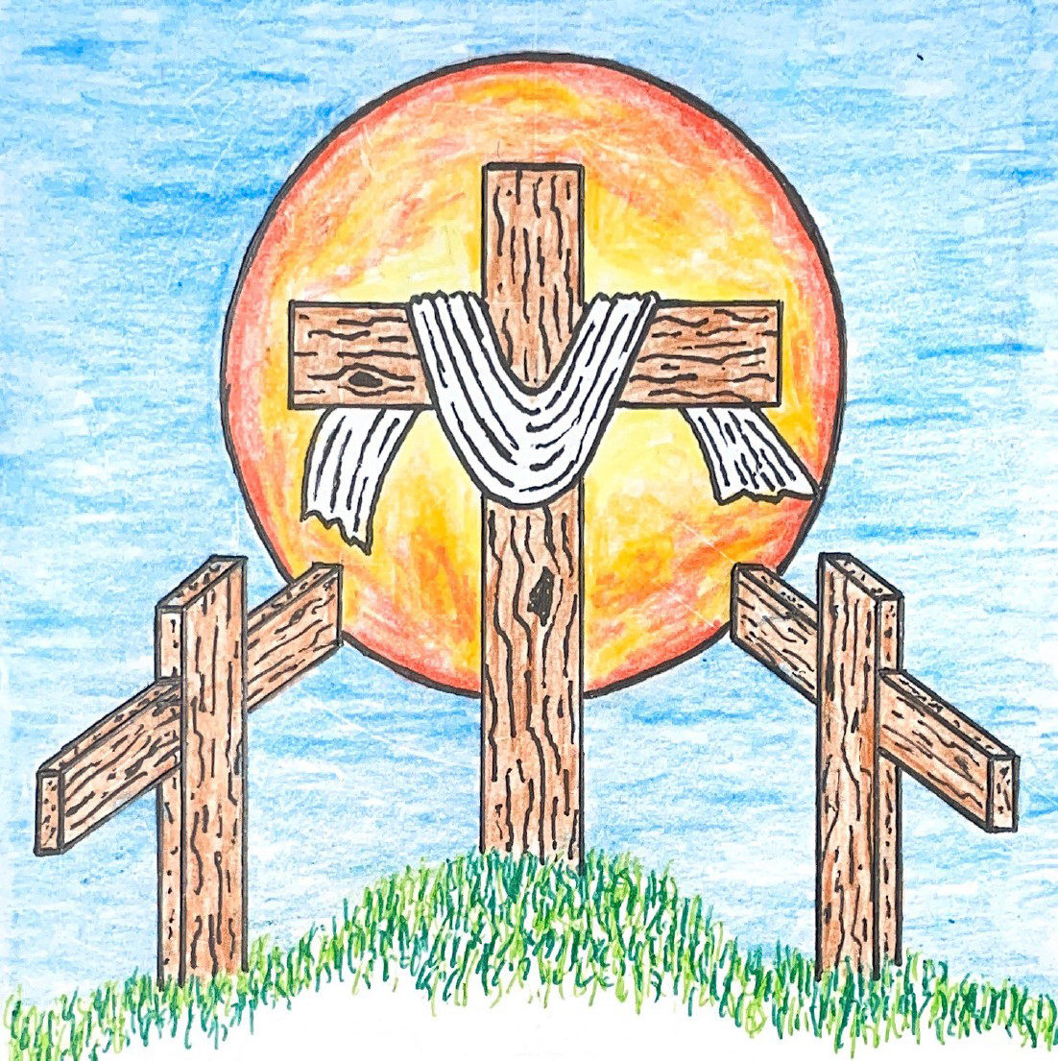

13th Sunday after Pentecost
August 23, 2026 10:00 am
Pastor Mark Swanson

Hymn My Faith Looks Up to Thee CW 811

Stand

In the name of the Father and of the T Son and of the Holy Spirit.
Amen.

Confession CW 172
If we claim to be without sin, we deceive ourselves and the truth is not in us.
If we confess our sins, God is faithful and just
and will forgive us our sins
and purify us from all unrighteousness.

Let us confess our sins to the Lord.
Holy God, gracious Father,
I am sinful by nature
and have sinned against you in my thoughts, words, and actions.
I have not loved you with my whole heart;
I have not loved others as I should.
I deserve your punishment both now and forever.
But Jesus, my Savior, paid for my sins
with his innocent suffering and death.
Trusting in him, I pray: God, have mercy on me, a sinner.

Silence for meditation and reflection

Our gracious Father in heaven has been merciful to us. He sent his only Son, Jesus Christ, who gave his life as the atoning sacrifice for the sins of the whole world. Therefore, as a called servant of Christ and by his authority, I forgive you all your sins in the name of the Father and of the T Son and of the Holy Spirit.
Amen.

Lord, Have Mercy
In peace let us pray to the Lord.
Lord, have mercy.

For the peace from above and for our salvation, let us pray to the Lord.
Lord, have mercy.

For the peace of the whole world, for the well-being of the Church of God, and for the unity of all, let us pray to the Lord.
Lord, have mercy.

For this holy house and for all who offer here their worship and praise, let us pray to the Lord.
Lord, have mercy.

Help, save, comfort, and defend us, gracious Lord.
Amen.

The Word

The Lord be with you.
And also with you.

Prayer of the Day
Let us pray.

Almighty God, whom to know is everlasting life, grant us to know your Son, Jesus, to be the way, the truth, and the life that we may boldly confess him to be the Christ and steadfastly walk in the way that leads to life eternal; through your Son, Jesus Christ our Lord, who lives and reigns with you and the Holy Spirit, one God, now and forever.
Amen.

Be seated

First Reading Exodus 34:5–9
5The Lord came down in the cloud. He took his stand there with Moses and proclaimed the name of the Lord. 6The Lord passed by in front of him and proclaimed: “The Lord, the Lord, the compassionate and gracious God, slow to anger, and overflowing with mercy and truth, 7maintaining mercy for thousands, forgiving guilt and rebellion and sin. He will by no means clear the guilty. He calls their children and their children's children to account for the guilt of the fathers, even to the third and the fourth generation.”
8Moses quickly bowed to the ground and worshipped. 9He said, “If I have now found favor in your sight, Lord, please let the Lord go along with us. Although this is a stiff-necked people, pardon our guilt and our sin, and accept us as your possession.”

The Word of the Lord.
Thanks be to God.

850 It Is Well with My Soul CW 850

Second Reading Romans 10:5–13
5Indeed, Moses writes this about the righteousness that comes by the law: “The one who does these things will live by them.” 6But the righteousness that comes by faith speaks like this: “Do not say in your heart, ‘Who will ascend into heaven?’” (that is, to bring Christ down) 7“or ‘Who will descend into the abyss?’” (that is, to bring Christ up from the dead). 8But what does it say? “The word is near you, in your mouth and in your heart,” that is, the word of faith that we are proclaiming. 9Certainly, if you confess with your mouth that Jesus is Lord and believe in your heart that God raised him from the dead, you will be saved. 10For it is with the heart a person believes, resulting in righteousness, and it is with the mouth that a person confesses, resulting in salvation. 11For Scripture says, “Everyone who believes in him will not be put to shame.”
12So there is no distinction between Jew and Greek, because the same Lord is Lord of all, who gives generously to all who call on him. 13Yes, “Everyone who calls on the name of the Lord will be saved.”

The Word of the Lord.
Thanks be to God.

Stand

Gospel Matthew 16:13–20
13When Jesus came into the region of Caesarea Philippi, he asked his disciples, “Who do people say the Son of Man is?”
14They said, “Some say John the Baptist, others say Elijah, and others Jeremiah or one of the prophets.”
15He said to them, “But you, who do you say that I am?”
16Simon Peter answered, “You are the Christ, the Son of the living God.”
17Jesus replied, “Blessed are you, Simon son of Jonah, for flesh and blood did not reveal this to you, but my Father who is in heaven. 18And I tell you that you are Peter, and on this rock I will build my church, and the gates of hell will not overpower it. 19I will give you the keys of the kingdom of heaven. Whatever you bind on earth will be bound in heaven, and whatever you loose on earth will be loosed in heaven.” 20Then he commanded the disciples not to tell anyone that he was the Christ.

The Gospel of the Lord.
Praise be to you, O Christ!

Be seated

856 Built on the Rock CW 856

Sermon This is Our Confession

Stand

Apostles’ Creed
I believe in God, the Father Almighty,
maker of heaven and earth.

I believe in Jesus Christ, his only Son, our Lord,
who was conceived by the Holy Spirit,
born of the Virgin Mary,
suffered under Pontius Pilate,
was crucified, died, and was buried.
He descended into hell.
The third day he rose again from the dead.
He ascended into heaven
and is seated at the right hand of God the Father Almighty.
From there he will come to judge the living and the dead.

I believe in the Holy Spirit,
the holy Christian Church,
the communion of saints,
the forgiveness of sins,
the resurrection of the body,
and the life everlasting. Amen.

Be seated

Prayer of the Church
Brief intercessory prayers may be added in a fitting place.

Eternal Lord, give us peace as we ponder the good news that you forgive our sins in Christ. Lead us to see clearly the path you have laid out for us.
Work in us so that we believe and live the Word we have heard today.

Provide courage and compassion to all who preach and teach your Word. Fill them with a love like yours as they proclaim your grace to us and all people.
Move us to love all ministers of the Word wherever they serve.

Guard and guide the families of our congregation. Lead husbands and wives to love each other with commitment, respect, and patience. Help parents to grasp the eternal value of keeping their children close to Jesus all their lives. Grant joy to those who are single, and make them a blessing to others.
Protect us from the temptations that surround us; give us pure hearts and minds.

Provide wisdom and insight to those who make laws and set policies. Give us respect for those who protect us from crime. Lead us to value the rights of our fellow citizens and to defend those who cannot defend themselves.
Bless our land with peace and prosperity so that the gospel may be proclaimed to all.

Give us passion to share the story of your love with our family and friends. Overcome unbelief, and open the hearts of people everywhere to believe the good news that Jesus has forgiven their sins and opened the gates of heaven.
Fill us with joy over every sinner who repents and comes to trust in you.

Extend your healing power to those who are sick and suffering in body or mind. [Pour out your special blessing on . . . here name the person and the cause of the petition.] Give patience and compassion to all who care for the sick and dying.
Lift the eyes of the distressed to your love in Christ.

Hear us, Lord, as we pray in silence.

Silent prayer

Gracious God, you govern and direct all things and you love all people. Hear our prayers, spoken and silent, and answer them in your wisdom and grace.
In Jesus’ name we pray. Amen.

Lord’s Prayer
Our Father, who art in heaven,
hallowed be thy name,
thy kingdom come,
thy will be done
on earth as it is in heaven.
Give us this day our daily bread;
and forgive us our trespasses,
as we forgive those
who trespass against us;
and lead us not into temptation,
but deliver us from evil.
For thine is the kingdom
and the power and the glory
forever and ever. Amen.

876 Fight the Good Fight CW 876

Holy Spirit, God and Lord, keep us ever mindful of the fields ripe for harvest here and throughout the world. Give our members a deep passion for the welfare of others and great courage to witness your lifesaving truth to friends, family members, and coworkers. Establish gospel outreach as an immovable pillar of our congregation’s ministry. Make us eager to invest our talents and offerings in evangelism efforts so that many more may be won for your kingdom through faith in Jesus Christ, the Savior of all people.

Blessing
The Lord bless you and keep you.
The Lord make his face shine on you and be gracious to you.
The Lord look on you with favor and T give you peace.
Amen.

885 There Is a Higher Throne CW 885

Acknowledgments
Setting Two from Christian Worship
Unless otherwise noted, Scripture quotations are from the Holy Bible, Evangelical Heritage Version® (EHV®) © 2017 Wartburg Project. All rights reserved. Used by permission.
Liturgical and musical settings of Scripture based on text from The Holy Bible, New International Version®, NIV®. Copyright © 1973, 1978, 1984, 2011 by Biblica, Inc.TM Used by permission of Zondervan. All rights reserved worldwide.
Software distributed in partnership with Northwestern Publishing House.
Created by Christian Worship: Service Builder © 2026 Concordia Publishing House.

Sun, Sep 13 Council meeting 5 pm

Our next Council meeting will be September 13th at 5 pm.

This morning after worship, Bible Class will explore the topic of Evangelism.

In Holy Communion Jesus assures us that all our sins have been forgiven. When we receive the Lord’s Supper, we are expressing our unity in the faith. While we do not want to judge anyone's heart, we also recognize that there are differences among churches. For this reason we ask that only communicant members of our congregation or another WELS/ELS congregation come forward to receive the Lord’s supper. If you have questions about this, please speak with Pastor.

Acknowledgments
Morning Prayer from Christian Worship
Unless otherwise noted, Scripture quotations are from the Holy Bible, Evangelical Heritage Version® (EHV®) © 2017 Wartburg Project. All rights reserved. Used by permission.
Liturgical and musical settings of Scripture based on text from The Holy Bible, New International Version®, NIV®. Copyright © 1973, 1978, 1984, 2011 by Biblica, Inc.TM Used by permission of Zondervan. All rights reserved worldwide.
Software distributed in partnership with Northwestern Publishing House.
Created by Christian Worship: Service Builder © 2026 Concordia Publishing House.

Welcome to Trinity
God welcomes you, no matter who you are or where you come from—and so do we. We believe that Jesus Christ is the true Savior of all people. By his perfect life, innocent death, and triumphant resurrection, he saves all lost sinners even without our help. Jesus Christ makes us special people, right with God and ready for life! We learn this from the Bible, God's authentic message of grace and guidance for us. Whether you are here for the first-time or returning, we are delighted to share our worship with you.

Quiet Room Available
If your child becomes restless during worship, that's okay—we're glad they're here! You may take them into the fellowship hall which we have set up so you can still hear and see the service. This way you can teach your child they're still "in church" and will return to the Sanctuary when they've calmed down.

Wi-Fi Available
Network: Trinity Public Password: triunegod
Regular Worship Schedule
Every Sunday morning at 10:00am.

Our Pastor
Pastor Mark Swanson
Mdws89@gmail.com or telcwels@gmail.com
Office: 541-344-9719
Church Cell: 541-729-4681
Pastor’s Cell: 920-609-6204
Our Church Body
Trinity is affiliated with the
Wisconsin Evangelical Lutheran Synod (WELS).
Follow Us
www.trinityeugene.org
Facebook: “Trinity Evangelical Lutheran Church”
Give Online
Go to www.trinityeugene.org/firstfruits

Address and Phone Number
1310 Echo Hollow Road, Eugene, OR 97402 541-344-9719

