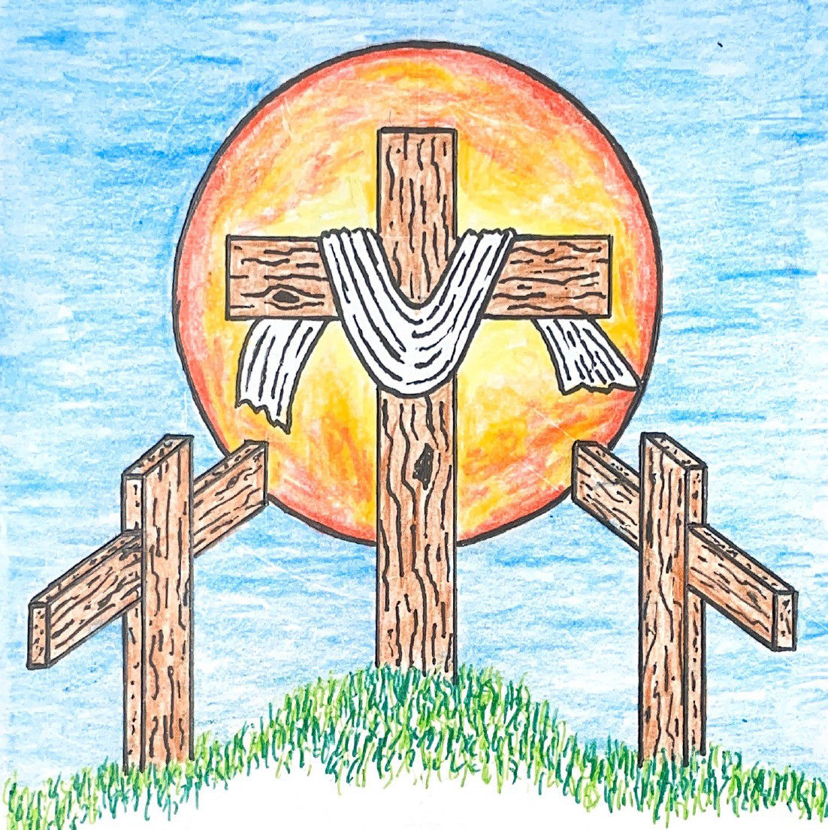

14th Sunday after Pentecost
August 30, 2026 10:00 am
Pastor Mark Swanson
Service of the Word (CW 93 pg. 38)
Hymn Come, Follow Me, the Savior Spoke (pg 14) CW93 453

STAND

M: The grace of our Lord (+) Jesus Christ and the love of God and the fellowship of the Holy Spirit be with you.

C: And also with you.

CONFESSION OF SINS

M: We have come into the presence of God, who created us to love and serve him as his dear children. But we have disobeyed him and deserve only his wrath and punishment. Therefore, let us confess our sins to him and plead for his mercy.

C: Merciful Father in heaven, I am altogether sinful from birth. In countless ways I have sinned against you and do not deserve to be called your child. But trusting in Jesus, my Savior, I pray: Have mercy on me according to your unfailing love. Cleanse me from my sin, and take away my guilt.

M: God, our heavenly Father, has forgiven all your sins. By the perfect life and innocent death of our Lord Jesus Christ, he has removed your guilt forever. You are his own dear child. May God give you strength to live according to his will.

C: Amen.

PRAYER AND PRAISE

M: In the peace of forgiveness, let us praise the Lord.
OH, TASTE AND SEE

PRAYER OF THE DAY

M: Let us pray.
C: Almighty God, your Son willingly endured the agony and shame of the cross for our redemption. Grant us courage to take up our cross daily and follow him wherever he leads; through your Son, Jesus Christ our Lord, who lives and reigns with you and the Holy Spirit, one God, now and forever. Amen.

BE SEATED

THE WORD

FIRST LESSON Jeremiah 15:15–21 ¹⁵O Lord, you understand. Remember me and care for me. Take vengeance for me on those who persecute me. You are slow to anger. Do not take me away. Keep in mind that for your sake I bear disgrace. ¹⁶Your words came to me, and I devoured them. Your words became my joy, the delight of my heart, because I bear your name, O Lord God of Armies. ¹⁷I did not sit with the band of partygoers, nor did I celebrate with them. I sat alone, because your hand was upon me. You filled me with indignation. ¹⁸Why is my pain unending? Why is my wound incurable, refusing to heal? Will you be as deceptive as an intermittent stream to me, like a source of water that a person can't depend on? ¹⁹Therefore this is what the Lord says. If you repent, I will take you back, so that you may stand before me. If what you say is worthwhile and not worthless, you will be my spokesman. They must turn to you, but you must not turn to them. ²⁰I will make you like a bronze wall to this people. They will fight against you, but they will not overcome you, because I am with you to save you and to rescue you, declares the Lord. ²¹I will rescue you from the hand of the wicked, and I will deliver you from the grasp of the ruthless.

Hymn Take the World, but Give Me Jesus CW93 355

SECOND LESSON Romans 8:18–25 ¹⁸For I conclude that our sufferings at the present time are not worth comparing with the glory that is going to be revealed to us. ¹⁹In fact, creation is waiting with eager longing for the sons of God to be revealed. ²⁰For creation was subjected to futility, not by its own will, but by the will of the one who subjected it, in the hope ²¹that even creation itself will be set free from slavery to corruption, in order to share in the glorious freedom of the children of God. ²²For we know that all of creation is groaning with birth pains right up to the present time. ²³And not only creation, but also we ourselves, who have the firstfruits of the Spirit, groan inwardly while we eagerly await our adoption as sons, the redemption of our body. ²⁴Indeed, it was for this hope we were saved. But hope that is seen is not hope, because who hopes for what he already sees? ²⁵But if we hope for something we do not see, we eagerly wait for it with patient endurance.

STAND

GOSPEL Matthew 16:21–26 ²¹From that time, Jesus began to show his disciples that he had to go to Jerusalem and suffer many things from the elders, chief priests, and experts in the law, and be killed, and on the third day be raised again.
²²Peter took him aside and began to rebuke him, saying, “May you receive mercy, Lord! This will never happen to you.”
²³But Jesus turned and said to Peter, “Get behind me, Satan! You are a snare to me because you are not thinking the things of God, but the things of men.”
²⁴Then Jesus said to his disciples, “If anyone wants to follow me, let him deny himself, take up his cross, and follow me. ²⁵In fact whoever wants to save his life will lose it, and whoever loses his life for my sake will find it. ²⁶After all, what will it benefit a person if he gains the whole world, but forfeits his soul? Or what can a person give in exchange for his soul?

C: Praise be to you, O Christ!

BE SEATED

Hymn God’s Own Child, I Gladly Say It (pg 12) CWS 737

SERMON What are you thinking about?

STAND

APOSTLES’ CREED
I believe in God, the Father almighty,
maker of heaven and earth.
I believe in Jesus Christ, his only Son, our Lord,
who was conceived by the Holy Spirit,
born of the virgin Mary,
suffered under Pontius Pilate,
was crucified, died, and was buried.
He descended into hell.
The third day he rose again from the dead.
He ascended into heaven
and is seated at the right hand of God the Father almighty.
From there he will come to judge the living and the dead.
I believe in the Holy Spirit,
the holy Christian Church,
the communion of saints,
the forgiveness of sins,
the resurrection of the body,
and the life everlasting. Amen.

STAND

PRAYER OF THE CHURCH

M: Lord God, our maker and preserver, we praise and thank you for all that you give us day after day.

C: We are not worthy of all the mercies you show us.

M: You have given us your precious Word to nourish our souls and to protect us from the temptations of the devil, the world, and our sinful nature.

C: We thank you for those who teach and preach your saving truth at this place and everywhere. Grant them a rich measure of patience, wisdom, and love.

M: Heavenly Father, we pray that you shield us from every kind of danger: sudden catastrophe, terrors of crime, and the pain of disease. Watch over those who travel by land, sea, and air. Keep our loved ones from whatever perils may threaten them.

C: Heal those who are sick, cheer those who are sad, calm those who are distressed, and comfort all who are old and infirm.

M: Bless our land, our people, and those who hold offices of high trust. Keep our government and schools upright and strong for the advancement of good citizenship and useful vocations, that we may enjoy your gifts of peace, security, and well-being.

C: Grant your blessing to every nation on earth. Where there are wars, may there be peace. Where there is hatred, let it be healed. Where there is poverty, danger, or disaster, come with your almighty power to help and restore.
M: Hear us, Lord, as we bring you our private petitions.

Silent prayer.

M: We bring these requests before you in the name of Jesus our Lord, and ask you to hear us. Take all that we have, our bodies and minds, our time and skills, our ministries and offerings, and use them to your glory.

C: We give ourselves to you that we may serve you in whatever way is pleasing in your sight. Amen.

LORD’S PRAYER
C: Our Father, who art in heaven, hallowed be thy name, thy kingdom come, thy will be done on earth as it is in heaven. Give us this day our daily bread; and forgive us our trespasses, as we forgive those who trespass against us; and lead us not into temptation, but deliver us from evil. For thine is the kingdom and the power and the glory forever and ever. Amen.

Hymn Be Still, My Soul (pg 13) CW93 415

STAND

M: O Lord God, our heavenly Father, pour out the Holy Spirit on your faithful people. Keep us strong in your grace and truth, protect and comfort us in all temptation, and bestow on us your saving peace, through Jesus Christ, our Lord, who lives and reigns with you and the Holy Spirit, one God, now and forever.

C: Amen.

M: Brothers and sisters, go in peace. Live in harmony with one another. Serve the Lord with gladness.

The Lord bless you and keep you.
The Lord make his face shine on you and be gracious to you.
The Lord look on you with favor and (+) give you peace.

C: Amen. Amen. Amen.
Hymn Abide with Me (pg 11) CW93 588

Sun, Sep 13 Picnic Potluck
Sun, Sep 13 Council meeting 5 pm
Sun, Sep 20 Davis Family Baby Shower
Fri, Sep 25 Mary Martha Guild meeting 1pm

Our next Council meeting will be September 13th at 5 pm.

This morning after worship, Bible Class will explore the topic of Stewardship

Picnic Potluck is the theme for fellowship on Sunday, September 13th, after the service! Hamburgers, Hot dogs, buns, condiments, Potato Chips & Beverages will be provided. And if you'd like to, feel free to bring a Dish to pass or a Dessert.

The Davis Family is expecting the arrival of a baby boy in early October! Please join us for a Baby Shower on Sunday, September 20th, after the service. Food & Beverages will be provided.

The Mary Martha Guild's monthly meetings will resume. The Guild will be meeting Friday, September 25th at 1 pm. If you cannot attend the meeting, and have ideas or questions, please let Shirley Mathewson know. Talk to her anytime. Email her at shirlannm@gmail.com or call/text her at 920-205-7266.

In Holy Communion Jesus assures us that all our sins have been forgiven. When we receive the Lord’s Supper, we are expressing our unity in the faith. While we do not want to judge anyone's heart, we also recognize that there are differences among churches. For this reason we ask that only communicant members of our congregation or another WELS/ELS congregation come forward to receive the Lord’s supper. If you have questions about this, please speak with Pastor.

Welcome to Trinity
God welcomes you, no matter who you are or where you come from—and so do we. We believe that Jesus Christ is the true Savior of all people. By his perfect life, innocent death, and triumphant resurrection, he saves all lost sinners even without our help. Jesus Christ makes us special people, right with God and ready for life! We learn this from the Bible, God's authentic message of grace and guidance for us. Whether you are here for the first-time or returning, we are delighted to share our worship with you.

Quiet Room Available
If your child becomes restless during worship, that's okay—we're glad they're here! You may take them into the fellowship hall which we have set up so you can still hear and see the service. This way you can teach your child they're still "in church" and will return to the Sanctuary when they've calmed down.

Wi-Fi Available
Network: Trinity Public Password: triunegod
Regular Worship Schedule
Every Sunday morning at 10:00am.

Our Pastor
Pastor Mark Swanson
Mdws89@gmail.com or telcwels@gmail.com
Office: 541-344-9719
Church Cell: 541-729-4681
Pastor’s Cell: 920-609-6204
Our Church Body
Trinity is affiliated with the
Wisconsin Evangelical Lutheran Synod (WELS).
Follow Us
www.trinityeugene.org
Facebook: “Trinity Evangelical Lutheran Church”
Give Online
Go to www.trinityeugene.org/firstfruits

Address and Phone Number
1310 Echo Hollow Road, Eugene, OR 97402 541-344-9719

