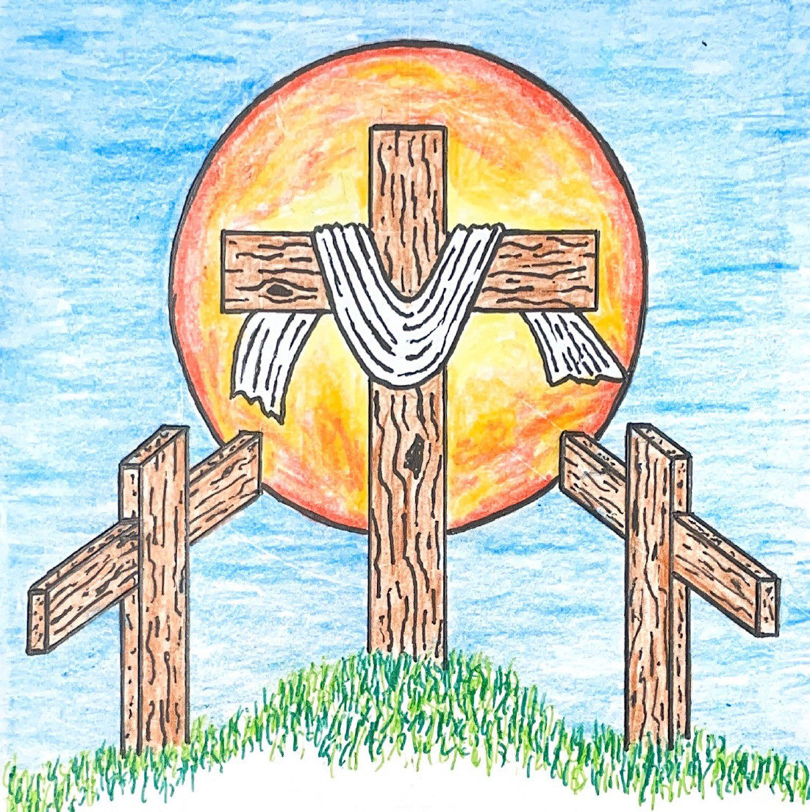

15th Sunday after Pentecost
September 6, 2026 10:00 am
Pastor Mark Swanson
745 Hark, the Voice of Jesus Crying CW 745

In the name of the Father and of the T Son and of the Holy Spirit.
Amen.

Confession
If we claim to be without sin, we deceive ourselves and the truth is not in us.
If we confess our sins, God is faithful and just
and will forgive us our sins
and purify us from all unrighteousness.

Let us confess our sins to the Lord.
Holy God, gracious Father,
I am sinful by nature
and have sinned against you in my thoughts, words, and actions.
I have not loved you with my whole heart;
I have not loved others as I should.
I deserve your punishment both now and forever.
But Jesus, my Savior, paid for my sins
with his innocent suffering and death.
Trusting in him, I pray: God, have mercy on me, a sinner.

Silence for meditation and reflection

Our gracious Father in heaven has been merciful to us. He sent his only Son, Jesus Christ, who gave his life as the atoning sacrifice for the sins of the whole world. Therefore, as a called servant of Christ and by his authority, I forgive you all your sins in the name of the Father and of the T Son and of the Holy Spirit.
Amen.

Lord, Have Mercy
In peace let us pray to the Lord.
Lord, have mercy.

For the peace from above and for our salvation, let us pray to the Lord.
Lord, have mercy.

For the peace of the whole world, for the well-being of the Church of God, and for the unity of all, let us pray to the Lord.
Lord, have mercy.

For this holy house and for all who offer here their worship and praise, let us pray to the Lord.
Lord, have mercy.

Help, save, comfort, and defend us, gracious Lord.
Amen.

Glory to God in the Highest
Refrain: Glory to God in the highest, and peace to his people on earth.

Lord God, heavenly King, almighty God and Father, we worship you, we give you thanks, we praise you for your glory. Refrain

Lord Jesus Christ, only Son of the Father, Lord God, Lamb of God, you take away the sin of the world; have mercy on us. You are seated at the right hand of the Father: receive our prayer, receive our prayer. Refrain

For you alone are the Holy One, you alone are the Lord, you alone are the Most High, Jesus Christ, with the Holy Spirit in the glory of God the Father. Refrain

Glory to God, glory to God.

The Word

The Lord be with you.
And also with you.

Prayer of the Day
Let us pray.
O Lord Jesus Christ, preserve the congregation of believers with your never­failing mercy. Help us avoid whatever is wicked and harmful, and guide us in the way that leads to our salvation; for you live and reign with the Father and the Holy Spirit, one God, now and forever.
Amen.

Be seated

First Reading Ezekiel 33:7–11
7But I have appointed you, son of man, to be a watchman for the house of Israel. So whenever you hear a word from my mouth, you are to warn them from me. 8When I say to a wicked man, “Wicked man, you shall surely die,” if you do not speak to warn the wicked man against his way, that wicked man will die because of his guilt, but I will also hold you responsible for his blood. 9But if you do warn the wicked man to turn from his way, and he does not turn from his way, he will die because of his guilt, but you will have saved your life.
10So you, son of man, say the following to the house of Israel.
This is what you people are saying: “Certainly our rebellion and our sins weigh us down, and because of them we are rotting away. How then can we live?” 11Say to them, “As I live, declares the Lord God, I take no pleasure in the death of the wicked, but rather that the wicked turn from their way and live. Turn back, turn back from your evil ways, for why should you die, O house of Israel?”

The Word of the Lord.
Thanks be to God.

2D Great Are the Works of the LORD Psalm 2D
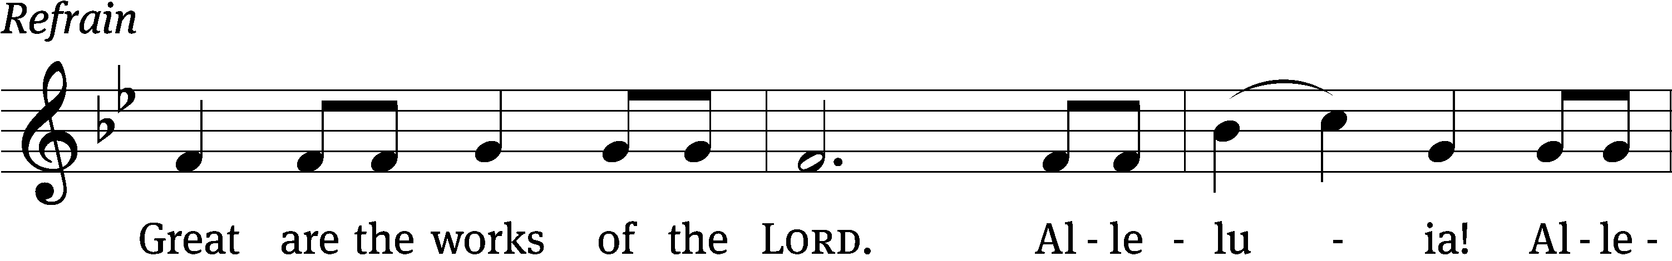
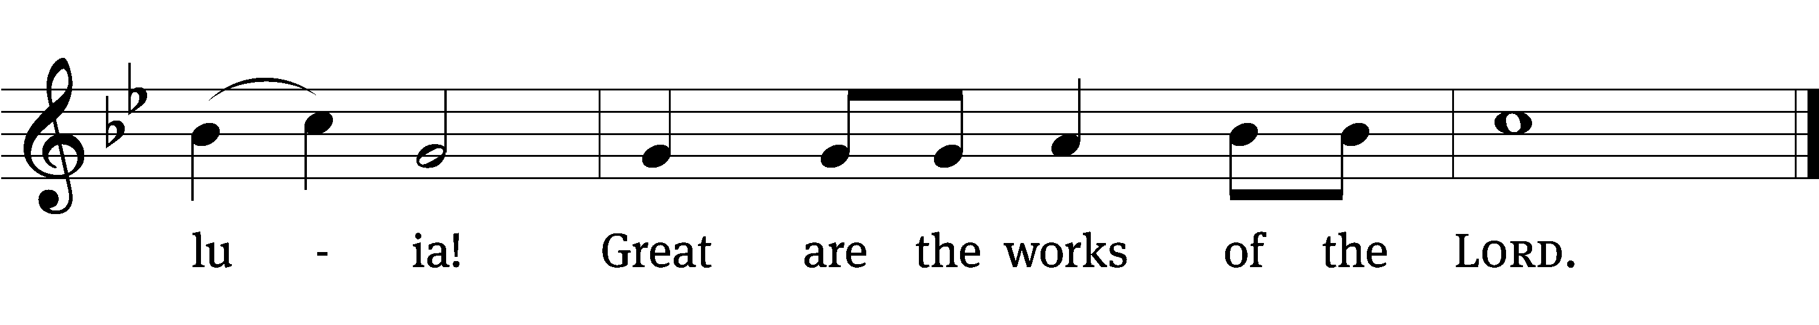
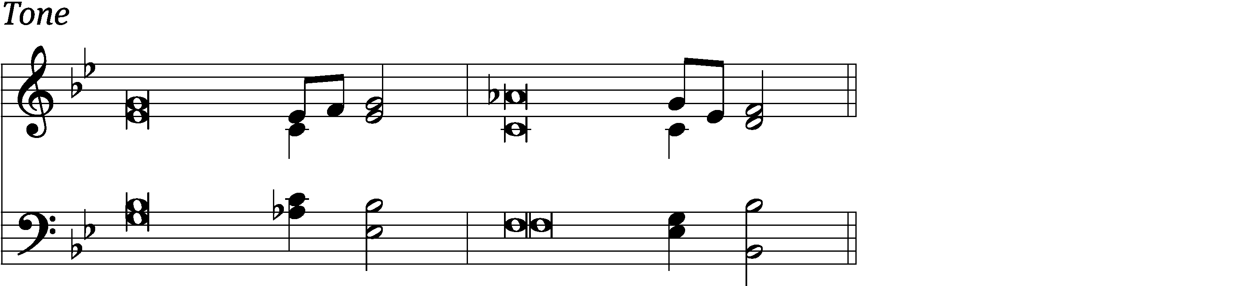

Why do the nations / conspire
and the peoples / plot in vain?
The kings of the earth rise up and the rulers band together a- / gainst the Lord
and against his A- / nointed. Refrain

The One enthroned in / heaven laughs;
the Lord / scoffs at them.
He rebukes them in his anger and terrifies them in his wrath, / saying,
“I have installed my King on Zion, my holy / mountain.” Refrain

I will proclaim the / Lord’s decree:
He said to me, “You are my Son; today I have become your / Father.”
Glory be to the Father and / to the Son
and to the Holy / Spirit,
as it was in the be- / ginning,
is now, and will be forever. / Amen. Refrain
Tune: Kermit G. Moldenhauer
Setting: Kermit G. Moldenhauer
Music: © 1993 Kermit G. Moldenhauer, admin. Northwestern Publishing House. Used by permission: OneLicense no. 740069

Second Reading Galatians 2:11–16
11But when Cephas came to Antioch, I opposed him to his face, because he was clearly wrong. 12For before some people came from James, he ate with the Gentiles. But when those people came, he drew back and separated himself, because he feared those from the circumcision group. 13And the rest of the Jews joined him in his hypocrisy, with the result that even Barnabas was carried away by their hypocrisy. 14But when I saw that they were not acting according to the truth of the gospel, I said to Cephas in front of all of them, “If you, a Jew, live like the Gentiles and not like the Jews, why do you compel the Gentiles to live like the Jews?”
15“We are Jews by birth and not Gentile sinners. 16We know that a person is not justified by the works of the law but through faith in Jesus Christ. So we also believed in Christ Jesus that we might be justified by faith in Christ and not by the works of the law, because no one will be justified by the works of the law.

The Word of the Lord.
Thanks be to God.

Gospel Matthew 18:15–20
15“If your brother sins against you, go and show him his sin just between the two of you. If he listens to you, you have regained your brother. 16But if he will not listen, take one or two others along with you, so that ‘every matter may be established by the testimony of two or three witnesses.’ 17If he refuses to listen to them, tell it to the church. And, if he refuses to listen even to the church, then treat him as an unbeliever or a tax collector. 18Amen I tell you: Whatever you bind on earth will be bound in heaven, and whatever you loose on earth will be loosed in heaven. 19Amen I tell you again: If two of you on earth agree to ask for anything, it will be done for them by my Father who is in heaven. 20In fact where two or three have gathered together in my name, there I am among them.”

The Gospel of the Lord.
Praise be to you, O Christ!

856 Built on the Rock CW 856

Sermon A Difficult Conversation

Nicene Creed
We believe in one God, the Father, the Almighty,
maker of heaven and earth,
of all that is,
seen and unseen.

We believe in one Lord, Jesus Christ, the only Son of God,
eternally begotten of the Father,
God from God, Light from Light, true God from true God,
begotten, not made,
of one being with the Father.
Through him all things were made.
For us and for our salvation, he came down from heaven,
was incarnate of the Holy Spirit and the Virgin Mary,
and became truly human.
For our sake he was crucified under Pontius Pilate.
He suffered death and was buried.
On the third day he rose again in accordance with the Scriptures.
He ascended into heaven
and is seated at the right hand of the Father.
He will come again in glory to judge the living and the dead,
and his kingdom will have no end.

We believe in the Holy Spirit,
the Lord, the giver of life,
who proceeds from the Father and the Son,
who in unity with the Father and the Son
is worshiped and glorified,
who has spoken through the prophets.
We believe in one holy Christian and apostolic Church.
We acknowledge one baptism for the forgiveness of sins.
We look for the resurrection of the dead
and the life of the world to come. Amen.

Prayer of the Church
Almighty God and Father, we thank you for all your mercies, especially for the gift of your Son, through whom you have revealed your gracious will. We praise you for the Holy Spirit and his working through the means of grace.
Plant your Word in our hearts, and cause it to produce fruit in our lives.

Strengthen and defend your Church, that by your Word and sacraments faith may grow and love toward all may increase.
Support all who spread the light of your truth throughout the world.

Keep our children in the grace of their baptisms. Enable their parents to train them in lives of faith.
Raise up Christians to serve you in the ministry of the Word and in all godly walks of life.

Preserve our nation in justice and honor. Guide and bless all who make, administer, and judge our laws.
Give them wisdom that they may promote justice and hinder evil.

Let your blessing rest on planting and harvest, commerce and industry, medicine and science, the arts and culture. Protect all who travel, and care for those whose work is difficult or dangerous.
Be with all who devote themselves to any useful task.

Comfort all who are in sorrow or need, sickness or adversity. Remember those who suffer persecution for the faith. Have mercy on those for whom death draws near.
Grant them your love, and take them into your tender care.

Hear us, Lord, as we pray in silence.

Silent prayer

We remember with thanksgiving those who have loved and served you, who now rest from their labors. Console those who are mourning or living with sadness.
Keep us in the true faith, and bring us at last to the joys of heaven.

Grant us these things, Father, for the sake of Jesus, who died and rose again.
Amen.

Lord’s Prayer
Our Father, who art in heaven,
hallowed be thy name,
thy kingdom come,
thy will be done
on earth as it is in heaven.
Give us this day our daily bread;
and forgive us our trespasses,
as we forgive those
who trespass against us;
and lead us not into temptation,
but deliver us from evil.
For thine is the kingdom
and the power and the glory
forever and ever. Amen.

The Sacrament

Stand

Preface
The Lord be with you.
And also with you.

Lift up your hearts.
We lift them up to the Lord.

Let us give thanks to the Lord our God.
It is right to give him thanks and praise.

It is truly good and right that we should at all times and in all places give you thanks, O Lord, holy Father, almighty and everlasting God, through Jesus Christ our Lord, who promised that wherever two or three come together in his name, there he is with them to shepherd his flock until he comes again in glory. Therefore, with all the saints on earth and hosts of heaven, we praise your holy name and join their glorious song:

Holy, Holy, Holy
Holy, holy, holy Lord, God of power, God of might.
Heav’n and earth are full of your glory.
Hosanna in the highest. Blessed is he who comes in the name of the Lord.
Hosanna in the highest, hosanna in the highest!
Words of Institution
Our Lord Jesus Christ, on the night he was betrayed, took bread; and when he had given thanks, he broke it and gave it to his disciples, saying, “Take and eat; this is my T body, which is given for you. Do this in remembrance of me.”

Then he took the cup, gave thanks, and gave it to them, saying, “Drink from it, all of you; this is my T blood of the new covenant, which is poured out for you for the forgiveness of sins. Do this, whenever you drink it, in remembrance of me.”

The peace of the Lord be with you always.
Amen.

O Christ, Lamb of God
O Christ, Lamb of God, you take away the sin of the world; have mercy on us.
O Christ, Lamb of God, you take away the sin of the world; have mercy on us.
O Christ, Lamb of God, you take away the sin of the world; grant us your peace. Amen. Amen.

670 I Come, O Savior, to Your Table CW 670

Give thanks to the Lord, for he is good;
his mercy endures forever.

Whenever we eat this bread and drink this cup,
we proclaim the Lord’s death until he comes.

We give thanks, almighty God, that you have refreshed us with this saving gift. We pray that through it you will strengthen our faith in you and increase our love for one another. We ask this in the name of Jesus Christ our Lord, who lives and reigns with you and the Holy Spirit, one God, now and forever.
Amen.

Blessing
The Lord bless you and keep you.
The Lord make his face shine on you and be gracious to you.
The Lord look on you with favor and T give you peace.
Amen.

654 Jesus Sinners Does Receive CW 654

Acknowledgments
Setting Four from Christian Worship
Unless otherwise noted, Scripture quotations are from the Holy Bible, Evangelical Heritage Version® (EHV®) © 2017 Wartburg Project. All rights reserved. Used by permission.
Liturgical and musical settings of Scripture based on text from The Holy Bible, New International Version®, NIV®. Copyright © 1973, 1978, 1984, 2011 by Biblica, Inc.TM Used by permission of Zondervan. All rights reserved worldwide.
Software distributed in partnership with Northwestern Publishing House.
Created by Christian Worship: Service Builder © 2026 Concordia Publishing House.

Sun, Sep 13 Picnic Potluck
Sun, Sep 13 Council meeting 5 pm
Sun, Sep 20 Davis Family Baby Shower
Fri, Sep 25 Mary Martha Guild meeting 1pm
Sun, Sep 27 Trunk or Treat meeting 9am

Our next Council meeting will be September 13th at 5 pm.

This morning after worship, Bible Class will explore Paul’s letter to the Philippians.

Picnic Potluck is the theme for fellowship on Sunday, September 13th, after the service! Hamburgers, Hot dogs, buns, condiments, Potato Chips & Beverages will be provided. And if you'd like to, feel free to bring a Dish to pass or a Dessert.

The Davis Family is expecting the arrival of a baby boy in early October! Please join us for a Baby Shower on Sunday, September 20th, after the service. Food & Beverages will be provided.

The Mary Martha Guild's monthly meetings will resume. The Guild will be meeting Friday, September 25th at 1 pm. If you cannot attend the meeting, and have ideas or questions, please let Shirley Mathewson know. Talk to her anytime. Email her at shirlannm@gmail.com or call/text her at 920-205-7266.

In Holy Communion Jesus assures us that all our sins have been forgiven. When we receive the Lord’s Supper, we are expressing our unity in the faith. While we do not want to judge anyone's heart, we also recognize that there are differences among churches. For this reason we ask that only communicant members of our congregation or another WELS/ELS congregation come forward to receive the Lord’s supper. If you have questions about this, please speak with Pastor.

Welcome to Trinity
God welcomes you, no matter who you are or where you come from—and so do we. We believe that Jesus Christ is the true Savior of all people. By his perfect life, innocent death, and triumphant resurrection, he saves all lost sinners even without our help. Jesus Christ makes us special people, right with God and ready for life! We learn this from the Bible, God's authentic message of grace and guidance for us. Whether you are here for the first-time or returning, we are delighted to share our worship with you.

Quiet Room Available
If your child becomes restless during worship, that's okay—we're glad they're here! You may take them into the fellowship hall which we have set up so you can still hear and see the service. This way you can teach your child they're still "in church" and will return to the Sanctuary when they've calmed down.

Wi-Fi Available
Network: Trinity Public Password: triunegod
Regular Worship Schedule
Every Sunday morning at 10:00am.

Our Pastor
Pastor Mark Swanson
Mdws89@gmail.com or telcwels@gmail.com
Office: 541-344-9719
Church Cell: 541-729-4681
Pastor’s Cell: 920-609-6204
Our Church Body
Trinity is affiliated with the
Wisconsin Evangelical Lutheran Synod (WELS).
Follow Us
www.trinityeugene.org
Facebook: “Trinity Evangelical Lutheran Church”
Give Online
Go to www.trinityeugene.org/firstfruits

Address and Phone Number
1310 Echo Hollow Road, Eugene, OR 97402 541-344-9719

