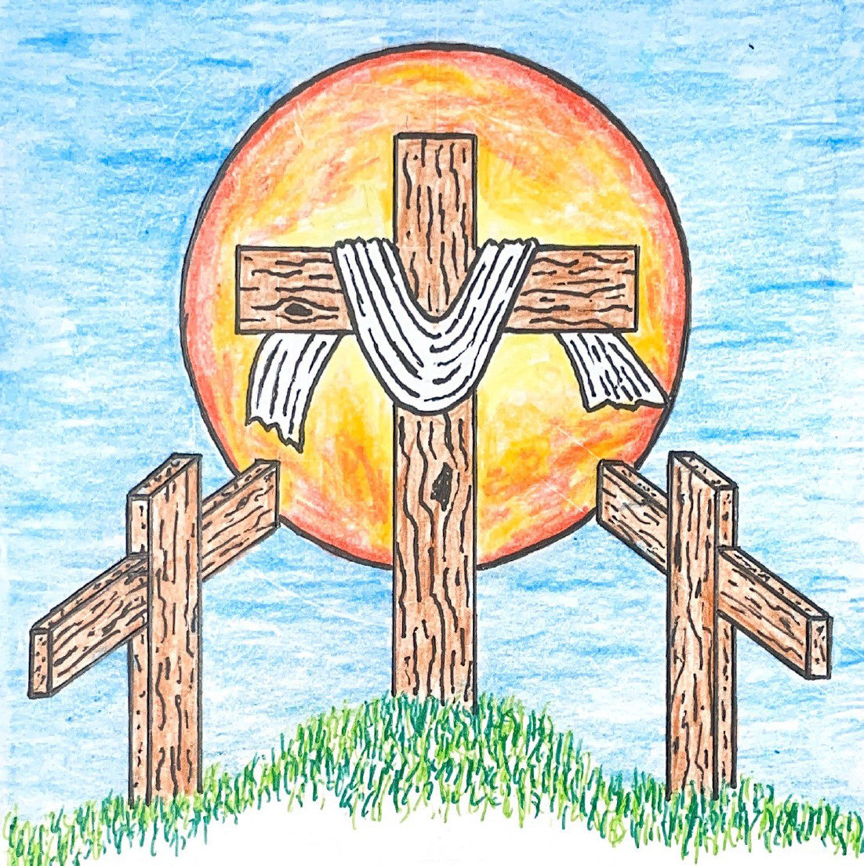

16th Sunday after Pentecost
September 13, 2026 10:00 am
Pastor Mark Swanson
704 Let Us Ever Walk with Jesus CW 704

Stand

In the name of the Father and of the T Son and of the Holy Spirit.
Amen.

Confession CW 172
If we claim to be without sin, we deceive ourselves and the truth is not in us.
If we confess our sins, God is faithful and just
and will forgive us our sins
and purify us from all unrighteousness.

Let us confess our sins to the Lord.
Holy God, gracious Father,
I am sinful by nature
and have sinned against you in my thoughts, words, and actions.
I have not loved you with my whole heart;
I have not loved others as I should.
I deserve your punishment both now and forever.
But Jesus, my Savior, paid for my sins
with his innocent suffering and death.
Trusting in him, I pray: God, have mercy on me, a sinner.

Silence for meditation and reflection

Our gracious Father in heaven has been merciful to us. He sent his only Son, Jesus Christ, who gave his life as the atoning sacrifice for the sins of the whole world. Therefore, as a called servant of Christ and by his authority, I forgive you all your sins in the name of the Father and of the T Son and of the Holy Spirit.
Amen.

Lord, Have Mercy
In peace let us pray to the Lord.
Lord, have mercy.

For the peace from above and for our salvation, let us pray to the Lord.
Lord, have mercy.

For the peace of the whole world, for the well-being of the Church of God, and for the unity of all, let us pray to the Lord.
Lord, have mercy.

For this holy house and for all who offer here their worship and praise, let us pray to the Lord.
Lord, have mercy.

Help, save, comfort, and defend us, gracious Lord.
Amen.

Glory to God in the Highest CW 176
Refrain: Glory to God in the highest, and peace to his people on earth.

Lord God, heavenly King, almighty God and Father, we worship you, we give you thanks, we praise you for your glory. Refrain

Lord Jesus Christ, only Son of the Father, Lord God, Lamb of God, you take away the sin of the world; have mercy on us. You are seated at the right hand of the Father; receive our prayer. Refrain

For you alone are the Holy One, you alone are the Lord, you alone are the Most High, Jesus Christ, with the Holy Spirit in the glory of God the Father. Amen. Amen. Refrain

The Word

The Lord be with you.
And also with you.

Prayer of the Day
Let us pray.

Lord God, heavenly Father, you graciously forgive us all our sins and abundantly provide for all our needs of body and soul. Give us confidence in your mercy, and teach us also to be merciful to our neighbor, that we willingly forgive all people, and judging only ourselves, lead blessed lives to your glory; through your Son, Jesus Christ our Lord, who lives and reigns with you and the Holy Spirit, one God, now and forever.
Amen.

Be seated

First Reading Genesis 50:15–21
15When Joseph's brothers saw that their father was dead, they said, “It may be that Joseph will hate us and will pay us back in full for all of the evil that we did to him.”
16They sent the following message to Joseph: “Before he died your father commanded us, 17‘You are to tell Joseph, “Please forgive the offense of your brothers and their sin, because they did evil to you.”’ Now, please forgive the offense of the servants of the God of your father.”
Joseph wept when they spoke to him.
18His brothers also came and fell down in front of him, and they said, “See now, we are your servants.”
19Joseph said to them, “Do not be afraid, for am I in the place of God? 20You meant evil against me, but God meant it for good, to bring this to pass and to keep many people alive, as it is this day. 21Now therefore, do not be afraid. I will nourish you and your little ones.” He comforted them and spoke to them in a kind way.

The Word of the Lord.
Thanks be to God.

876 Fight the Good Fight CW 876

Second Reading Ephesians 4:29—5:2
29Do not let any unwholesome talk come from your mouths. Say only what is beneficial when there is a need to build up others, so that it will be a blessing to those who hear. 30Do not grieve the Holy Spirit of God, with whom you were sealed for the day of redemption. 31Get rid of every kind of bitterness, rage, anger, quarreling, and slander, along with every kind of malice. 32Instead, be kind and compassionate to one another, forgiving one another, just as God in Christ has forgiven us.
1Therefore, be imitators of God as his dearly loved children. 2And walk in love, just as Christ loved us and gave himself for us, as a fragrant offering and sacrifice to God.

The Word of the Lord.
Thanks be to God.

Stand

Gospel Matthew 18:21–35
21Then Peter came up and asked Jesus, “Lord, how many times must I forgive my brother when he sins against me? As many as seven times?”
22Jesus said to him, “Not seven times, but I tell you as many as seventy-seven times. 23For this reason the kingdom of heaven is like a king who wanted to settle accounts with his servants. 24When he began to settle them, a man who owed him ten thousand talents was brought to him. 25Because the man was not able to pay the debt, his master ordered that he be sold, along with his wife, children, and all that he owned to repay the debt.
26“Then the servant fell down on his knees in front of him, saying, ‘Master, be patient with me, and I will pay you everything!’ 27The master of that servant had pity on him, released him, and forgave him the debt.
28“But when that servant went out, he found one of his fellow servants who owed him one hundred denarii. He grabbed him and began choking him, saying, ‘Pay me what you owe!’
29“So his fellow servant fell down and begged him, saying, ‘Be patient with me, and I will pay you back!’ 30But he refused. Instead he went off and threw the man into prison until he could pay back what he owed.
31“When his fellow servants saw what had happened, they were very distressed. They went and reported to their master everything that had taken place.
32“Then his master called him in and said to him, ‘You wicked servant! I forgave you all that debt when you begged me to. 33Should you not have had mercy on your fellow servant just as I had mercy on you?’ 34His master was angry and handed him over to the jailers until he could pay back everything he owed.
35“This is what my heavenly Father will also do to you unless each one of you forgives his brother from his heart.”

The Gospel of the Lord.
Praise be to you, O Christ!

Be seated

518 Christ Be My Leader CW 518

Sermon More Than We can Pay

Stand

Apostles’ Creed
I believe in God, the Father Almighty,
maker of heaven and earth.

I believe in Jesus Christ, his only Son, our Lord,
who was conceived by the Holy Spirit,
born of the Virgin Mary,
suffered under Pontius Pilate,
was crucified, died, and was buried.
He descended into hell.
The third day he rose again from the dead.
He ascended into heaven
and is seated at the right hand of God the Father Almighty.
From there he will come to judge the living and the dead.

I believe in the Holy Spirit,
the holy Christian Church,
the communion of saints,
the forgiveness of sins,
the resurrection of the body,
and the life everlasting. Amen.

Be seated

Prayer of the Church

Eternal Lord, give us peace as we ponder the good news that you forgive our sins in Christ. Lead us to see clearly the path you have laid out for us.
Work in us so that we believe and live the Word we have heard today.

Provide courage and compassion to all who preach and teach your Word. Fill them with a love like yours as they proclaim your grace to us and all people.
Move us to love all ministers of the Word wherever they serve.

Guard and guide the families of our congregation. Lead husbands and wives to love each other with commitment, respect, and patience. Help parents to grasp the eternal value of keeping their children close to Jesus all their lives. Grant joy to those who are single, and make them a blessing to others.
Protect us from the temptations that surround us; give us pure hearts and minds.

Provide wisdom and insight to those who make laws and set policies. Give us respect for those who protect us from crime. Lead us to value the rights of our fellow citizens and to defend those who cannot defend themselves.
Bless our land with peace and prosperity so that the gospel may be proclaimed to all.

Give us passion to share the story of your love with our family and friends. Overcome unbelief, and open the hearts of people everywhere to believe the good news that Jesus has forgiven their sins and opened the gates of heaven.
Fill us with joy over every sinner who repents and comes to trust in you.

Extend your healing power to those who are sick and suffering in body or mind. Give patience and compassion to all who care for the sick and dying.
Lift the eyes of the distressed to your love in Christ.

Hear us, Lord, as we pray in silence.

Silent prayer

Gracious God, you govern and direct all things and you love all people. Hear our prayers, spoken and silent, and answer them in your wisdom and grace.
In Jesus’ name we pray. Amen.

Lord’s Prayer
Our Father, who art in heaven,
hallowed be thy name,
thy kingdom come,
thy will be done
on earth as it is in heaven.
Give us this day our daily bread;
and forgive us our trespasses,
as we forgive those
who trespass against us;
and lead us not into temptation,
but deliver us from evil.
For thine is the kingdom
and the power and the glory
forever and ever. Amen.

560 Your Works, Not Mine, O Christ CW 560

How can I thank you, Father, for allowing me to worship in your house today! I have heard the promises of your love in the gospel. I have praised you, confessed you, and prayed for your blessings. I have been strengthened by the witness and worship of others. Keep my faith strong as I live out the tasks of my life, take away my doubts and fears, and give me courage to share the good news of your Son wherever I go and however I can.

Blessing
The Lord bless you and keep you.
The Lord make his face shine on you and be gracious to you.
The Lord look on you with favor and T give you peace.
Amen.

627 To God Be the Glory CW 627

Acknowledgments
Setting Two from Christian Worship
Unless otherwise noted, Scripture quotations are from the Holy Bible, Evangelical Heritage Version® (EHV®) © 2017 Wartburg Project. All rights reserved. Used by permission.
Liturgical and musical settings of Scripture based on text from The Holy Bible, New International Version®, NIV®. Copyright © 1973, 1978, 1984, 2011 by Biblica, Inc.TM Used by permission of Zondervan. All rights reserved worldwide.
Software distributed in partnership with Northwestern Publishing House.
Created by Christian Worship: Service Builder © 2026 Concordia Publishing House.

In Holy Communion Jesus assures us that all our sins have been forgiven. When we receive the Lord’s Supper, we are expressing our unity in the faith. While we do not want to judge anyone's heart, we also recognize that there are differences among churches. For this reason we ask that only communicant members of our congregation or another WELS/ELS congregation come forward to receive the Lord’s supper. If you have questions about this, please speak with Pastor.

Sun, Sep 13 Picnic Potluck
Sun, Sep 13 Council meeting 5 pm
Sun, Sep 20 Davis Family Baby Shower
Fri, Sep 25 Mary Martha Guild meeting 1pm
Sun, Sep 27 Trunk or Treat meeting 9am

Our next Council meeting will be today at 5 pm.

Today, for Fellowship, we're having grilled hamburgers & hot dogs. Along with side dishes, potato chips, cookies, iced tea, lemonade and more!

Next Sunday, September 20th, you are all invited to a Baby Shower for Allison, Zachary & Rosalie Davis. They are expecting the arrival of a baby boy in early October! Food and beverages are being provided.

The Mary Martha Guild will be meeting Friday, September 25th at 1:00 pm. All Ladies ages 18 & up should have received the meeting notice email from Cathy Doperalski, Secretary, on Friday. If you cannot attend the meeting, have ideas or questions, you can speak to any of the officers; Shirley Mathewson, President; Cathy Doperalski, Secretary, Gwen White, Vice President; or Cynthia Wilder, Treasurer.

Welcome to Trinity
God welcomes you, no matter who you are or where you come from—and so do we. We believe that Jesus Christ is the true Savior of all people. By his perfect life, innocent death, and triumphant resurrection, he saves all lost sinners even without our help. Jesus Christ makes us special people, right with God and ready for life! We learn this from the Bible, God's authentic message of grace and guidance for us. Whether you are here for the first-time or returning, we are delighted to share our worship with you.

Quiet Room Available
If your child becomes restless during worship, that's okay—we're glad they're here! You may take them into the fellowship hall which we have set up so you can still hear and see the service. This way you can teach your child they're still "in church" and will return to the Sanctuary when they've calmed down.

Wi-Fi Available
Network: Trinity Public Password: triunegod
Regular Worship Schedule
Every Sunday morning at 10:00am.

Our Pastor
Pastor Mark Swanson
Mdws89@gmail.com or telcwels@gmail.com
Office: 541-344-9719
Church Cell: 541-729-4681
Pastor’s Cell: 920-609-6204
Our Church Body
Trinity is affiliated with the
Wisconsin Evangelical Lutheran Synod (WELS).
Follow Us
www.trinityeugene.org
Facebook: “Trinity Evangelical Lutheran Church”
Give Online
Go to www.trinityeugene.org/firstfruits

Address and Phone Number
1310 Echo Hollow Road, Eugene, OR 97402 541-344-9719

