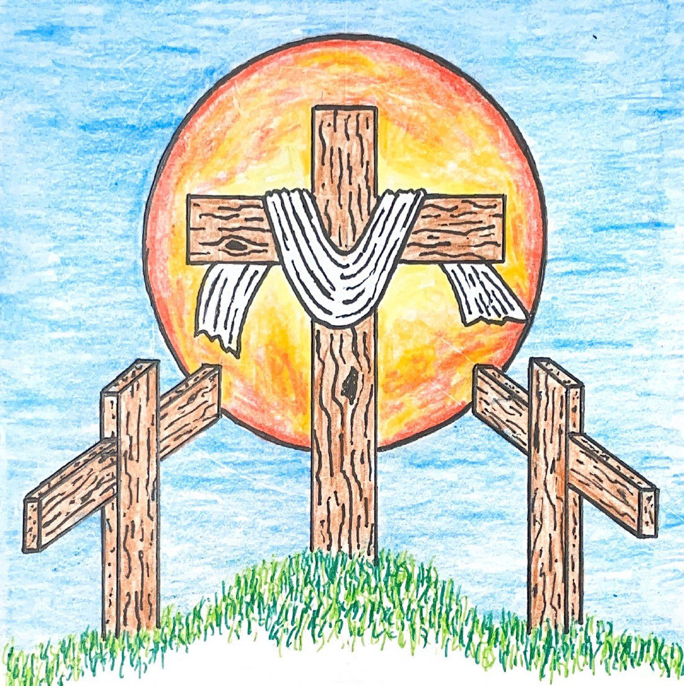

17th Sunday after Pentecost
September 20, 2026 10:00 am
Pastor Mark Swanson

575 By Grace I’m Saved CW 575

Stand

In the name of the Father and of the T Son and of the Holy Spirit.
Amen.

Confession
Our help is in the name of the Lord,
the maker of heaven and earth.
Let us confess our sins to God and ask for his forgiveness.
Almighty God, merciful Father,
I confess to you that I have not loved you with all my heart.
In what I have done and left undone,
I have pursued my ways instead of your ways.
I have not loved others as you command.
For this I deserve your punishment now and forever.
I am sorry for my sins.
I repent of them.
I beg for your mercy.

Silence for meditation and reflection

God, our merciful Father, has forgiven all our sins. He sent his Son, Jesus Christ, to be our Redeemer and Savior. Jesus paid the penalty for our guilt by his death on the cross and freed us from death by his resurrection from the grave. We have peace with God now and forever.
Amen.

Lord, Have Mercy CW 213
Hear my voice when I call, O Lord; be merciful and answer me.
Lord, have mercy. Christ, have mercy. Lord, have mercy.

Glory Be to God on High CW 157
Glory be to God on high, and on earth peace, good will toward men.
We praise you, we bless you, we worship you,
we glorify you, we give thanks to you, for your great glory,
O Lord God, heav’nly King, God the Father Almighty.
O Lord, the only-begotten Son, Jesus Christ;
O Lord God, Lamb of God, Son of the Father,
you take away the sin of the world; have mercy on us.
You take away the sin of the world; receive our prayer.
You sit at the right hand of God the Father; have mercy on us.
For you only are holy; you only are the Lord.
You only, O Christ, with the Holy Spirit,
are most high in the glory of God the Father. Amen.

The Word

The Lord be with you.
And also with you.

Prayer of the Day
Let us pray.

Lord God, you call us to work in your kingdom and promise to reward us according to your grace. Help us to rid our minds of worldly expectations and rejoice that you freely pour out the blessings of salvation to all people; through the merits of Jesus Christ our Lord, who lives and reigns with you and the Holy Spirit, one God, now and forever.
Amen.

Be seated

First Reading Jonah 3:10—4:11
10When God saw their actions, that they had turned from their evil way, God relented from the disaster which he said he would bring on them, and he did not carry it out.
1But to Jonah all this seemed very bad, and he became very angry. 2He prayed to the Lord, “Lord, wasn't this exactly what I said when I was still in my own country? That is why I previously fled to Tarshish, because I knew that you are a gracious and merciful God, slow to anger and abounding in mercy, and you relent from sending disaster. 3So now, Lord, please take my life from me, for it is better for me to die than to live.”
4But the Lord replied, “Is it right for you to be angry?”
5Jonah went out of the city and sat down east of the city. He made a shelter for himself there and sat in the shade under it, waiting to see what would happen in the city.
6Then the Lord God provided a plant and made it grow up over Jonah to provide shade over his head, to relieve him from his discomfort. So Jonah was very happy about the plant. 7But at dawn the next day God provided a worm, and it attacked the plant so that it withered. 8When the sun rose, God provided a scorching east wind. The sun beat down on Jonah's head so that he grew faint. He wanted to die, so he said, “It is better for me to die than to live.”
9But God said to Jonah, “Is it right for you to be angry about the plant?”
Jonah said, “I do have a right to be angry—angry enough to die!”
10So the Lord said, “You have been concerned about this plant. You did not work for it or make it grow. It grew up in one night and perished after one night. 11So should I not be concerned for Nineveh, the great city, in which there are more than one hundred twenty thousand people who do not know the difference between their right hand and their left—and also many animals?”

The Word of the Lord.
Thanks be to God.

579 His Mercy Is More CW 579

Second Reading Romans 9:6–16
6This does not mean that God's word has failed, because not all who are descended from Israel are really Israel, 7and not all who are descended from Abraham are really his children. On the contrary, “Your line of descent will be traced through Isaac.” 8This means that it is not the children of the flesh who are God's children, but it is the children of the promise who are counted as his descendants. 9For this is what the promise said: “I will arrive at this set time, and Sarah will have a son.”
10Not only that, but Rebekah also had children by one man, our forefather, Isaac. 11Even before the twins were born or did anything good or bad, in order that God's purpose in election might continue— 12not by works but because of him who calls us—it was said to her, “The older will serve the younger.” 13Just as it is written: “Jacob I loved, but Esau I hated.”
14What will we say then? Does this mean that God is unjust? Absolutely not! 15For God says to Moses:
I will show mercy to whom I show mercy,
and I will have compassion on whom I have compassion.
16So then, it does not depend on human desire or effort, but on God's mercy.

The Word of the Lord.
Thanks be to God.

Stand

Gospel Acclamation Ephesians 2:8
Alleluia, alleluia, alleluia.
For it is by grace you have been saved, through faith—
and this is not from yourselves, it is the gift of God.
Alleluia, alleluia, alleluia.

Gospel Matthew 20:1–16
1“Indeed the kingdom of heaven is like a landowner who went out early in the morning to hire workers for his vineyard. 2After agreeing to pay the workers a denarius for the day, he sent them into his vineyard. 3He also went out about the third hour and saw others standing unemployed in the marketplace. 4To these he said, ‘You also go into the vineyard, and I will give you whatever is right.’ So they went. 5Again he went out about the sixth and the ninth hour and did the same thing. 6When he went out about the eleventh hour, he found others standing unemployed. He said to them, ‘Why have you stood here all day unemployed?’
7“They said to him, ‘Because no one hired us.’
“He told them, ‘You also go into the vineyard.’ 8When it was evening, the owner of the vineyard said to his foreman, ‘Call the workers and pay them their wages, starting with the last group and ending with the first.’
9“When those who were hired around the eleventh hour came, they each received a denarius. 10When those who were hired first came, they thought they would receive more. But they each received a denarius too. 11After they received it, they began to grumble against the landowner: 12‘Those who were last worked one hour, and you made them equal to us who have endured the burden of the day and the scorching heat!’
13“But he answered one of them, ‘Friend, I am doing you no wrong. Did you not make an agreement with me for a denarius? 14Take what is yours and go. I want to give to the last one hired the same as I also gave to you. 15Can't I do what I want with my own money? Or are you envious because I am generous?’ 16In the same way, the last will be first, and the first, last.”

The Gospel of the Lord.
Praise be to you, O Christ!

Be seated

576 Amazing Grace CW 576

Sermon

Stand

Nicene Creed
We believe in one God, the Father, the Almighty,
maker of heaven and earth,
of all that is,
seen and unseen.

We believe in one Lord, Jesus Christ, the only Son of God,
eternally begotten of the Father,
God from God, Light from Light, true God from true God,
begotten, not made,
of one being with the Father.
Through him all things were made.
For us and for our salvation, he came down from heaven,
was incarnate of the Holy Spirit and the Virgin Mary,
and became truly human.
For our sake he was crucified under Pontius Pilate.
He suffered death and was buried.
On the third day he rose again in accordance with the Scriptures.
He ascended into heaven
and is seated at the right hand of the Father.
He will come again in glory to judge the living and the dead,
and his kingdom will have no end.

We believe in the Holy Spirit,
the Lord, the giver of life,
who proceeds from the Father and the Son,
who in unity with the Father and the Son
is worshiped and glorified,
who has spoken through the prophets.
We believe in one holy Christian and apostolic Church.
We acknowledge one baptism for the forgiveness of sins.
We look for the resurrection of the dead
and the life of the world to come. Amen.

Be seated

Prayer of the Church

Eternal Lord, give us peace as we ponder the good news that you forgive our sins in Christ. Lead us to see clearly the path you have laid out for us.
Work in us so that we believe and live the Word we have heard today.

Provide courage and compassion to all who preach and teach your Word. Fill them with a love like yours as they proclaim your grace to us and all people.
Move us to love all ministers of the Word wherever they serve.

Guard and guide the families of our congregation. Lead husbands and wives to love each other with commitment, respect, and patience. Help parents to grasp the eternal value of keeping their children close to Jesus all their lives. Grant joy to those who are single, and make them a blessing to others.
Protect us from the temptations that surround us; give us pure hearts and minds.

Provide wisdom and insight to those who make laws and set policies. Give us respect for those who protect us from crime. Lead us to value the rights of our fellow citizens and to defend those who cannot defend themselves.
Bless our land with peace and prosperity so that the gospel may be proclaimed to all.

Give us passion to share the story of your love with our family and friends. Overcome unbelief, and open the hearts of people everywhere to believe the good news that Jesus has forgiven their sins and opened the gates of heaven.
Fill us with joy over every sinner who repents and comes to trust in you.

Extend your healing power to those who are sick and suffering in body or mind. Give patience and compassion to all who care for the sick and dying.
Lift the eyes of the distressed to your love in Christ.

Hear us, Lord, as we pray in silence.

Silent prayer

Gracious God, you govern and direct all things and you love all people. Hear our prayers, spoken and silent, and answer them in your wisdom and grace.
In Jesus’ name we pray. Amen.

Offering

The Sacrament

Stand

Preface CW 165
The Lord be with you.
And also with you.

Lift up your hearts.
We lift them up to the Lord.

Let us give thanks to the Lord our God.
It is right to give him thanks and praise.

It is truly good and right that we should at all times and in all places give you thanks, O Lord, holy Father, almighty and everlasting God, through Jesus Christ our Lord, who promised that wherever two or three come together in his name, there he is with them to shepherd his flock until he comes again in glory. Therefore, with all the saints on earth and hosts of heaven, we praise your holy name and join their glorious song:

Holy, Holy, Holy CW 167
Holy, holy, holy Lord God of heavenly hosts: heav’n and earth are full of your glory.
Hosanna, hosanna, hosanna in the highest.
Blessed is he, blessed is he, blessed is he who comes in the name of the Lord.
Hosanna, hosanna, hosanna in the highest.

Prayer of Thanksgiving
We give thanks to you, O God, through your dear Son, Jesus Christ, whom you sent to be our Savior, our Redeemer, and the messenger of your grace. Through him you made all things; in him you are well pleased. He is the incarnate Word, conceived by the Holy Spirit and born of the Virgin Mary. To fulfill your promises, he stretched out his hands on the cross and released from eternal death all who believe in you.

As we remember Jesus’ death and resurrection, we thank you that you have gathered us together to receive your Son’s body and blood. Send us your Spirit, unite us as one, and strengthen our faith so that we may praise you in your Son, Jesus Christ. Through him, we glorify and honor you, O God our Father, with the Holy Spirit, one God, now and forever.
Amen.

Lord’s Prayer
Our Father, who art in heaven,
hallowed be thy name,
thy kingdom come,
thy will be done
on earth as it is in heaven.
Give us this day our daily bread;
and forgive us our trespasses,
as we forgive those
who trespass against us;
and lead us not into temptation,
but deliver us from evil.
For thine is the kingdom
and the power and the glory
forever and ever. Amen.

Words of Institution
Our Lord Jesus Christ, on the night he was betrayed, took bread; and when he had given thanks, he broke it and gave it to his disciples, saying, “Take and eat; this is my T body, which is given for you. Do this in remembrance of me.”

Then he took the cup, gave thanks, and gave it to them, saying, “Drink from it, all of you; this is my T blood of the new covenant, which is poured out for you for the forgiveness of sins. Do this, whenever you drink it, in remembrance of me.”

The peace of the Lord be with you always.
Amen.

O Christ, Lamb of God CW 169
O Christ, Lamb of God, you take away the sin of the world; have mercy on us.
O Christ, Lamb of God, you take away the sin of the world; have mercy on us.
O Christ, Lamb of God, you take away the sin of the world; grant us your peace. Amen.

Be seated

Distribution

602 Great Is Thy Faithfulness CW 602

Stand

Give thanks to the Lord, for he is good;
his mercy endures forever.

Whenever we eat this bread and drink this cup,
we proclaim the Lord’s death until he comes.

We give thanks, almighty God, that you have refreshed us with this saving gift. We pray that through it you will strengthen our faith in you and increase our love for one another. We ask this in the name of Jesus Christ our Lord, who lives and reigns with you and the Holy Spirit, one God, now and forever.
Amen.

Blessing
The grace of our Lord T Jesus Christ and the love of God and the fellowship of the Holy Spirit be with you all.
Amen.

581 Lord, ’Tis Not That I Did Choose You CW 581

Acknowledgments
Setting One from Christian Worship
Unless otherwise noted, Scripture quotations are from the Holy Bible, Evangelical Heritage Version® (EHV®) © 2017 Wartburg Project. All rights reserved. Used by permission.
Liturgical and musical settings of Scripture based on text from The Holy Bible, New International Version®, NIV®. Copyright © 1973, 1978, 1984, 2011 by Biblica, Inc.TM Used by permission of Zondervan. All rights reserved worldwide.
Software distributed in partnership with Northwestern Publishing House.
Created by Christian Worship: Service Builder © 2026 Concordia Publishing House.

Sun, Sep 20 Davis Family Baby Shower
Fri, Sep 25 Mary Martha Guild meeting 1pm
Sun, Sep 27 Trunk or Treat meeting 9am

You are all invited to a Baby Shower for Allison, Zachary & Rosalie Davis. They are expecting the arrival of a baby boy in early October! Food and beverages are being provided.

The Mary Martha Guild will be meeting Friday, September 25th at 1:00 pm. All Ladies ages 18 & up should have received the meeting notice email from Cathy Doperalski, Secretary, on Friday. If you cannot attend the meeting, have ideas or questions, you can speak to any of the officers; Shirley Mathewson, President; Cathy Doperalski, Secretary, Gwen White, Vice President; or Cynthia Wilder, Treasurer.

Welcome to Trinity
God welcomes you, no matter who you are or where you come from—and so do we. We believe that Jesus Christ is the true Savior of all people. By his perfect life, innocent death, and triumphant resurrection, he saves all lost sinners even without our help. Jesus Christ makes us special people, right with God and ready for life! We learn this from the Bible, God's authentic message of grace and guidance for us. Whether you are here for the first-time or returning, we are delighted to share our worship with you.

Quiet Room Available
If your child becomes restless during worship, that's okay—we're glad they're here! You may take them into the fellowship hall which we have set up so you can still hear and see the service. This way you can teach your child they're still "in church" and will return to the Sanctuary when they've calmed down.

Wi-Fi Available
Network: Trinity Public Password: triunegod
Regular Worship Schedule
Every Sunday morning at 10:00am.

Our Pastor
Pastor Mark Swanson
Mdws89@gmail.com or telcwels@gmail.com
Office: 541-344-9719
Church Cell: 541-729-4681
Pastor’s Cell: 920-609-6204
Our Church Body
Trinity is affiliated with the
Wisconsin Evangelical Lutheran Synod (WELS).
Follow Us
www.trinityeugene.org
Facebook: “Trinity Evangelical Lutheran Church”
Give Online
Go to www.trinityeugene.org/firstfruits

Address and Phone Number
1310 Echo Hollow Road, Eugene, OR 97402 541-344-9719

