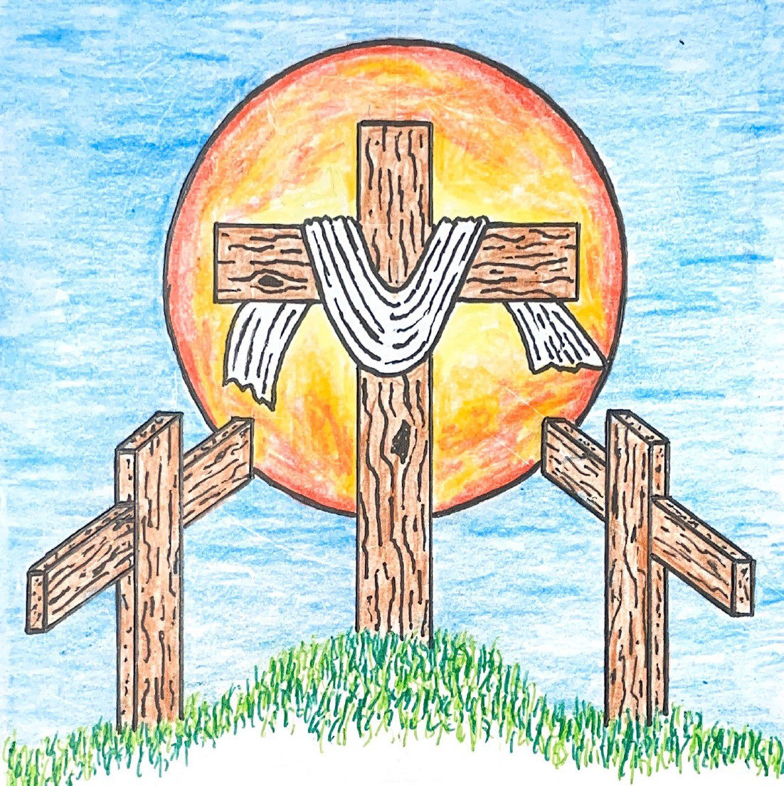

3rd Sunday after Pentecost
June 14, 2026 10:00 am
Pastor Mark Swanson
745 Hark, the Voice of Jesus Crying CW 745

Stand

In the name of the Father and of the T Son and of the Holy Spirit.
Amen.

Confession
If we claim to be without sin, we deceive ourselves and the truth is not in us.
If we confess our sins, God is faithful and just
and will forgive us our sins
and purify us from all unrighteousness.

Let us confess our sins to the Lord.
Holy God, gracious Father,
I am sinful by nature
and have sinned against you in my thoughts, words, and actions.
I have not loved you with my whole heart;
I have not loved others as I should.
I deserve your punishment both now and forever.
But Jesus, my Savior, paid for my sins
with his innocent suffering and death.
Trusting in him, I pray: God, have mercy on me, a sinner.

Silence for meditation and reflection

Our gracious Father in heaven has been merciful to us. He sent his only Son, Jesus Christ, who gave his life as the atoning sacrifice for the sins of the whole world. Therefore, as a called servant of Christ and by his authority, I forgive you all your sins in the name of the Father and of the T Son and of the Holy Spirit.
Amen.

Lord, Have Mercy
In peace let us pray to the Lord.
Lord, have mercy.

For the peace from above and for our salvation, let us pray to the Lord.
Lord, have mercy.

For the peace of the whole world, for the well-being of the Church of God, and for the unity of all, let us pray to the Lord.
Lord, have mercy.

For this holy house and for all who offer here their worship and praise, let us pray to the Lord.
Lord, have mercy.

Help, save, comfort, and defend us, gracious Lord.
Amen.

Glory to God in the Highest
Refrain: Glory to God in the highest, and peace to his people on earth.

Lord God, heavenly King, almighty God and Father, we worship you, we give you thanks, we praise you for your glory. Refrain

Lord Jesus Christ, only Son of the Father, Lord God, Lamb of God, you take away the sin of the world; have mercy on us. You are seated at the right hand of the Father: receive our prayer, receive our prayer. Refrain

For you alone are the Holy One, you alone are the Lord, you alone are the Most High, Jesus Christ, with the Holy Spirit in the glory of God the Father. Refrain

Glory to God, glory to God.

The Word

The Lord be with you.
And also with you.

Prayer of the Day
Let us pray.

Almighty, eternal God, in the Word of your apostles and prophets, you have proclaimed to us your saving will. Grant us faith to believe your promises that we may receive eternal salvation; through your Son, Jesus Christ our Lord, who lives and reigns with you and the Holy Spirit, one God, now and forever.
Amen.

Be seated

First Reading Numbers 27:15–23
15Moses spoke to the Lord, 16“May the Lord, the God of the spirits of all flesh, appoint a man over the community, 17who will go out before them and come in before them, who will lead them out and bring them in, so that the community of the Lord will not be like sheep without a shepherd.”
18The Lord said to Moses, “Take Joshua son of Nun, a man in whom is the Spirit, and place your hand on him. 19Have him stand in front of Eleazar the priest and the entire community. You will commission him in their sight. 20You will give some of your authority to him so that the entire Israelite community will listen to him. 21He will stand before Eleazar the priest, who will inquire for him before the Lord with the decision of the Urim. He and all the Israelites with him, the entire community, will go out at his command and come in at his command.”
22Moses did just as the Lord commanded him. He took Joshua and had him stand in front of Eleazar the priest and the entire community. 23He placed his hands on him and commissioned him, just as the Lord spoke through Moses.

The Word of the Lord.
Thanks be to God.

100B All People That on Earth Do Dwell Psalm 100B

Second Reading 1 Corinthians 4:1–7
1This is the way a person should think of us: as servants of Christ and stewards of God's mysteries. 2In this connection, moreover, it is required of stewards that they be found faithful. 3But it is a trivial matter to me if I am evaluated by you or by a day in a human court. Why, I do not even evaluate myself. 4I do not in fact know of anything against myself, but I am not justified by this; rather, the one who evaluates me is the Lord. 5Therefore judge nothing ahead of time, until the Lord comes. He will bring to light whatever is hidden in darkness and also reveal the intentions of hearts. Then there will be praise for each person from God.
6Brothers, I turned these things into a lesson using myself and Apollos as examples. I did this for your benefit, so that you may learn from us not to go beyond what is written. Then you will not be arrogant, favoring one person over the other. 7For who makes you so special? And what do you have that you did not receive? But if you did receive it, why do you boast as if you had not received it?

The Word of the Lord.
Thanks be to God.

Stand

Gospel Matthew 9:35—10:8
35Jesus traveled through all the towns and villages, teaching in their synagogues, preaching the gospel of the kingdom, and healing every disease and every sickness.
36When he saw the crowds, he was moved with compassion for them, because they were troubled and downcast, like sheep without a shepherd. 37Then he said to his disciples, “The harvest is plentiful, but the workers are few. 38Therefore pray that the Lord of the harvest will send out workers into his harvest.”
1Jesus called his twelve disciples to himself and gave them authority to drive out unclean spirits and to heal every disease and every sickness. 2These are the names of the twelve apostles: first, Simon (who is called Peter) and his brother Andrew; James the son of Zebedee and his brother John; 3Philip and Bartholomew; Thomas and Matthew the tax collector; James the son of Alphaeus, and Thaddaeus; 4Simon the Zealot and Judas Iscariot, who betrayed him.
5Jesus sent these twelve out and commanded them,
"Do not go among the Gentiles, and do not enter any town of the Samaritans.
6Go instead to the lost sheep of the house of Israel. 7As you go, preach this message: ‘The kingdom of heaven is near!’ 8Heal the sick. Raise the dead. Cleanse lepers. Drive out demons. Freely you have received; freely give.

The Gospel of the Lord.
Praise be to you, O Christ!

Be seated

729 Son of God, Eternal Savior CW 729

Sermon Harvest Work

Stand

Nicene Creed
We believe in one God, the Father, the Almighty,
maker of heaven and earth,
of all that is,
seen and unseen.

We believe in one Lord, Jesus Christ, the only Son of God,
eternally begotten of the Father,
God from God, Light from Light, true God from true God,
begotten, not made,
of one being with the Father.
Through him all things were made.
For us and for our salvation, he came down from heaven,
was incarnate of the Holy Spirit and the Virgin Mary,
and became truly human.
For our sake he was crucified under Pontius Pilate.
He suffered death and was buried.
On the third day he rose again in accordance with the Scriptures.
He ascended into heaven
and is seated at the right hand of the Father.
He will come again in glory to judge the living and the dead,
and his kingdom will have no end.

We believe in the Holy Spirit,
the Lord, the giver of life,
who proceeds from the Father and the Son,
who in unity with the Father and the Son
is worshiped and glorified,
who has spoken through the prophets.
We believe in one holy Christian and apostolic Church.
We acknowledge one baptism for the forgiveness of sins.
We look for the resurrection of the dead
and the life of the world to come. Amen.

Be seated

Prayer of the Church

Almighty God and Father, we thank you for all your mercies, especially for the gift of your Son, through whom you have revealed your gracious will. We praise you for the Holy Spirit and his working through the means of grace.
Plant your Word in our hearts, and cause it to produce fruit in our lives.

Strengthen and defend your Church, that by your Word and sacraments faith may grow and love toward all may increase.
Support all who spread the light of your truth throughout the world.

Keep our children in the grace of their baptisms. Enable their parents to train them in lives of faith.
Raise up Christians to serve you in the ministry of the Word and in all godly walks of life.

Preserve our nation in justice and honor. Guide and bless all who make, administer, and judge our laws.
Give them wisdom that they may promote justice and hinder evil.

Let your blessing rest on planting and harvest, commerce and industry, medicine and science, the arts and culture. Protect all who travel, and care for those whose work is difficult or dangerous.
Be with all who devote themselves to any useful task.

Comfort all who are in sorrow or need, sickness or adversity, Remember those who suffer persecution for the faith. Have mercy on those for whom death draws near.
Grant them your love, and take them into your tender care.

Hear us, Lord, as we pray in silence.

Silent prayer

We remember with thanksgiving those who have loved and served you, who now rest from their labors, Console those who are mourning or living with sadness.
Keep us in the true faith, and bring us at last to the joys of heaven.

Grant us these things, Father, for the sake of Jesus, who died and rose again.
Amen.

Lord’s Prayer
Our Father, who art in heaven,
hallowed be thy name,
thy kingdom come,
thy will be done
on earth as it is in heaven.
Give us this day our daily bread;
and forgive us our trespasses,
as we forgive those
who trespass against us;
and lead us not into temptation,
but deliver us from evil.
For thine is the kingdom
and the power and the glory
forever and ever. Amen.

Be seated

Lord Jesus Christ, you sent your disciples to proclaim your coming. Bless all the missions of your church, and enable your workers to gather in your harvest. Through them, show your love to the helpless, enlighten those in darkness, assist those in peril and need, and at last bring all your children home to yourself; you live and reign, now and forever.

Blessing
The Lord bless you and keep you.
The Lord make his face shine on you and be gracious to you.
The Lord look on you with favor and T give you peace.
Amen.

508 Sing to the Lord of Harvest CW 508

Acknowledgments
Setting Four from Christian Worship
Unless otherwise noted, Scripture quotations are from the Holy Bible, Evangelical Heritage Version® (EHV®) © 2017 Wartburg Project. All rights reserved. Used by permission.
Liturgical and musical settings of Scripture based on text from The Holy Bible, New International Version®, NIV®. Copyright © 1973, 1978, 1984, 2011 by Biblica, Inc.TM Used by permission of Zondervan. All rights reserved worldwide.
Software distributed in partnership with Northwestern Publishing House.
Created by Christian Worship: Service Builder © 2026 Concordia Publishing House.

Sun, June 14 Council meeting 5 pm
Wed-Fri, June 17-19 Vacation Bible School
Sun, June 21 Pies for Guys

Council Meeting today. June 14 at 5 pm.

Bible Study today we will look at God’s Providence. Everyone is invited after refreshments to explore this topic.

You have 1 more chance for our collection for Food for Lane County. Pastor is dropping items off on Tuesday the 16th.

VBS is fast Approaching! June 17,18, and 19. If you would like to help out talk to Vickie or Pastor.

In Holy Communion Jesus assures us that all our sins have been forgiven. When we receive the Lord’s Supper, we are expressing our unity in the faith. While we do not want to judge anyone's heart, we also recognize that there are differences among churches. For this reason we ask that only communicant members of our congregation or another WELS/ELS congregation come forward to receive the Lord’s supper. If you have questions about this, please speak with Pastor.

Welcome to Trinity
God welcomes you, no matter who you are or where you come from—and so do we. We believe that Jesus Christ is the true Savior of all people. By his perfect life, innocent death, and triumphant resurrection, he saves all lost sinners even without our help. Jesus Christ makes us special people, right with God and ready for life! We learn this from the Bible, God's authentic message of grace and guidance for us. Whether you are here for the first-time or returning, we are delighted to share our worship with you.

Quiet Room Available
If your child becomes restless during worship, that's okay—we're glad they're here! You may take them into the fellowship hall which we have set up so you can still hear and see the service. This way you can teach your child they're still "in church" and will return to the Sanctuary when they've calmed down.

Wi-Fi Available
Network: Trinity Public Password: triunegod
Regular Worship Schedule
Every Sunday morning at 10:00am.

Our Pastor
Pastor Mark Swanson
Mdws89@gmail.com or telcwels@gmail.com
Office: 541-344-9719
Church Cell: 541-729-4681
Pastor’s Cell: 920-609-6204
Our Church Body
Trinity is affiliated with the
Wisconsin Evangelical Lutheran Synod (WELS).
Follow Us
www.trinityeugene.org
Facebook: “Trinity Evangelical Lutheran Church”
Give Online
Go to www.trinityeugene.org/firstfruits

Address and Phone Number
1310 Echo Hollow Road, Eugene, OR 97402 541-344-9719

