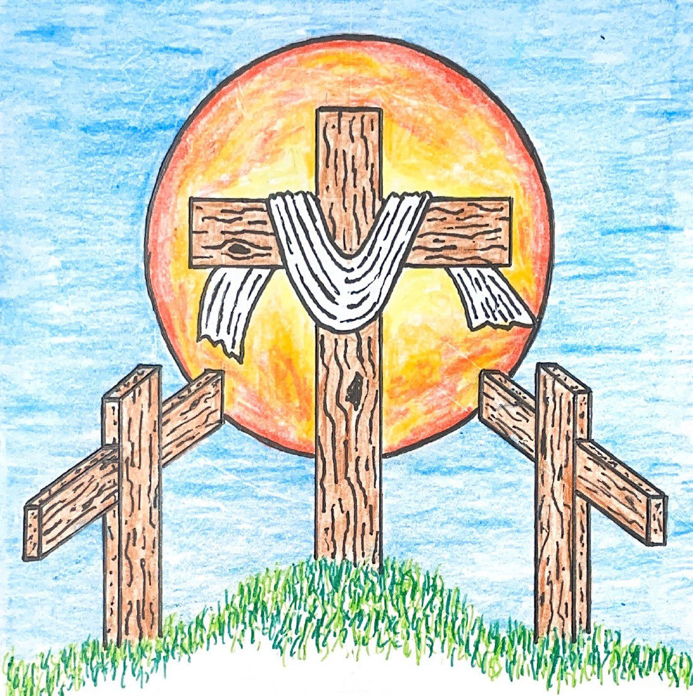

7th Sunday after Pentecost
July 12, 2026 10:00 am
Pastor Mark Swanson
698 Seek Where You May to Find a Way CW 698

Stand

Opening Sentences
O Lord, open my lips.
And my mouth shall declare your praise.

Hasten to save me, O God.
O Lord, come quickly to help me.

Give glory to God, our light and our life.
Come, O come, let us worship.

O Come, Let Us Sing to the Lord CW 208
1 O come, let us sing to the Lord,
let us make a joyful noise to the rock of our salvation.
Let us come into his presence with thanksgiving,
let us make a joyful noise to him with songs of praise.

2 For the Lord is a great God
and a great king above all gods.
The deep places of the earth are in his hand;
the heights of the hills are also his.

3 The sea is his, for he made it,
and his hand formed the dry land.
O come, let us worship and bow down,
let us kneel before the Lord our maker.

4 For he is our God,
and we are the people of his pasture
and the sheep of his hand.

Be seated

Prayer of the Day
Let us pray.

Blessed Lord, since you have caused all Holy Scriptures to be written for our learning, grant that we may so hear them, read, mark, learn, and inwardly digest them that we may embrace and ever hold fast the blessed hope of everlasting life; through your Son, Jesus Christ our Lord, who lives and reigns with you and the Holy Spirit, one God, now and forever.
Amen.

First Reading Isaiah 55:6–11
6Seek the Lord while he may be found!
Call on him while he is near!
7Let the wicked man abandon his way.
Let an evil man abandon his thoughts.
Let him turn to the Lord,
and he will show him mercy.
Let him turn to our God,
because he will abundantly pardon.
8Certainly my plans are not your plans,
and your ways are not my ways, declares the Lord.
9Just as the heavens are higher than the earth,
so my ways are higher than your ways,
and my plans are higher than your plans.
10Just as the rain and the snow come down from the sky
and do not return there
unless they first water the earth, make it give birth, and cause it to sprout,
so that it gives seed to the sower and bread to the eater,
11in the same way my word that goes out from my mouth
will not return to me empty.
Rather, it will accomplish whatever I please,
and it will succeed in the purpose for which I sent it.

The Word of the Lord.
Thanks be to God.

63A In the Morning I Will Sing Psalm 63A
Ref In the morning I will sing,
I will sing glad songs to you,
I will sing glad songs of praise to you.
I will sing glad songs of praise to you.

1 O God, you are my God; for you I long;
for you my soul is thirsting.
My body pines for you
like a dry, weary land without water.
So I gaze on you in the sanctuary
to see your strength and your glory. (Refrain)

2 For your love is better than life,
my lips will speak your praise.
So I will bless you all my life,
in your name I will lift up my hands.
My soul shall be filled as with a banquet,
my mouth shall praise you with joy. (Refrain)

3 On my bed I remember you.
On you I muse through the night,
for you have been my help;
in the shadow of your wings I rejoice.
My soul clings to you;
your right hand holds me fast. (Refrain)
Text: © 1963, 1986, 1993 The Grail, GIA Publications, Inc., agent. Used by permission: OneLicense no. 740069

Second Reading 1 Corinthians 3:5–11
5What then is Apollos? And what is Paul? They are ministers through whom you believed, and each served as the Lord gave him his role. 6I planted, Apollos watered, but God was causing the growth. 7So then, neither the one who plants nor the one who waters is anything, but it is God who causes the growth. 8The one who plants and the one who waters are united, and each will receive his own reward according to his own labor. 9For God is the one whom we serve as coworkers, and you are God's field, God's building.
10In keeping with the grace of God given to me, as a wise master builder, I laid a foundation, and someone else is building on it. But let each person be careful how he builds on it. 11In fact, no one can lay any other foundation than the one that has been laid, which is Jesus Christ.

The Word of the Lord.
Thanks be to God.

Gospel Matthew 13:1–9, 18–23
1That same day Jesus left the house and was sitting by the sea. 2A large crowd gathered around him. So he stepped into a boat and sat down, while all the people stood on the shore. 3He told them many things in parables, saying: “Listen, a sower went out to sow. 4As he sowed, some seed fell along the path, and the birds came and ate it. 5Other seed fell on rocky ground, where it did not have much soil. Immediately the seed sprang up, because the soil was not deep. 6But when the sun rose, the seed was scorched. Because it had no root, it withered away. 7Other seed fell among thorns. The thorns grew up and choked it. 8But some seed fell on good ground and produced grain: some one hundred times, some sixty, and some thirty times more than was sown. 9Whoever has ears to hear, let him hear.”
18“So listen carefully to the parable of the sower. 19When anyone hears the word of the kingdom and does not understand it, the Evil One comes and snatches away what has been sown in his heart. This is the seed that was sown along the path. 20The seed that was sown on rocky ground is the person who hears the word and immediately receives it with joy, 21yet he is not deeply rooted and does not endure. When trouble or persecution comes because of the word, he immediately falls away. 22The seed that was sown among the thorns is the one who hears the word, but the worry of this world and the deceitfulness of wealth choke the word, and it produces no fruit. 23But the seed that was sown on the good ground is the one who continues to hear and understand the word. Indeed he continues to produce fruit: some a hundred, some sixty, and some thirty times more than was sown.”

The Gospel of the Lord.
Praise be to you, O Christ!

633 Speak, O Lord CW 633

Sermon Working Together

Stand

607 Ten Thousand Reasons CW 607

Stand

Prayer
Brief intercessory prayers may be added in a fitting place.

Praise to you, Holy Spirit! We worship you as the Lord and adore you as the giver of life. As you were present at the beginning of the world to give life to all created things and as you enlightened and equipped the disciples on the Day of Pentecost by the baptism of fire, so by the baptism of water with the Word you made the light of faith shine in our hearts to know Jesus as our Lord. We confess:

I believe that I cannot by my own thinking or choosing believe in Jesus Christ, my Lord, or come to him. But the Holy Spirit has called me by the gospel, enlightened me with his gifts, sanctified and kept me in the true faith. In the same way he calls, gathers, enlightens, and sanctifies the whole Christian Church on earth, and keeps it with Jesus Christ in the one true faith.

Holy Spirit, Spirit of truth and source of all spiritual gifts, stand by us in the weakness of our sinful nature. Grant us a right understanding of the truths that Jesus taught. Give us strength to endure with patience whatever afflictions God may send into our lives. Help us, intercede for us, and train us that we may pray to the Father with boldness and confidence. Preserve us by the power of your Word in our most holy faith as members of the Church, the body of Jesus.
In this Christian Church he daily and fully forgives all sins to me and all believers.

Holy Spirit, you comfort and counsel us in every need. In dark and difficult days strengthen our feeble hands, steady our weak knees, and encourage our fearful hearts. [We pray especially for…here name the person and the cause of the petition.] Support us with the promise that in your final creative act you will raise up our bodies so that together with all believers we may see and enjoy the glorious return of Jesus Christ.
On the Last Day he will raise me and all the dead and give eternal life to me and all believers in Christ. This is most certainly true. Amen.

Hear us, Lord, as we pray in silence.

Silent prayer

Come, Holy Spirit, renew our hearts
And kindle in us the fire of your love. Amen.

Lord’s Prayer
Our Father, who art in heaven,
hallowed be thy name,
thy kingdom come,
thy will be done
on earth as it is in heaven.
Give us this day our daily bread;
and forgive us our trespasses,
as we forgive those
who trespass against us;
and lead us not into temptation,
but deliver us from evil.
For thine is the kingdom
and the power and the glory
forever and ever. Amen.

Words of Institution
Our Lord Jesus Christ, on the night he was betrayed, took bread; and when he had given thanks, he broke it and gave it to his disciples, saying, “Take and eat; this is my T body, which is given for you. Do this in remembrance of me.”

Then he took the cup, gave thanks, and gave it to them, saying, “Drink from it, all of you; this is my T blood of the new covenant, which is poured out for you for the forgiveness of sins. Do this, whenever you drink it, in remembrance of me.”

667 Lord Jesus Christ, You Have Prepared CW 667

Prayer for Grace
O Lord, our heavenly Father, almighty and everlasting God, you have brought us safely to this new day. Defend us with your mighty power, and grant that this day we neither fall into sin nor run into any kind of danger. And in all we do, direct us to what is right in your sight; through Jesus Christ, your Son, our Lord.
Amen.

Benedicamus
Let us praise the Lord.
Thanks be to God.

Blessing
The almighty and merciful Lord—the Father, the T Son, and the Holy Spirit—bless us and keep us.
Amen.

905 Good News of God Above CW 905

Acknowledgments
Morning Prayer (alternate) from Christian Worship
Unless otherwise noted, Scripture quotations are from the Holy Bible, Evangelical Heritage Version® (EHV®) © 2017 Wartburg Project. All rights reserved. Used by permission.
Liturgical and musical settings of Scripture based on text from The Holy Bible, New International Version®, NIV®. Copyright © 1973, 1978, 1984, 2011 by Biblica, Inc.TM Used by permission of Zondervan. All rights reserved worldwide.
Software distributed in partnership with Northwestern Publishing House.
Created by Christian Worship: Service Builder © 2026 Concordia Publishing House.

Sun, July 12 Council Meeting
Sun July 19 Pastor Swanson 10th Anniversary
Sun, July 19 Pastor Dowling installation Corvallis 4 pm
Sun, July 26 Open Forum

Council meeting tonight at 5 pm.

No Bible Class this morning due to a meeting.

Trinity is recognizing Pastor Mark Swanson on July 19 during fellowship. This is a milestone month for it is his 10 year anniversary in the ministry. There will be tortilla wrap appetizers, a veggie tray with dip, sliced sausage, turkey & cheese tray, a small cake and cupcakes, & beverages provided for fellowship.

Acknowledgments
Setting Four from Christian Worship
Unless otherwise noted, Scripture quotations are from the Holy Bible, Evangelical Heritage Version® (EHV®) © 2017 Wartburg Project. All rights reserved. Used by permission.
Liturgical and musical settings of Scripture based on text from The Holy Bible, New International Version®, NIV®. Copyright © 1973, 1978, 1984, 2011 by Biblica, Inc.TM Used by permission of Zondervan. All rights reserved worldwide.
Software distributed in partnership with Northwestern Publishing House.
Created by Christian Worship: Service Builder © 2026 Concordia Publishing House.

In Holy Communion Jesus assures us that all our sins have been forgiven. When we receive the Lord’s Supper, we are expressing our unity in the faith. While we do not want to judge anyone's heart, we also recognize that there are differences among churches. For this reason we ask that only communicant members of our congregation or another WELS/ELS congregation come forward to receive the Lord’s supper. If you have questions about this, please speak with Pastor.

Welcome to Trinity
God welcomes you, no matter who you are or where you come from—and so do we. We believe that Jesus Christ is the true Savior of all people. By his perfect life, innocent death, and triumphant resurrection, he saves all lost sinners even without our help. Jesus Christ makes us special people, right with God and ready for life! We learn this from the Bible, God's authentic message of grace and guidance for us. Whether you are here for the first-time or returning, we are delighted to share our worship with you.

Quiet Room Available
If your child becomes restless during worship, that's okay—we're glad they're here! You may take them into the fellowship hall which we have set up so you can still hear and see the service. This way you can teach your child they're still "in church" and will return to the Sanctuary when they've calmed down.

Wi-Fi Available
Network: Trinity Public Password: triunegod
Regular Worship Schedule
Every Sunday morning at 10:00am.

Our Pastor
Pastor Mark Swanson
Mdws89@gmail.com or telcwels@gmail.com
Office: 541-344-9719
Church Cell: 541-729-4681
Pastor’s Cell: 920-609-6204
Our Church Body
Trinity is affiliated with the
Wisconsin Evangelical Lutheran Synod (WELS).
Follow Us
www.trinityeugene.org
Facebook: “Trinity Evangelical Lutheran Church”
Give Online
Go to www.trinityeugene.org/firstfruits

Address and Phone Number
1310 Echo Hollow Road, Eugene, OR 97402 541-344-9719

