Weeks of: Oct. 27- Nov 7
Life Skills: Develop good table manners. Clean up when finished eating.
Family Tool Box: Save the Jesus’ sheets and read or talk about the stories make a list of things you are thankful for.
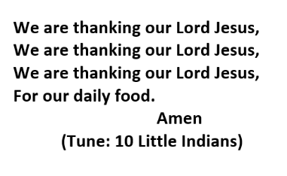
Snack Prayer:
Songs:
