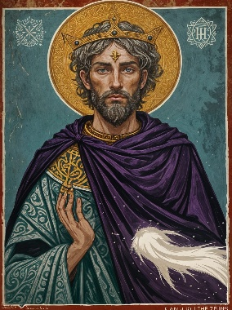
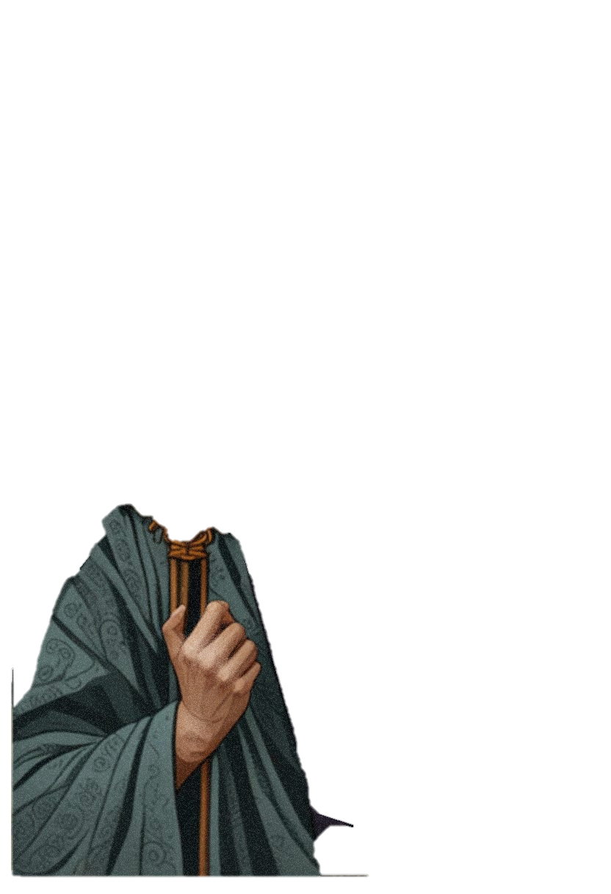
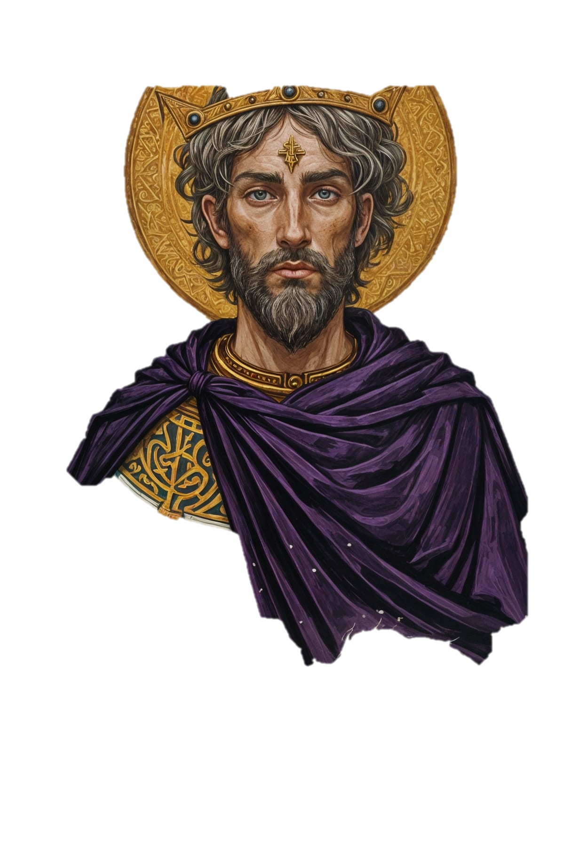

THE Opening
2KGS 18:1-12; 2CHR 29:1-2; 31:20-21


Introduction:
the opening moves
Your strategic _________________ will affect
the rest of your life.

Hezekiah _____________ as king of Judah in the middle of a chaotic context.
Hezekiah’s family of origin had a _____________ influence on his life. (2K 18:1-2; 2C 29:1-2)

HZK’s MOVE: Hezekiah did what was right in the sight of the LORD according to the kinging pattern of ___________, not Ahaz. (2K 18:3; 2C 29:2)
Hezekiah’s opening moves included ____________ and growth. (2K 18:4-6; 2C 29:3)
- ______________ high places
- ______________ sacred stones
- ______________ the Asherah poles
- ______________ the Bronze Snake

- ______________ the LORD, God of Israel (ISA 26:3-4)
- ______________ the LORD
- ______________ the LORD
- ______________ the LORD’s commandments
HZK’s MOVE: Hezekiah’s _________________ with the LORD made him one of the best kings of Judah. (2K 18:5; 2C 29:2)

Therefore, the LORD was “_________________”. (2K 18:7-8)
By contrast, the LORD was ______________ Hoshea, king of Israel. (2K 18:9-12)
HSH’s MOVE: Hoshea and his people disregarded the voice of God
and His commandments; they wouldn’t ____________ or ________________. (2K 18:12)
HZK’s MOVE: Hezekiah did what was good, ____________, and true before the LORD his God. He ____________ God with all his heart and prospered. (2C 31:20-21)
CONCLUSION: WHAT’S YOUR NEXT MOVE?

