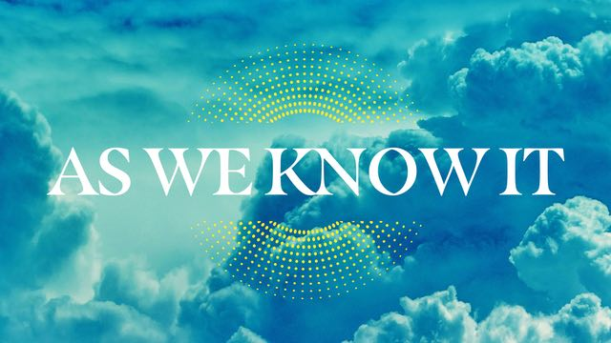

June 7, 2026
Learning #1: Heaven is greater than anything we can fully imagine.
Revelation 21:11-19 (NLT) - It shone with the glory of God and sparkled like a precious stone—like jasper as clear as crystal. The city wall was broad and high, with twelve gates guarded by twelve angels. And the names of the twelve tribes of Israel were written on the gates. There were three gates on each side—east, north, south, and west. The wall of the city had twelve foundation stones, and on them were written the names of the twelve apostles of the Lamb.
The angel who talked to me held in his hand a gold measuring stick to measure the city, its gates, and its wall. When he measured it, he found it was a square, as wide as it was long. In fact, its length and width and height were each 1,400 miles. Then he measured the walls and found them to be 216 feet thick (according to the human standard used by the angel).
The wall was made of jasper, and the city was pure gold, as clear as glass. The wall of the city was built on foundation stones inlaid with twelve precious stones…
1 Corinthians 2:9 (NLT) - … no eye has seen, no ear has heard, and no mind has imagined what God has prepared for those who love him.
Revelation 21:1 (NLT) - Then I saw a new heaven and a new earth, for the old heaven and the old earth had disappeared.
Learning #2: We will not be passive in Heaven. In Heaven, we will have a purpose.
Luke 16:10-11 (NLT) - If you are faithful in little things, you will be faithful in large ones. But if you are dishonest in little things, you won’t be honest with greater responsibilities. And if you are untrustworthy about worldly wealth, who will trust you with the true riches of heaven?
Isaiah 65:21-22 (NLT) - In those days people will live in the houses they build and eat the fruit of their own vineyards. Unlike the past, invaders will not take their houses and confiscate their vineyards.
Genesis 3:17-19 (NLT) - … the ground is cursed because of you. All your life you will struggle to scratch a living from it. It will grow thorns and thistles for you, though you will eat of its grains. By the sweat of your brow will you have food to eat until you return to the ground from which you were made.
Learning #3: Heaven is free from pain, loss, and brokenness.
Revelation 21:4 (NLT) - He will wipe every tear from their eyes, and there will be no more death or sorrow or crying or pain. All these things are gone forever.
Romans 8:18 (NLT) - Yet what we suffer now is nothing compared to the glory he will reveal to us later.
2 Corinthians 4:17 (NLT) - For our present troubles are small and won’t last very long. Yet they produce for us a glory that vastly outweighs them and will last forever!
Learning #4: Heaven is a place of relationship, reunion, and restoration.
Luke 23:43 (NLT) - And Jesus replied, “I assure you, today you will be with me in paradise.
Revelation 7:9 (NLT) - After this I saw a vast crowd, too great to count, from every nation and tribe and people and language, standing in front of the throne and before the Lamb.
Ephesians 1:10 (NLT) - And this is the plan: At the right time he will bring everything together under the authority of Christ—everything in heaven and on earth.
Hebrews 11:16 (NLT) - But they were looking for a better place, a heavenly homeland. That is why God is not ashamed to be called their God, for he has prepared a city for them.
Learning #5: To prepare for heaven, we need to refocus our priorities.
Matthew 6:19-21 (NLT) - Don’t store up treasures here on earth, where moths eat them and rust destroys them, and where thieves break in and steal. Store your treasures in heaven, where moths and rust cannot destroy, and thieves do not break in and steal. Wherever your treasure is, there the desires of your heart will also be.
Philippians 3:14 (NLT) - I press on to reach the end of the race and receive the heavenly prize for which God, through Christ Jesus, is calling us.
Colossians 3:2 (NLT) - Think about the things of heaven, not the things of earth.
Ephesians 2:8-9 (NLT) - God saved you by his grace when you believed. And you can’t take credit for this; it is a gift from God. Salvation is not a reward for the good things we have done, so none of us can boast about it.

