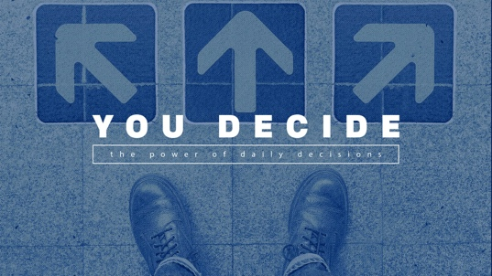

August 16, 2026
Learning #1: Despite knowing the cost, we often aren’t great decision makers.
Romans 7:19 (NLT) I want to do what is good, but I don’t. I don’t want to do what is wrong, but I do it anyway.
Learning #2: To learn how to make better decisions, we've got to leave behind our old way of making decisions.
Isaiah 43:18-19 (NIV) Forget the former things; do not dwell on the past. See, I am doing a new thing!
Proverbs 16:3 (NIV) Commit to the Lord whatever you do, and he will establish your plans.
Learning #3: We can ask God to help us decide what we will do later.
Daniel 1:8 (NLT) But Daniel was determined not to defile himself by eating the food and wine given to them by the king. He asked the chief of staff for permission not to eat these unacceptable foods.
- I will be ready for temptation.
- I will be devoted to putting God first.
- I will be faithful in every opportunity.
- I will make a difference.
- I will live generously.
- I will be consistent.
- I will be a finisher.
Philippians 3:13-14 (NLT) No, dear brothers and sisters, I have not achieved it, but I focus on this one thing: Forgetting the past and looking forward to what lies ahead, I press on to reach the end of the race and receive the heavenly prize for which God, through Christ Jesus, is calling us.

