

August 30, 2026
Ephesians 2:8 (NLT) - God saved you by his grace when you believed… it is a gift from God.
Ephesians 2:10 (NLT) - For we are God’s masterpiece. He has created us anew in Christ Jesus, so we can do the good things he planned for us long ago.
Learning #1: To keep God first, we should keep a spiritual inventory.
Hurts: What breaks my heart?
Matthew 25:35-36 & 40 (NLT) - For I was hungry, and you fed me. I was thirsty, and you gave me a drink. I was a stranger, and you invited me into your home. I was naked, and you gave me clothing. I was sick, and you cared for me. I was in prison, and you visited me. “And the King will say, ‘I tell you the truth, when you did it to one of the least of these my brothers and sisters, you were doing it to me!’
Expenses: Where does my money go?
Matthew 6:21 (NIV) - For where your treasure is, there your heart will be also.
Attention: What occupies my thoughts?
Colossians 3:2 (NIV) - Set your minds on things above, not on earthly things.
Relationships: Who influences my decisions?
Proverbs 3:5-6 (NLT) - Trust in the Lord with all your heart; do not depend on your own understanding. Seek his will in all you do, and he will show you which path to take.
Time: How am I spending my time?
Matthew 6:33 (NIV) - Seek the Kingdom of God above all else, and live righteously, and he will give you everything you need.
Hurts: What breaks my heart?
Expenses: Where does my money go?
Attention: What occupies my thoughts?
Relationships: Who influences my decisions?
Time: How am I spending my time?
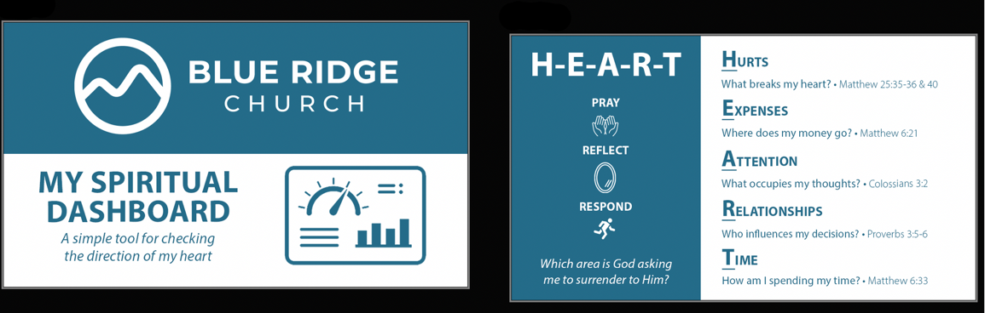
Learning #2: To keep God first, we should say no to some good things to say yes to what’s best.
Romans 12:2 (NLT) - Don’t copy the behavior and customs of this world, but let God transform you into a new person by changing the way you think. Then you will learn to know God’s will for you, which is good and pleasing and perfect.
Ephesians 5:15-17 (NLT) - So be careful how you live. Don’t live like fools, but like those who are wise. Make the most of every opportunity in these evil days. Don’t act thoughtlessly but understand what the Lord wants you to do.
Matthew 11:28-29 (NLT) - Then Jesus said, “Come to me, all of you who are weary and carry heavy burdens, and I will give you rest. Take my yoke upon you. Let me teach you, because I am humble and gentle at heart, and you will find rest for your souls.
Learning #3: To keep God first, we should spend strategic, undistracted time with God.
Galatians 5:22-23 (NLT) - But the Holy Spirit produces this kind of fruit in our lives: love, joy, peace, patience, kindness, goodness, faithfulness, gentleness, and self-control.
John 15:5 (NLT) - Yes, I am the vine; you are the branches. Those who remain in me, and I in them, will produce much fruit. For apart from me you can do nothing.
Mark 1:35 (NLT) - Before daybreak the next morning, Jesus got up and went out to an isolated place to pray.
Ephesians 1:4-5 (NLT) - Even before he made the world, God loved us and chose us in Christ to be holy and without fault in his eyes. God decided in advance to adopt us into his own family by bringing us to himself through Jesus Christ. This is what he wanted to do, and it gave him great pleasure.

