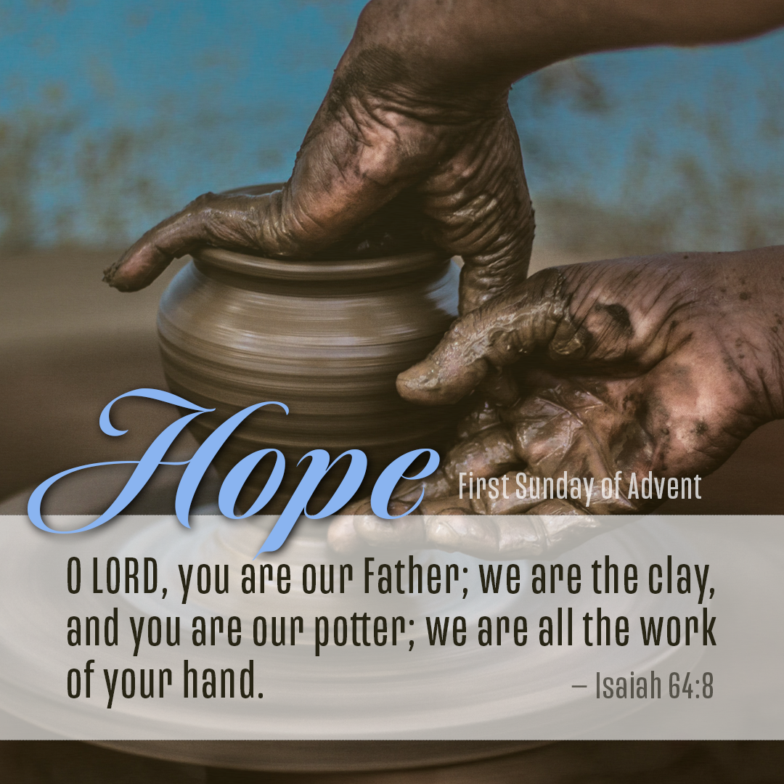

PRELUDE – BECKI SMITH
WELCOME – Welcome to Scott Memorial United Methodist Church. It is always a privilege to join in unity with children of God to praise and worship our Savior. Let us prepare ourselves for what God has for us this day. May we rejoice in knowing that each one in this place has been called to live as children of light. May we build one another up as we share God’s word this day.
ANNOUNCEMENTS – If you have prayer requests, please email them to us at scottmemorialumc@hotmail.com or call the church at 740-942-2825.
Bible Study - We are beginning a new Bible Study beginning this week on December 1, 2020 titled - Faithful -by Adam Hamilton – we are planning to meet at two times – on Tuesdays Dec. 1st at 10:30 am and on Wednesdays Dec. 2nd – at 7:00 pm. Both can be attended in-person or utilizing Zoom. If you would like to be included on Zoom, please call the church at 740-942-2825 and give us your email address to receive the invitation to the Zoom meeting. Remember, you do not need to be a member of the church to participate!
Volunteers needed– If you would like to volunteer to be a reader for our Advent readings during the next three weeks and on Christmas Eve, please leave a message at the church, text the pastor, or email the church. Please let us know and do not make me come begging. Thank you in advance for answering the call!

CALL TO WORSHIP – based on Isaiah 64 by Mary Petrina Boyd
We are continuing our method of call and response again this week. After each sentence that I say, you all can repeat: Come down, O God! Come down, O God!
You alone, O Lord, are God.
Come down, O God!
You have done wonderful things in the past.
Come down, O God!
We need you here with us now.
Come down, O God!
We wait for you, O Lord, we wait with hope.
Come down, O God!
LIGHTING OF THE ADVENT CANDLES:
Reader One: If ever there was a year that we needed Advent, this is the year. We hardly know how to describe the year we have lived through. We hesitate to reflect on all the mess around us in 2020. All we know is that nothing seems right, nothing seems like it used to be, nothing. We need Advent!
Reader Two: The prophet Isaiah cried out for us, “O that you would tear open the heavens and come down … To make your name known … so that nations might tremble at your presence.” So, tear through the mess, O Lord, and come down to us again. We long to be your people, a people of hope.
Reader One: We light this first candle as a sign of our hope. Hope that you can meet us, even in the mess of our world. Hope that you still see us, though we feel we are lost in the rubble. Let this light be the guide that brings us to Emmanuel once more.
Reader Two: O Come, O Come Emmanuel.
PRAYER – GRACIOUS AND LOVING GOD, AS THIS 2020 SEASON OF ADVENT BEGINS SPEAK TO US THROUGH YOUR WORD. GOD, PREPARE OUR HEARTS TO RECEIVE THE GIFTS THAT YOU BRING. SHAPE US SO THAT WE ARE READY FOR THE COMING OF YOUR PRECIOUS SON, JESUS CHRIST. ALERT US TO THE SIGNS THAT TELL US THAT GOD IS NEAR. MAY YOUR SPIRIT GUIDE US IN HEARING YOUR CALL. AS THE CANDLES HAVE BEEN LIT THIS MORNING, MAY YOU LIGHT OUR SPIRITS WITH YOUR ETERNAL LOVE. MAKE US TRUE VESSELS TO SHARE YOUR PRESENCE AT THIS SPECIAL TIME. WE WAIT ON YOU O, GOD AND PLACE OUR TRUST IN YOUR LOVE. LET US RESPOND WITH GIFTS OF JOY AND PRAISE AS WE WORSHIP TOGETHER AS ONE BODY OF CHRIST.
GOD, OUR GREAT PHYSICIAN, WE BRING TO YOU TODAY THOSE WHO NEED A SPECIAL HEALING TOUCH FROM YOU. WE KNOW THAT YOU LOVE ALL PEOPLE AND THAT YOU PROVIDE ALL THAT IS NEEDED IN EACH LIFE. YOU HAVE HEARD EACH SPOKEN REQUEST AND KNOW EACH HEART THAT IS CARRYING AN UNSPOKEN CONCERN THIS MORNING. AND WE LAY BEFORE YOU OUR PLEAS KNOWING THAT YOU WILL ANSWER. THERE IS NOTHING THAT WE LACK BECAUSE OF YOUR LOVE. AS WE BRING TO YOU OUR OFFERINGS THIS MORNING, MAY THEY HELP TO PROVIDE HEALING AND BRING HOPE TO ALL.
Lord, we pray together this day the prayer you so graciously taught us to pray:
Our Father, who art in heaven, hallowed be your name. Thy kingdom come; thy will be done on earth as it is in heaven. Give us this day our daily bread. And forgive us our trespasses, as we forgive those who trespass against us. Lead us not into temptation but deliver us from evil. For thine is the kingdom, the power, and the glory forever. Amen.
SCRIPTURE – ISAIAH 64:1-9
MESSAGE – THE GOOD OLD DAYS
Oh, the good old days. Do you remember the good old days? I remember my parents talking about the good old days. “I remember when . . .” my parents would say. “Back in my day . . .” was another favorite. What about, “When I was you age . . ..” Simon and Garfunkel had a song in the 60s that said, “Where have you gone Joe DiMaggio?” They were longing for different times, the good old days. The “All in the Family” theme song was a satire, but it points out that people often long for the good old days. Oh, we love the good old days. Why aren’t things like they used to be? What happened to the good old days?
The prophet Isaiah sang a similar song in our scripture reading for today.
The glory days are long gone. The Northern Kingdom of a divided Israel had been taken into captivity. The southern kingdom of Judah was precariously balanced between rival international powers. This is similar to modern times. Israel is currently balanced rather precariously in an area world that desperately wants to see it destroyed. Rival powers were vying for supremacy in the Middle East. That sounds familiar. Judah longed for the days of its power. David and Solomon were only distant memories. They were names in the history books, like George Washington and Abraham Lincoln.
Isaiah looks longingly back on the good old days. Those were the days. God had done many wonderful things. Verse 3 states, “For when you did awesome things that we did not expect, you came down, and the mountains trembled before you.” There was Noah, Abraham, Isaac, Jacob, Joseph, Moses, Joshua, David and Solomon. Good intervened at Mt. Moriah, Sinai, the Passover, the Red Sea, Jericho, and with Goliath. They were only faded memories. Isaiah wanted God to demonstrate His power. He wanted to see the heavens split open. He wanted an earthquake. Why wasn’t God intervening like God used to? Why wasn’t there another Mt. Sinai or Red Sea crossing? Where have Moses and David gone? I can see the ancient Israel equivalent of the “All in the Family” theme song:
“Oh, the way King David played, songs that made the Psalms parade. Guys like us we had it made, those were the days, and you knew who you were then, Israel was Israel and heathens were heathen, mister we could use a man like Old Solomon again, didn’t need no divided state, we were all headed the same way, gee our old Sinai was great, those were the days!”
Where had Israel’s and Judah’s good old days gone? Isaiah understands why. In verse 5, Isaiah states that God helps “those who gladly do right, who remember [His] ways.” Judah “continued to sin against” God’s ways. They had missed God’s plan for their lives. God was angry with them. Isaiah wondered if perhaps they have gone too far, “How then can we be saved?”
Verse 6 is rather eye opening. Isaiah says, “All of us have become like one who is unclean, and all our righteous acts are like filthy rags.” The people were stained by their sins. They had become polluted. They weren’t gladly doing right. Even worse, they were doing right things. Isaiah states, “All our righteous acts are like filthy rags.” They were going through the motions, but there was no heart commitment to the Lord.
Sometimes we fall into that mode. We go through the motions of playing Church. Then we wonder why God isn’t blessing us, or things are rough. God wants our heart. And then Isaiah really brings it home in verse 7. The real problem is, “No one calls on your name or strives to lay hold of you.” No one bothered to seek God’s will. No one was praying. No one was trying to reach God. Consequently, God had turned His face from the people. He allowed them to “waste away because of [their] sins.” Sin causes separation from God. Sin had driven a wedge between the people and God. This is why Isaiah wonders, in verse 5, “How then can we be saved?” Isaiah wondered if the people had gone too far.
But verses 8 and 9 are ones of hope. “Yet, O Lord, you are our Father. We are the clay; you are the potter; we are the work of your hands. Do not be angry beyond measure, O Lord; do not remember our sins forever. Oh, look upon us, we pray, for we are your people.
Isaiah asserts that God is the Father. It’s not easy for a father to turn his back on a child. I have watched fathers agonize over the mistakes of a child. It takes a long time for a father to turn his back on his child. One man I knew had a son who was constantly in trouble. He had been in jail, skipped school, and done other things. But dad was always there. I was talking to him one day and he threw up his hands and said, “I don’t know what to do with my son.” Imagine the pain that God must have felt to turn His head from His people.
But there is hope. Isaiah says, “We are the clay, and you are the potter; we are all the work of you hand.” Isaiah says that they are willing to be molded into what the Lord wants them to be molded. The people were broken. They were in a difficult position as far as international politics go. They were going through the motions. No one was calling to God. God had turned His face from them. They were wasting away in their sins. Isaiah pleads with God to take them and turn them into something new.
In verse 9, Isaiah prays for the forgiveness of the sins of the people. Isaiah acknowledges God’s right to be angry, in saying, “Do not be angry beyond measure, O Lord.” In other words, don’t be angrier than you have to be. God has a right to angry when we sin, the same way we, as parents, have the right to be angry with our children when the act in direct defiance of something we have instructed them. He then pleads with God to not remember the sins of the people. When we experience the forgiveness of God, our sins are deleted from His memory. They are not remembered against us.
Two weeks ago, I was having trouble with my computer, while I was trying to get the computer ready to use for our Zoom meeting and it appeared to overheat and crash. I finally got the thing to shut down and then it failed to restart. Finally, it did restart, but went immediately to an update. When it finished, most of my applications that are usually on my screen disappeared. They were gone. That stupid computer had eaten my apps. Or so I thought. The next day I realized that it wasn’t the computer that was stupid, it was the update that cleaned off all the programs that were consuming the computer’s energy. They were gone. That’s how God treats our sins that are forgiven. They are deleted from God’s memory, and there is no way to recover them.
We have hope as we enter this advent season. God has dramatically intervened at several points in history. There was Noah, Mt. Sinai, the Red Sea crossing, the battle of Jericho and others that Isaiah recalled. God intervened later as well. We can think of Daniel in the lion’s den, the Hebrew children in fiery furnace (Shadrach, Meshach and Abednego), Nehemiah rebuilding the wall of Jerusalem, Esther, and the biggest of them all, the sending of God’s Son, Jesus Christ. This is what we celebrate this season.
This is not the end of the story. Christmas is not the main focus of the Christian year. Commercialism has made Christmas the most important day of the year. The thing to remember is that the story does not end with the manger of wood; the story ends with a cross of wood and an empty tomb. The forgiveness that God offers was not accomplished in the manger. It was accomplished on the cross. Jesus became the perfect sacrifice for our sins. He conquered death and rose again to life. What we celebrate this season is the invasion of God into human history. Isaiah pleaded for God to “rend the heavens and come down,” he wanted God to “cause the nations to quake.” God invaded human history on that night in Bethlehem, although it was not with a mighty earthquake, but with the gentle coo of little baby.
Our hope is found in the person of Jesus Christ. He is God, and in Him rests our hope. Isaiah was full of hope as he wrote verse 9, “Do not be angry beyond measure, O Lord; do not remember our sins forever. Oh, look upon us, we pray for we are all your people.” Jesus gives us the hope that this prayer will be answered for us.
Have you ever been a position like Isaiah was? Have you ever been in position like the people for whom Isaiah was praying? Are you going through the motions? My friends, God does not so much care about our actions as God does about our hearts. If our hearts are not right with God, it does not matter that we do the right things or not. We can come to church and sing the songs and pray the prayers and read the scriptures, but if our heart is not right with God all that stuff is “like filthy rags” according to verse 6. Those things will “shrivel up like a leaf.” A fall leaf has a short life span. It is burned up, blown away or crushed into a million pieces.
Is your heart right with the Lord today? Are you longing for the good old days? Do you remember the times God invaded your life and rocked your world? Do you long for the days that God was super-real in your life? The answer is provided in Isaiah’s assessment of the people of Israel. He says, “No one calls on your name or strives to lay hold of you.” The answer is to call on His name and try to lay hold of Him. Prayer is the answer to the return to the good old days. Jesus said in Matthew 17:20, “He replied, ‘Because you have so little faith. I tell you the truth, if you have faith as small as a mustard seed, you can say to this mountain, ‘Move from here to there’ and it will move. Nothing will be impossible for you.”
Jesus offers us the hope of moving mountains. Isaiah pleaded with God to make the mountains quake. Isaiah pleaded for an invasion of God. God did do that through His Son. Prayer is the answer for us to make the mountains quake. If you are feeling as though God has turned from you, call on God, seek God’s will for you.
BENEDICTION – Stay awake, for God is coming. Prepare your heart, for God is near. In the darkness, a candle of hope burns brightly. In the quiet, God speaks to us. Go with joy and remain aware and awake. Grace and peace to you, from God the creator, and from our Lord, Jesus Christ.

